Chapter 15 Notes

Sex Linked Traits: Thomas Hunt Morgan: Columbia University.

Looked at fruit flies. Only saw males with white eyes. Maybe traits are linked to the sex chromosomes. Found that eye color was linked to the X chromosome.

Sex linked traits are carried on the X chromosome and can be masked in females, because they have a back-up copy.

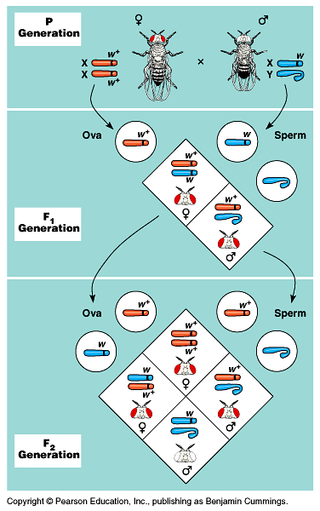

c⁺ = normal c = colorblind [found on X chromosome]

*see website for practice problems

Some traits are linked because they are on the same chromosome. So genes on the same chromosome can go to the same gamete.

Recombination of traits: (crossing over) Yields offspring that don’t fit the Mendelian ratios perfectly.

You can measure how far apart the traits are based on how frequently the traits cross-over.

This gives you a way to map a chromosome. The more they cross over (%) the further apart they are.

G/B = 20% (20 map units)
B/Q = 13%
Q/G = 7%
Q/A = 3 %
A/F = 5 %
F/G = 1%

5 20
F- G------A---Q-------------------------------B
1 3
7 13

Females deactivate one X-Chromosome into a barr body.

Calico cats = show the colors of one chromosome or the other, not both, because one X chromosome is deactivated in every cell.

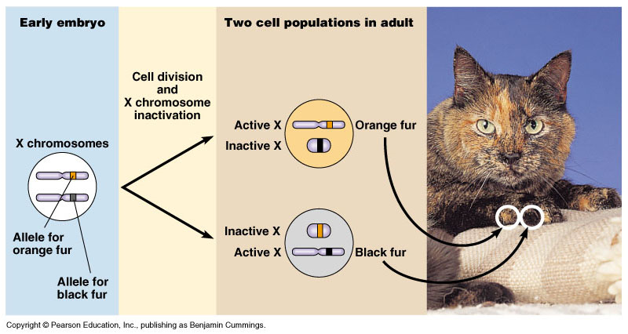
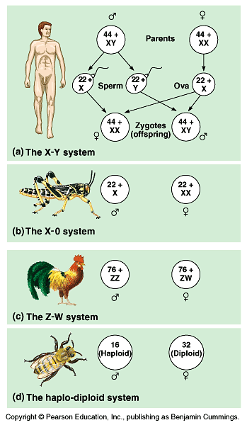
Sometimes your chromosomes don’t split during meiosis I or II, that leads to extra or missing chromosomes in the gamete.

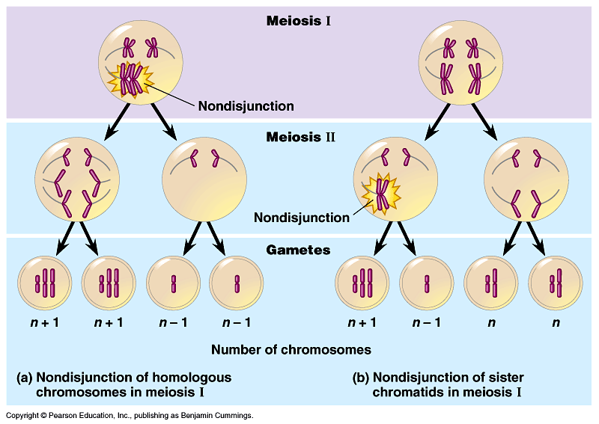
When you have an extra/or missing chromosome it’s called aneuploidy.

Extra #21, trisomy 21 or Down’s Syndrome.
Trisomy 5: Cru du chat (cry of the cat)

Extra/missing sex chromosomes:
XXX – super female 1/1000
XXY – Klinefelter’s 1/2000 look male, but have secondary female traits (extra estrogen/progesterone)

XYY – super male, extra tall/violent.
X0 – Turner’s syndrome. Female. Sex organs don’t fully develop.

Sometimes chromosomes can be altered… (mutations)

