Ch 16 Notes: Molecular Basis of Inheritance

In the 1400’s – people thought there were tiny dormant embryo’s inside a woman… after sex… a baby would come out that looked like both parents.

1900’s - More research started on the molecular level.

Griffith, Frederick (British) 1928: Worked with mice, streptococcus (bacteria).

Mouse 1: injected the S –strain. Mouse died.

Mouse 2: injected with R – strain. Mouse lived.
Mouse 3: injected heat killed S-strain. Mouse lived.
Mouse 4: injected heat killed S-strain + living R-strain. DEATH.

Discovered nothing… BUT… there is something that can change a R-strain into a deadly form from the s-strain.

Avery, Oswald, 1944, repeated Griffith’s experiment and found that it was DNA that transformed the bacteria. But not everyone believed it.

Hershey, Alfred & Chase, Martha 1952. Backed up Avery.

Worked with Bacteriophages (viruses = proteins and nucleic acids). The phages attack bacteria and change them.

Labeled the proteins with a radioactive tag (Sulfur)
Labeled the DNA of the virus with radioactive Phosphorus.

Let the virus attach to bacteria, and infect them, afterwards they looked inside the bacteria to see what was inside. They found radioactive Phosphorus inside when means…. DNA was the factor that changes the bacteria.

Chargaff, Erwin 1947 Studied DNA, isolated the bases A,T,G,C. When he analyzed the amounts of them, he found distinct ratios: there was always the same amount of A’s and T’s, and the same amount of G and C. Came up with the rules that A always pairs with T and G always pairs with C. Base Pairing rules (Chargaff’s rules).

DNA Replication: How does life perpetuate life?

DNA has an anti-parallel structure, one strand goes up, the other goes down.

DNA Replication: How does life perpetuate life?

DNA has an anti-parallel structure, one strand goes up, the other goes down.

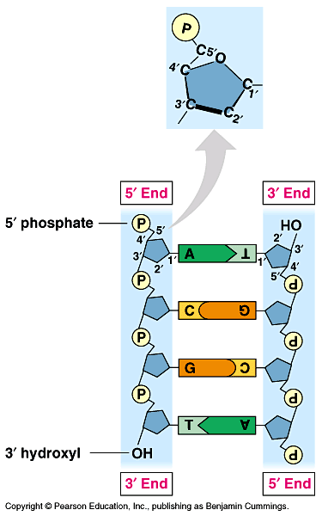

The base pairing rules state that A-T, G-C. This keeps the distance between strands the same. They are held together by hydrogen bonds. A-T have 2 bonds, and G-C have 3 bonds.

Phosphate-Sugar backbone held together with covalent bonds, so DNA is very strong going up and down, but “unzippable” from side to side, b/c hydrogen bonds are weaker.

Messelson and Stahl were the first to describe the semi-conservative reproduction of DNA. Semi-Conservative, means that when it reproduces it uses an old strand as a template and makes a new strand that is half old/half new pieces.

James Watson and Francis Crick and Rosalind Franklin. 1953. Described the shape of DNA (Double Helix), which led us to understand how it reproduces.

Rosalind Franklin was working with DNA in England, using X-ray crystallography.

How does DNA replicate:

1) Origin of Replication (usually a bubble). DNA has to unzip. Enzyme is Helicase.

2) DNA has 2 strands in opposite directions. 5’ on top and 3’ on bottom. You can only add new pieces on the 3’ end.

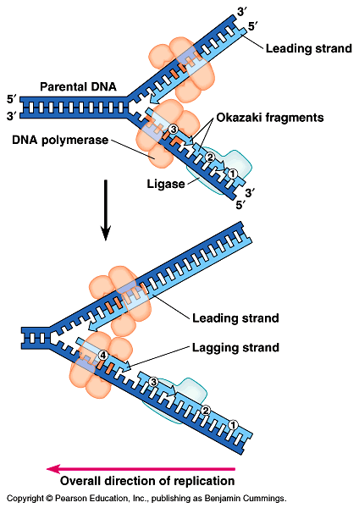

3) DNA polymerase, is an enzyme that adds new nucleotides to the 3’ end.
- The Leading strand has no problem adding new pieces to the 3’ end as it unwinds.
- The Lagging strand has to restart every time more of it unwinds.
  - DNA Polymerase adds new DNA pieces to a double strand.
  - SO, another enzyme, called primase, has to add a small piece of RNA to the DNA before new pieces can be added, this is called a primer.
  - Then the RNA has to be removed by DNA polymerase, and joined together using Ligase.

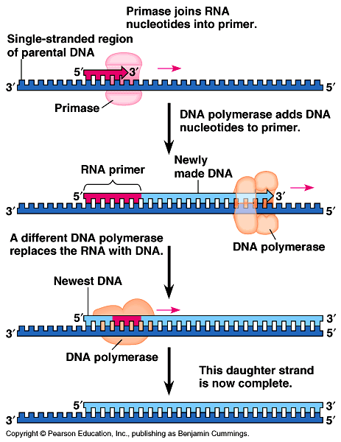
- DNA polymerase then proofreads for any mistakes.
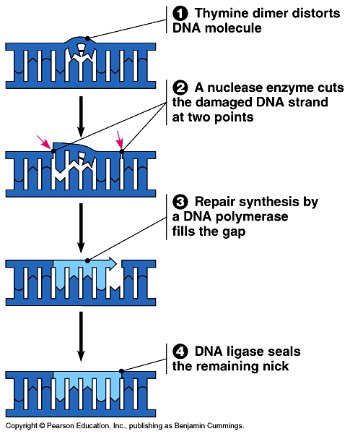

Summary Picture:

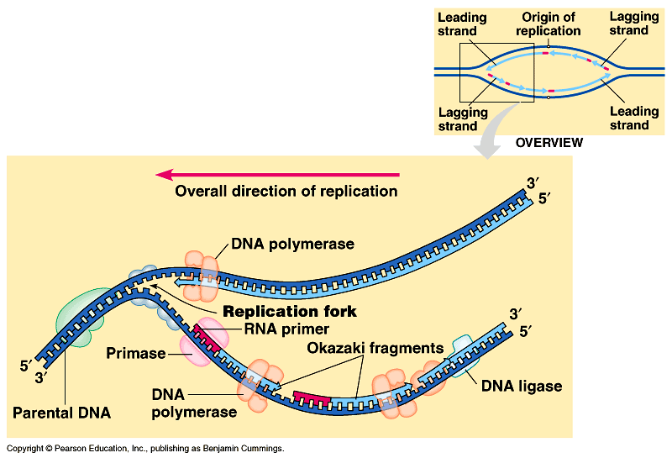

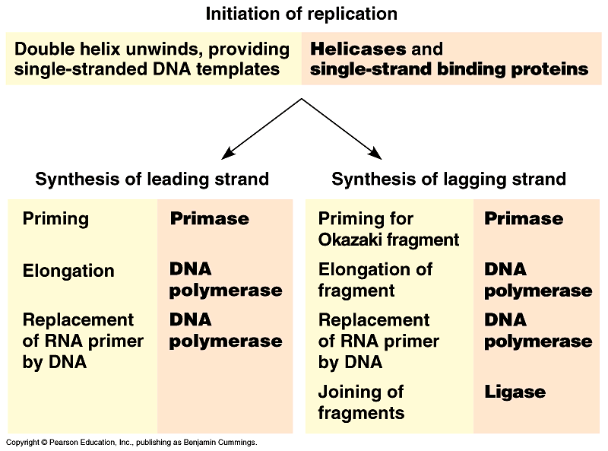

Telomeres: the ends of the chromosomes. We normally don’t reproduce the ends of the chromosomes, full repetitive sequences. In order to keep the chromosome from getting too short, an enzyme telomerase adds new pieces of the telomere.

