Notes: DNA Replication

Making an exact copy of existing DNA, in order to reproduce… a cell… an organism. You had to copy your DNA trillions of times to make your cells.

Semi-Conservative replication. Use the old strands as templates to make new strands.

DNA replication take place in the nucleus (except bacteria).

1. DNA is unwound/unzipped using Helicase.
2. DNA polymerase attaches to the template, and starts to add new pieces of DNA. Except… you can only add new pieces on the 3’ side.
3. It needs to form a replication bubble.
4. One side is called the leading strand and makes a copy from 5’ to 3’.
4b. The other side is called the lagging strand, because it has to start and restart.

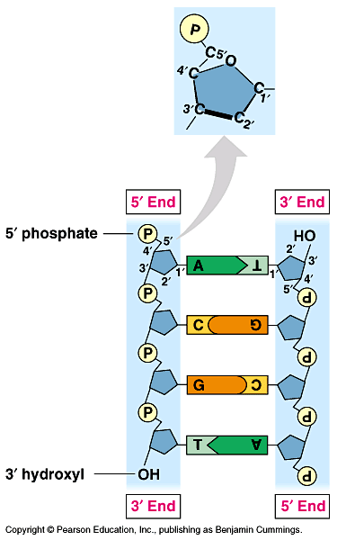
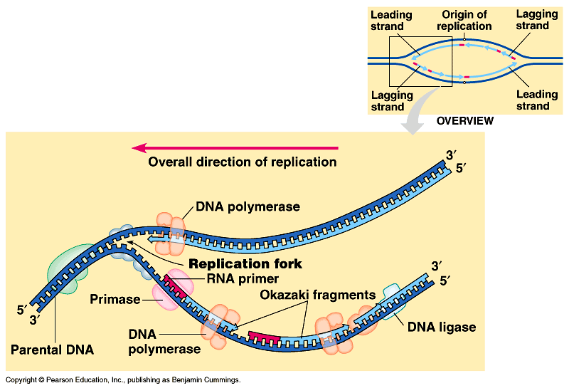

5. The molecule that adds new pieces of DNA is called DNA polymerase.
6. DNA polymerase can only add new nucleotides to a double stranded piece. An enzyme called Primase adds a small piece of RNA to it.
7. DNA polymerase removes the RNA after the chain has formed, and replaces it with DNA.
8. Ligase “glues” the sections together.
9. DNA polymerase then proofreads all the DNA to look for mistakes.

