Ch 19: The Organization and control of Eukaryotic Genomes

DNA is packed on many levels.
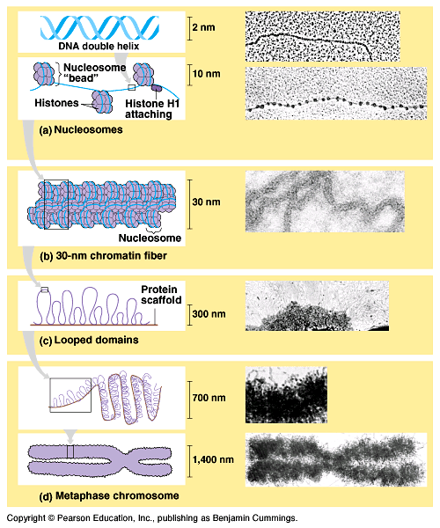
- Double Helix. Only unwound for replication and transcription.
- “Beads on a String” DNA wrapped around histone proteins.
- Chromatin = those beads wrapped up even more. During Interphase.
- Looped Domains = chromatin in loops.
- Loops are looped = chromosome during metaphase/anaphase.

When we need to divide the cells (mitosis or meiosis) the DNA needs to be moved quickly and easily so it’s in chromosome form.

In interphase the genes need to be “read” more easily so the DNA is in looser Chromatin form.

How is the genome organized? The genetic information contained in the DNA.

About 95-97% of the human genome is non-coding DNA (doesn’t code for a protein).
- much of it is called repetitive DNA (sequences that repeat over and over). Why?
- May serve as markers for the genes.
- Also are unique for every human. (makes up our DNA fingerprint). Example = alu fragments
- Some of these repeated sequences can actually lead to diseases.
- May be left overs from ancestor species.

Gene families. More than one copy of a gene or related gene. (multigene families)

Sometimes the genes are different at different ages. When you’re born you have one type of hemoglobin made… later in life you have another.
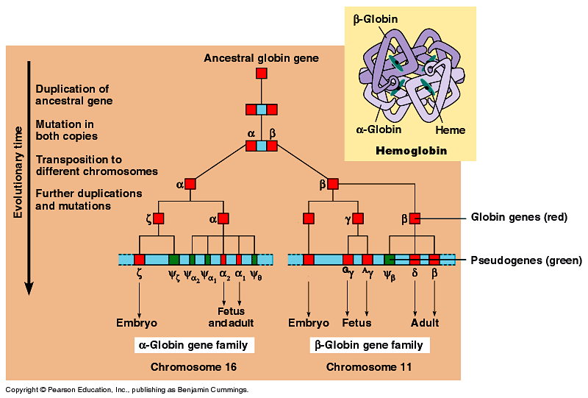
Gene Amplification. You make more copies of one gene to increase the protein output. Ex: ribosome genes.

Gene can be rearranged: transposons (jumping genes) can move from one chromosome to another. Maybe viruses started as transposons?

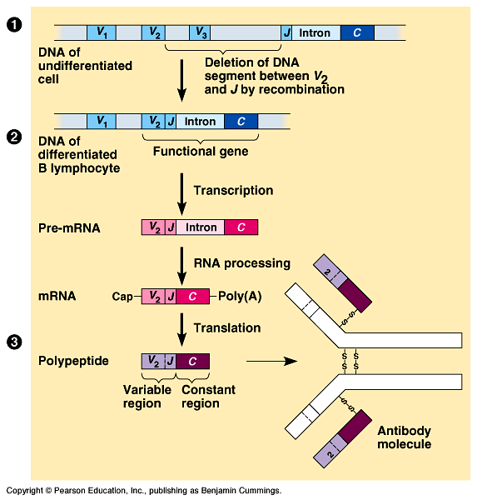
Control of Gene Expression: How and when a protein is made. We need to turn genes on or off. (in bacteria they use: operons)

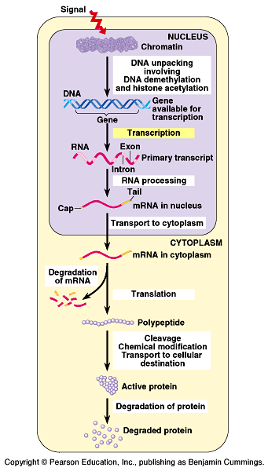
- DNA Methylation (-CH₃) Add methyl groups to DNA to make it more compacted so it won’t be read.

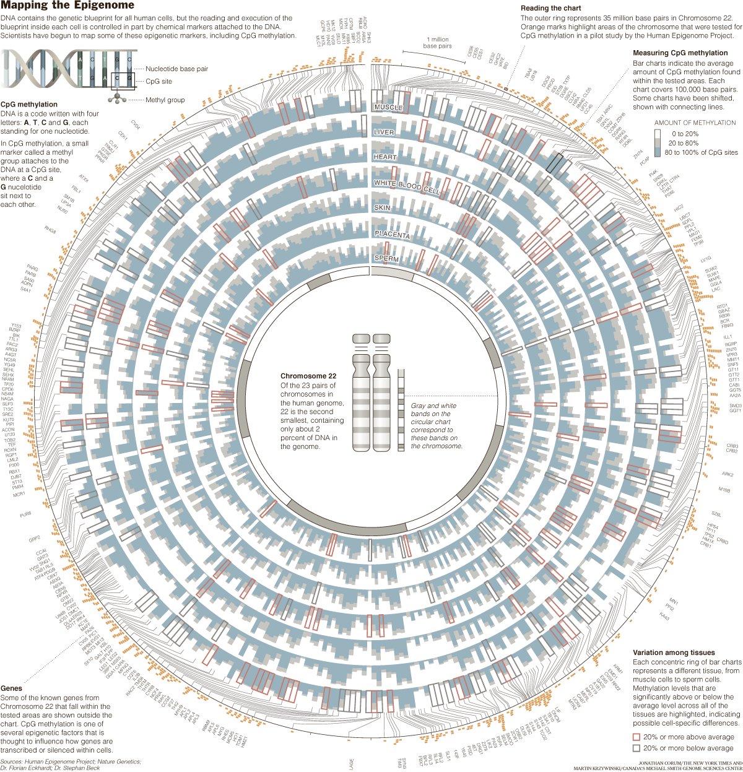
- Transcriptural control. Control the transcription factors that are released.
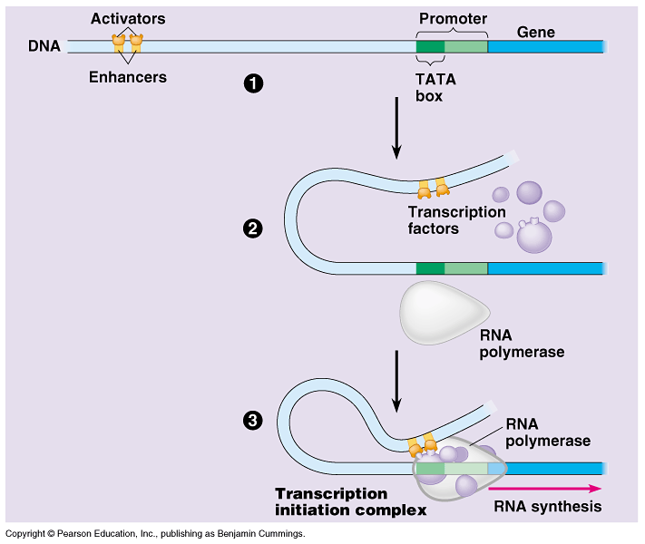

- Post Transcriptural Control. Pre-mRNA (introns and 5’cap…) Sometimes you’ll wait to add the 5’ cap… sometimes you won’t take out the introns…

Cancer: continued…

There are genes called oncogenes, they code for the uncontrolled division. Some viruses have these and insert them. Sometimes
proto-oncogenes mutate into oncogenes.

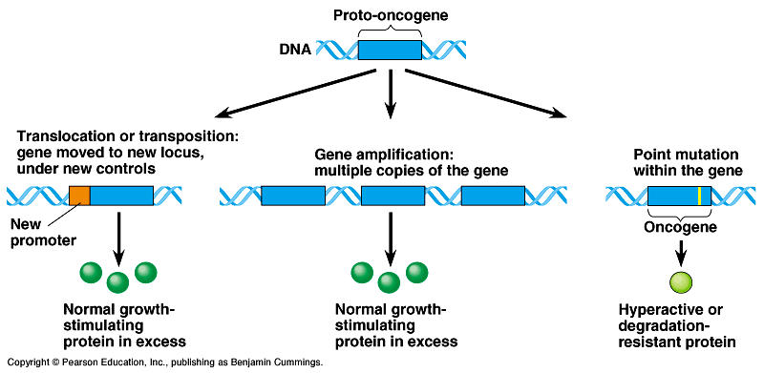

Tumor suppressor genes… these tell cells to not divide like crazy. Sometimes we have faulty tumor suppressor genes. P53 (breast cancer tumor suppressor gene).

