Ch 20 DNA Technology and Genomics

Biotechnology = manipulating a living organism to somehow benefit man.

Early biotechnology → used in agriculture (selective breeding) ex: cattle, fruit. Used for food processing: ex: wine, bread, cheese, yogurt, kimchi.

Recombinant DNA = taking DNA from one organism and combining it with another organisms DNA.

Ex: taking a human gene for insulin and inserting it into a bacterial plasmid. 1980’s… company called Genentech which uses this technique.

Uses for recombinant DNA…
- To manufacture medicines. Take a gene (for a protein that someone needs) from a healthy person’s DNA and then cut it out. Insert it into a plasmid (using restriction enzymes and ligase). Then clone the bacteria – which will make the protein we need.

The human gene has to be made into cDNA (complimentaryDNA) by using a piece of “edited” mRNA and using reverse transcriptase to make it back into cDNA that can be inserted into the bacterial plasmid.

- To insert genes into plants. Ex: frost resistant strawberries. Herbicide resistant plants.
- Insert an “oil eating” gene into bacteria. Used for oil spills.

PCR: Polymerase Chain Reaction discovered by a guy named Kerry Mullis. 1985. Way of multiplying DNA.
- All you need is one cell, and you can make millions of copies of that DNA.
- Used for forensic science.
  - Start with one copy of DNA you want to make copies of.
  - Raise temp to 95 degrees, “melts” DNA.
  - Add primers for the DNA replication.
  - Add taq polyermase*, that will add new pieces of DNA.
  - Repeat the steps many more times to make millions/billions of copies.
* must use a heat resistant polymerase found in thermobacteria from hot springs called taq polymerase.

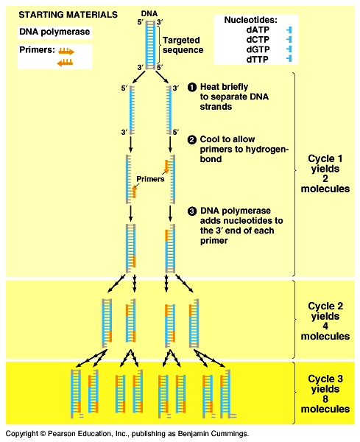
Gel Electrophoresis:

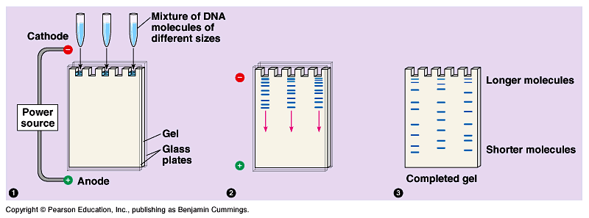

Fragments of DNA move from negative to positive (b/c DNA is neg). Smaller fragments will move further away from the wells. Must be submerged in buffer to allow an electrical current to flow through.

DNA sequencing. Figuring out the entire human code…A,T, G, C…. Sanger Technique.
    - Started with a random sample of DNA
    - Soaked in radioactive nucleotides
    - Analyzed where the radioactive nucleotides stuck and put it in order.

Restriction Enzymes: in nature, found in bacteria, they were used to break down foreign DNA (from viruses).

We started to use them like “scissors” to cut DNA. We can cut out genes and insert genes.

Opposite of restriction enzyme is ligase, used to “glue” pieces of DNA together.

RFLP’s (Restriction, Fragment, Length Polymorphism’s)

Restriction enzymes can be used to cut human DNA. For crime labs, you can cut human DNA into pieces using restriction enzymes. Run them on a gel and analyze and compare.
At a crime scene, they find a drop of the killer’s blood (or a hair, or skin, etc…)

- Isolate DNA from a nucleus.
- PCR – the DNA to make copies of it.
- Digest the DNA using a cocktail of restriction enzymes. To cut the DNA into RFLP’s.
- Run the RFLP’s on a gel, the different sized fragments move.
- You can compare the RFLP’s on the gel with other people’s RFLP’s. This is your DNA fingerprint.

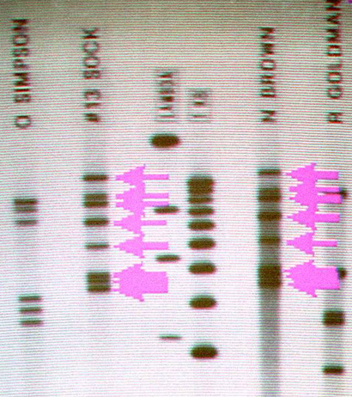

Modern DNA fingerprints analyze simple tandem repeats (STR)… ex: ACAACAACAACAACA The number of repeats is different for each person.

Some future uses of DNA technology:

Genetically Modified Foods (GM-foods)

You can make a tomato that stays ripe longer…
You can make strawberry that can grow in cold weather.

Controversy: some people worry that the food is not natural and so we don’t know what could happen if we eat it.

What if these genes breed with normal plants and make “crazy” mutant plants.

GMO’s Genetically Modified Organisms

Transgenic Species: Bacteria that makes human protein (insulin). But, where does it stop?

The future of biotech???

Gene Therapy: Changing your genes. For genetic diseases, insert a healthy gene? But where does this end? Could we “design babies?”

