Ch 23 – Notes Evolution in Populations
Smallest Unit that can evolve is a population.
Definitions:
- Populations: a localized group of individuals belonging to the same species.
- Gene Pool: All genes in a population.
- Species: A group of organisms that can interbreed and produce fertile offspring.
Hardy-Weinberg studied evolution in populations.
Hardy-Weinberg theorem: The frequencies of alleles and genotypes in populations remain constant in generations – UNLESS acted upon by agents* other than Mendelian segregation and recombination of alleles.
What *agents can cause the gene pool to change?
- Mutations
- Natural Selection
- Migration
- Non-Random Mating
- Genetic Drift (chance events that can change a population)
- Populations must be big
Microevolution: Changes in the gene pool on the smallest scale.
Genetic Drift can lead to microevolution. Examples: Accidents, part of the population getting separated (founder effect), chance events…

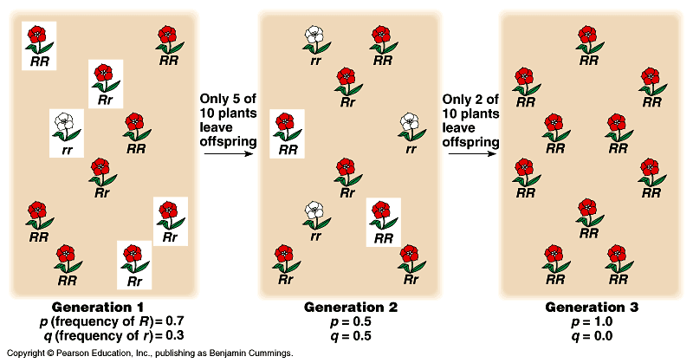

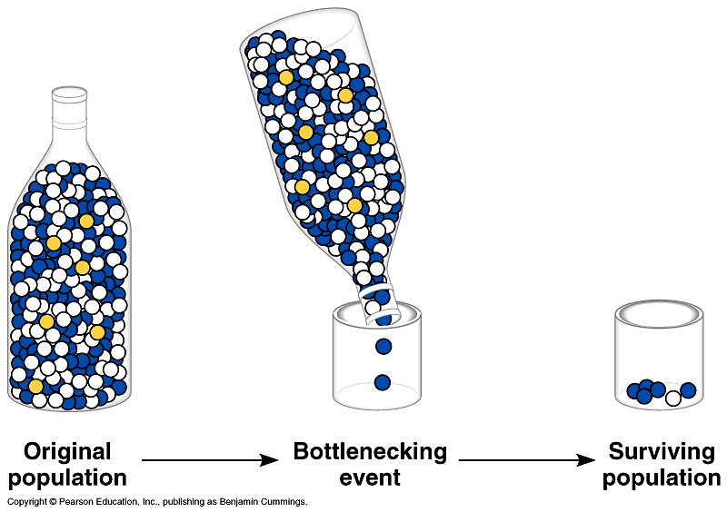
Gene flow can alter populations – migration. Especially small populations or islands.

GENETIC VARIATION: the substrate for natural selection.
Polymorphism is normal variation. So a black cat can have kittens of all different colors.
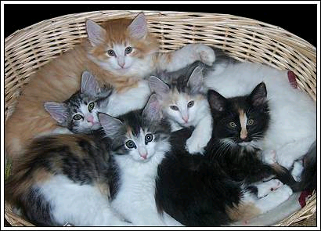

Geographic Variation: Organisms can vary depending on where they live.
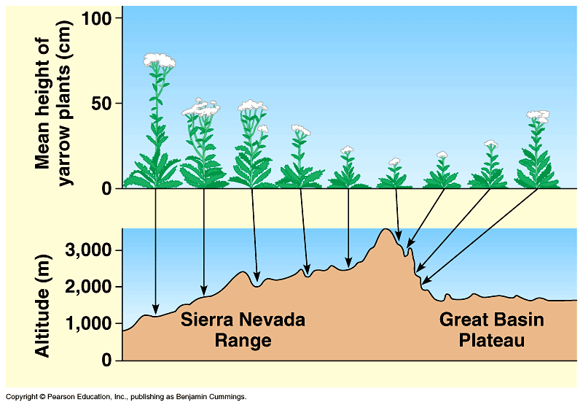

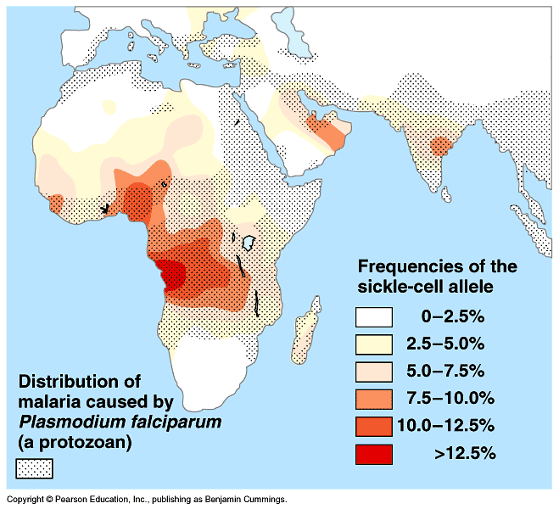

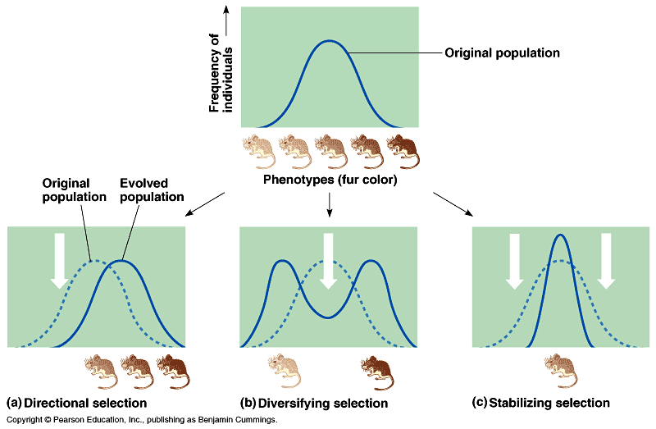

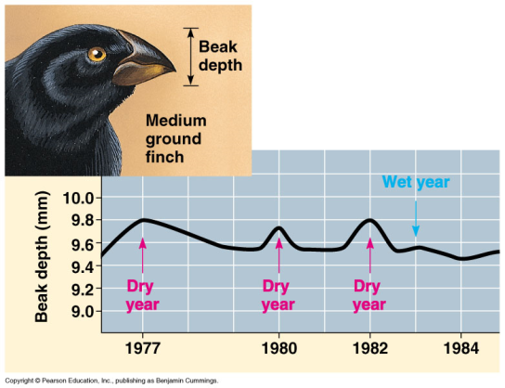
Sexual Dimorphism: Males and females look different. Some animals have a huge dimorphism (peacocks and peahens, sealions, praying mantis).
Intrasexual selection: males compete for the females.
The Perfect Animal? No…
- Evolution is limited to history… you have to have the genes to begin with. Evolution can only “edit” existing variations.
- Adaptations are often compromises…
- Not all evolution is adaptive… sometimes the adaptations are good… sometimes not… sometimes the survival of the lucky…

