Ch 24: Origin of Species

How does a new species form?

Usually a population needs to be “isolated” to become a new species. Isolated means, a group will not meet up with others from the same species for thousands of years.

PRE-ZYGOTIC BARRIERS

Habitat Isolation: if you live in a very cold climate, and the other population lives in very hot climate. You may never cross paths.

Temporal Isolation: Breed at different times of the year. Ex: flowers that only bloom in the Spring, and another population blooms in the winter.

Behavioral Isolation: Special behaviors separate the groups, ex: mating dance. One group does the dance the other doesn’t.

Mechanical Isolation: The parts don’t fit.
St. Bernard and a Chihuahua.

Gametic Isolation: The gametes have enzymes and glycoproteins on their cells, so eggs and sperm won’t recognize each other.

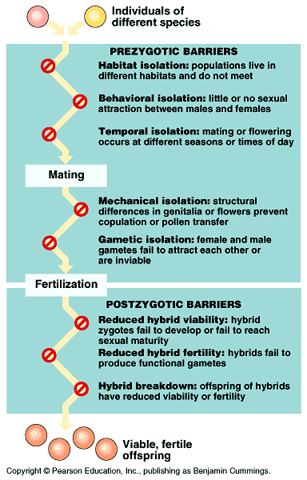

POST ZYGOTIC BARRIERS

Reduced Hybrid Viability: the zygote may not develop fully and not be born.

Reduced Hybrid Fertility: The offspring don’t reproduce. Ex. Horse + donkey = mule (usually infertile)

Hybrid Breakdown: sometimes the first generation can be viable and fertile… but after that they start to break down (future generations are not as healthy)

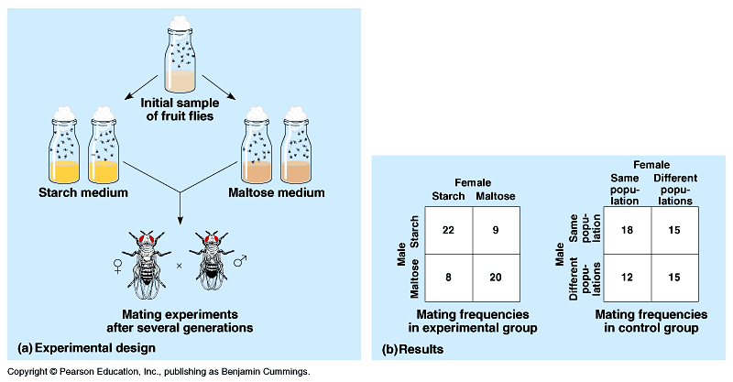
Modes of Speciation:

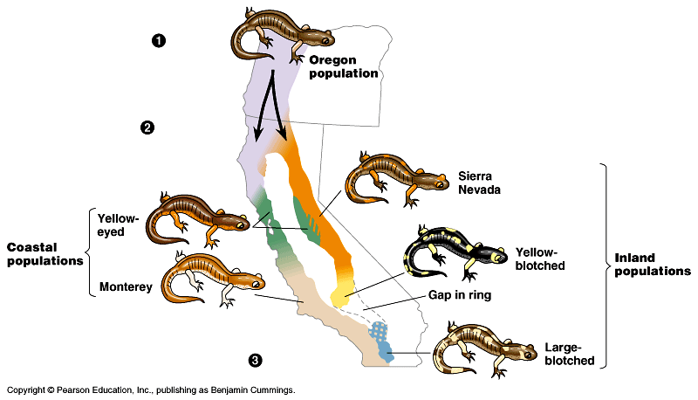

Sympatric: become species and live in the same area.

Allopatric: become species in different areas (ex: Islands, or separated by canyons)

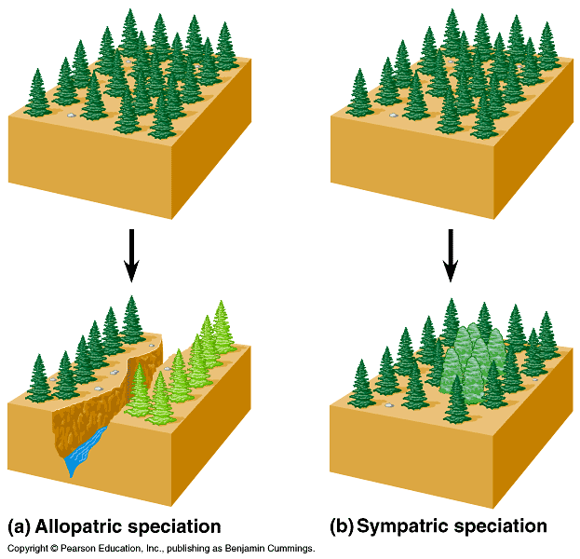

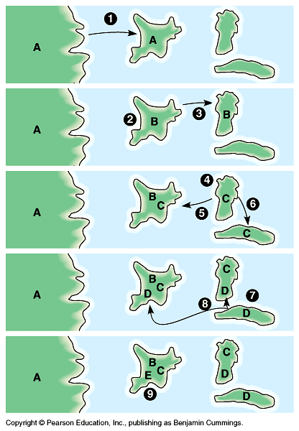

Gradualism vs. Punctuated Equilibrium

Gradualism: slow changes over time (gradual). Darwin.

Punctuated Equilibrium: bursts of evolution followed by long periods of no change. A drastic change in the environment makes things adapt faster.

