Ch 25: Phylogeny and Systematics

Phylogeny: the grouping of organisms based on possible relationships.

Systematics: A way of organizing the relationships.

Dating:
- Relative Dating: Use relative position in the ground to determine which is older. Doesn’t tell you the age, but tells you which is older.

- Absolute Dating: Determine the age of the fossil/bone/etc…
  - Radiometric dating: As minerals age, some of the isotopes change from radioactive to more stable. Ex: C¹⁴ changes to N¹⁴ it takes 5730 for half of the C¹⁴ to change to N¹⁴ (called a half life).
    - 100g of C¹⁴ after a bunch of time (x), you only have 12.5 g of C¹⁴ (the other 87.5g = N¹⁴) what is x? 100g →50g = 5,730 years. 50 →25 = another 5,730. 25 →12.5 = another 5,730 years… SO it took 17,190 years to go from 100g → 12.5g
  - Uranium ²³⁸ decays into Lead ²⁰⁶. Has a half life of 4.5 billion years.
If a sample started with 20g of Uranium ²³⁸… how much would be left after 18 billion years?

18 billion years = 4 half lives
20→10→5→2.5→1.25g

The problem is… fossil record is very incomplete. Why? To be a fossil, you have to have died in a sedimentary (where particles settle, ex swamp, lake…) the layers need to cover you up. Not many animals or organisms died this way.

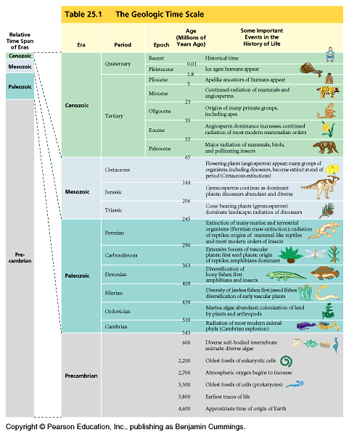

0.2 m.y.a. Homo sapiens?
60 mya birds, insects, flowers, mammals radiate
300-100 mya reptiles dominate
400 mya amphibians and bony fish radiate
450 mya first land plants
600 mya first animals (jellies, coral, sponges)
2.2 bya first eukaryote (amoeba, algae)
3.5-3.8 bya first bacteria
4.6 bya earth forms

Life was shaped by some mass extinctions:

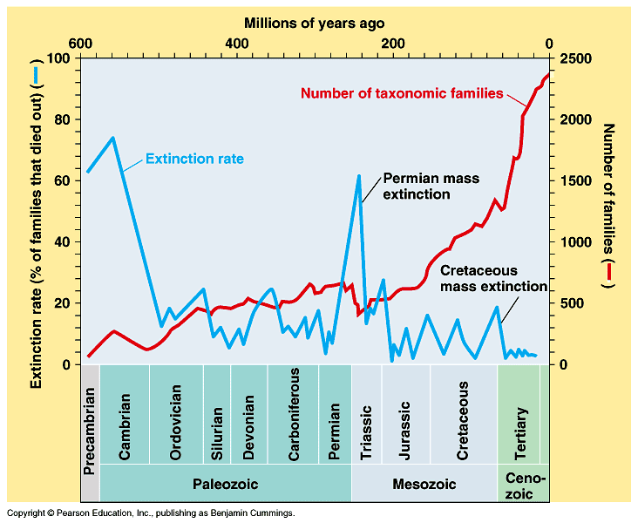

Mass Extinctions: Some theories:
- Giant Asteroid/Meteor (block out sun/kill plants)
- Famines and disease.
- Global climate changes

Continental Drift: 250 million years ago, continents were connected into a super continent called Pangea. This explains how some species are closely related even though they are on different continents today.

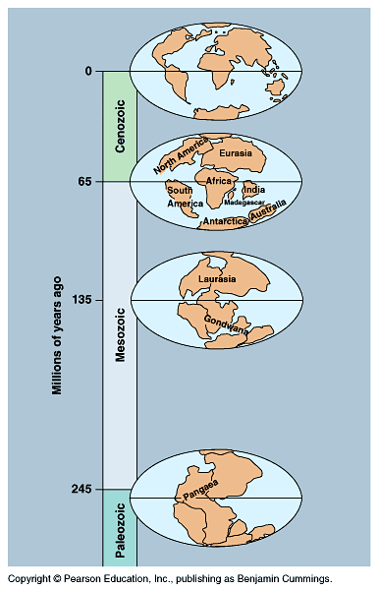

Classification System: Uses Latin names, because it keeps things universal.

General name of each species: Genus species

Hierarchy: Domain, Kingdom, Phylum, Class, Order, Family, Genus, species.
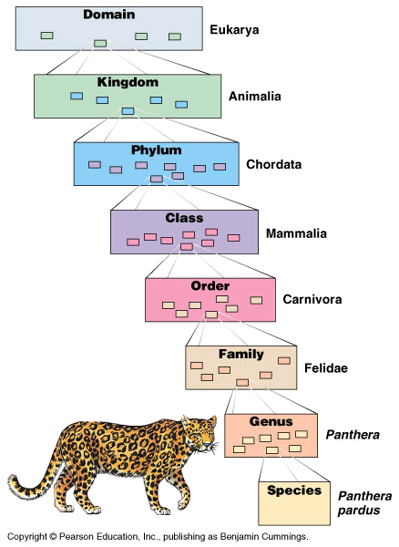
How do you classify species?
- Physical Appearance
- Molecular evidence: DNA, RNA, proteins…
- Fossils, bones, people’s accounts

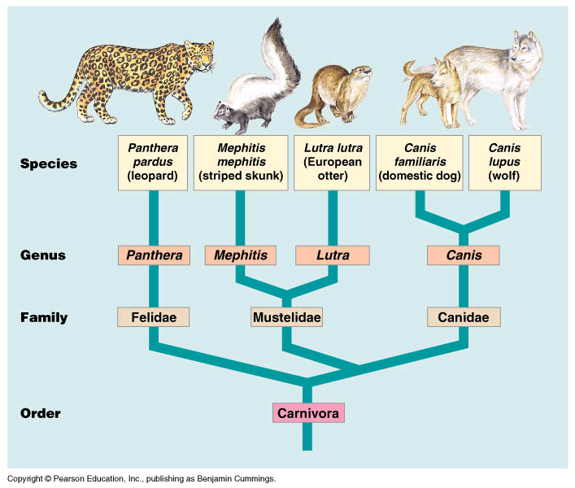
We try to form cladograms (phylogenetic trees, phylogenies) based on certain traits.
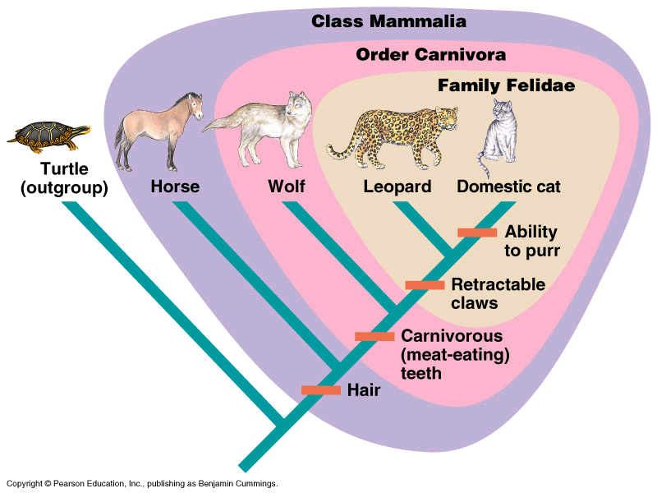
Shared primitive characters: something they all have. 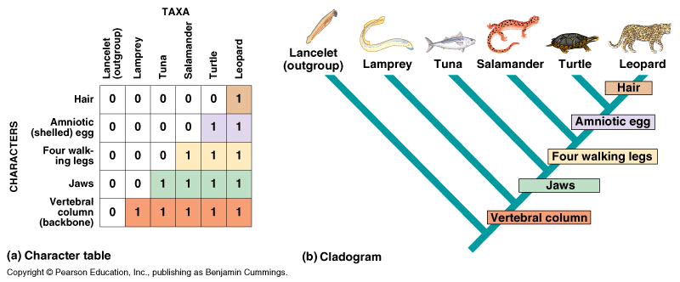
Shared derived character: trait only groups above it share it.

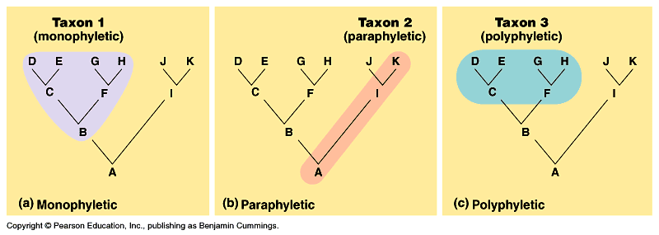

Analogous Traits: Traits that different groups can share (even if not related).

Homologous Traits: Traits passed down from a shared ancestry.

Some cladograms are more complete than others.
- Monophyletic (where all ancestors and descendants are indicated)
- Paraphyletic (where there’s a link, but there are also missing links)
- Polyphyletic ( where we really don’t know the common ancestor)

Molecular Clock: using molecules to determine when things evolved (branched off of each other). How different are molecules today vs. 100 years ago.
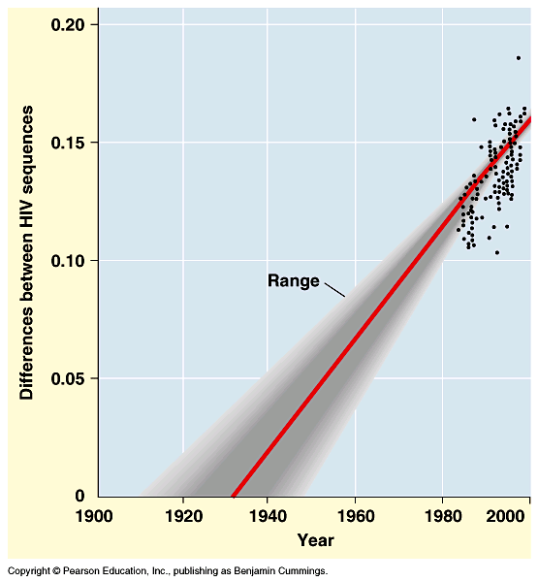
Some data from molecules was different than fossil record… how to reconcile?
