Chapter 46: Animal Reproduction

Why sex?
Creates new variations/diversity.
Protects against mutations taking over a population.
Creates new phenotypes that evolution can select.

Asexual Repro in Animals: (rare)
- Invertebrates
  - “bud” splits off and grows into a new organism.
  - Fragmentation. New parts regenerate.

Reproductive Patterns:
- Sequential Hermaphroditism:
  - Ex: fish, wrasses, start as females. When the dominant male dies, the next most dominant female becomes the male.

- Parthenogenesis: egg develops with out fertilization. Komodo Dragon.

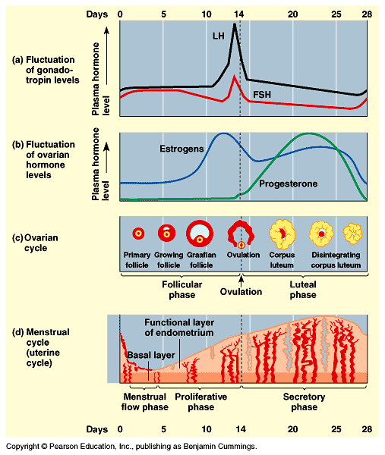
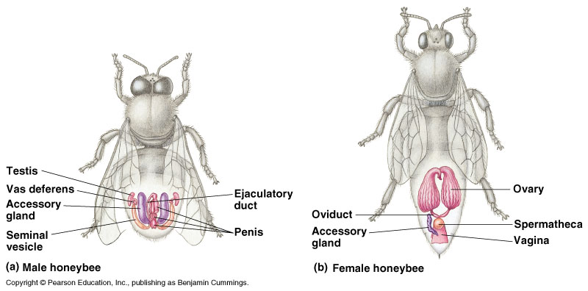

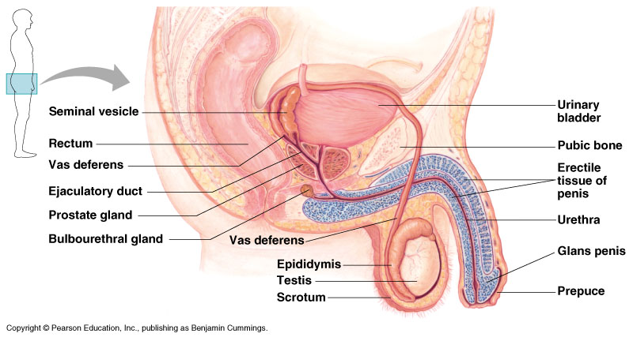

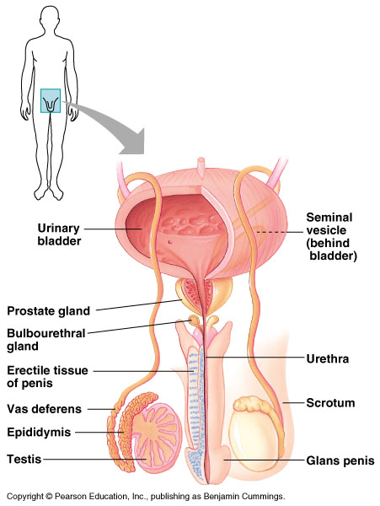

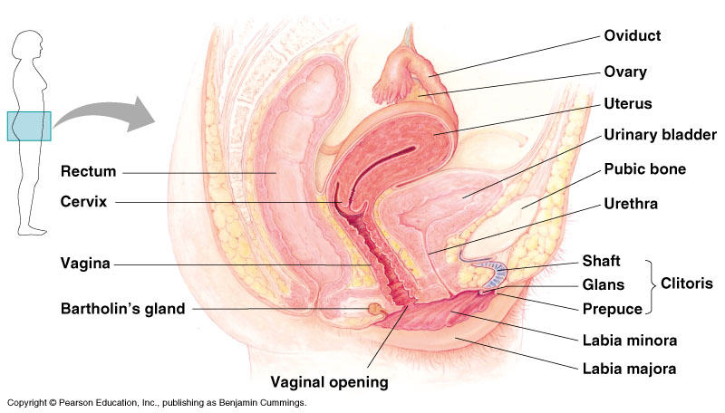

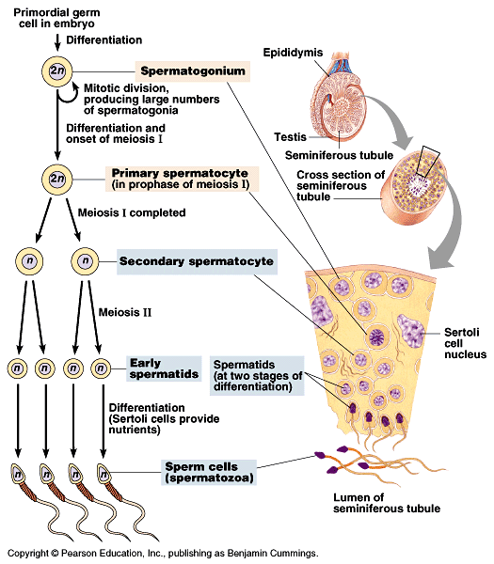

Spermatogenesis: making of sperm.

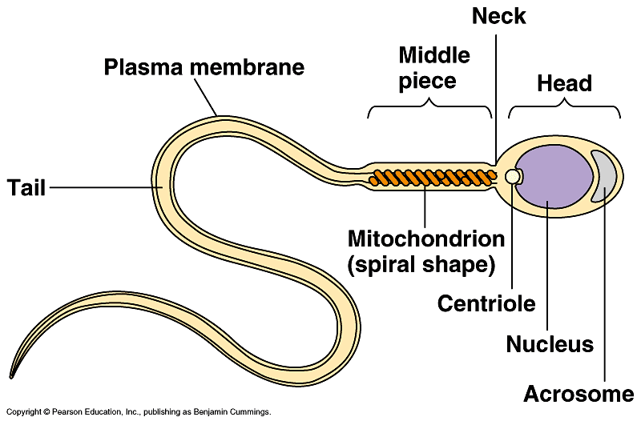

Oogenesis: making an egg
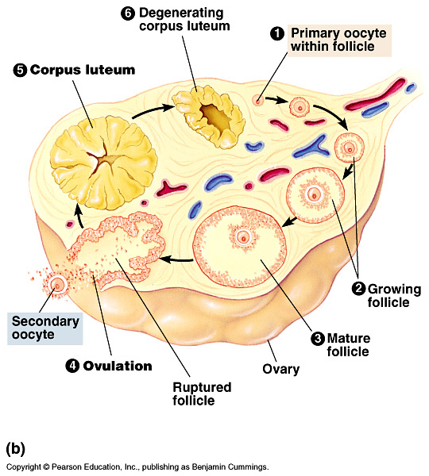

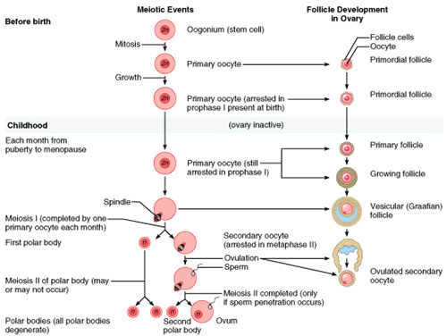
Menopause: ovaries lose responsiveness to FSH and LH.
