Chapter 47 Notes: Animal Development

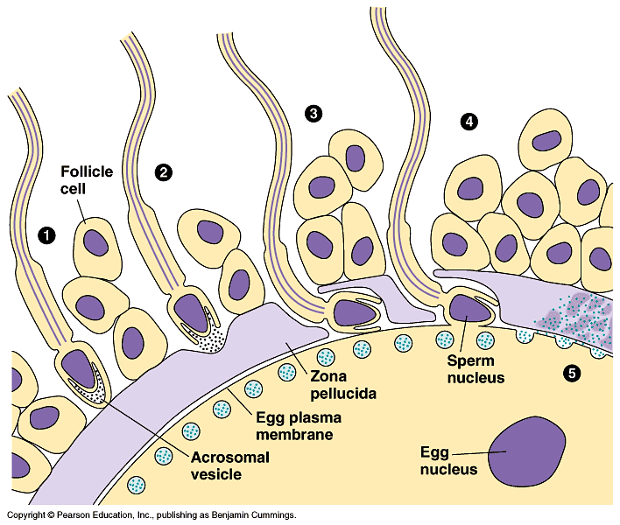

The sperm makes its way through the outer layer of the egg, using enzymes in the acrosome. When the nucleus reaches the inside, it causes a reaction with the “cortical granules” signals a pathway, which causes the egg to depolarize. 1-3 seconds “fast block to polyspermy”

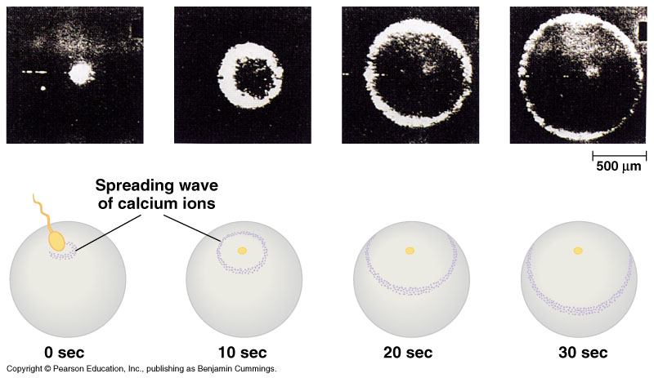

It takes about 90 minutes for the first cell to divide. (making proteins, DNA synthesis)

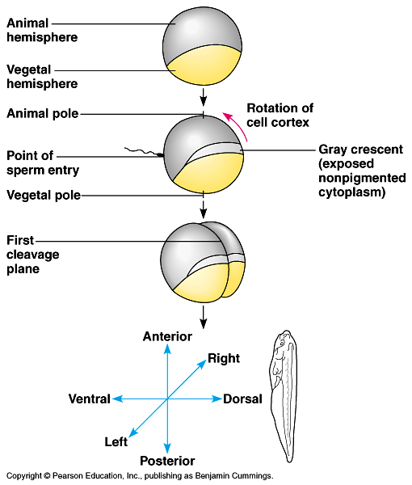

Blastula (at least 128 cells) “ball of cells”… flip outside in… to make a Gastrula.
