Ch 48/49 – Nervous System and Muscles

CNS (Central Nervous System): Brain/Spinal Cord
PNS (Peripheral): Nerves (Cranial and Body)

Nerves are made of neurons (nerve cells)

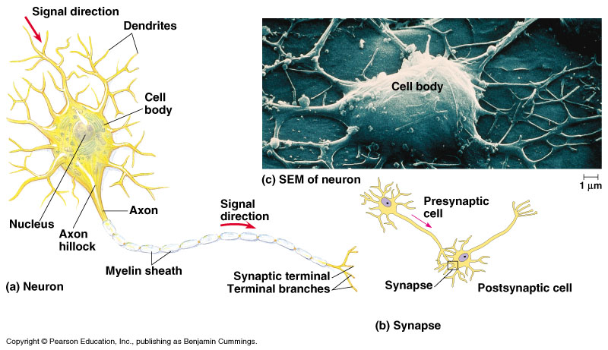

Action Potential: A rapid depolarization of the neuron (+’s on the outside, trade places with the -‘s on the inside).

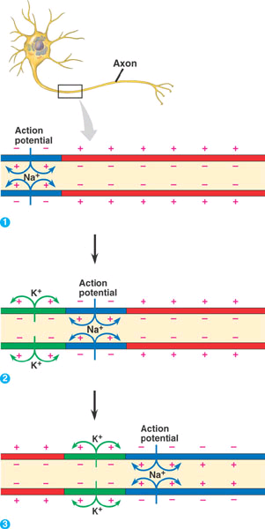

Some neurons are myelinated, wrapped in myelin (protein). Causes the action potential to skip down faster. MUCH faster. Saltatory conduction. (called the Nodes of Ranvier).

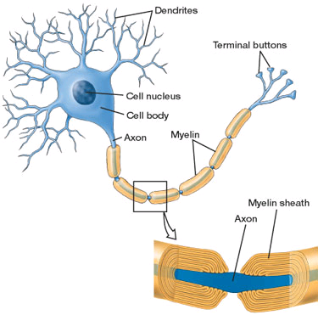
Refractory period, is when neuron needs to repolarize.

Neurons are “connected” at the synapse. There is a space between neurons called the synaptic gap.

Neurotransmitters are chemicals that communicate between synapses. 1037, 48.1

http://www.blackwellpublishing.com/matthews/nmj.html

- Acetylcholine (Ach) – used to stimulate the muscles.
- Dopamine – excitatory (stimulant). [a lot of drugs try to simulate this neurotransmitter].
- Seratonin – inhibitory (depressant).
- Endorphins – natural pain killer.

Cephalization: collection of nerves at the head (brain).

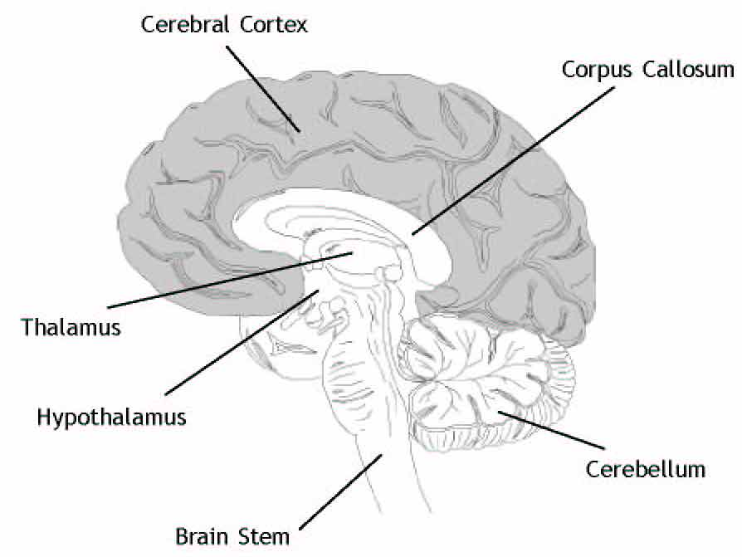

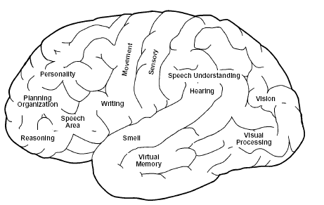

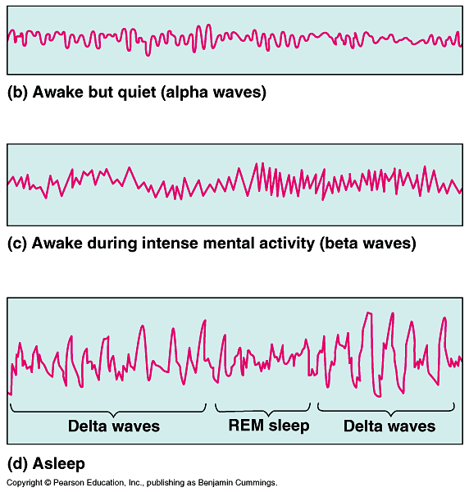

Memory: Short Term/Long Term.

Short term lasts few minutes/hours.
Long term: can last “forever.”

How to move memories from short term to long term? Rehearsal/repetition.

Ch 49 Notes: LAST CHAPTER!!!

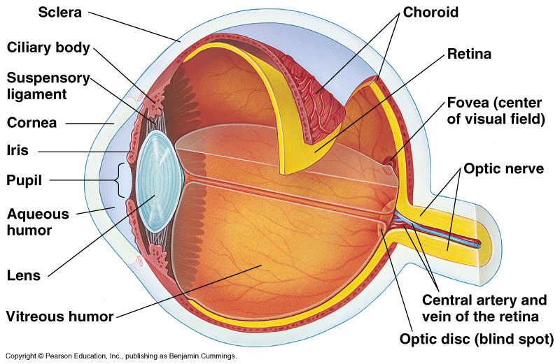
Photoreceptors in the Retina
Rods = light and dark
Cones = sense colors

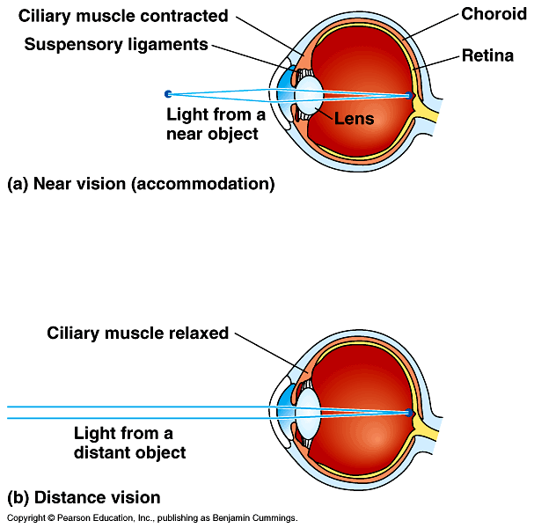

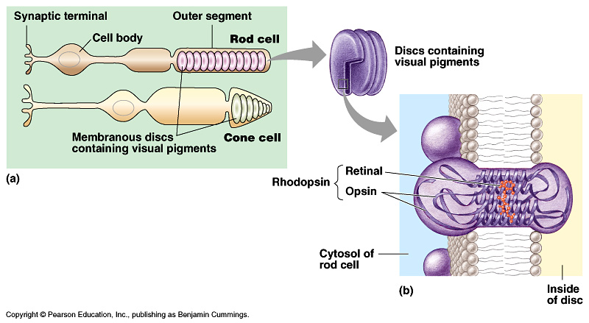

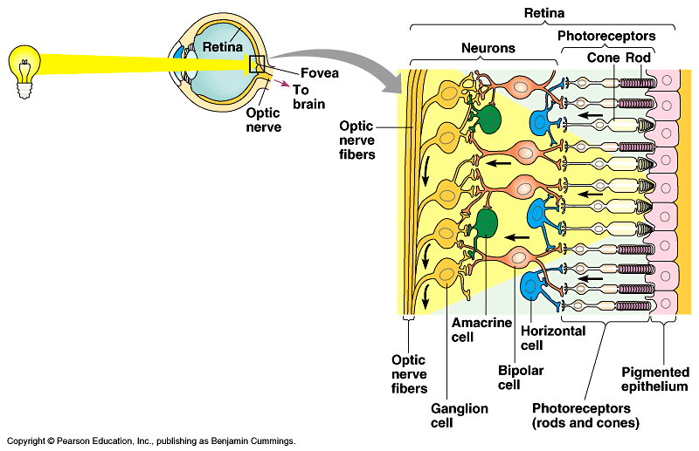

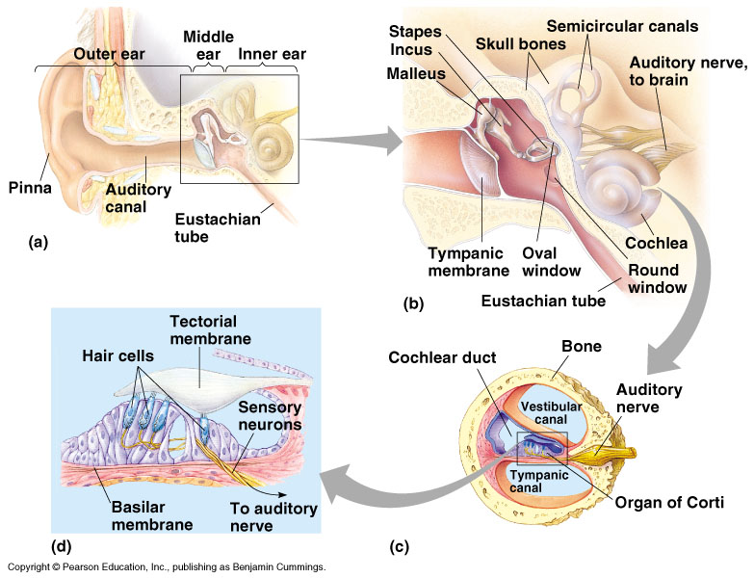

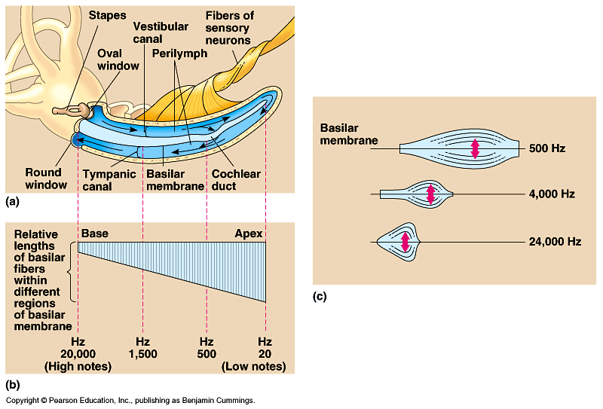

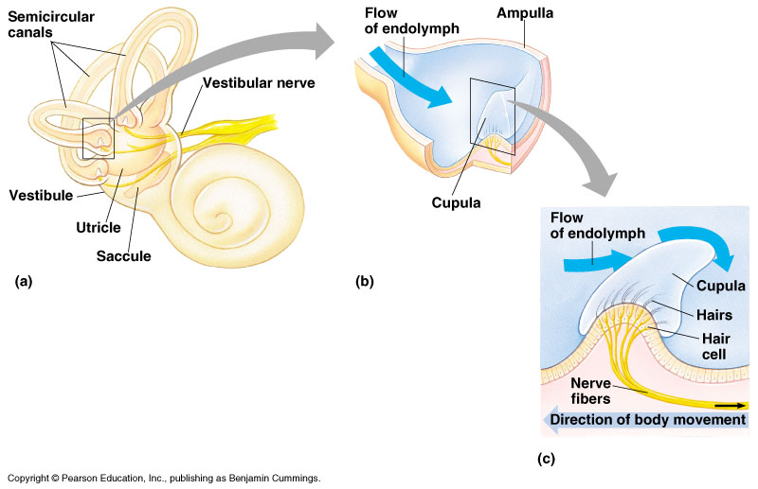

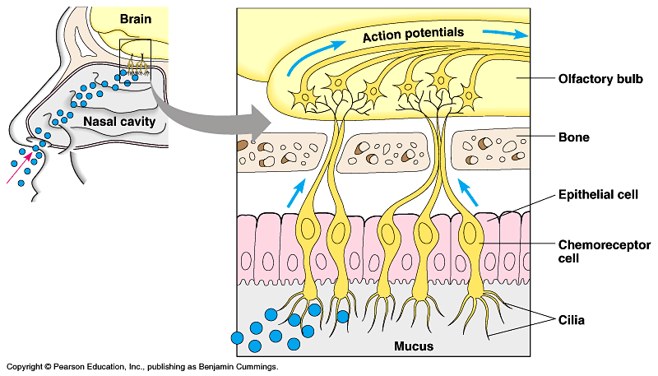

Bones: Support, Shape, Protection, Cell Production (blood), Storage, Hearing

