FIRST, go to the website: cccapply.org & click on Apply Online. Then create account if you don’t have one or login.


CLICK: Continue:
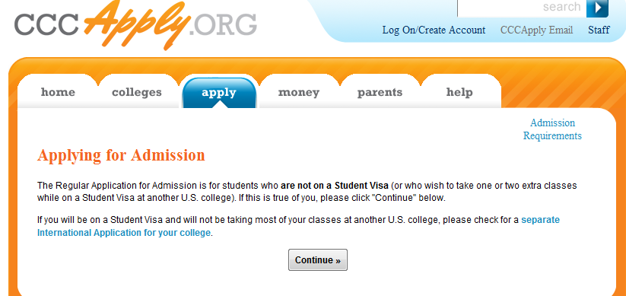
(2) Make account if you don’t have one, or log-in if you already have one: Make sure you remember your account username and password.
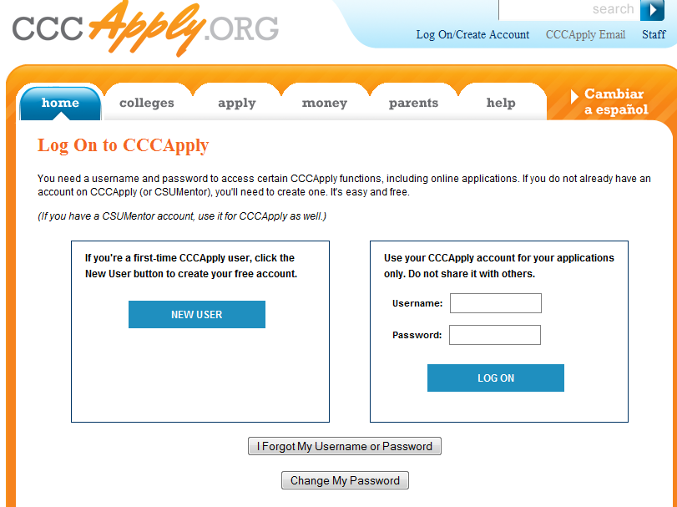

(3) Once you login, click on City College of San Francisco, and click on “Start New Application.”
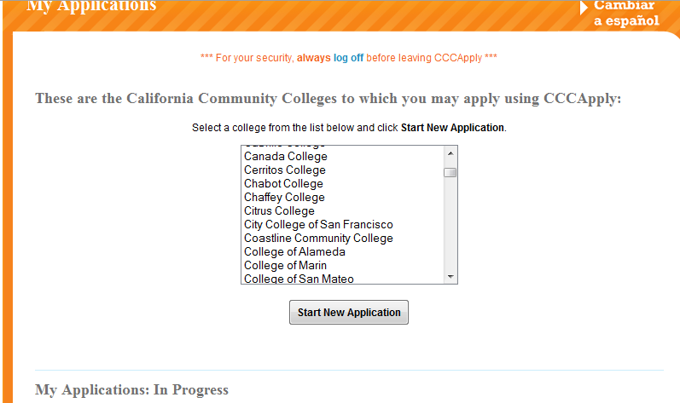

(4) Read through the process, and scroll down and click on “Begin Application.”
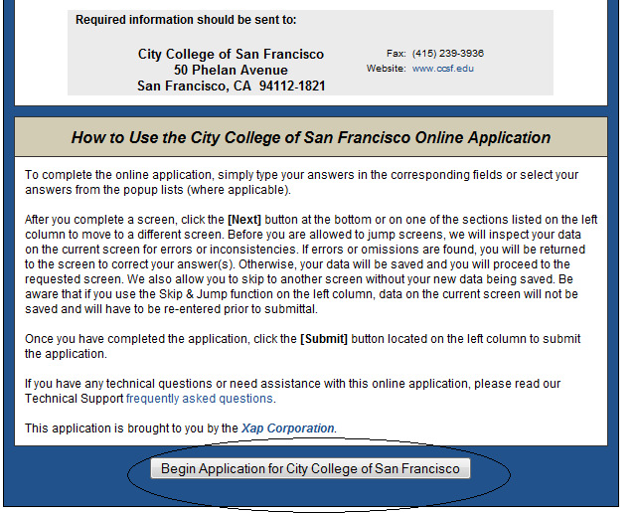

(5) Remember, if you are doing the Priority Registration class Orientation make sure to do BOTH Spring 2011 and FALL 2011; otherwise, only apply for FALL 2011. If you are in Health academy or already enrolled in CCSF for Spring 2011 then you don’t need to do Spring 2011.
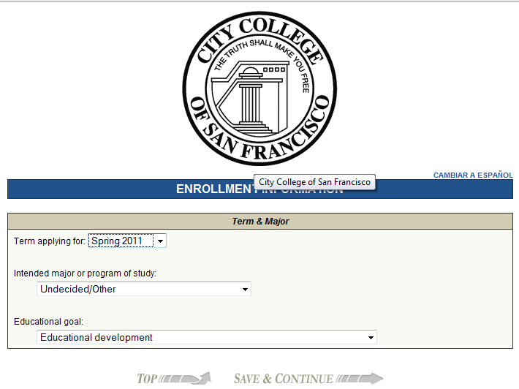

The rest of the application is pretty straightforward.

Make sure you double-check your work and have me double-check it before you submit it.

LAST TIP:
For Spring 2011 applications indicate under Education, the following manner: “Enrolling in high school (or lower grade) and college at the same time, since the class is during this semester.
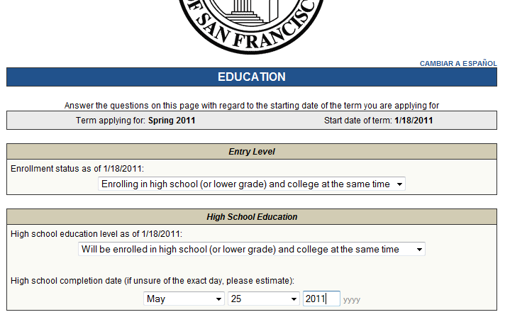

For Fall 2011 application, for most of you indicate it the following way under Education, since you’ll be graduating from high school already. “First-Time student in College (after high school)
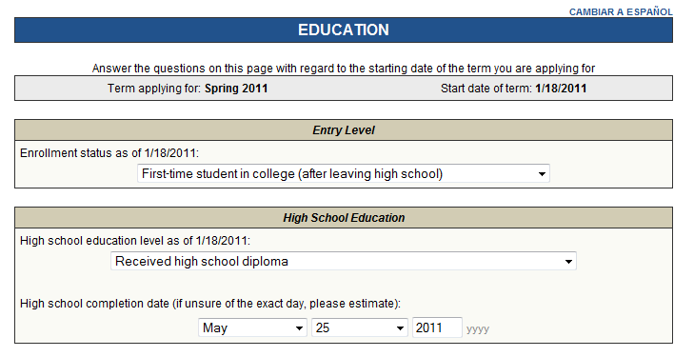

LASTLY, make sure you do the application completely, otherwise it might delay your application, have me checked over to make sure it is complete. Email me if you have any questions at: zhenb@galileoweb.org Thanks, Sincerely, Bai

