CAL-GRANT: Submit High School Graduation Confirmation Simple Guide

(1) First, login to your Cal-Grant Account here:
Note: Make sure to remember your User ID and Password!!
https://mygrantinfo.csac.ca.gov/logon.asp
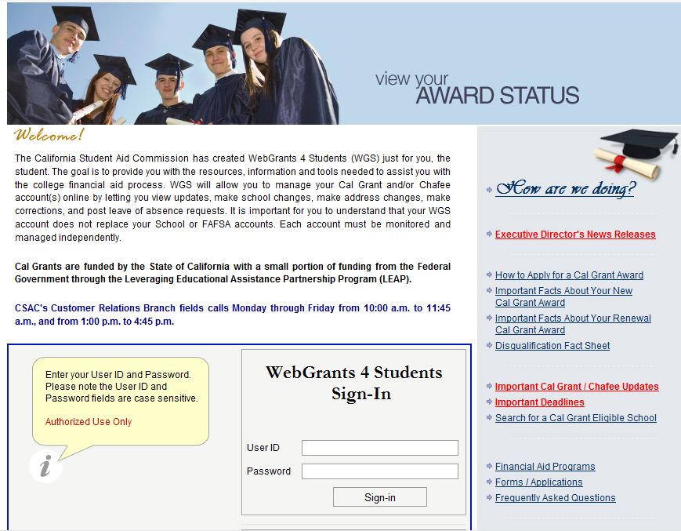

(2) Once you login, click on the Submit High School Graduation Confirmation link (see bottom):
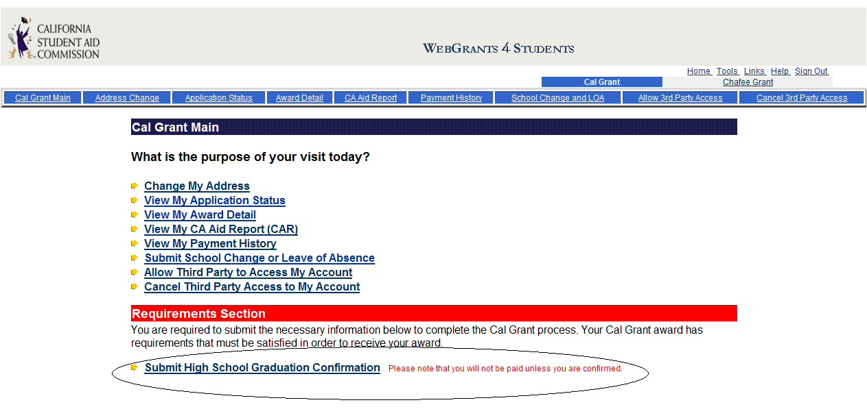
(3) Once you click on the link, read the paragraph carefully. For most students, I suggest to click on the first bubble on (A), then click submit.
TIP: Make sure that your college is the Cal-Grant recipient. You can see what college has been assigned Cal-Grant and you can change it in this website. In the middle right-side of this page, you see a tab call “School Change and LOA” click on that and you can choose the college you want to change it to. Make sure to contact your college’s financial-aid office to make sure they receive the information too.
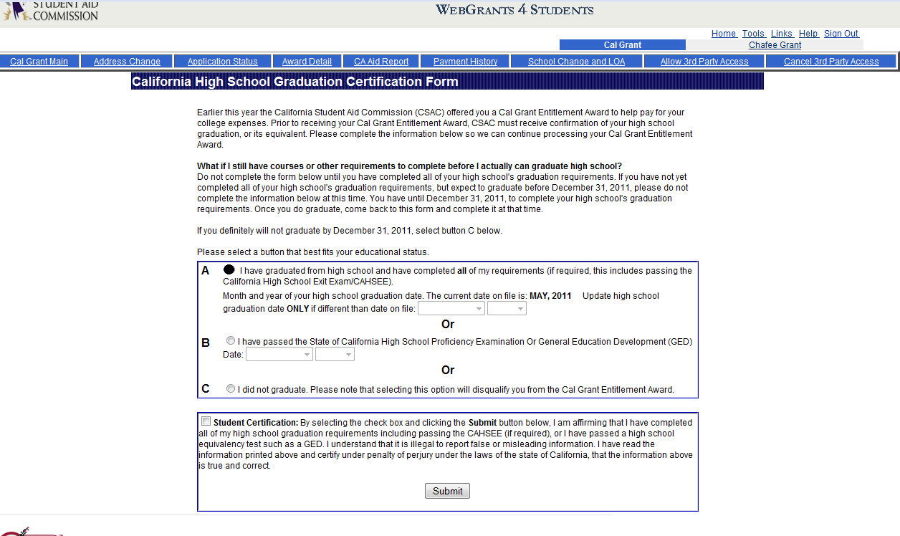

Lastly, once you submit it, it should look like this. Best wishes, remember that for any financial-aid question, you should communicate and talk to your college’s financial-aid as soon as possible. A lot of times, they ask students to submit verification forms, so submit those early if you want money for college and ask about scholarship opportunities.
