HOW to SEND ACT SCORES
Deadline: the Thursday (10 am) immediately after the ACT Test
Example: For Oct. 23 exam, the deadline is next Thursday, 10/28 (10 am).
GALILEO SCHOOL CODE: 052945

WEBSITE: www.ACTSTUDENT.org
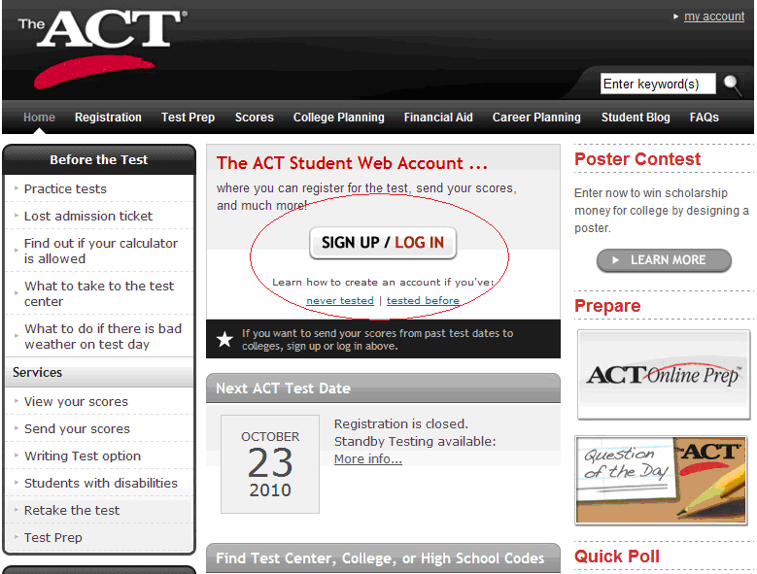

- To send scores, you got to sign in: actstudent.org and click on “Send Your Scores”

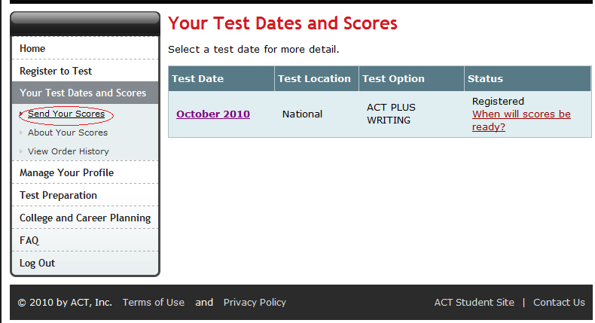

(2) Click on Continue

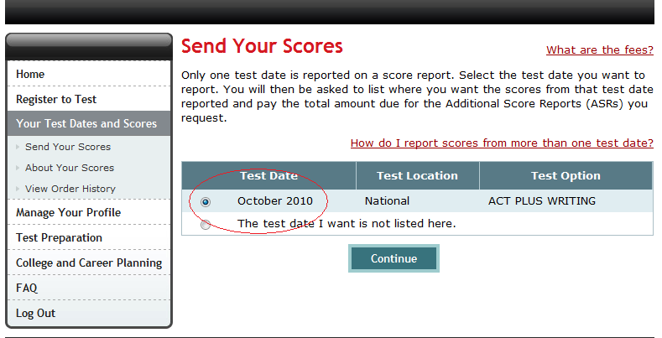

(3) Read Instructions, and Continue
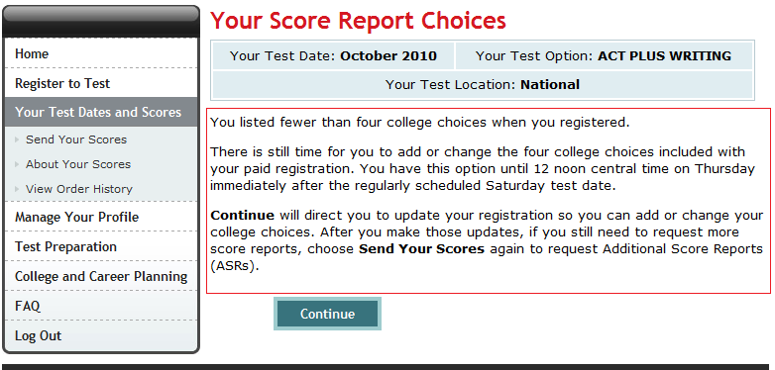

(4) Click on “Change”
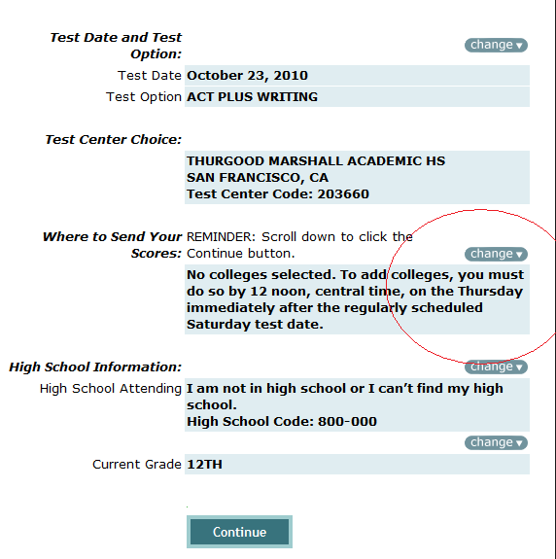

(5) Click on “Add a Choice”
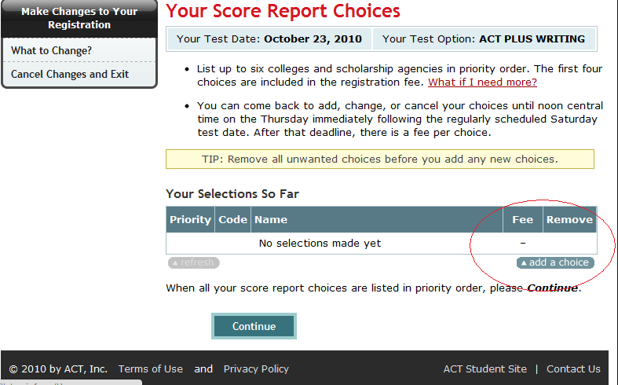
(6) Search by “Name” of the school.
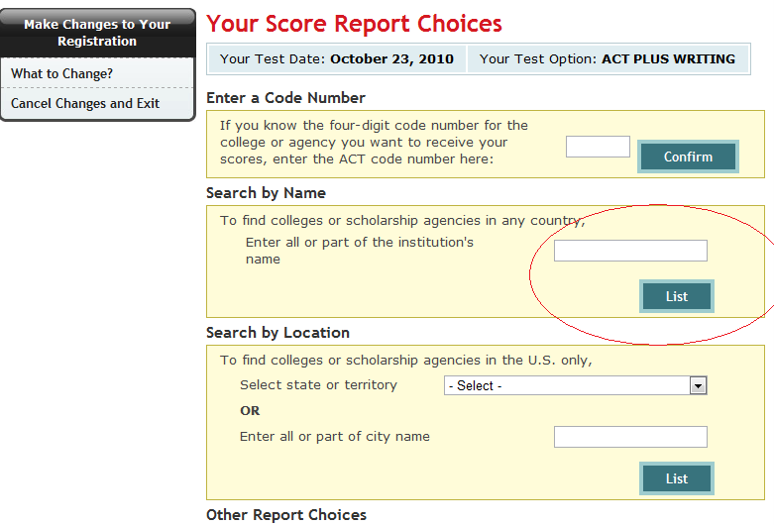

EXAMPLE: SAN FRANCISCO STATE UNIVERSITY.
For CSU, you may send it to ONE CSU, and use ACT Score Manager once the CSU receives your score, takes about 3-4 weeks (See below) to release it to other CSU.
For UC, for this year if you send it to ONE UC, all of them should receive it, you should double-check with all UC that they receive score (just in case).
For Private schools, you’ll need to send it to every single private school that you apply to.
- TYPE in “SAN FRANCISCO” under Search by Name. Then Click “Continue” and “Continue” and “SUBMIT”
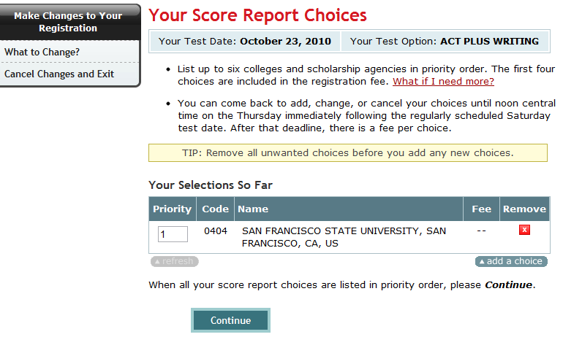
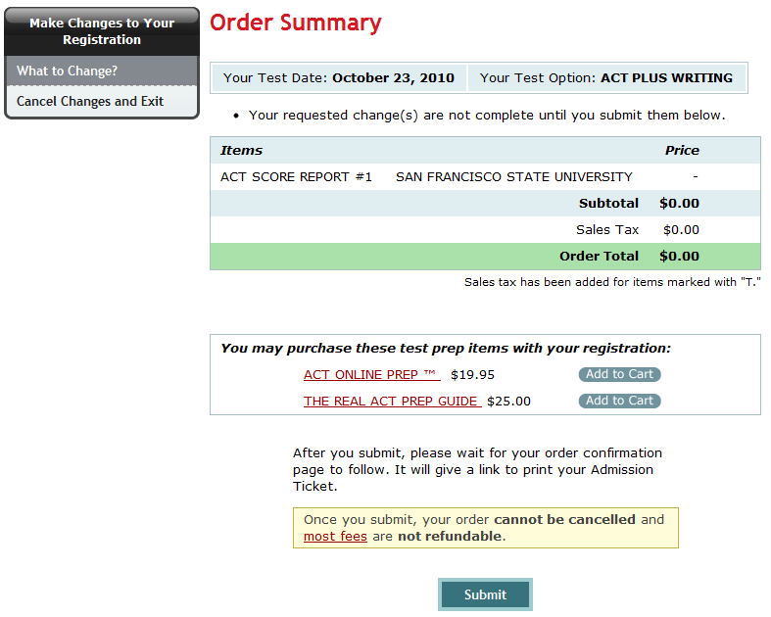

YOU’RE DONE!
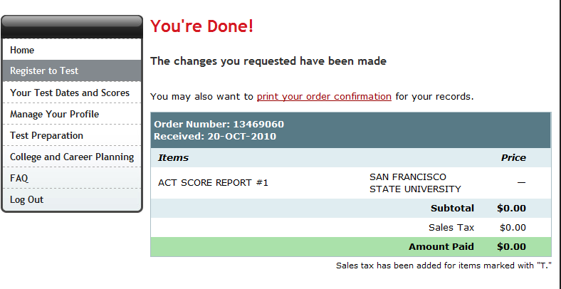

ACT SCORE MANAGER for CSU:
Go to www.csumentor.edu and click on “Undergraduate Admission Test”


Then click on “ACT Score Manager”
