To check if you submitted your scores, login to your SAT account, go to your organizer:
[REMEMBER that it takes about 3-4 weeks for Normal Delivery, but if you rush it (will cost you money though), it’ll be a lot faster, the last time I check it was about 1 week. In most cases, sending it by Normal Delivery is fine. But, make sure you communicate with your college about the deadlines for sending scores, some schools are very strict about when they need to receive these scores. Most school’s deadline are in January, but some schools have deadlines in December (example: San Jose State wants test scores by Dec. 22, see below for more detail)
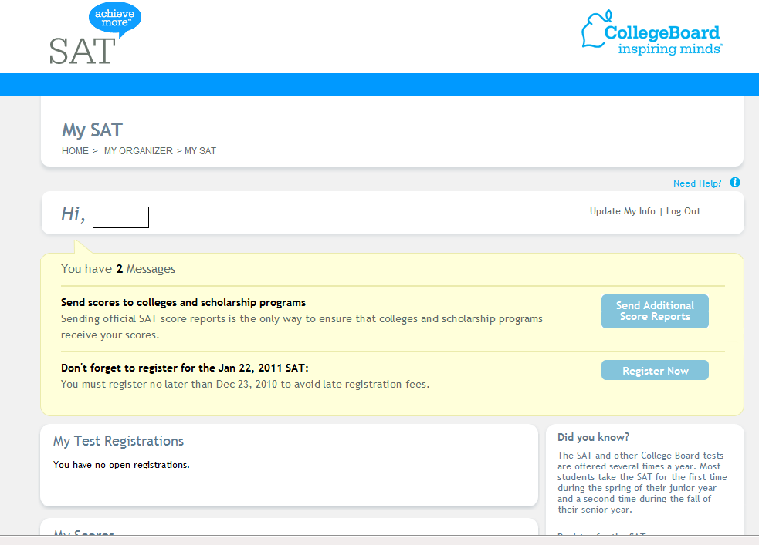
Once you are in your organizer, scroll down and check on My SCORE Send History:
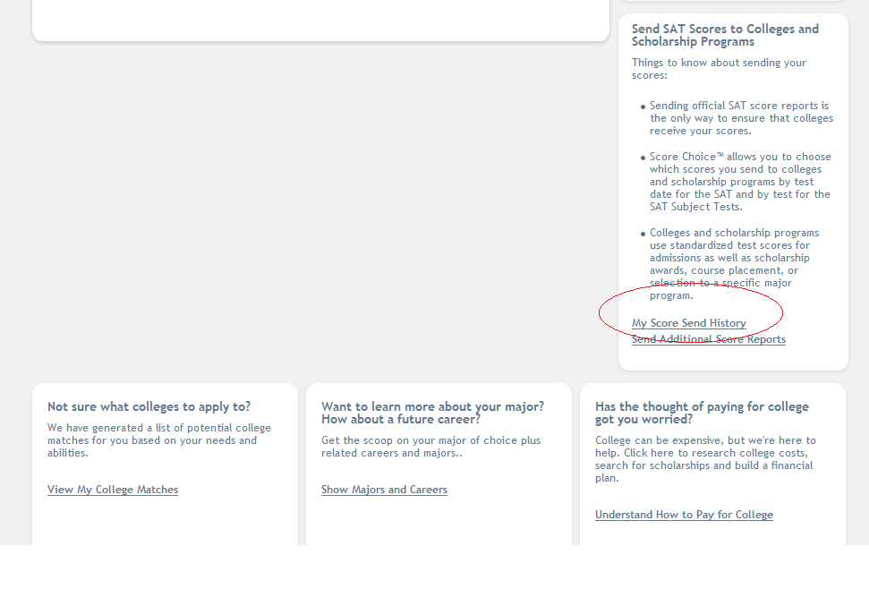
Once you click on “My Score Send History” you should see if your scores were sent:
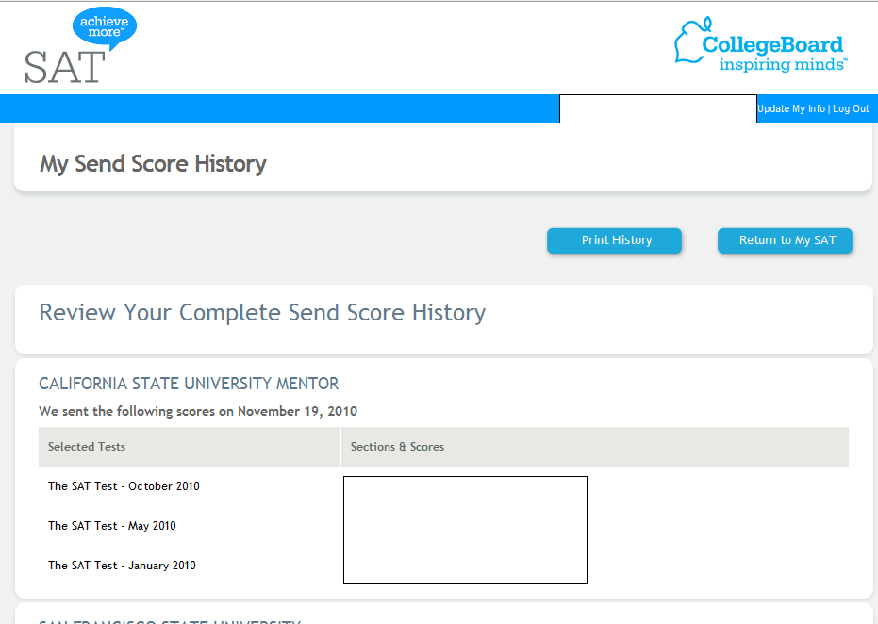

Question: What if I don’t see anything?
If you are sending your December test scores, College Board will wait until Dec scores are available (on Dec. 21) so that they’ll send ALL scores. For most schools it is not a problem, but if you applied to San Jose State, San Diego State, and Cal Poly, make sure you send the November test scores (or earlier). You want to make sure they receive the scores, and check their deadlines.
To send Nov. test scores, do the following:
Going back to My Organizer screen, and scrolling down, you’ll see this, and then click on “Send Additional Scores” Once you are in that screen, follow my directions from the previous guide to how to send scores. Good Luck, make sure you follow-up with all these deadlines, ask me or email me if you have any questions.
