SENDING SCORES for SAT

- CLICK on MY Organizer, then click on MY TESTS
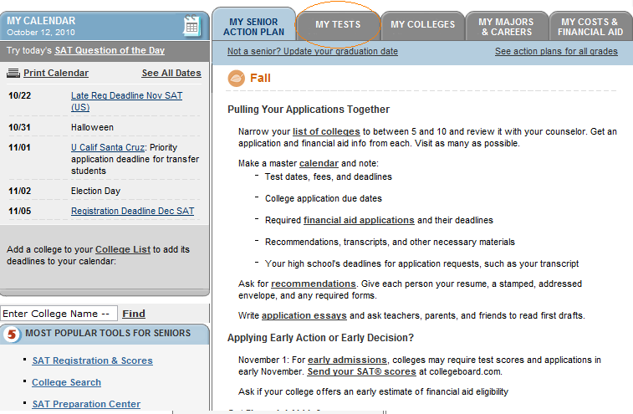

- Click on Send Scores:
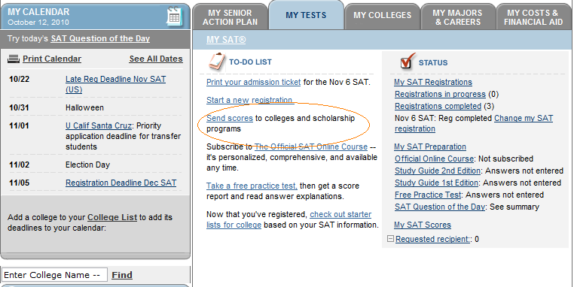

- Click on Send Registration Score Reports.
ON the TOP you’ll also find the DEADLINE to submit your test scores for FREE (you get 4 free score reports, and an extra 4 if you used the fee-waiver).

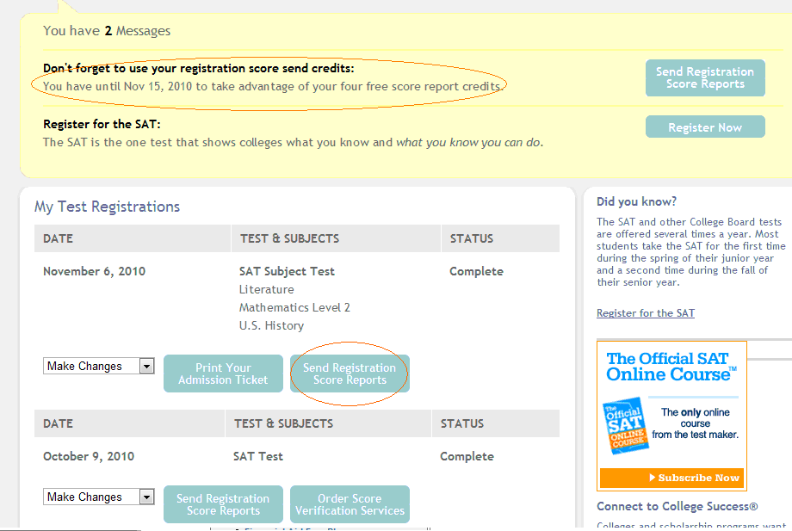

- Click on Send Registration Score Reports

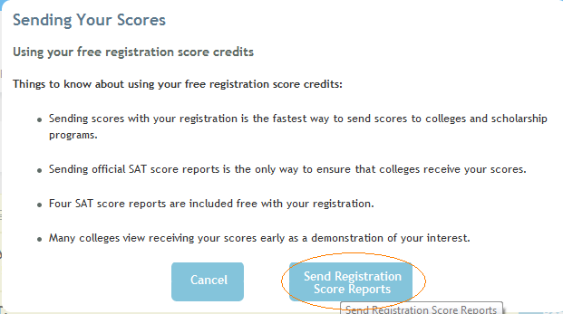

- Sending Score Screen:
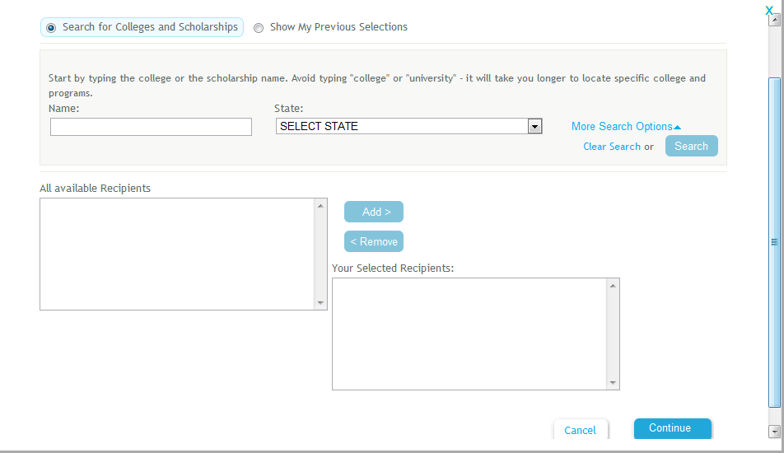

- Sending to ONE UC school, all of the UC will receive your score.
EXAMPLE: UC Davis (type in Davis under NAME). Select UNIVERSITY OF CALIFORNIA, DAVIS and click ADD, and then click on Continue.

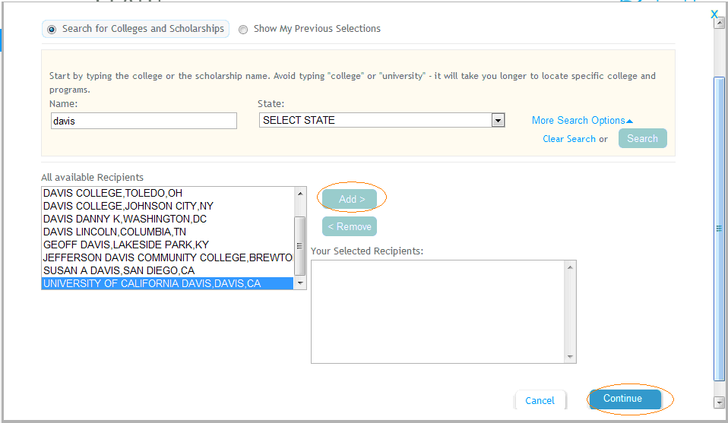

Click Continue again
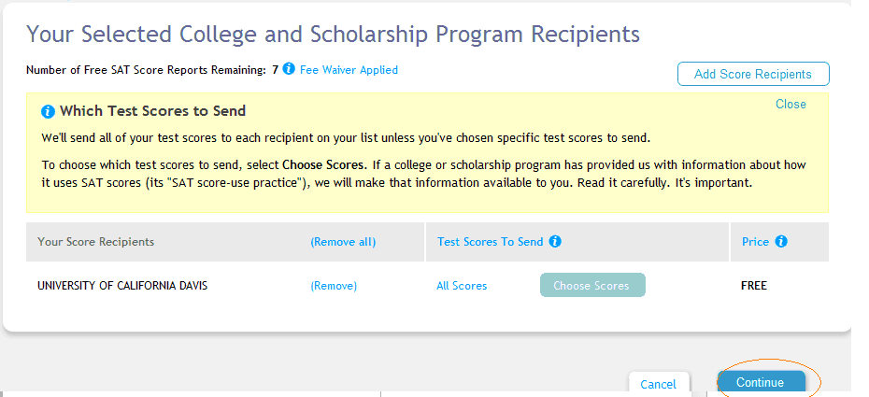

Click Continue (yes, again)
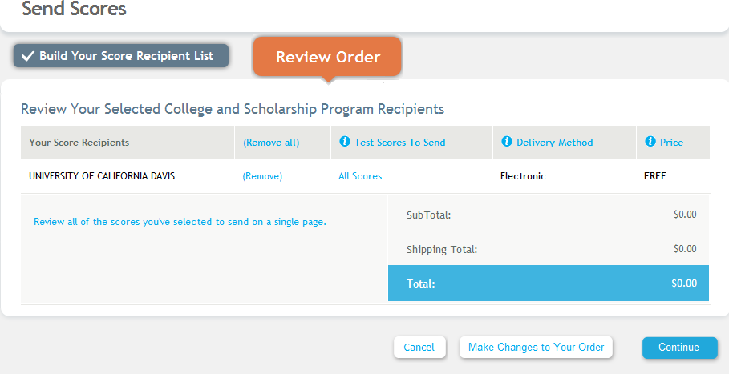Click on Place your order:
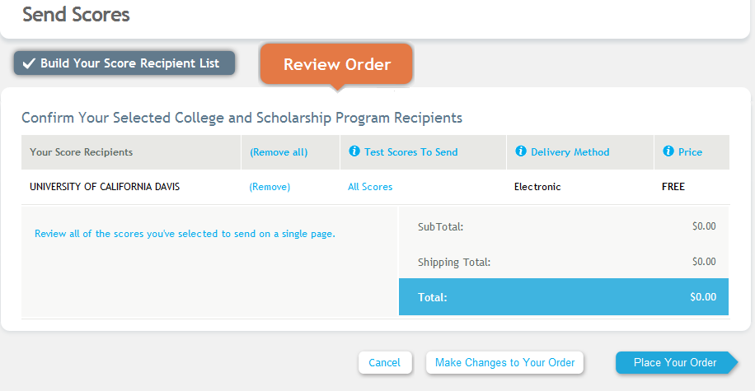

- CSU Example: (SEND it to CODE: 3594 and ALL CSU will receive your scores)

CLICK on More Search Options:
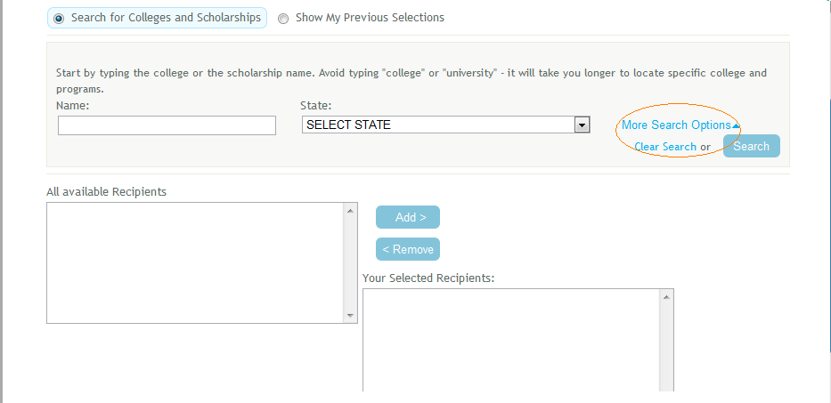

Type in 3594 under CODE, and select CALIFORNIA STATE UNIVERSITY MENTOR-LONG BEACH, CLICK on ADD and Continue THEN continue again and place order.
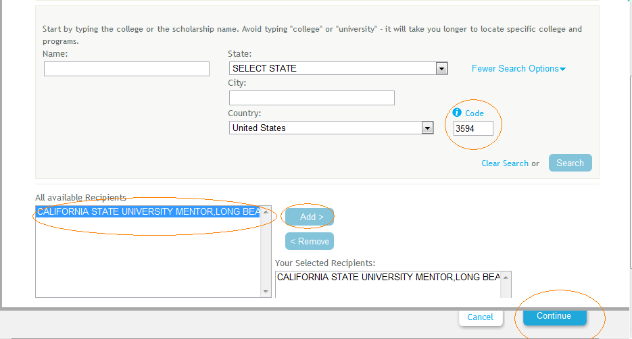

Lastly, an example of a PRIVATE school: University of San Francisco

