Environmental Science Pathway

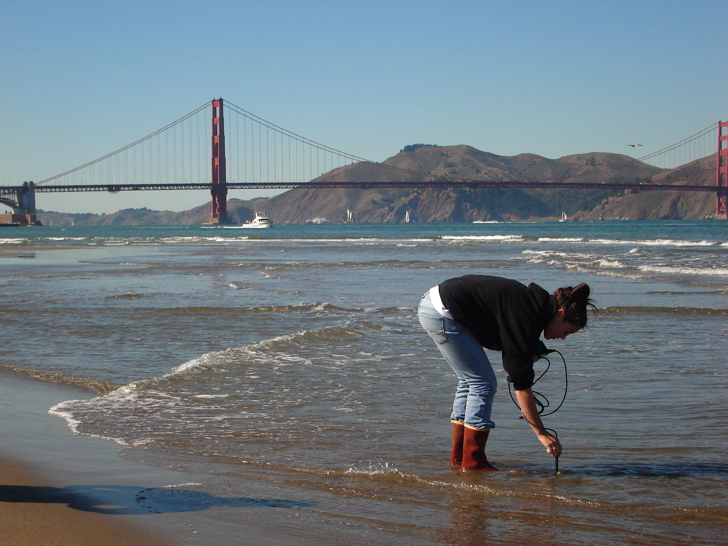
I. Hands On Curriculum

Through the incorporation of lab activities, weekly on-site fieldwork in the Presidio National Park, classroom lectures and discussions, the curriculum offers a wide variety of experiences that are not traditionally found in most science classes.

II. Program Goals

- To teach students the fundamentals of environmental science and ecology.
- To develop stewardship.
- To understand interconnections between humans and the environment.
- To expose students to environmental careers.
- To train students in the use of modern field skills and technology:

• GPS and Computer Mapping
• Chemical Test Kits
• Electronic Monitoring Probes
• Plant Identification
• Habitat Assessment
• Computer Graphing
• Computer Data Analysis

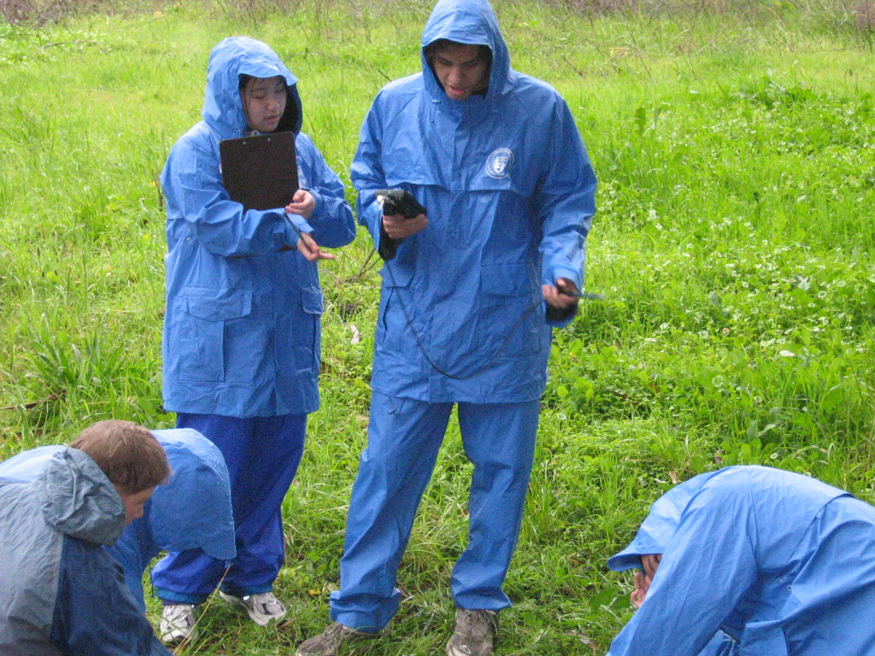

III. Pathway Schedule Requirements

- 9th or 10th grade - Biology
- 11th grade - Advanced Environmental Science
- 12th grade – Environmental Internship

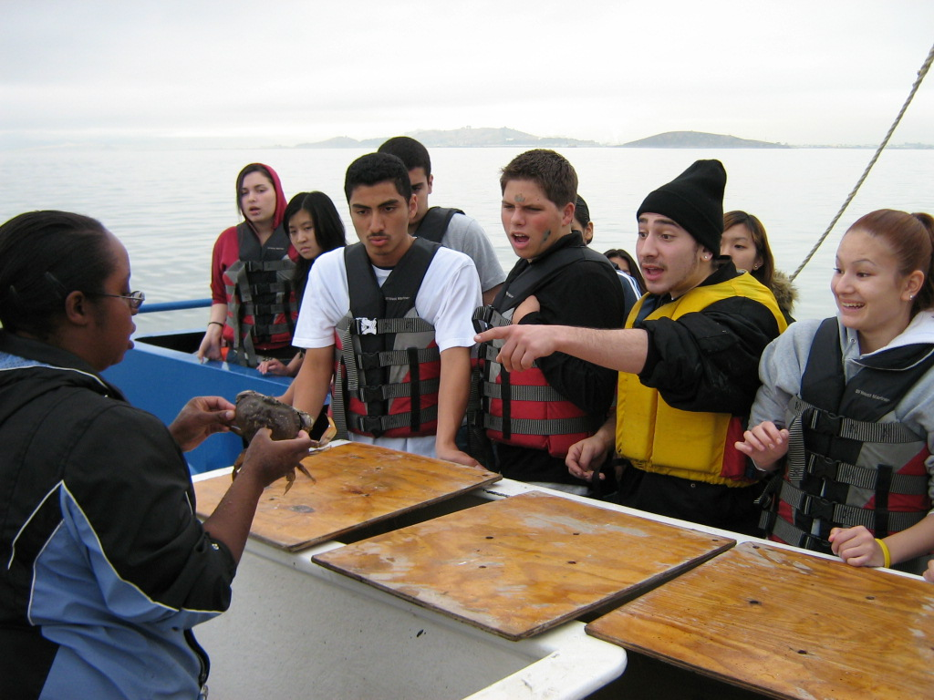

IV. Students enrolled in Environmental Science Pathway receive:

- 5 extra high school science credits
- 1-2 college credits available through CCSF
- Opportunities to apply for Internships

