JAZZ DANCE CLUB

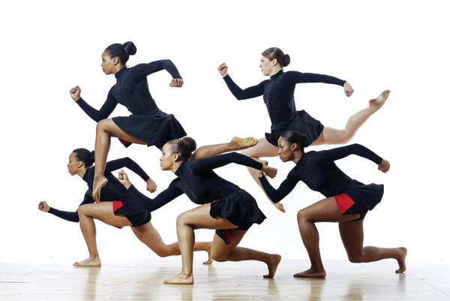

Like the dancing you see on So You Think You Can Dance? That style is commonly referred to as Jazz. Come take a class!
Friday’s 3:10-4:10
Come to Room 119!

