Name_________________________________
Anatomy and Physiology – Neuron Worksheet

Below is a diagram of a neuron. Use the term bank below to label the parts of the neuron.

Schwann cell nucleus Nucleus Axon terminals
Dendrites Node of Ranvier Cell body
Myelin sheath Axon

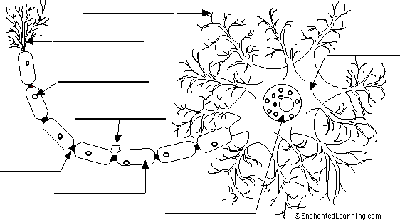

Using Chapter 9 (Sections 9.3 & 9.4) of your textbook, answer the following questions pertaining to neurons.

1. Which types of nerves can regenerate after being damaged? Which cannot? Explain why the difference exists.

2. List and contrast the 3 types of neurons, according to structural differences.

3. What is the importance of neuroglial cells to the human nervous system? Are there more or fewer of these (compared to neurons) in the central nervous system?

4. With respect to relative sizes of typical neuron parts: If the cell body of a neuron were the size of a tennis ball, how would the axon and dendrites relate to this?

5.. What is the function of myelin?

6. Why is a newborn baby’s nervous system unable to function as effectively as that of an older child or adult?

7. Contrast the functions of sensory neurons, interneuron, and motor neurons.

