WORK PERMIT OFFICE  Pupil Services Department  555 Portola Drive, Room 380  San Francisco, CA 94131  (415) 695-5504 | Hours of Operation:  Monday through Friday  8:00 am to 4:30 pm

TO GET A WORK PERMIT,
YOU MUST HAVE
ALL FOUR OF THESE:

1. COMPLETED APPLICATION
with parent/guardian’s signature at the bottom, employer signature in the employer section completed.

2. SOCIAL SECURITY CARD
(photocopy acceptable), OR verification letter from Social Security Administration Office

3. PROOF OF AGE
birth certificate, passport, OR California ID or Driver License

4. PROOF OF SCHOOL ATTENDANCE
current report card, OR dated and signed verification letter with current grades on official school stationery from the school administrator.

INCOMPLETE FORMS WILL NOT BE PROCESSED!

- For Individual applications, please allow 2-3 days to process

- For Large Group/Organization applications, allow 2 weeks processing time

Work Permit Office  Pupil Services Department  555 Portola Drive, Room 380  San Francisco, CA 94131  (415) 695-5504 | Hours of Operation:  Monday through Friday  8:00 am to 4:30 pm

INSTRUCTIONS TO STUDENTS APPLYING FOR A WORK PERMIT

1. The following students do NOT need work permits:

A. Those who have graduated from high school, regardless of age
B. Those who have passed the California High School Proficiency Examination
C. Those who are 18 years of age or older

2. The green form is only the “Statement of Intent to Employ Minor and Request for Work Permit” (henceforth known as the application). In completing the application, note the following:

A. Parent/Guardian must sign and date the section titled “For Parent to Complete” at the bottom half of the application.
B. Student must fill in the portions of the application “For Minor to Complete”:
C. Employer must complete the middle part of the application. The employer must sign the application; which indicates the employer has “Workers’ Compensation” insurance; list the hours of work for the student and the wage.

3. The following documents need to accompany your application (photocopies are acceptable):

A. Social security card
B. Proof of age (birth certificate, passport, alien registration card, or California Identification Card/Driver’s License)
C. Report card for the current school year, OR a dated and signed verification letter with current grades on official school stationery from the school administrator.

4. You can submit the application in person or by mail to the address above. Student submitting application by mail must enclose copies of the required documents from item #3 above. Requests submitted without the required documentation in item #3 will not be processed and will be returned to the applicant.

5. If applying in person, a work permit may be issued on the same day or dropped off to picked up within 2-3 working days during hours of operation. If applying through the mail, the work permit will be mailed to the home address of the student.

For further information, telephone the Work Permit Office at 695-5504 or the Pupil Services Department at 695-5543.
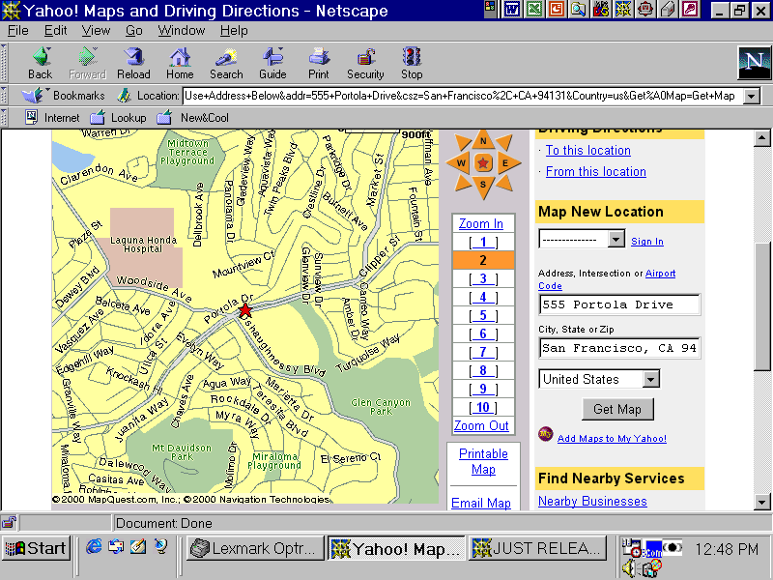

WORK PERMIT OFFICE
555 Portola Drive, Room 380
San Francisco, CA 94131
(415) 695-5504

Driving Directions to the Work Permit Office from the Civic Center Area.

Go south on Van Ness Avenue (towards Market Street).
Turn right onto Market Street.
Market Street becomes Portola Drive. Turn left onto O’Shaughnessy Blvd.
Turn left into parking lot.
Turn left after the gates and follow driveway to other side of school building/end of the parking area.
Follow posted signs to Room 380.

MUNI SERVICE

Bus Lines:

36 Teresita
37 Corbett
43 Masonic. Passes by the Forest Hill Metro
Station; stops 4 blocks away at Laguna
Honda Blvd. on Portola.
44 O’ Shaughnessy
(connects with BART at Glen Park Station)
48 Quintara - 24th Street
52 Excelsior

Streetcars:

K, L, and M streetcars will take you to Forest Hill Metro Station. Transferring to 36, 43, 44 or 52 bus will take you the remaining distance.

BART

Take BART to Glen Park Station & transfer to Muni 44 Bus

On foot: Walk to Portola Drive and O’Shaughnessy, cross to the south side of Portola Drive and continue east, take stairs down to the parking lot before you get to the next light at Glenview.

DRIVING DIRECTIONS FROM OUTSIDE THE CITY OF SAN FRANCISCO

From North: Take the CA-1 exit towards 19th Ave./Golden Gate Park. Merge onto CA-1 S. Turn left onto Sloat Blvd. Turn Left onto Portola Drive. Cross O’Shaughnessy and turn Right into the parking lot at the next light (Glenview).

From East: Take I-80 W ramp towards San Francisco. Keep left at fork in ramp. Turn right onto I-80 West Ramp. Merge onto I-80 W. Take the exit towards Mission/Fell Street. Merge onto US 101 N. Take Duboce Ave./Mission exit. Stay straight and go onto Duboce. Turn Left onto Market St. Market becomes Portola Drive. Turn left on O’ Shaughnessy. Turn left into parking lot. Turn left after the gates and follow driveway to other side of school building/end of the parking area.

From South: Take US-101 N ramp towards San Francisco. Merge onto US-101 N. Take the I-380 W. Exit towards I 280/San Bruno. Merge onto I-380 W. Take the I-280 N. exit towards San Francisco. Merge onto I-280 N. Take CA-1 N. towards 19th Ave. Keep to two right lanes which turn into Junipero Serra, which in turn becomes Portola Drive. Cross O’Shaughnessy and turn Right into the parking lot at next light (Glenview).

From West Side of City: Take either 19th Ave. or Sunset to Sloat Blvd. Left onto Portola Drive. Cross O’Shaughnessy and turn Right into the parking lot at the next light (Glenview).

