Proceeds will be used to support critical Galileo educational needs identified by Galileo staff and teachers.

DEADLINE: April 30, 2009 COST: $100 donation per tile*
*(covers material, engraving & installation)
Additional duplicate keepsake tiles can still be ordered from Tile Drive 1 or 2 (exact wording from Tile Drive 1 or 2 order will be used) at $50 each and/or Tile Drive 3.

The new Galileo Main Courtyard still has LIMITED SPACE for approximately 56 additional custom engraved tiles to be installed. This is a unique gift; donate/dedicate a commemorative tile for yourself, family, friend, teacher, staff, club, team, business, etc. FIRST COME, FIRST SERVED FOR THE FINAL 56 INSTALLED TILES.
Your donation is 100% tax deductible. Galileo Academy PTSA Tax ID: 20-1159768
J. Lee
Class of 2009
Go Galileo Lions

TILE SAMPLE →
(Text with logo option. Actual
appearance may differ)

Each tile is 6 inches by 6 inches
(6” x 6”)
See reverse side of this form to enter the information you want engraved on your personal tile. WRITE or TYPE ALL INFORMATION CLEARLY ON BOTH SIDES OF THIS ORDER FORM, in case we need to get back to you to clarify any issues before tile engraving.

TILE DONOR NAME:

PHONE and EMAIL: ____________________________________________________

QUESTIONS ??? Contact Bruce Eng
Email: Lattjiu@aol.com Phone: (415) 731-4020 Web site: www.galileoweb.org/ptsa

MAIL this completed form and $ donation with check payable to “GALILEO Academy PTSA” Don’t send cash.
Number of tiles ___ x $100 each = ________
Number of duplicate tiles ___ x $50 each = _____ Duplicate from Tile drive 1 or 2 or 3 (please circle)
Grand total = _________ Check #_____________

NOTE: Please contact Bruce (2 weeks after mailing of this form) to see if your tile order is one of the 56 tiles. Tile purchasers beyond tile 56 and up will be notified of their tile order options (engrave tile or refund) on February 18, 2009.

Address: GALILEO ACADEMY PTSA
1150 Francisco Street, Room 206C
San Francisco, CA 94109
Attn: Karin Lau – Tile Drive 3
GALILEO New Courtyard Custom Engraved TILE DRIVE 3 ORDER FORM

COMPLETE OPTION 1 or 2 BELOW: i.e. Name, Galileo Class, Club, Team, Etc. or Other Message or Dedication.

PICK ONLY ONE OPTION BELOW. Use a separate order form for each tile. If possible, download this Order Form from PTSA’s web site or request from Bruce Eng. Complete the form on the computer to ensure accuracy. Choose messages, which fit in the Options below, maximum 16 characters per line, including spaces. (Engraver automatically centers each line.) Each box should contain no more than one letter or punctuation mark/symbol. Leave a blank space to indicate a space between words. You may use upper and lower case letters.

OPTION 1 - ALL TEXT (standard computer keyboard characters):
Line1
Line2
Line3
Line4

Or OPTION 2 - TEXT AND LOGO (select only 1 logo–circle logo and # or type #):
Line1
Line2
Line3
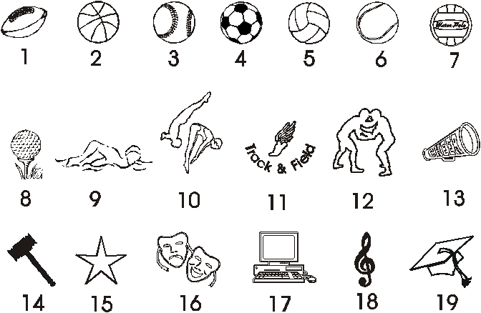
NOTE:

Logo 24 is Class of 2008

Logo 25 is Class of 1967

For Logo 24 or 25, 2 lines of text max.
20 21 22 23 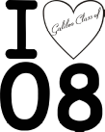24 25

Note: Galileo PTSA and administration reserve the right to deny the engraving of any tile that has offensive language, messages or artwork. Galileo PTSA and administration are not responsible for any issues/errors in the engraved tile or installation.

