Ch 22 Notes: Descent with Modification: A Darwinian View of Life.

Some influential people:

Linnaeus: (1700’S) Specialized in classification of living things. Based mostly on physical appearance. Not always accurate, because looks can be deceiving. Used a system based on Latin names. Binomial, nomenclature.

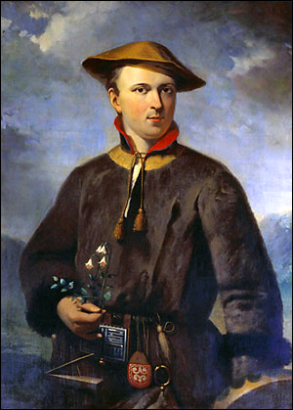

Had difficulty grouping animals that may look alike but aren’t related, or animals that look different but are related.

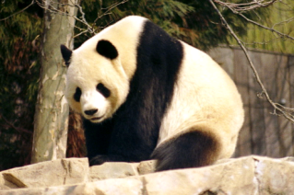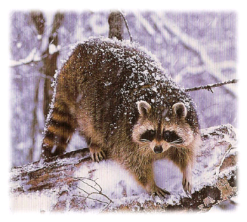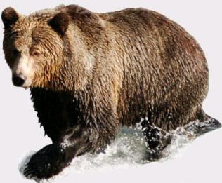

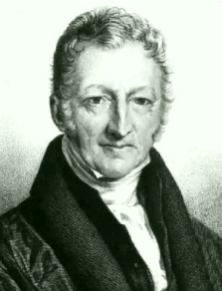

Malthus: (1700-1800) Wrote about – disease, famine, homelessness and war… were a result of not enough resources.

Hutton (1726-97) & Lyell (1795-1875): Geologists.

* Hutton was saying that things have changed slowly over time – gradualism. Geologic Time.
* Lyell observed, Uniformitarianism – idea that geologic processes are still going today. Could apply to living things too… that the same things that shaped organisms in the past is still working today.

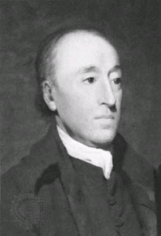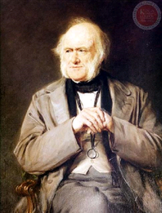

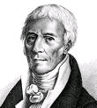

**Jean-Baptiste Pierre Antoine de Monet, Chevalier de Lamarck**

Lamarck (early 1800’s) : Came with a early theory about how species look the way they do. “Use and disuse” theory. If an animal used some part, over time it would become dominant and be passed on to offspring.

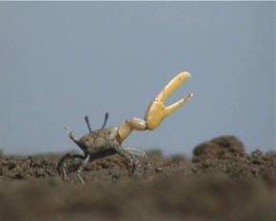

Charles Darwin (1809-1882) Started medical school, but left to be a clergyman. 1831 after graduation didn’t know what he wanted to… so he went on a world wide voyage…on the HMS Beagle as it’s naturalist.

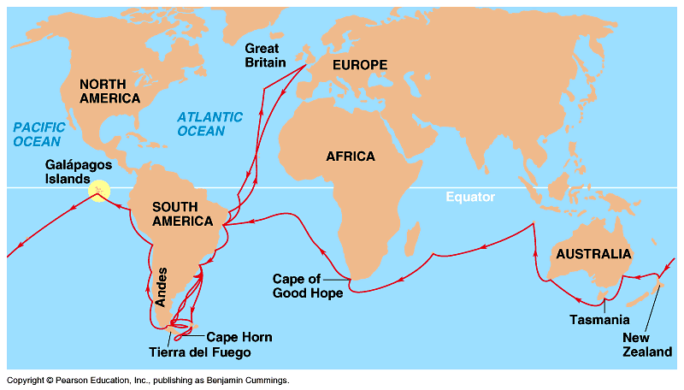

Most famous stop was on the Galapagos Islands. Islands are isolated from the mainland. Relatively few species. These species showed some interesting patterns that Darwin noted.

Darwin’s Inferences:

Observation: Resources are limited.

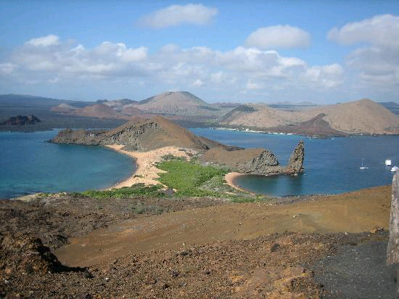

Inference: Not all can survive.

Observation: Organisms vary (look different)

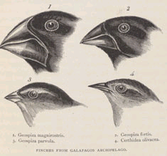

Inference: Some are better suited than others to survive.

Observation: Traits are heritable.

Inference: Those with the best traits will pass those traits on.

Returned to England in 1836… was studying his collection. Noticed the patterns. Applied them to his theory of “evolution.” Finished major points in 1844… but didn’t publish it. Until 1858… when he received a letter from Alfred Wallace… then he decided to publish his essay. Called it the Origin of Species.

Darwin’s Two Main Points:

* There is evolution over time (descent with modification) – like a tree with branches.
* Natural Selection is the mechanism by which organisms change over time.

You can see natural selection happen relatively quickly in some instances.

* Pepper moths during the industrial revolution

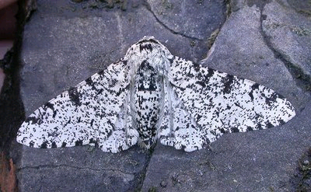

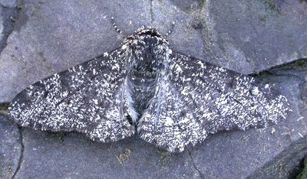

* Cockroaches and “Raid Roach Spray”
* Drug resistant HIV and “super” bacteria

Some other evidence for Natural Selection and Darwinian evolution.

* Homology. Similar structures in vastly different organisms. Ex: bones in the arm of a human vs. bones in the flipper of a dolphin.

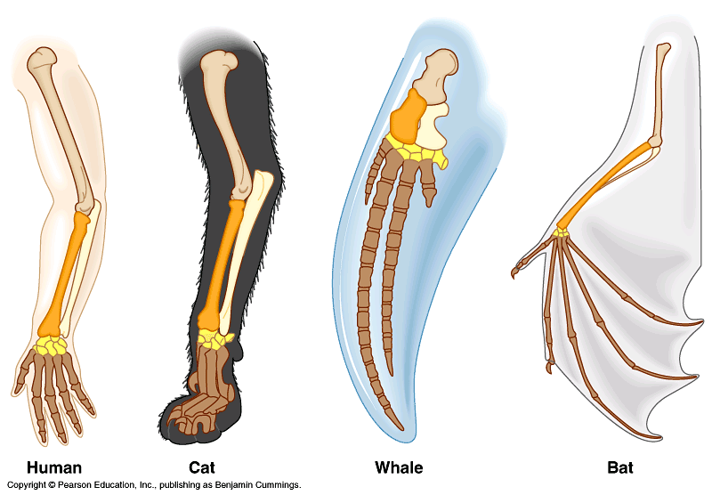

* Vestigial Organs. Left-overs from evolution. Ex: appendix or tailbone. Doesn’t have a function now, but might have.
* Molecular Homologies ex: chimpanzee hemoglobin and human hemoglobin…

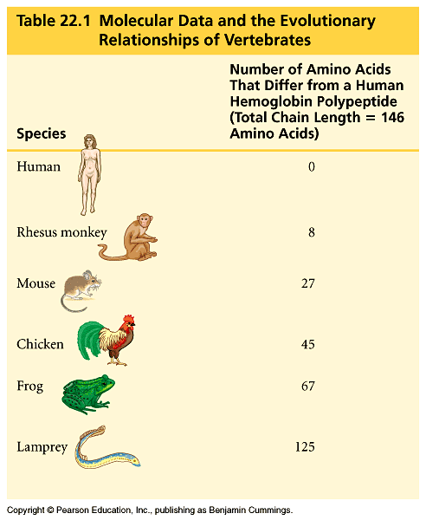

Embryonic Homologies – similarities when we are developing as embryos.

Biogeography – distribution of species seems to support a Darwinian view of evolution. Similar environments seem to lead to similar traits being favored.

Ex: white colored animals in areas where it snows are not related, but have the same traits b/c the environment “selected” that trait.

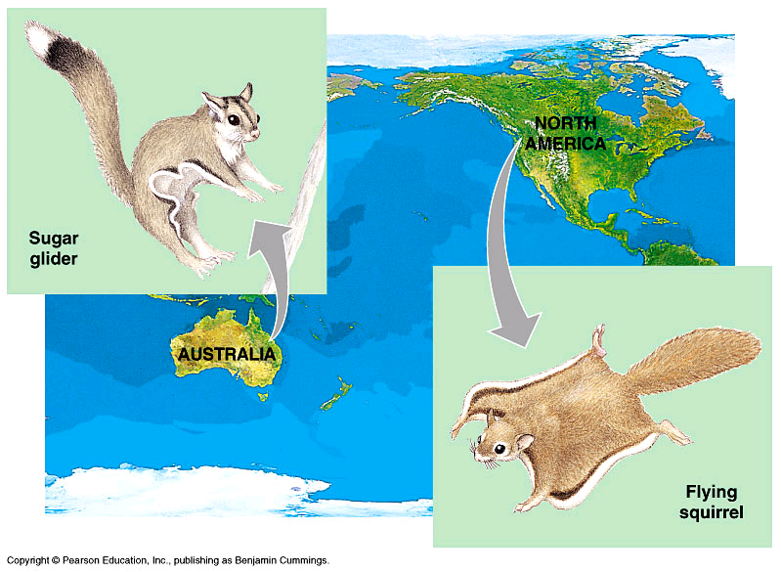

Fossil Record – A look into the past… to see how organisms have changed over time. Fossils show some transition species.

