FUTURAMA PERSONAL TRAINING CLASS

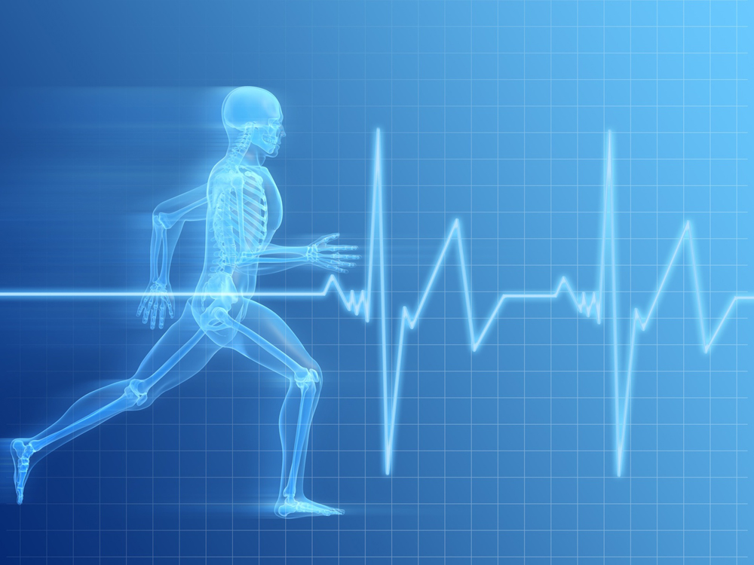

IMPROVE YOUR SPORTS PERFORMANCE!

BURN FAT FAST!

BUILD MUSCLES!

CHANGE YOUR LIFESTYLE!

THURSDAY, FEBURARY 9TH

WEIGHT ROOM 2:10PM-3:10PM

SIGN UP IN ROOM 119 NOW!