FUTURAMA KOREAN LANGUAGE CLASS

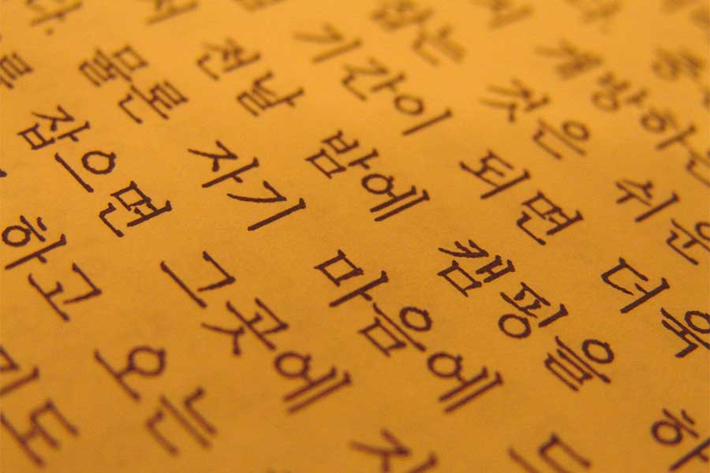

WANT TO LEARN ABOUT KOREAN LANGUAGE AND CULTURE?

EVERY WEDNESDAY,2:15-3:30

SIGN UP NOW IN ROOM 119