Galileo Wellness Program

Youth Outreach Worker (YOW) Application 2014-2015

Why do you think the Galileo Wellness Program needs YOWs?

(see job description on backside)

Tell us about yourself~

Strengths?

Weaknesses?

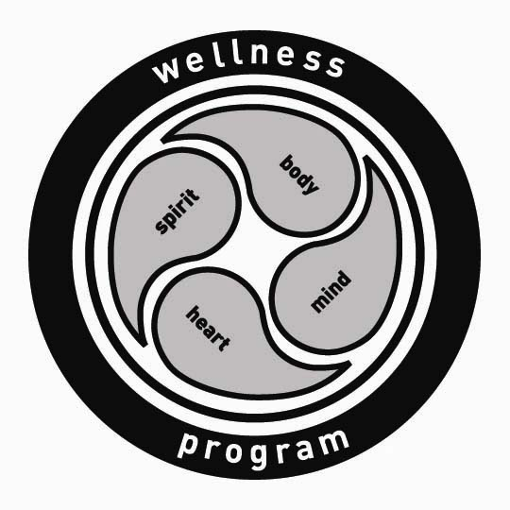

What are your specific health and wellness-related areas of interest? *(please check all that apply)*

🔾 Mental / Emotional Health 🔾 Tobacco/Substance Abuse

🔾 Physical Health 🔾 Sexual Minority Youth issues and awareness

🔾 Sexual Health 🔾 School Health policies

🔾 Safety/Violence Prevention 🔾 HIV/AIDS

🔾 Stress Management

🔾 Tobacco/ Substance Use

🔾 HIV/AIDS Prevention

🔾 Lesbian, Gay, Bisexual,

Transgender, Questioning (LGBTQ)

🔾 Other: _________________ 🔾 Other:

Are you available **Wednesdays after school from 2:15-3:45** for mandatory YOW meetings?

☐ Yes ☐ No

Do you know that this position involves trainings and events that may require you to miss class?

☐ Yes ☐ No

Which of these roles would you be best at?

☐ Artist/ poster designer

☐ Workshop developer

☐ Presenter/ speaker

☐ Outreacher/ planner

☐ Website & technology

Any other skills you are good at?

___________________________

___________________________

What are some creative ways you can help to address these Wellness issues at Galileo?

**Name: Grade:**

**Birthdate: Counselor:**

How did you find out about the YOW position?

On a scale from 1-10, how comfortable are you with giving presentations in front of a class?

1---------------------5---------------------10

Not Comfortable Very Comfortable

How do you feel about discussing issues like sexual health, emotional health, and drugs & alcohol?

☐ Very comfortable

☐ Need more info & education to be comfortable

☐ Not comfortable

☐ Could be comfortable if… ___________________

______________________________________________

Congratulations! You’ve completed the application! We’ll be contacting you to schedule an interview between September 5th and 9th, 2014

**Please return your application by Wednesday, Sept. 3rd to Naomi in the Wellness**

**Center, Room 151**

What other school & recreation activities (sports, clubs, etc) are you participating in this year?