Applications are in the Wellness Center, Room 151.

Applications are due Wednesday September 5th.

For more info ask Naomi!

**Be a Wellness Youth Outreach Worker!**

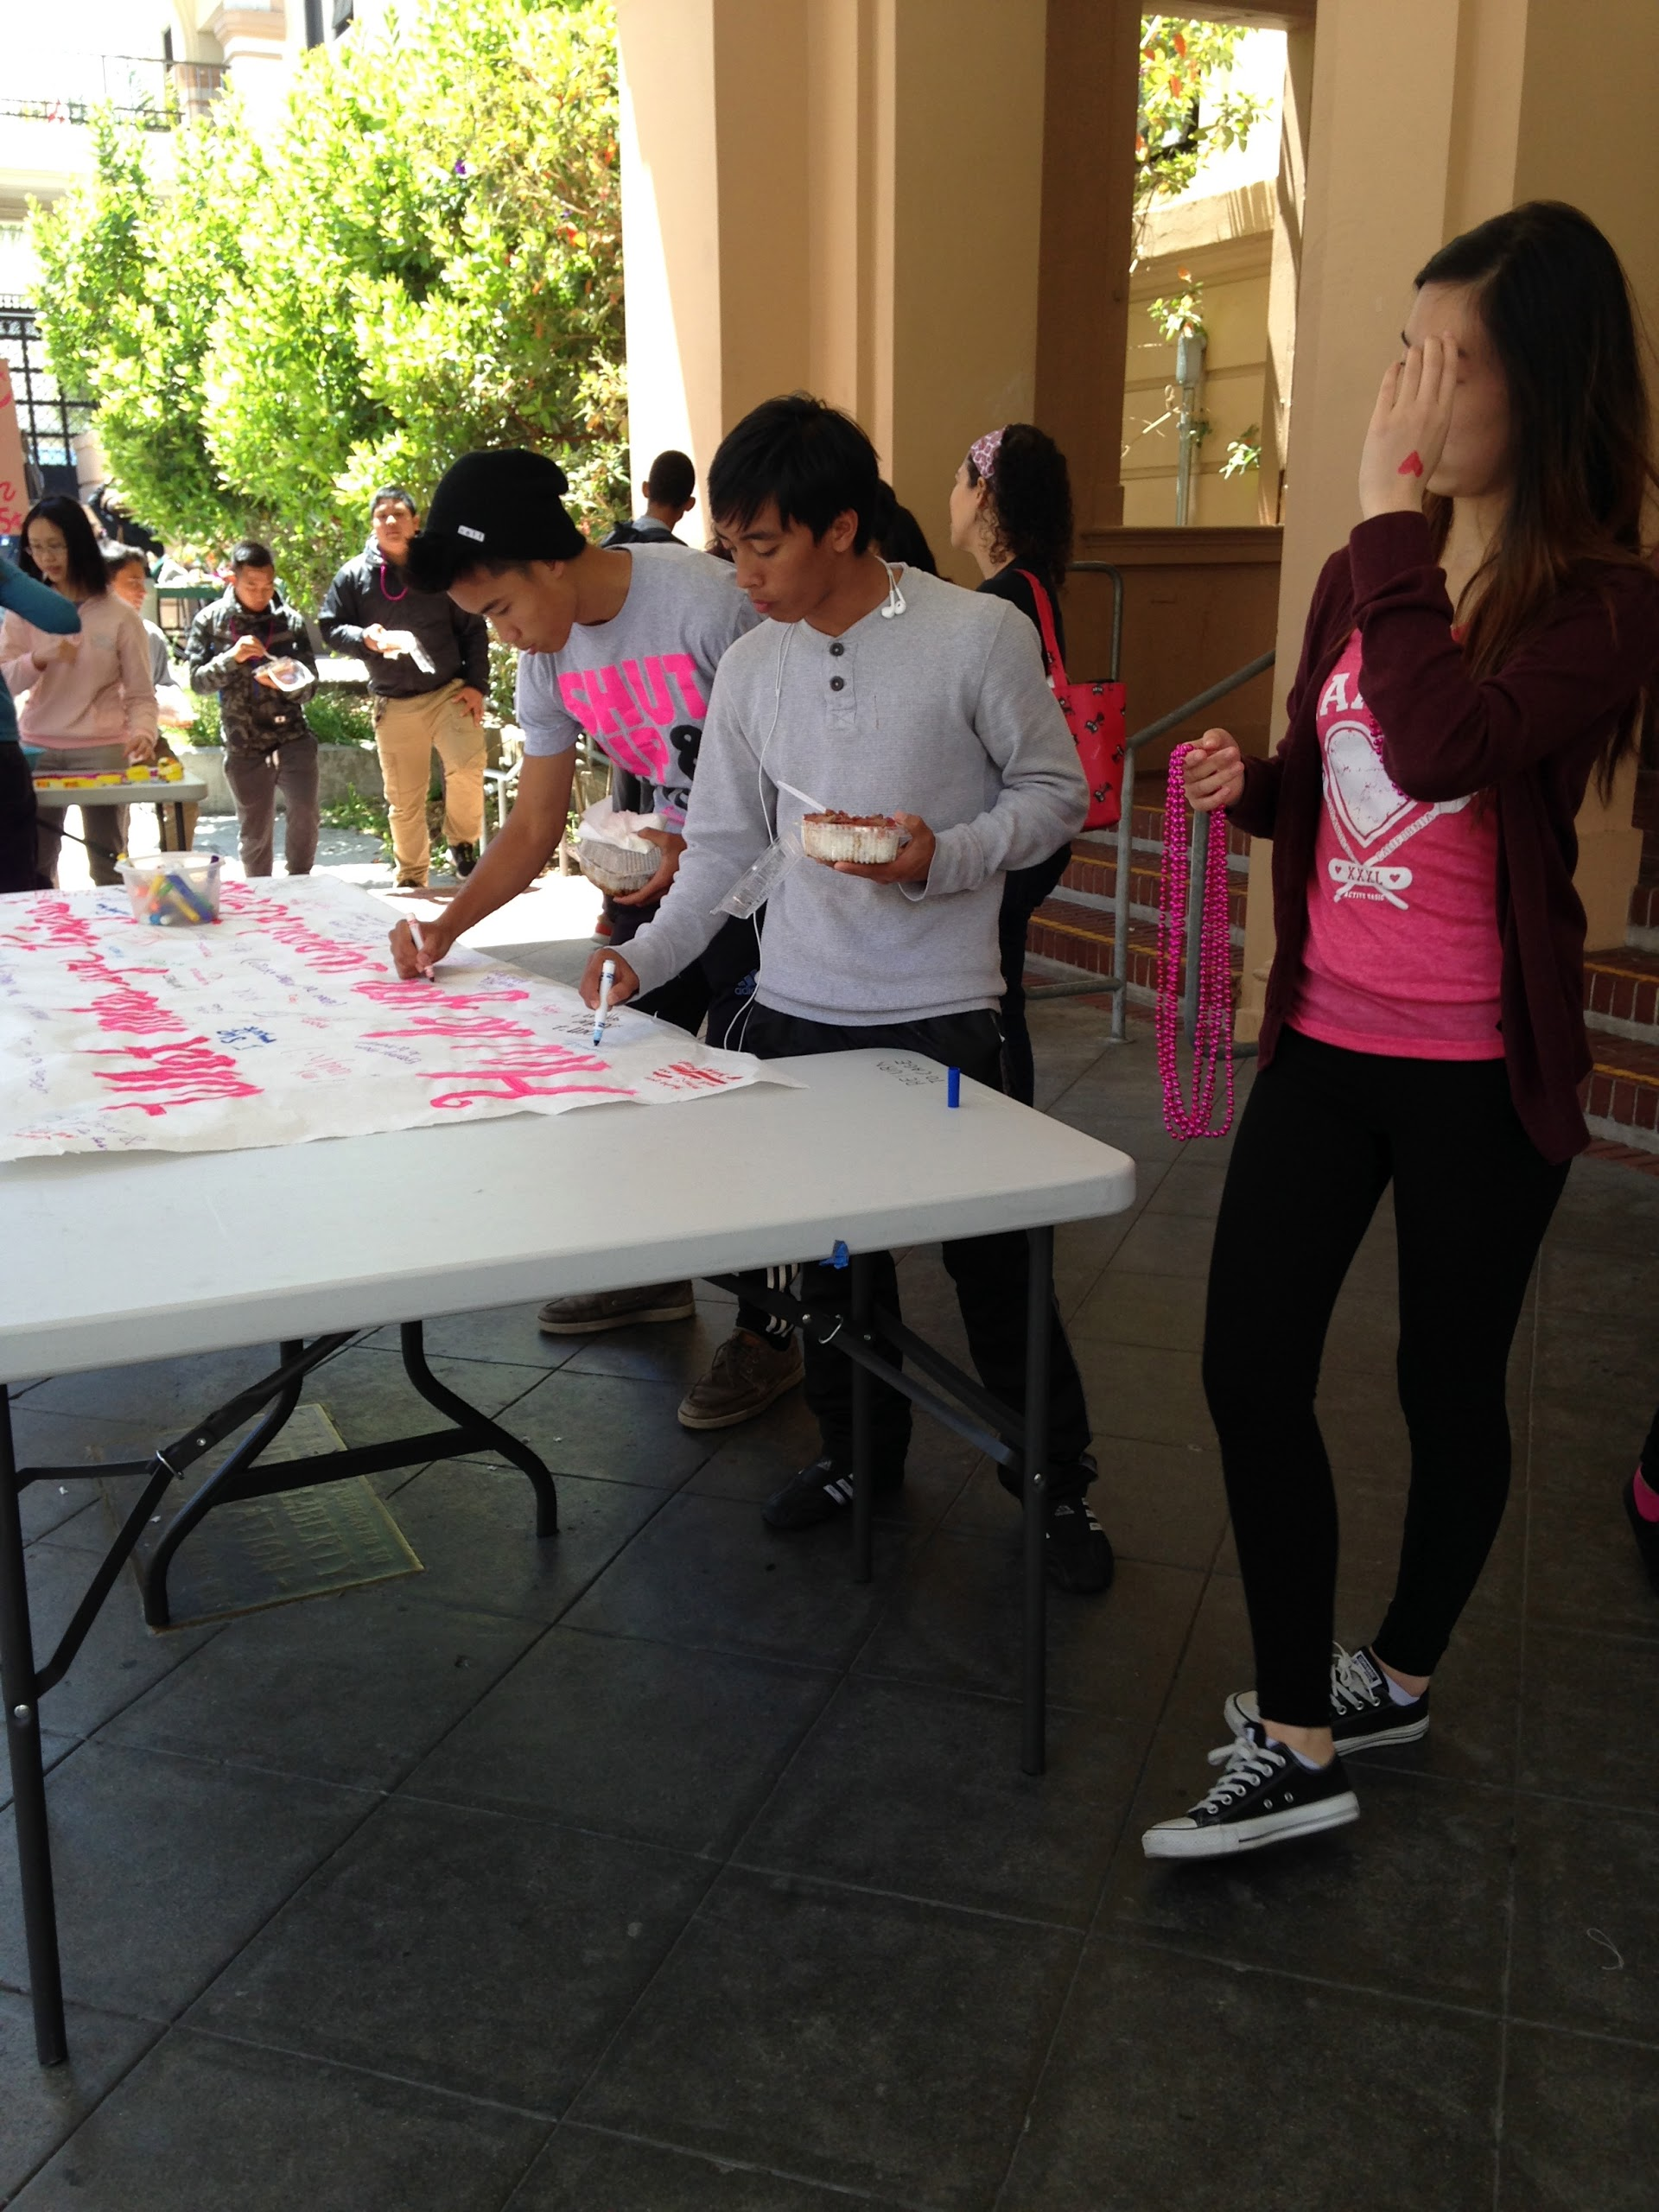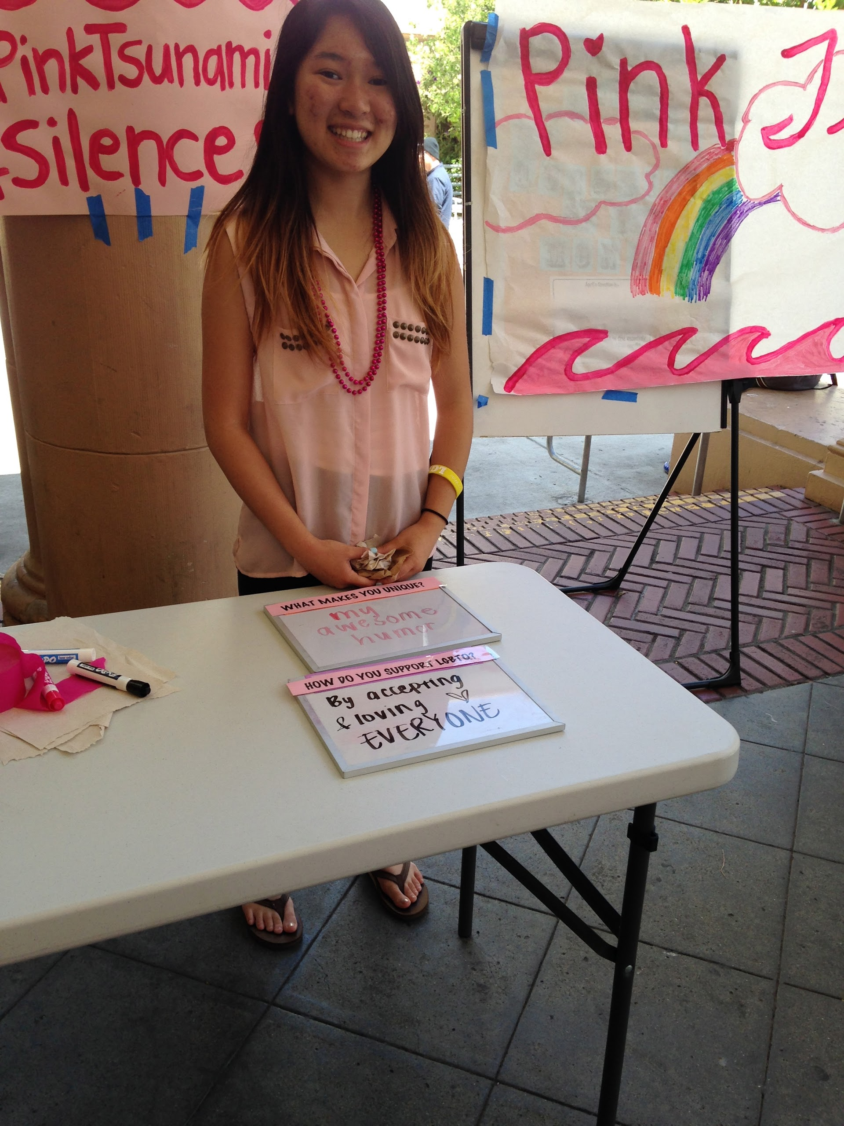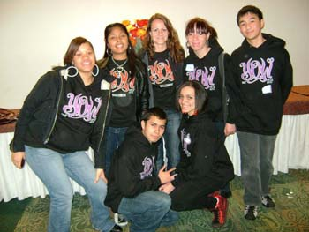

* Be a student leader
* Organize school-wide events (like Lovefest and Pink Tsunami)
* Do presentations in classes about social media, sex ed, healthy relationships, and more!
* Learn new skills & meet new people!
* Get PAID!!!