**Problem 1:**

*Entities*: Treatment details, doctors, patients, hospital.

*Attributes*:

Doctor: code, name, date of employment, specialty.

Patients: id, name.

Treatment: date, duration, results.

*Relationship:*

Doctor - patients: a doctor can take on many patients, and a patient is admitted by many doctors.

Hospital - treatment: hospital save many treatments, and a treatment are save by one hospital.

*Weak entities:* Treatment

*Weak Relationship:*

Doctor - treatment

Patient - treatment

*ER Model:*

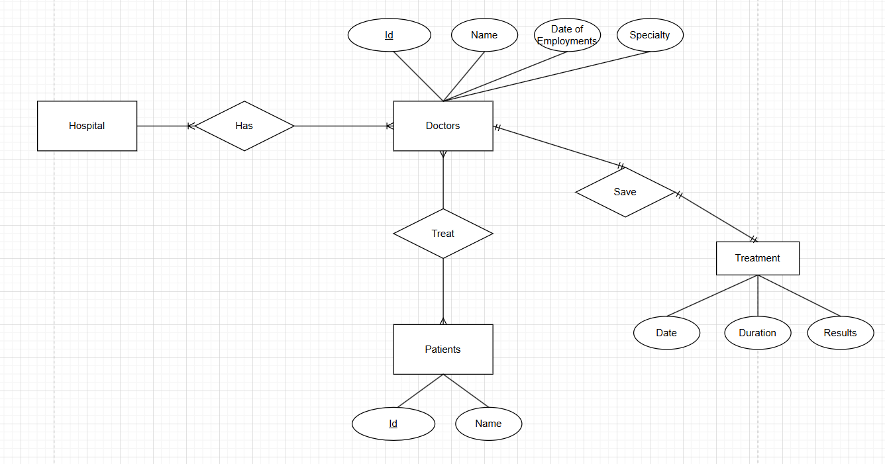

**Problem 2:**

*Entities:* University, faculties, department, classes, students, subjects, exam score, graduation point, library card.

*Attributes:*

Faculty: code, name.

Class: code, name, wholesale number.

Student: id, full name, date of birth, gender, address.

Subject: code, name, number of credits.

Library card: number, issue date, expiration date.

Relationship:

University - faculties: has (1-many)

Faculties - department: has (1-many)

Department - classes: has (1-many)

Student - class: be placed (1-1)

Students - subjects: study (1-many)

Student - exam score: has (1-1)

Student - graduation point: has (1-1)

Library card - student: belongs to (1-1)

Weak entities: Exam score, graduation point

Weak relationship: Student - exam score, student - graduation point

ER model

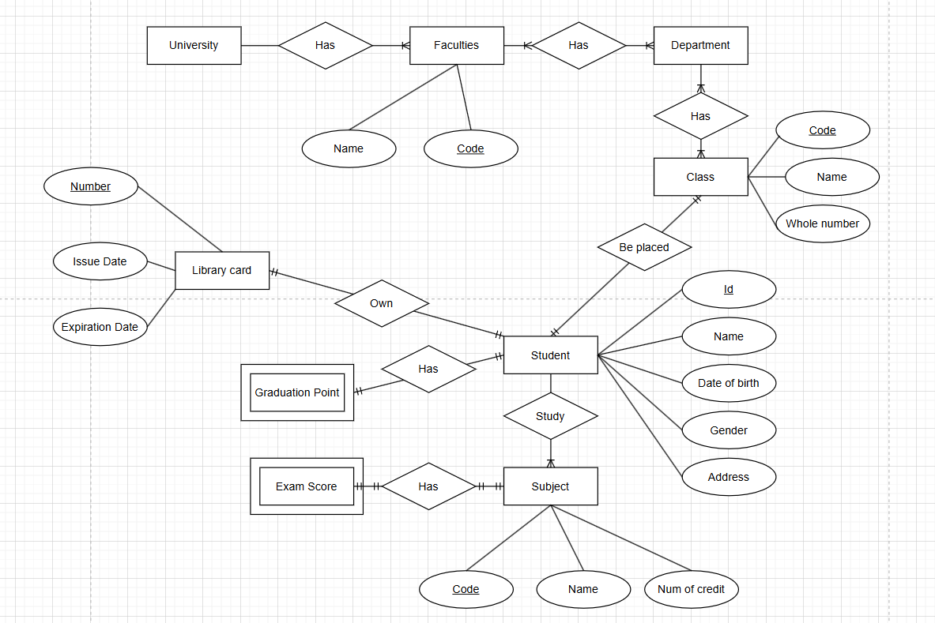

**Problem 3:**

*Entities*: Room, floor, guest, service information, invoice.

*Attributes*:

Room: code, name, price per day, price per weak.

Floor: code, name.

Guest: ID card number, full name, phone number.

Service: code, name, amount.

Invoice: code, Id card number, full name, day stay, room, amount.

*Relationship:*

Floor - room: has (1-many)

Guest - invoice: has (1-1)

Room - invoice: has (1-1)

Invoice - service: have (1-many)

*Weak entities:* Room price

*Weak Relationship:* Invoice - service

*ER Model:*

