1.

Entities: Customer, staff, products, invoice, detailofinvoice

Attribute:

Customers: customerid, full name, address, phone, birthday, sale, registrationdate.

Staff: staffid, fullname, dayofentry, phone.

Product: productid, productname, unit, nation, price.

Invoice: invoiceid, purchasedate, customerid, staffid, value.

Detailofinvoice: invoiceid, purchasedate, customerid, staffid, value.

Relationship:

Customer - product: buy (1-many)

Staff - product: manage (1-many)

Product - detail: appear (1-many)

Customer - invoice: receive (1-many)

Invoice - detail: include (1-1)

ER model

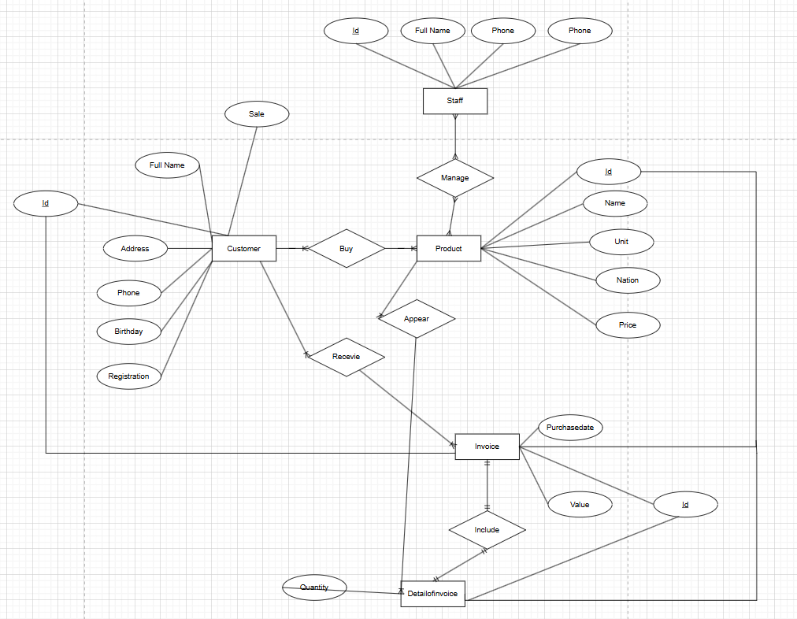

2.

Entities: Employee, department, salary,

Attribute:

Employee: code, middlename, firstname, dateofbirth, address, gender, salary, working hour, position.

Department: code, room name, records.

Project: code, name, location.

Relatives: names, dateofbirth, relationship

Relationship:

Company - employee: has (1-many)

Manager - employee: manage (1-many)

Department - location: has (1-many)

Location employee: has (1-many)

Employee - project: implement (many - many)

Employee - relative: has (many - many)

Weak entity: relative

ER model

