ABRACAdabra1

* August 21, 2017

Great American Eclipse 2017

* Skywatchers on the American continent today are in for a special astronomical treat: front row seats to a total solar eclipse. An eclipse occurs when the moon passes between the sun and the earth, blocking the light of the sun from reaching us.

While eclipses aren’t rare, a *total* eclipse, when viewers from Earth are at the very center of the moon’s shadow, only happens once every 18 months. To see one requires you to be in just the right place on earth, and a total eclipse in the same location only happens every 375 years on average.

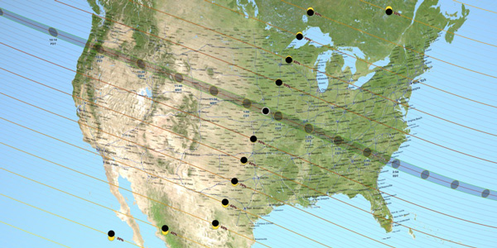

Map credit: NASA's Scientific Visualization Studio

It’s been 99 years since an total eclipse crossed the width the United States. This year, the 65-mile wide path of totality with sweep, sash-like, across the country—entering the [map](https://eclipse2017.nasa.gov/eclipse-maps) at Oregon and exiting at South Carolina. The once-in-a-lifetime spectacle will attract an estimated 7.4 million people to areas in the path of totality, including so-called eclipse-chasers, who plan for years in advance and travel from far and wide to get a glimpse of the stellar phenomenon. ABRACAdabra1

No matter where you are in the country, if you plan to look at or even toward the sun, be sure to protect your eyes. According to experts, only those in the path of totality are safe to look at the eclipse without protection, and only during totality.

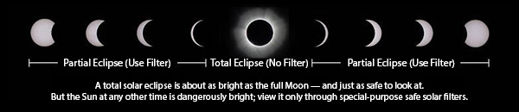

Image credit: NASA

To learn more about [solar eclipse science](https://www.google.com/search?q=solar+eclipse+science), you can click beyond the Doodle to Google Search and get some fun facts courtesy of our friendly space aliens. You can learn about a [crowd-sourced photo project](https://eclipsemega.movie/) to capture images of the eclipse as it traverses North America even follow NASA’s live, [streaming video](https://www.nasa.gov/eclipselive) of the event.

|  |  |  |
| --- | --- | --- |
| https://lh3.googleusercontent.com/LOJNtVoYen6lxSpjwkyDfJ5XPXnm9UM1RN2-g7fYyyazcd6IQ2_fVQjH38xMVyOdIfdiBeL8MhC2PmZyM6ufNwAYvtPGyx9YDhenuAtgxA=s0 | https://lh3.googleusercontent.com/QK2ReGd1Aiths4ekhZuWlshobSHFze_96k4BEatht2iDtGDHBdXJSNnjn9a7G99Xo-ZXQXJBkExRSiVaYIWp3SLWvOkLnZRXNkPCW3ePiw=s0 | https://lh3.googleusercontent.com/1nS7hSgqXqp0bJQaxfVfH5ELCUXwOwhmxbU7LKvXx248WFMpJGTtj00x2qodT7drIaJ-5Typcq56_rfj57DY5thYoGlpxIf2mNt1Pbwb=s0 |

Visit [timeanddate.com](https://www.timeanddate.com/eclipse/solar/2017-august-21) to learn more about how the eclipse will appear in your location. Happy viewing, skywatchers!