ASSIGNMENT

1.Declare an array and find sum and average.

#include<stdio.h>

void main()

{

int data[5]={1 ,2 ,3 ,4,5};

int sum=0,avg,i;

for(i=0;i<5;i++)

sum=sum+data[i];

avg=sum/5;

printf("%d %d ",sum,avg);

}

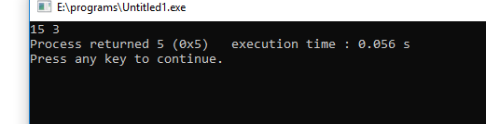

2.

3.Write code to create struct student with three variables age,section,percent.

Create variable and assign values and print the values.

#include<stdio.h>

#include<conio.h>

struct student

{

int age;

char section;

float percent;

};

void main()

{

struct student s;

s.age=20;

s.section='A';

s.percent=85.5;

printf("%d %c %f ",s.age,s.section,s.percent);

}

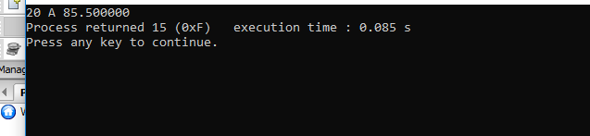

4.Write example code for malloc()

#include<stdio.h>

#include<conio.h>

#include<stdlib.h>

#include<string.h>

void main()

{

char \*description;

description=malloc(50\*sizeof(char));

if(description!=NULL)

strcpy(description,"c programming");

printf("%s",description);

}

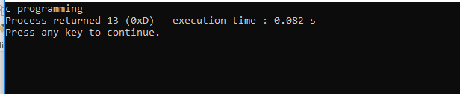

6.Write the 4 methods available for memory management with some examples.

a.malloc

#include<stdio.h>

#include<conio.h>

#include<stdlib.h>

#include<string.h>

void main()

{

char \*description;

description=malloc(50\*sizeof(char));

if(description!=NULL)

strcpy(description,"we are learning c programming");

printf("%s",description);

}

b.calloc

#include<stdio.h>

#include<conio.h>

#include<stdlib.h>

#include<string.h>

void main()

{

char \*description;

description=calloc(50,sizeof(char));

if(description!=NULL)

strcpy(description,"we are learning c programming");

printf("%s",description);

}

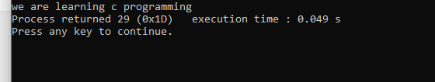

7.Create a simple struct and read the values from the user and print them.

#include<stdio.h>

#include<conio.h>

#include<stdlib.h>

#include<string.h>

struct employee

{

int id;

float salary;

};

void main()

{

struct employee e;

printf("enter id:");

scanf("%d",&e.id);

printf("enter salary:");

scanf("%f",&e.salary);

printf("values you entered : %d,%f\n\n",e.id,e.salary);

}

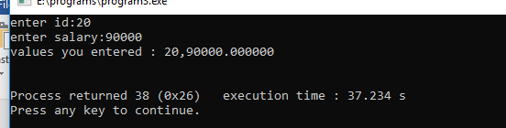

8.Using struct pointer read the employee id and salary and print the values.

#include<stdio.h>

#include<conio.h>

#include<stdlib.h>

#include<string.h>

struct employee

{

int id;

float salary;

};

void main()

{

struct employee \*e = (struct employee \*)malloc(sizeof(struct employee));

printf("enter id:");

scanf("%d",&e->id);

printf("enter salary:");

scanf("%f",&e->salary);

printf("values you entered : %d,%f\n\n",e->id,e->salary);

}

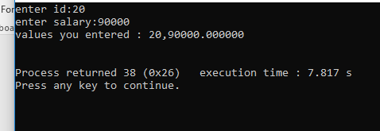

9.Create a linked list with three employees and print the values.

#include<stdio.h>

#include<conio.h>

#include<stdlib.h>

#include<string.h>

struct employee

{

int id;

float salary;

struct employee \*next;

};

void main()

{

struct employee \*e1 = (struct employee \*)malloc(sizeof(struct employee));

struct employee \*e2 = (struct employee \*)malloc(sizeof(struct employee));

struct employee \*e3 = (struct employee \*)malloc(sizeof(struct employee));

e1->id=1;

e1->salary=50000;

e1->next=e2;

e2->id=2;

e2->salary=75000;

e2->next=e3;

e3->id=3;

e3->salary=90000;

e3->next=NULL;

struct employee \*temp=(struct employee \*)malloc(sizeof(struct employee));

for(temp=e1;temp!=NULL;temp=temp->next)

{

printf("%d %f \n",temp->id,temp->salary);

}

}

