Red Round Sign Detection

Part 1: Dataset

I’ve downloaded both the train & test dataset from the links stated in the get_dataset.sh file. There are 300 high resolution(1360X800) images in test dataset & 600 in train dataset.

Since we are to detect only the signs which have **round red circle**, I’m labelling those images as 1 and rest of the other images as 0.

I’m loading the cropped images of the train dataset & the raw images of test dataset. Reason is straight forward, I will deal with this problem in two parts. One is to build a Region of interest detector and a sign prediction model. So I will train the neural network with the cropped images of train dataset so now I will have a model which predicts the red round traffic sign. The first part of the problem is to extract signs from the raw image and send it to the classifier to classify them correctly. To detect the signs from a raw image I have multiple approaches in my mind and couple of them work in progress. I will add them in part2 of the report which I’ll be submitting next.

However, I could see that the cropped images of the train dataset are of different shapes and sizes. Since these have to fed into the neural network, they should be all of same shape. So I’m re-sizing all the train dataset cropped images to 32x32 shape.

However, comparing the german dataset with the other traffic sign(like TENCENT, LISA) dataset one thing I could observe is that the images of the german dataset have mostly dull weather conditions which resulted in darker photos. Whereas Tencent dataset which has very high(2K) resolution images are having wide variety of signs in very clear lighting. However it is challenging to solve german dataset as it simulates worst case scenarios of real world driving ☺ Some type of weather conditions which German traffic sign dataset lacks is snow, rainy weather conditions. I could see entire dataset is just filled with clear sky, sunny or dim weather conditions only.

I’m also performing data augmentation so that we can fill in the gap being created due to lack of different climatic conditions. Before data augmentation, the instances of train data were 852, now after augmentation the train data size has grown to 53676, which is 63 times the number of images we previously had.

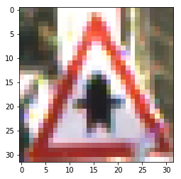

Fig1. Base Image

The types of image augmentations I have performed are:

1. Random rotation:

I’m rotating the Base image randomly between -25 to +25 degrees. Sample of a rotated image is below.

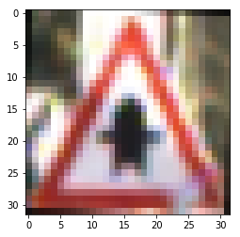

1. Brightness:

Since there is also need to simulate brighter environmental conditions, I’m also performing this operation.

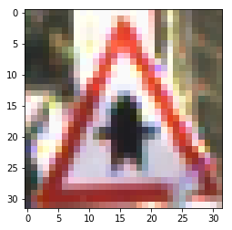

1. Snow:

I’m aswell adding snow to the cropped image which basically simulates the snowy weather which is lacking in the dataset.

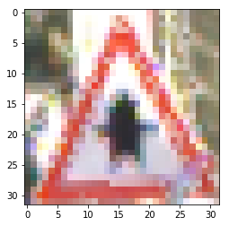

1. Noise:

I’ve also added noise which will simulate more of a realistic scenario where the cameras which are capturing the images are of poor quality or there is dust and mud in the camera lenses.

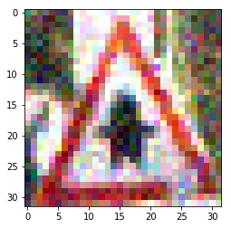

Since we are just dealing with the detection of round red circle with this dataset, I have plotted a graph to see the distribution of round red circles and non-round red circles, the dataset at hand is now equally distributed. Please see the graph below:

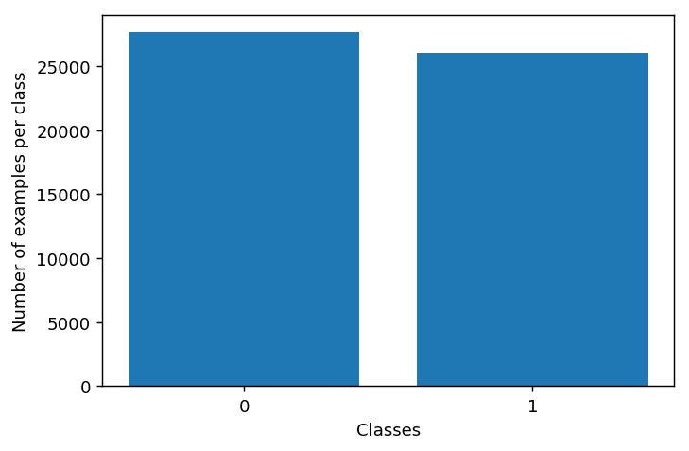

0 = Non-Round Red Circle Signs

1 = Round Red Circle Signs