Gaming Store

(08)

**Project Based Learning**

**Team Members**

Sai Shankar (2010030054) – Team Leader

Jessie Pramod (2010030069)

Aumesh (2010030247)

Medhilesh (2010030551)

**Department of Computer Science** **Engineering**

Koneru Lakshmaiah Education Foundation Hyderabad (KLH Deemed to be University), TSPA Junction, Chilkur Balaji Temple Road, Aziz Nagar, Hyderabad, Telangana, 500075.

**1. Introduction about the project**

The project titled as “GAMING STORE “is a web based application. Gaming Store is website, in which we can download the top games for free. Our application does not contains any advertisements and user can register easily and can login. User can download games with a click. We produce high quality games without any interruption.

**Modules**

* Admin of Gaming Store
* User

**Functional Requirements:**

**Admin of the Gaming Store:**

* Create update and delete accountant details after login
* Can search user details
* Can search all users data and can update and delete them

**User:**

* Can register his/her account and can login
* Can search thepcgames as per requirement after login
* Can see his/her profile

**Non –Functional Requirements:**

* Secure access of confidential data
* 24X7 availability
* Browse testing and support for Chrome , Mozila and Firefox

2. FEASIBILITY:

**2.1 Existing System:**

In the existing system only we can see the details of particular information about the police stations in our state, the existing system has more workload for the authorized person, but in the case of Proposed System, the user can registered in our site and send the crimereport and complaint about a particular city or person.

**2.2 Drawbacks of Existing System**

* More man power.
* Time consuming.
* Contains advertisement.
* Needs to click multiple links to download games.

To avoid all these limitations and make the working more accurately the system needs to be computerized.

**2.3 Proposed System:**

The aim of proposed system is to develop a system of improved facilities. The proposed system can overcome all the limitations of the existing system. The system provides proper security and reduces the time of user. The existing system has several disadvantages and many more difficulties to work well. The proposed system tries to eliminate or reduce these difficulties up to some extent. The proposed system will help the user to reduce the workload and mental conflict. The proposed system helps the user to work user friendly and he can download games easily without time lagging.

**2.4 Expected Advantages of Proposed System:**

The system is very simple in design and to implement. The system requires very low system resources and the system will work in almost all configurations. It has got following features

* Ensure data accuracy’s.
* One tap to download games.
* No harmful games.
* Reduce the damages of the machines.
* Minimum time needed for the various processing.
* Greater efficiency.
* Better service.
* User friendliness and interactive.
* Minimum time required.

**3.1 Software and Hardware Specifications**

**3.1.1 Hardware Specification**

Processor : Intel i3

RAM : 4GB

Hard disk : 20 GB

FDD : 1.44MB

Monitor : 14 inch

Mouse : 3 Button scroll

CD Drive : 52 X

Keyboard : 108 keys

**3.1.2 Software Specification**

Operating System : Windows 10/11

Languages : java (JDBC, JSP)

Front End : HTML, JavaScript, CSS

Platform : Eclipse

Web Servers : Tomcat 10.0

Backend : MySql

Browser Program : Internet explorer/Mozilla Fireworks/Chrome

**4. DESIGN:**

**4.1 MODULE DESIGN**

* Admin of Gaming Store
* User

**Admin of the Gaming Store:**

* Create update and delete accountant details after login
* Can search user details
* Can search all users data and can update and delete them

**User:**

* Can register his/her account and can login
* Can search thepcgames as per requirement after login
* Can see his/her profile

**4.2 Data Flow Diagram:**

USECASE DIAGRAM :

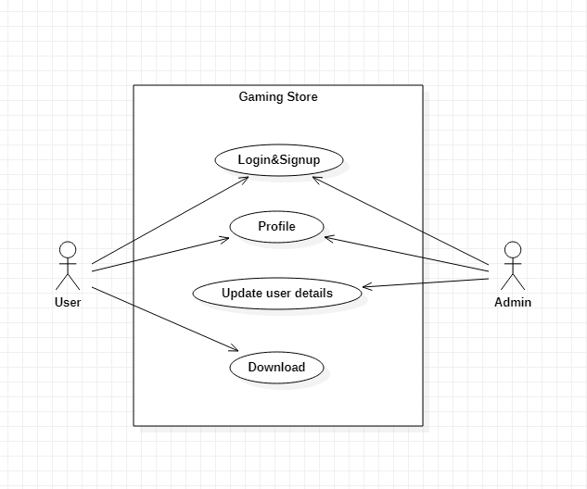

**5. Code:**

**https://github.com/sai-shankar08/GAMING_STORE-JSP**

**6. DATABASE DESIGN:**

**6.1 ER DIGRAM:**

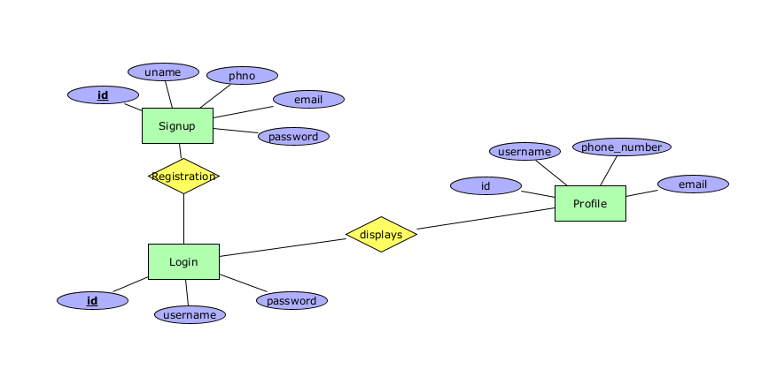

**6.2 tables structure**

**Table Name: Signup**

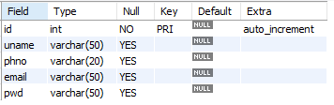

**Table Name: Login**

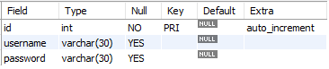

**7. OUTPUT SCREEN SHOTS:**

**Signup:**

# 

**Login:**

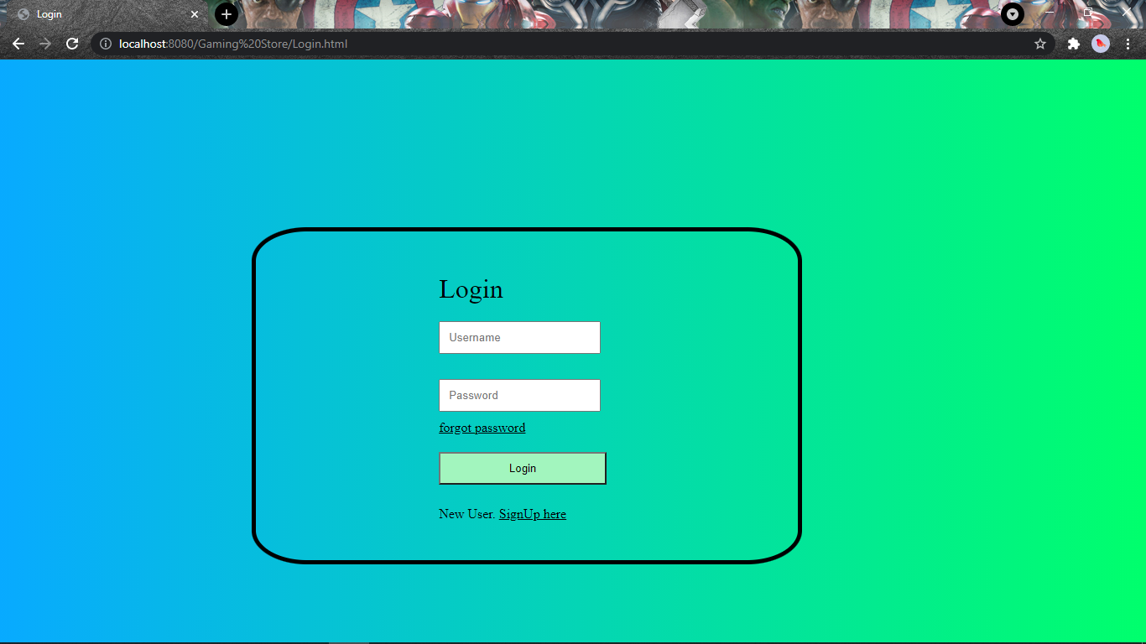

**Home:**

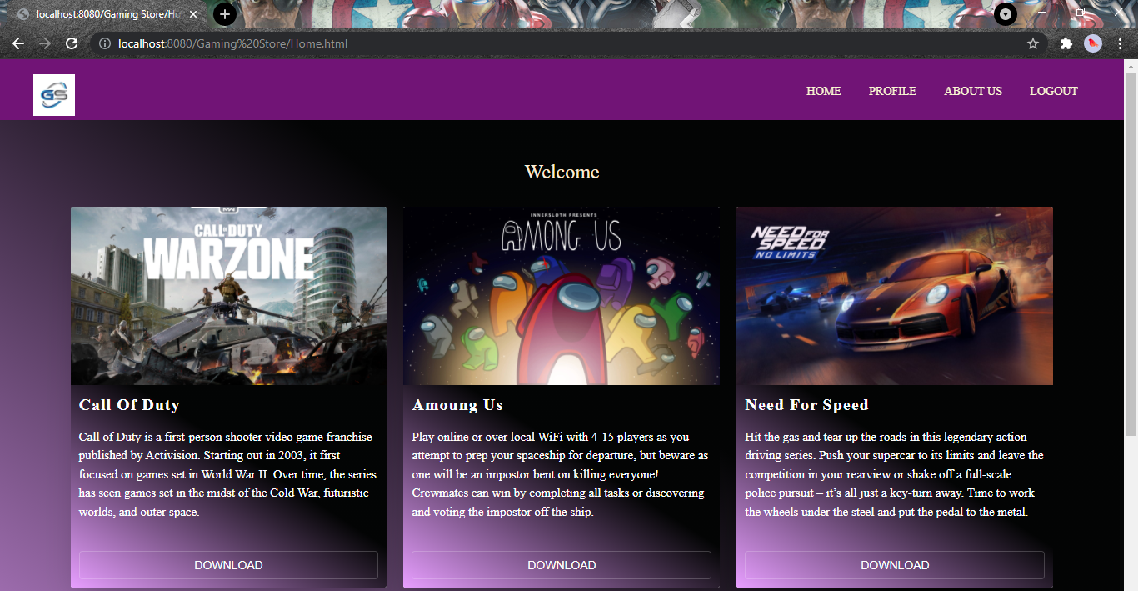

**Profile:**

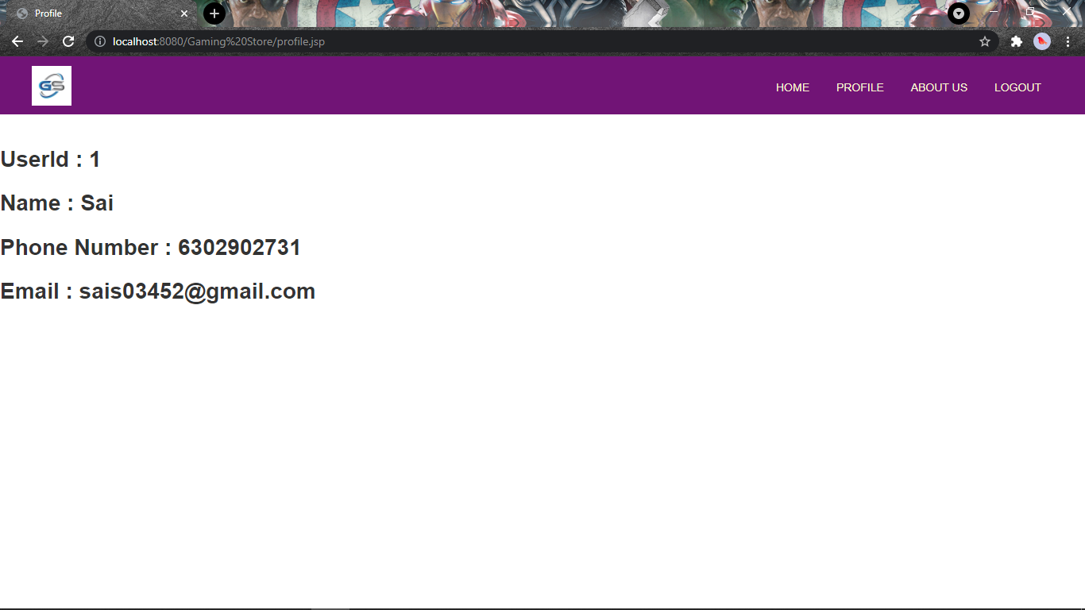

**About Us:**

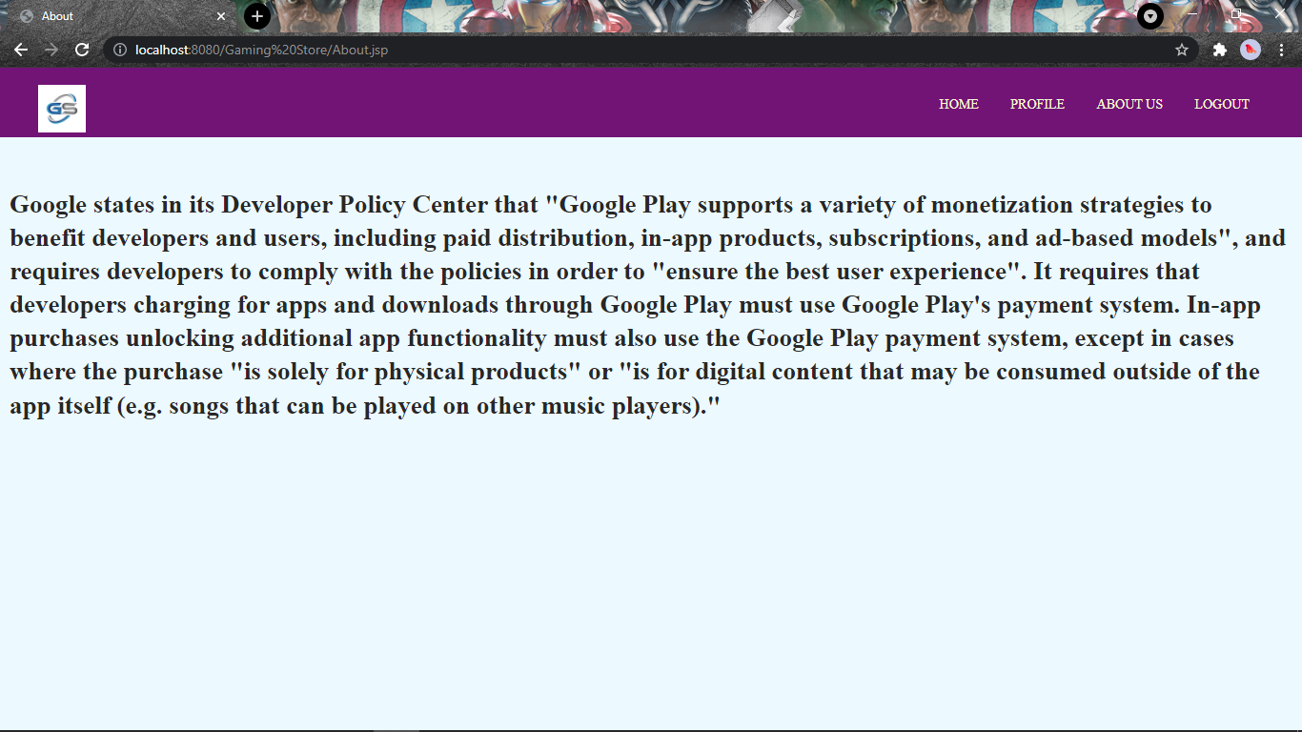

**8. Conclusion:**

Gaming Store is website, in which we can download the top games for free. Our application does not contains any advertisements and user can register easily and can login. User can download games with a click. We produce high quality games without any interruption.

The software is developed with modular approach. All modules in the system have been tested with valid data and invalid data and everything work successfully. Thus the system has fulfilled all the objectives identified and is able to replace the existing system.

The project has been completed successfully with the maximum satisfaction of the organization. The constraints are met and overcome successfully. The system is designed as like it was decided in the design phase. The project gives good idea on developing a full-fledged application satisfying the user requirements.

The system is very flexible and versatile. This software has a user-friendly screen that enables the user to use without any inconvenience. Validation checks induced have greatly reduced errors. Provisions have been made to upgrade the software.

**9. Bibliography**

BOOKS:

* Charles Hampfed (2000) ‘Instant Java Server Pages’ University of Toronto
* Herbert Schildt (2000) ‘Java Complete Reference’ Tata McGraw Hill
* John Zukowski (2000) ‘Mastering Java2’ BPB Publications
* Jamie Jaworsky ‘J2EE Bible’ Techmedia
* Stefen Denninger ‘Enterprise Java Beans-2.1’ Author’s Press
* Ian Somerville ‘Software engineering’
* Rajeev mall ‘Software engineering’
* Elmasri Navathe ‘Fundamentals of database systems’

**ONLINE REFERENCE:**

* [www.java.sun.com](http://www.java.sun.com)
* [www.w3schools.com](http://www.w3schools.com)
* www.wikipedia.com