Full Stack Development with MERN
Online Complaint Registration System
Project Documentation
Submitted By:
Galizerugulla Thirumala Ramyashri
Valisetty Priyanka
Rohitha Lakshmi Prasanna Ramanaboina
Thota Naga Sowjanya
Dusanapudi Jyothi
College Name:
Seshadri Rao Gudlavalleru Engineering College

1. Introduction

1.1 Project Title
Online Complaint Registration

1.2 Team Members
- Galizerugulla Thirumala Ramyashri
- Valisetty Priyanka
- Rohitha Lakshmi Prasanna Ramanaboina
- Thota Naga Sowjanya
- Dusanapudi Jyothi

1.3 Team Roles
Name | Role
Ramya | Full Stack Developer & Project Execution Lead
Priyanka | System Architect & Database Configuration Contributor
Rohitha | System Analyst & MVC Designer
Sowjanya | UI Setup & Feature Planning Contributor
Jyothi | Database Model & Backend Structure Developer

2. Project Overview

2.1 Purpose
Online Complaint Registration is a full-stack web application that allows citizens to register complaints against civic issues (e.g., water, electricity, sanitation, transport), track their status in real time, and communicate with the assigned officer. It replaces manual, paper-based complaint handling with a transparent digital workflow that connects three types of users — the complainant, the field officer/agent, and the administrator — on a single platform.

2.2 Features
- User registration and secure login
- Officer/Agent registration with department selection
- Admin registration protected by a secret admin code
- Complaint registration with category, department, urgency, and location details
- Complaint status tracking across a defined lifecycle
- Detailed complaint view with a full action/status history log
- In-app messaging thread on each complaint for user ↔ officer communication
- In-app notifications for key complaint events
- Admin panel to manage users, approve officers, and assign complaints
- Officer approval workflow — new agent accounts stay inactive until approved by an admin
- Complaint assignment from admin to a specific officer
- User profile management (contact and address details)
- Role-based dashboards for user, officer, and admin
- Hardened authentication: password strength rules, account lockout, JWT sessions

2.3 Complaint Status Workflow
Every complaint moves through a defined set of statuses over its lifecycle:
- Pending — submitted by the citizen, awaiting assignment
- Assigned — an admin has assigned the complaint to an officer/agent
- In Progress — the assigned officer has started working on it
- Resolved — the issue has been fixed and closed out by the officer
- Closed — the complaint is finalised and archived after resolution
- Rejected — the complaint was found invalid or out of scope
- Reopened — the citizen was not satisfied with a Resolved complaint and reopened it
Only the assigned Officer/Agent can change the status of a complaint. An admin may reassign or override an update where necessary, and a citizen may only move their own complaint from Resolved to Reopened.

2.4 Notifications
The system supports in-app notifications, stored in MongoDB, so every user sees relevant updates the next time they use the platform.
Notifications are triggered for the following events:
- A new complaint is submitted — the Admin receives a notification
- A complaint is assigned — the Customer and the assigned Agent both receive a notification
- A complaint's status is updated — the Customer receives a notification
SMS notifications are not enabled in the current version — all notifications are in-app only.

3. Architecture

3.1 Frontend
The frontend is a single-page application built with React 18 and Vite, styled with Material UI (MUI) and a small amount of custom CSS/Bootstrap. Routing is handled by React Router v6.
- App.jsx defines all routes and wraps the app in an MUI ThemeProvider with a custom teal/orange theme.
- context/AuthContext.jsx exposes login, register, logout and the current user via React Context, backed by localStorage for token/user persistence.
- components/ProtectedRoute.jsx guards authenticated routes and redirects unauthenticated users to /login.
- components/Layout.jsx renders the shared app shell (navigation) around protected pages.
- components/ComplaintCard.jsx and components/StatusChip.jsx render reusable complaint summaries and colour-coded status labels.
- pages/ contains one component per screen: Landing, Login, Register, Dashboard, NewComplaint, ComplaintDetails, Profile, and AdminPanel.
- api/axios.js configures a shared Axios instance that reads the API base URL from VITE_API_URL and automatically attaches the JWT bearer token to every request.

3.2 Backend
The backend is a RESTful API built with Node.js and Express.js, organised using the MVC pattern (models, controllers, routes) plus a middleware layer for cross-cutting concerns.
- index.js bootstraps Express, applies security middleware, mounts the four API route groups, and starts the HTTP server.
- routes/ maps URLs to controller functions for auth, users, complaints, and messages.
- controllers/ contains the business logic for each resource (authController, userController, complaintController, messageController).
- middleware/authMiddleware.js verifies the JWT (from an Authorization header or an httpOnly cookie) and enforces role-based access via an authorize(...roles) helper.
- middleware/securityMiddleware.js adds security response headers, a per-IP in-memory rate limiter, and NoSQL-injection sanitisation of the request body/params/query.
- middleware/errorHandler.js is a centralised Express error handler that returns consistent JSON error responses.
- utils/security.js contains password-strength validation, email normalisation, and the helper that sets the auth cookie.

3.3 Database
MongoDB is used as the data store, accessed through Mongoose object models. There are three collections:
Collection | Key Fields
User | name, email (unique), password (bcrypt-hashed, hidden by default), phone, address, city, state, pincode, role (user / agent / admin), department, isApproved, loginAttempts, lockUntil, passwordChangedAt, timestamps.
Complaint | complaintId (auto-generated, unique), user (ref User), assignedAgent (ref User), name, category, department, description, address/city/state/pincode, urgency (Low/Medium/High), attachmentUrl, status (Pending/Assigned/In Progress/Resolved/Closed/Rejected/Reopened), actionLogs[] (note, status, updatedBy, createdAt), timestamps.
Message | complaint (ref Complaint), sender (ref User), text, timestamps.
Notification | recipient (ref User), complaint (ref Complaint), type (new_complaint / assigned / status_updated), message, isRead, timestamps.

4. Setup Instructions

4.1 Prerequisites
- Node.js (v18 or later recommended) and npm
- MongoDB (local instance or a MongoDB Atlas connection string)
- Git (to clone the repository)

4.2 Installation
1. Clone the repository and open the project folder.
git clone <repository-url> cd "Online Complaint Registration"
2. Install backend dependencies.
cd server npm install
3. Create the backend environment file from the provided example and fill in real values.
cp .env.example .env
Variable | Purpose
PORT | Port the API server listens on (default 5000).
MONGO_URI | MongoDB connection string, e.g. mongodb://localhost:27017/OnlineComplaintRegistration
JWT_SECRET | A random secret of at least 32 characters used to sign JWTs.
ADMIN_REGISTRATION_CODE | Secret code required to self-register an admin account.
CLIENT_URL | Origin of the frontend, used for CORS (default http://localhost:5173).
4. Install frontend dependencies.
cd ../client npm install
5. (Optional) Create a client/.env file if the API is not running on the default URL.
VITE_API_URL=http://localhost:5000/api

5. Folder Structure

5.1 Client (React frontend)
client/ src/ api/axios.js Axios instance + JWT interceptor components/ ComplaintCard, Layout, ProtectedRoute, StatusChip context/AuthContext.jsx Auth state, login/register/logout pages/ Landing, Login, Register, Dashboard, NewComplaint, ComplaintDetails, Profile, AdminPanel App.jsx Route definitions and MUI theme main.jsx React entry point styles.css / App.css / index.css index.html package.json vite.config.js

5.2 Server (Node.js / Express backend)
server/ config/db.js MongoDB connection controllers/ authController, userController, complaintController, messageController middleware/ authMiddleware, securityMiddleware, errorHandler models/ User, Complaint, Message (Mongoose schemas) routes/ authRoutes, userRoutes, complaintRoutes, messageRoutes utils/security.js Password rules, email normalisation, auth cookie .env.example index.js App entry point package.json

6. Running the Application
Make sure MongoDB is running before starting the backend.

6.1 Backend
cd server npm run dev # starts with nodemon (auto-restart) # or npm start # starts with plain node
The API runs at http://localhost:5000 by default (see PORT in .env).

6.2 Frontend
cd client npm run dev
Vite serves the React app at http://localhost:5173 by default, and the Axios base URL points it at the backend.

7. API Documentation
All endpoints are prefixed with /api. Protected endpoints require a valid JWT, sent either as an Authorization: Bearer <token> header or as an httpOnly token cookie set at login.

7.1 Auth Routes — /api/auth
Method & Endpoint | Access | Description
POST /register | Public | Register a user, agent (with department), or admin (with admin code).
POST /login | Public | Authenticate with email/password; returns a JWT and sets an auth cookie.
GET /me | Authenticated | Return the currently logged-in user's profile.

7.2 User Routes — /api/users
Method & Endpoint | Access | Description
GET / | Admin | List all registered users.
GET /agents | Admin | List all officer/agent accounts.
PUT /profile | Authenticated | Update the logged-in user's own profile fields.
PUT /agents/:id/approve | Admin | Approve a pending agent account.

7.3 Complaint Routes — /api/complaints
Method & Endpoint | Access | Description
POST / | User, Admin | Create a new complaint.
GET / | Authenticated | List complaints (own complaints for users, assigned complaints for agents, all for admins).
GET /:id | Owner, assigned agent, or Admin | Get full details of one complaint, including populated user, agent, and action logs.
DELETE /:id | Owner, Admin | Delete a complaint.
PUT /:id/assign | Admin | Assign a complaint to an officer; sets status to Assigned; notifies the customer and the agent.
PUT /:id/status | Assigned Agent (primary), Admin (override), User (reopen only) | Update complaint status and append an action log entry. Only the assigned officer can normally change status; users may only reopen a Resolved complaint. Notifies the customer.

7.4 Message Routes — /api/messages
Method & Endpoint | Access | Description
GET /:complaintId | Authenticated | List all messages on a complaint, oldest first.
POST /:complaintId | Authenticated | Post a new message on a complaint.

7.5 Example — Login Request
POST /api/auth/login Content-Type: application/json { "email": "user@example.com", "password": "MyStrongPass!23" }

7.6 Example — Login Response
200 OK { "token": "<jwt>", "user": { "_id": "665f1c...", "name": "Jane Doe", "email": "user@example.com", "role": "user" } }

8. Authentication
Authentication is handled with JSON Web Tokens (JWT) and bcrypt password hashing.
- Passwords are hashed with bcrypt (12 salt rounds) before being stored; the password field is excluded from queries by default.
- On successful login, the server issues a JWT (signed with JWT_SECRET, 2-hour expiry) containing the user's id and role.
- The token is returned in the JSON response and also set as an httpOnly, SameSite=strict cookie, so the frontend can use either the Bearer header or the cookie.
- authMiddleware.protect verifies the token on every protected route and loads the current user onto req.user.
- authMiddleware.authorize(...roles) restricts specific routes to one or more roles (user, agent, admin).
- A strong password policy is enforced at registration: minimum 12 characters, upper- and lower-case letters, a number, a special character, no spaces, not a common password, and not derived from the user's name or email.
- Brute-force protection: after 5 consecutive failed login attempts, the account is locked for 15 minutes.
- Admin accounts can only be created by supplying the correct ADMIN_REGISTRATION_CODE.
- Agent/officer accounts start with isApproved = false and cannot log in until an admin approves them.

9. User Interface
Key screens of the application, built with Material UI components on a teal-and-orange theme.

Landing Page
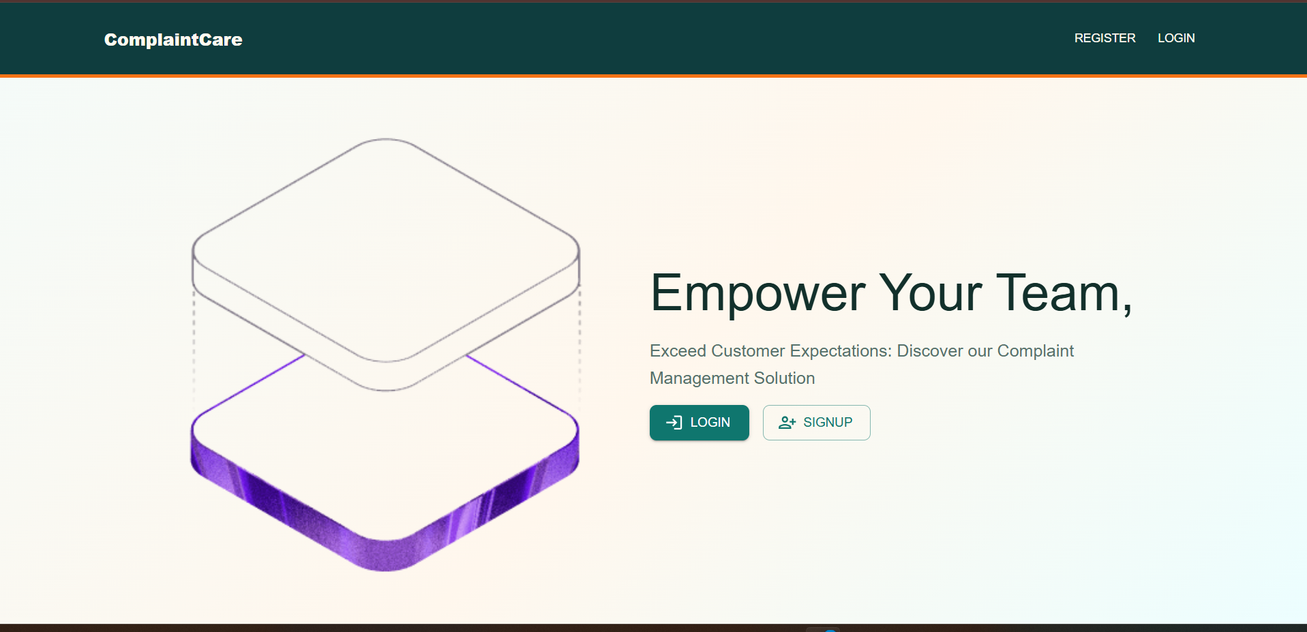
Landing page introducing the platform to visitors.

Register Page
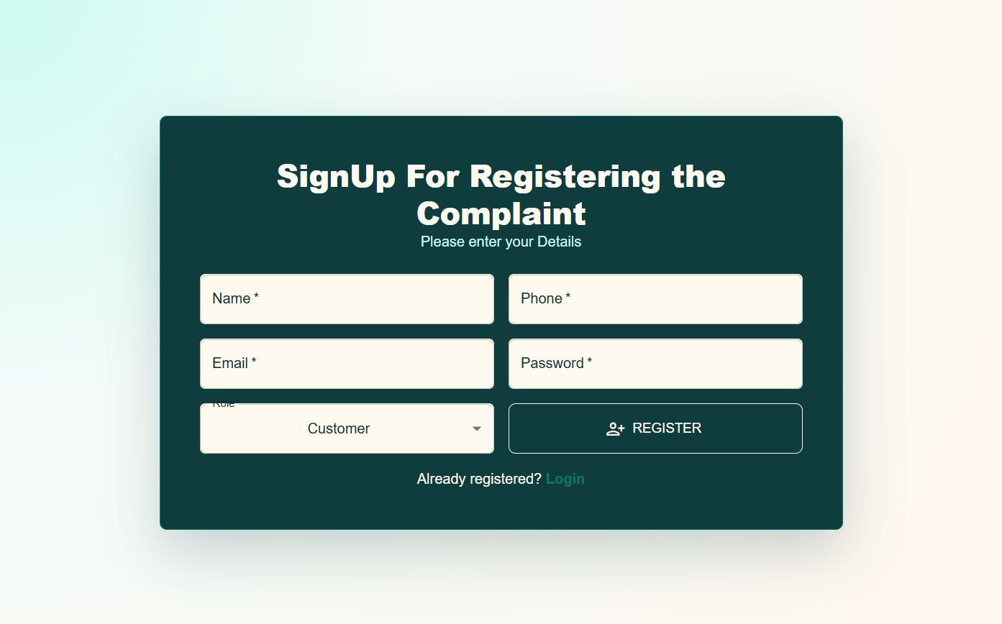
Registration form for users, officers, and admins.

Login Page
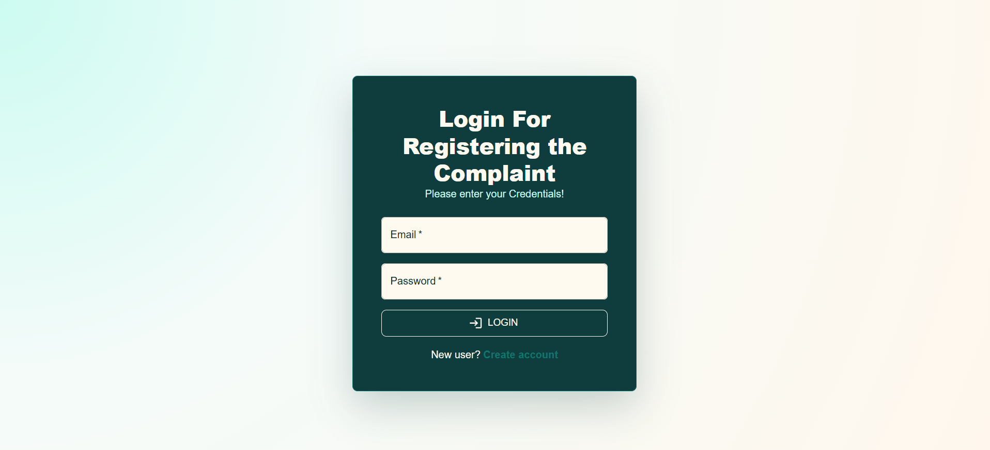
Login screen with email and password.

User Dashboard
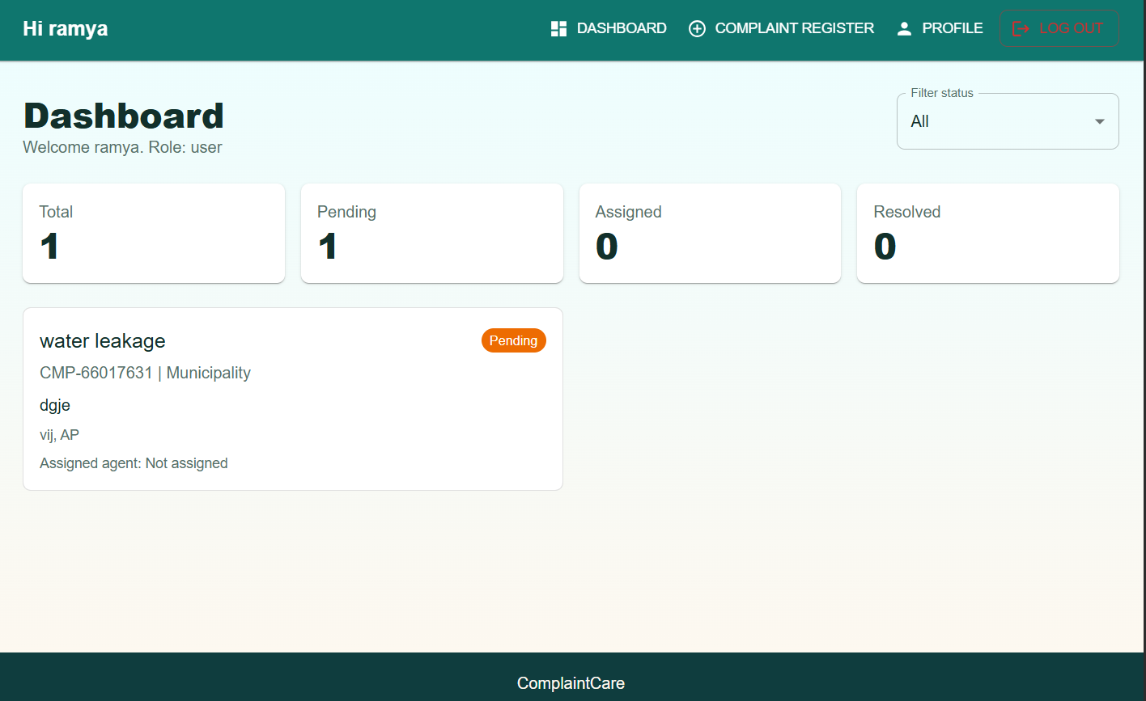
Dashboard showing complaint counts and status filters.

Complaint Register Page
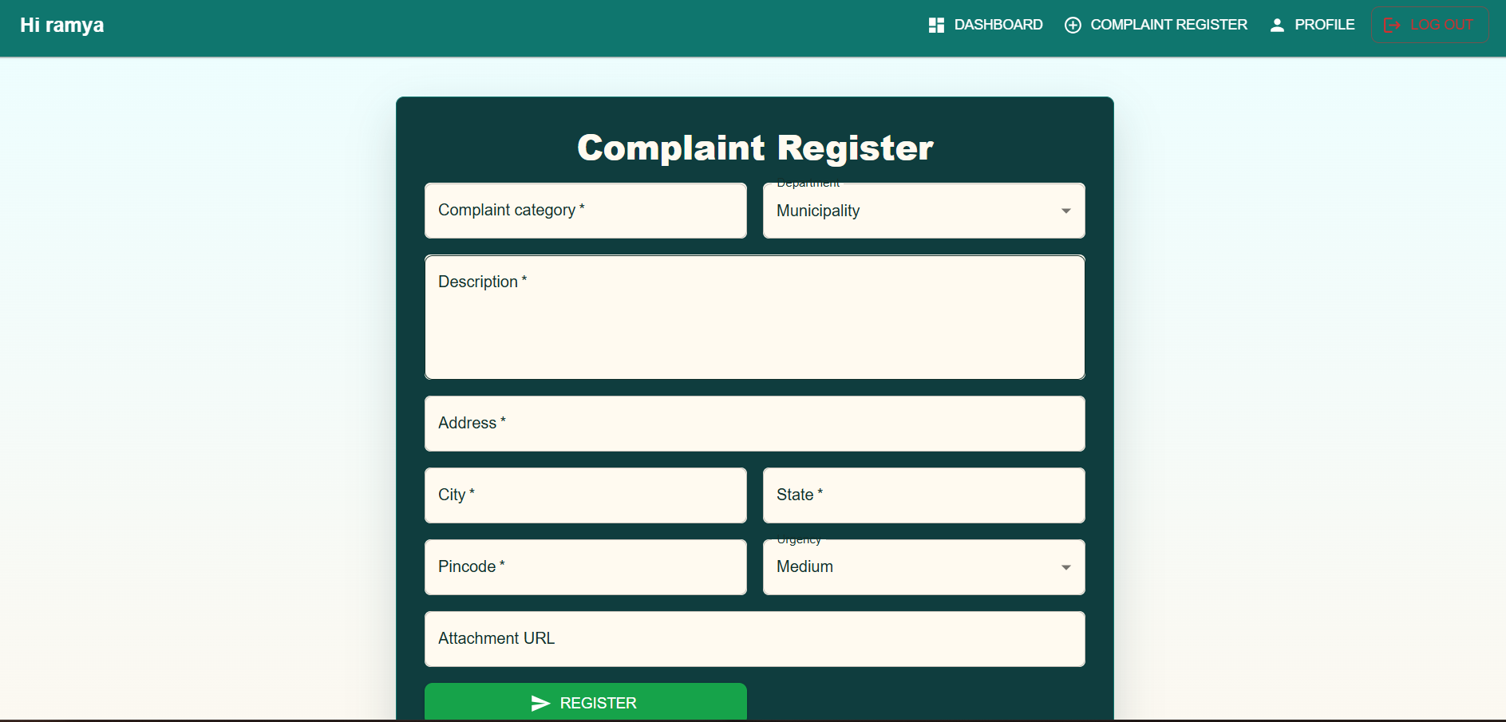
Form used to submit a new complaint.

Admin Dashboard
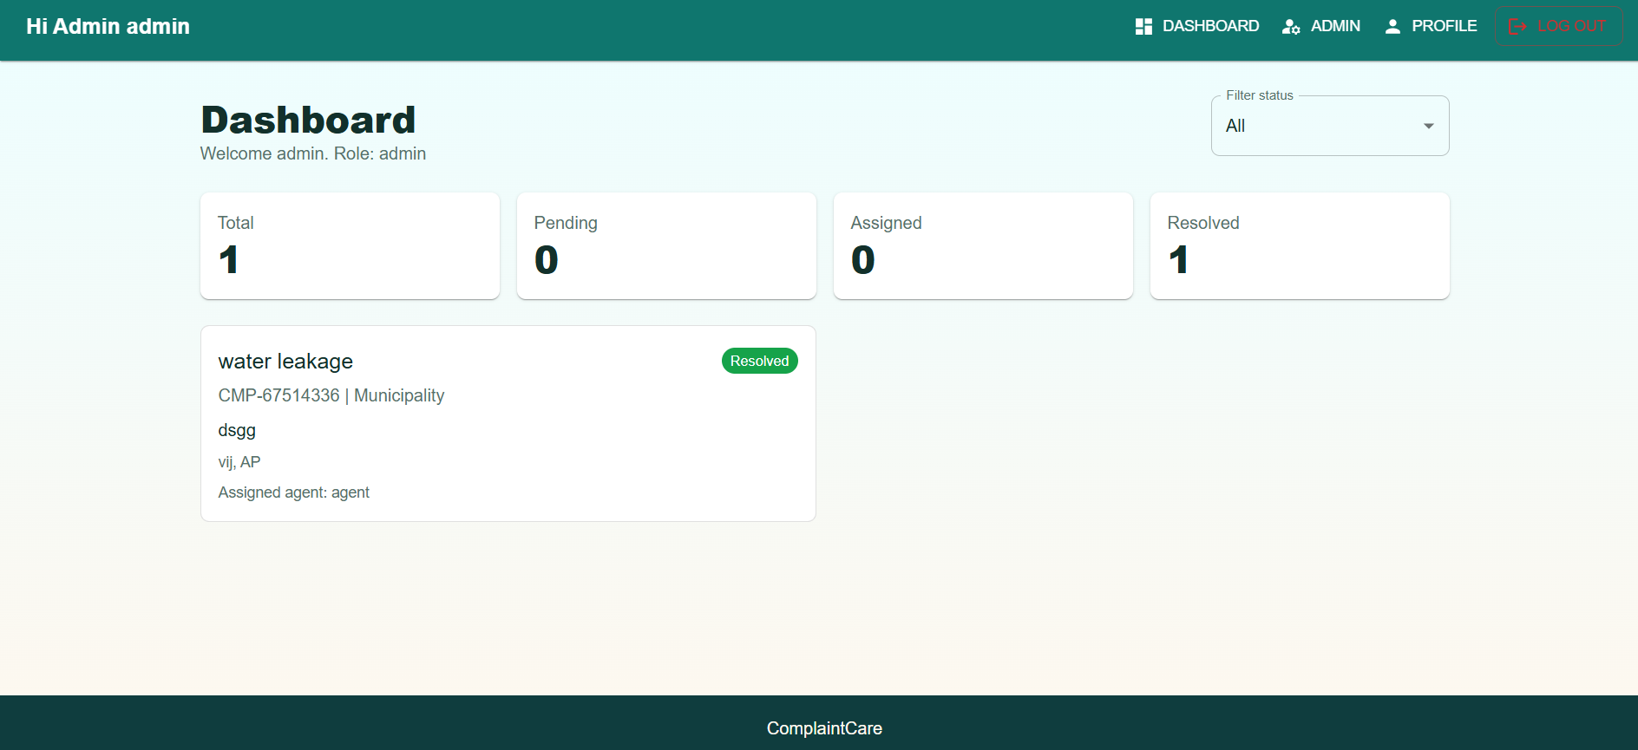
Administrator view of overall complaint activity.

Admin Panel
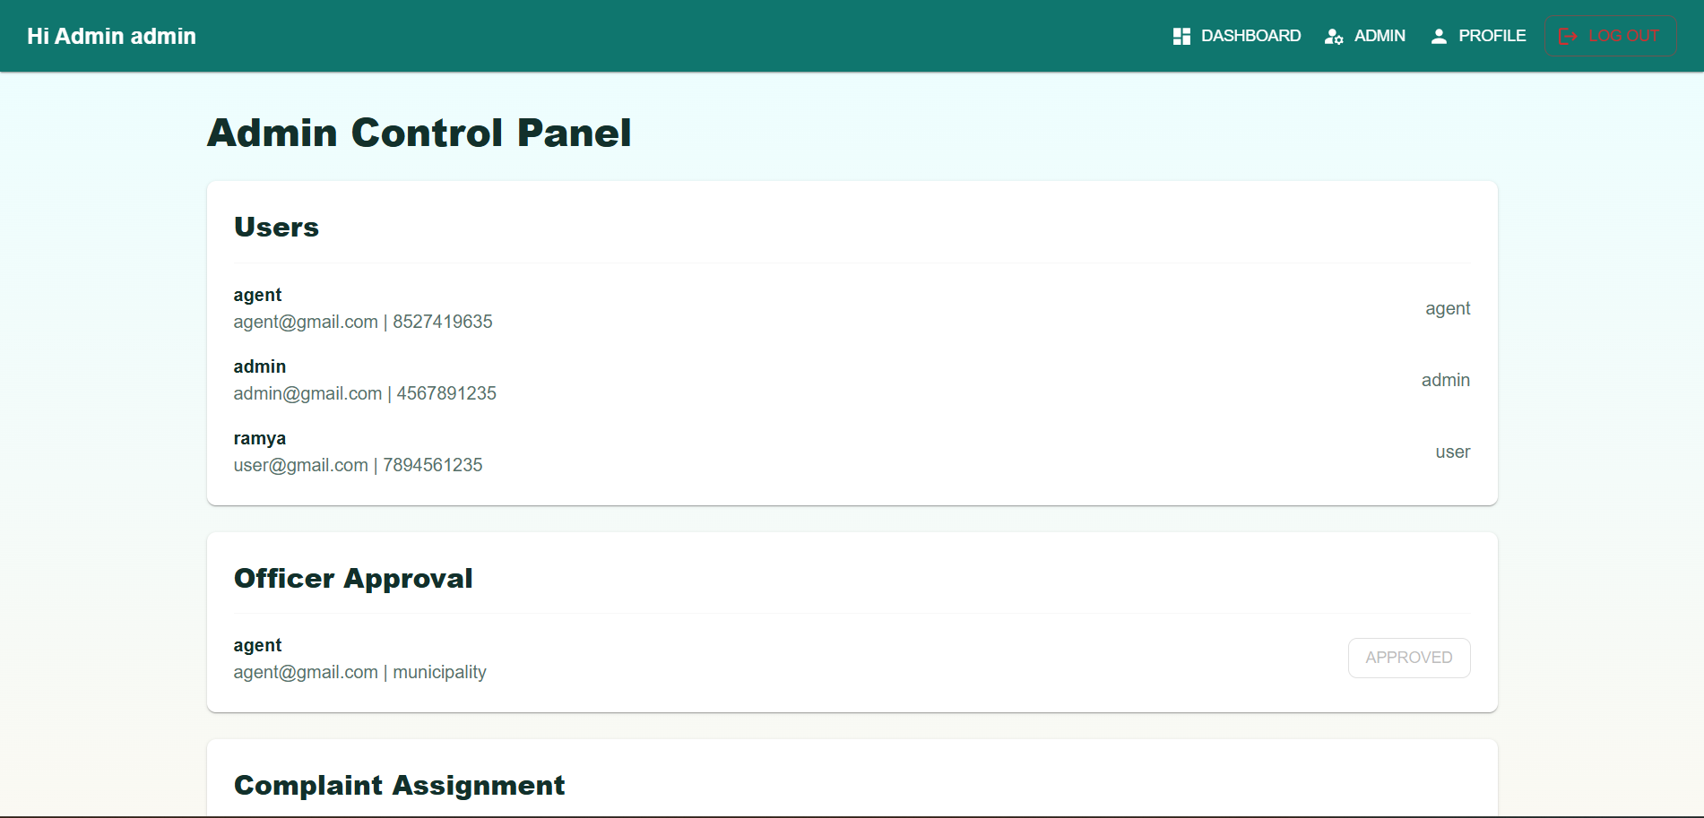
Admin panel — user and officer management.
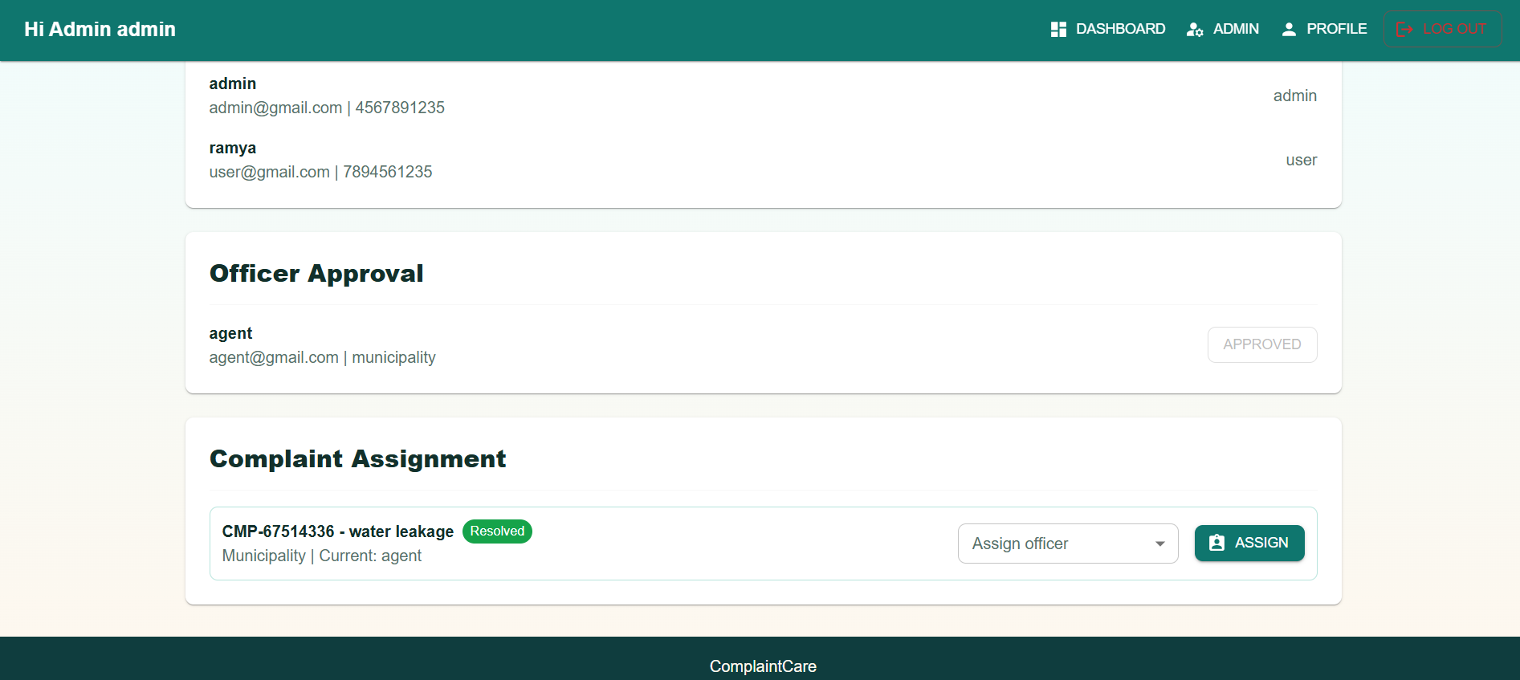
Admin panel — complaint assignment.

Officer Approval
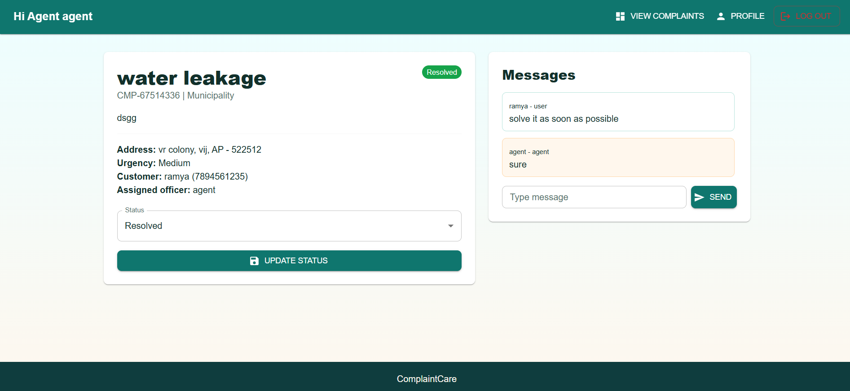
Admin approving a pending officer/agent account.

10. Testing
The project does not currently include an automated test suite (no test files or testing framework are configured in package.json). Testing has been carried out manually:
- Manual functional testing of each user flow: registration (user/agent/admin), login/lockout, complaint creation, status updates, assignment, messaging, notifications, and profile editing.
- API endpoints were exercised with a REST client (e.g., Postman/Thunder Client) to verify status codes, validation errors, and role-based access rules.
- Cross-role testing was performed by creating one account of each role (user, agent, admin) and confirming that each role only sees and can perform the actions permitted to it.
Suggested future work: add automated unit tests for controllers/middleware (e.g., Jest + Supertest) and component/integration tests for the React app (e.g., Vitest + React Testing Library).

11. Screenshots or Demo
A full walkthrough of the application is available in the demo video below. See Section 9 (User Interface) for individual annotated screenshots of every major screen.
Demo video:https://drive.google.com/file/d/1i9Jn8jAaxr1JG0dsOvmb14DbEpBPYJtV/view?usp=sharing

12. Known Issues
- Complaint attachments are stored as a plain URL text field (attachmentUrl); there is no built-in file upload endpoint, so users must host an image/document elsewhere and paste the link.
- The API rate limiter and login-attempt lockout are stored in memory, so counts reset on server restart and are not shared across multiple server instances.
- The frontend has two separate Axios setups (src/api/axios.js and src/services/api.js); only the former attaches the JWT token, so services/api.js should be removed or unified to avoid confusion.
- There is no password-reset / "forgot password" flow yet.
- No pagination is implemented on complaint or user lists, which may not scale well with large datasets.
- Notifications are in-app only; SMS notifications are not enabled in the current version.
- [Add any additional bugs or limitations discovered during your own testing here.]

13. Future Enhancements
- Add real file/image upload for complaint attachments (e.g., using Multer + cloud storage).
- Enable SMS notifications alongside the existing in-app notifications for complaint assignment, updates, and resolution.
- Email notifications when a complaint is assigned, updated, or resolved.
- Forgot-password / password-reset flow via email.
- Pagination, search, and advanced filtering on complaint and user lists.
- Analytics dashboard for admins (complaints by category, department, resolution time).
- Rating/feedback from users after a complaint is resolved.
- Real-time updates (e.g., WebSockets) for live status changes, new messages, and notifications.
- Automated test coverage for backend and frontend.

