Full Stack Development with MERN
Online Complaint Registration System
Project Documentation

Submitted By:
Galizerugulla Thirumala Ramyashri
Valisetty Priyanka
Rohitha Lakshmi Prasanna Ramanaboina
Dusanapudi Jyothi
Thota Naga Sowjanya

College Name:

Seshadri Rao Gudlavalleru Engineering College

1. Introduction

Project Title
Online Complaint Registration

Team Members
Galizerugulla Thirumala Ramyashri
Valisetty Priyanka
Rohitha Lakshmi Prasanna Ramanaboina
Dusanapudi Jyothi
Thota Naga Sowjanya

2. Project Overview
Name | Role
Ramyashri | Full Stack Developer & Project Execution Lead
Priyanka | System Architect Database Configuration Contributor
Rohitha | System Analyst MVC Designer
Sowjanya | UI Setup & Feature Planning Contributor
Jyothi | Database Model & Backend Structure Developer

2. Project Overview

Purpose
Online Complaint Registration is a full-stack web application that allows citizens to register complaints against civic issues (e.g., water, electricity, sanitation, transport), track their status in real time, and communicate with the assigned officer. It replaces manual, paper-based complaint handling with a transparent digital workflow that connects three types of users — the complainant, the field officer/agent, and the administrator — on a single platform.

Features
- User registration and secure login
- Officer/Agent registration with department selection
- Admin registration protected by a secret admin code
- Complaint registration with category, department, urgency, and location details
- Real-time complaint status tracking (Pending, Assigned, In Progress, Resolved, Rejected, Reopened)
- Detailed complaint view with a full action/status history log
- In-app messaging thread on each complaint for user ↔ officer communication
- Admin panel to manage users, approve officers, and assign complaints
- Officer approval workflow — new agent accounts stay inactive until approved by an admin
- Complaint assignment from admin to a specific officer
- User profile management (contact and address details)
- Role-based dashboards for user, officer, and admin
- Hardened authentication: password strength rules, account lockout, JWT sessions

3. Architecture

Frontend
The frontend is a single-page application built with React 18 and Vite, styled with Material UI (MUI) and a small amount of custom CSS/Bootstrap. Routing is handled by React Router v6.
- App.jsx defines all routes and wraps the app in an MUI ThemeProvider with a custom teal/orange theme.
- context/AuthContext.jsx exposes login, register, logout and the current user via React Context, backed by localStorage for token/user persistence.
- components/ProtectedRoute.jsx guards authenticated routes and redirects unauthenticated users to /login.
- components/Layout.jsx renders the shared app shell (navigation) around protected pages.
- components/ComplaintCard.jsx and components/StatusChip.jsx render reusable complaint summaries and colour-coded status labels.
- pages/ contains one component per screen: Landing, Login, Register, Dashboard, NewComplaint, ComplaintDetails, Profile, and AdminPanel.
- api/axios.js configures a shared Axios instance that reads the API base URL from VITE_API_URL and automatically attaches the JWT bearer token to every request.

Backend
The backend is a RESTful API built with Node.js and Express.js, organised using the MVC pattern (models, controllers, routes) plus a middleware layer for cross-cutting concerns.
- index.js bootstraps Express, applies security middleware, mounts the four API route groups, and starts the HTTP server.
- routes/ maps URLs to controller functions for auth, users, complaints, and messages.
- controllers/ contains the business logic for each resource (authController, userController, complaintController, messageController).
- middleware/authMiddleware.js verifies the JWT (from an Authorization header or an httpOnly cookie) and enforces role-based access via an authorize(...roles) helper.
- middleware/securityMiddleware.js adds security response headers, a per-IP in-memory rate limiter, and NoSQL-injection sanitisation of the request body/params/query.
- middleware/errorHandler.js is a centralised Express error handler that returns consistent JSON error responses.
- utils/security.js contains password-strength validation, email normalisation, and the helper that sets the auth cookie.

Database
MongoDB is used as the data store, accessed through Mongoose object models. There are three collections:
Collection | Key Fields
User | name, email (unique), password (bcrypt-hashed, hidden by default), phone, address, city, state, pincode, role (user / agent / admin), department, isApproved, loginAttempts, lockUntil, passwordChangedAt, timestamps.
Complaint | complaintId (auto-generated, unique), user (ref User), assignedAgent (ref User), name, category, department, description, address/city/state/pincode, urgency (Low/Medium/High), attachmentUrl, status (Pending/Assigned/In Progress/Resolved/Rejected/Reopened), actionLogs[] (note, status, updatedBy, createdAt), timestamps.
Message | complaint (ref Complaint), sender (ref User), text, timestamps.
Relationships are modelled with Mongoose ObjectId references: a Complaint references the User who filed it and the User (agent) it is assigned to, and each Message references both its parent Complaint and its sender.

4. Setup Instructions

Prerequisites
- Node.js (v18 or later recommended) and npm
- MongoDB (local instance or a MongoDB Atlas connection string)
- Git (to clone the repository)

Installation
- 1. Clone the repository and open the project folder.
git clone <repository-url> cd "Online Complaint Registration"
- 2. Install backend dependencies.
cd server npm install
- 3. Create the backend environment file from the provided example and fill in real values.
cp .env.example .env
Variable | Purpose
PORT | Port the API server listens on (default 5000).
MONGO_URI | MongoDB connection string, e.g. mongodb://localhost:27017/OnlineComplaintRegistration
JWT_SECRET | A random secret of at least 32 characters used to sign JWTs.
ADMIN_REGISTRATION_CODE | Secret code required to self-register an admin account.
CLIENT_URL | Origin of the frontend, used for CORS (default http://localhost:5173).
- 4. Install frontend dependencies.
cd ../client npm install
- 5. (Optional) Create a client/.env file if the API is not running on the default URL.
VITE_API_URL=http://localhost:5000/api

5. Folder Structure

Client (React frontend)
client/ ├── src/ │ ├── api/axios.js # Axios instance + JWT interceptor │ ├── components/ # ComplaintCard, Layout, ProtectedRoute, StatusChip │ ├── context/AuthContext.jsx # Auth state, login/register/logout │ ├── pages/ # Landing, Login, Register, Dashboard, │ │ # NewComplaint, ComplaintDetails, Profile, AdminPanel │ ├── App.jsx # Route definitions and MUI theme │ ├── main.jsx # React entry point │ └── styles.css / App.css / index.css ├── index.html ├── package.json └── vite.config.js

Server (Node.js / Express backend)
server/ ├── config/db.js # MongoDB connection ├── controllers/ # authController, userController, │ # complaintController, messageController ├── middleware/ # authMiddleware, securityMiddleware, errorHandler ├── models/ # User, Complaint, Message (Mongoose schemas) ├── routes/ # authRoutes, userRoutes, complaintRoutes, messageRoutes ├── utils/security.js # Password rules, email normalisation, auth cookie ├── index.js # App entry point ├── .env.example └── package.json

6. Running the Application
Make sure MongoDB is running before starting the backend.

Backend
cd server npm run dev # starts with nodemon (auto-restart) # or npm start # starts with plain node
The API runs at http://localhost:5000 by default (see PORT in .env).

Frontend
cd client npm run dev
Vite serves the React app at http://localhost:5173 by default, and proxies API calls to the backend through the Axios base URL.

7. API Documentation
All endpoints are prefixed with /api. Protected endpoints require a valid JWT, sent either as an Authorization: Bearer <token> header or as an httpOnly token cookie set at login.

Auth Routes — /api/auth
Method | Endpoint | Access | Description
POST | /api/auth/register | Public | Register a user, agent (with department), or admin (with admin code).
POST | /api/auth/login | Public | Authenticate with email/password; returns a JWT and sets an auth cookie.
GET | /api/auth/me | Authenticated | Return the currently logged-in user's profile.

User Routes — /api/users
Method | Endpoint | Access | Description
GET | /api/users | Admin | List all registered users.
GET | /api/users/agents | Admin | List all officer/agent accounts.
PUT | /api/users/profile | Authenticated | Update the logged-in user's own profile fields.
PUT | /api/users/agents/:id/approve | Admin | Approve a pending agent account.

Complaint Routes — /api/complaints
Method | Endpoint | Access | Description
POST | /api/complaints | User, Admin | Create a new complaint.
GET | /api/complaints | Authenticated | List complaints (own complaints for users, assigned complaints for agents, all for admins).
GET | /api/complaints/:id | Authenticated (owner/assigned/admin) | Get full details of one complaint, including populated user, agent, and action logs.
DELETE | /api/complaints/:id | Owner, Admin | Delete a complaint.
PUT | /api/complaints/:id/assign | Admin | Assign a complaint to an officer; sets status to Assigned.
PUT | /api/complaints/:id/status | Agent, Admin, User | Update complaint status; agents update assigned complaints, users may only reopen a resolved issues.

Message Routes — /api/messages
Method | Endpoint | Access | Description
GET | /api/messages/:complaintId | Authenticated | List all messages on a complaint, oldest first.
POST | /api/messages/:complaintId | Authenticated | Post a new message on a complaint.

Example — Login Request
POST /api/auth/login Content-Type: application/json { "email": "user@example.com", "password": "MyStrongPass!23" }

Example — Login Response
200 OK { "token": "<jwt>", "user": { "_id": "665f1c...", "name": "Jane Doe", "email": "user@example.com", "role": "user" } }

8. Authentication
Authentication is handled with JSON Web Tokens (JWT) and bcrypt password hashing.
- Passwords are hashed with bcrypt (12 salt rounds) before being stored; the password field is excluded from queries by default.
- On successful login, the server issues a JWT (signed with JWT_SECRET, 2-hour expiry) containing the user's id and role.
- The token is returned in the JSON response and also set as an httpOnly, SameSite=strict cookie, so the frontend can use either the Bearer header or the cookie.
- authMiddleware.protect verifies the token on every protected route and loads the current user onto req.user.
- authMiddleware.authorize(...roles) restricts specific routes to one or more roles (user, agent, admin).
- A strong password policy is enforced at registration: minimum 12 characters, upper- and lower-case letters, a number, a special character, no spaces, not a common password, and not derived from the user's name or email.
- Brute-force protection: after 5 consecutive failed login attempts, the account is locked for 15 minutes.
- Admin accounts can only be created by supplying the correct ADMIN_REGISTRATION_CODE.
- Agent/officer accounts start with isApproved = false and cannot log in until an admin approves them.

9. User Interface
Key screens of the application, built with Material UI components on a teal-and-orange theme.

Landing Page
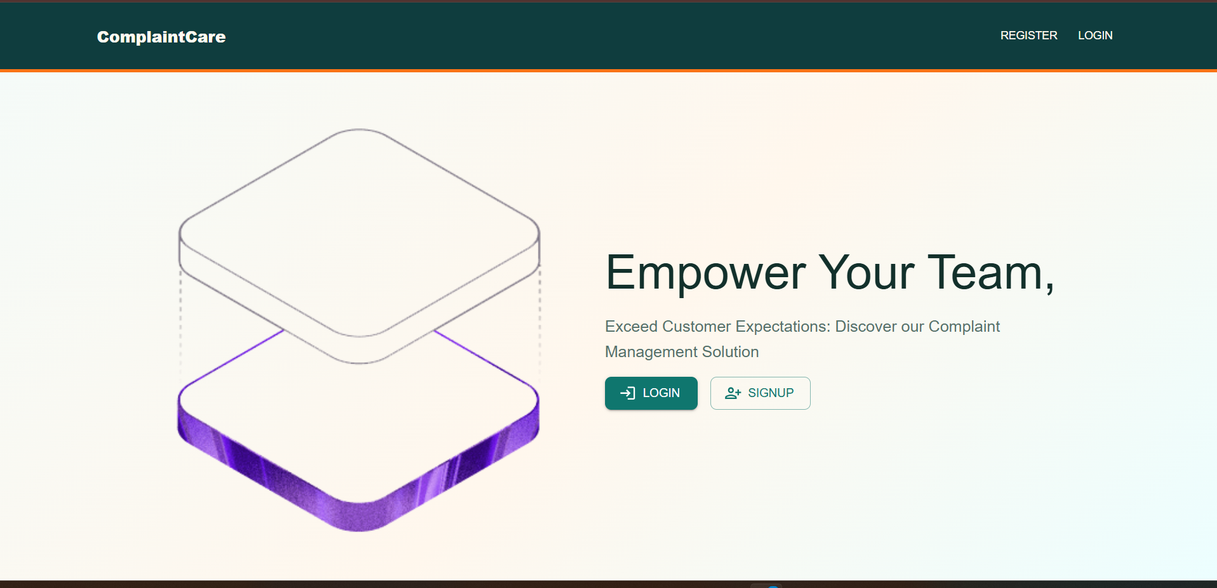
Landing page introducing the platform to visitors.

Register Page
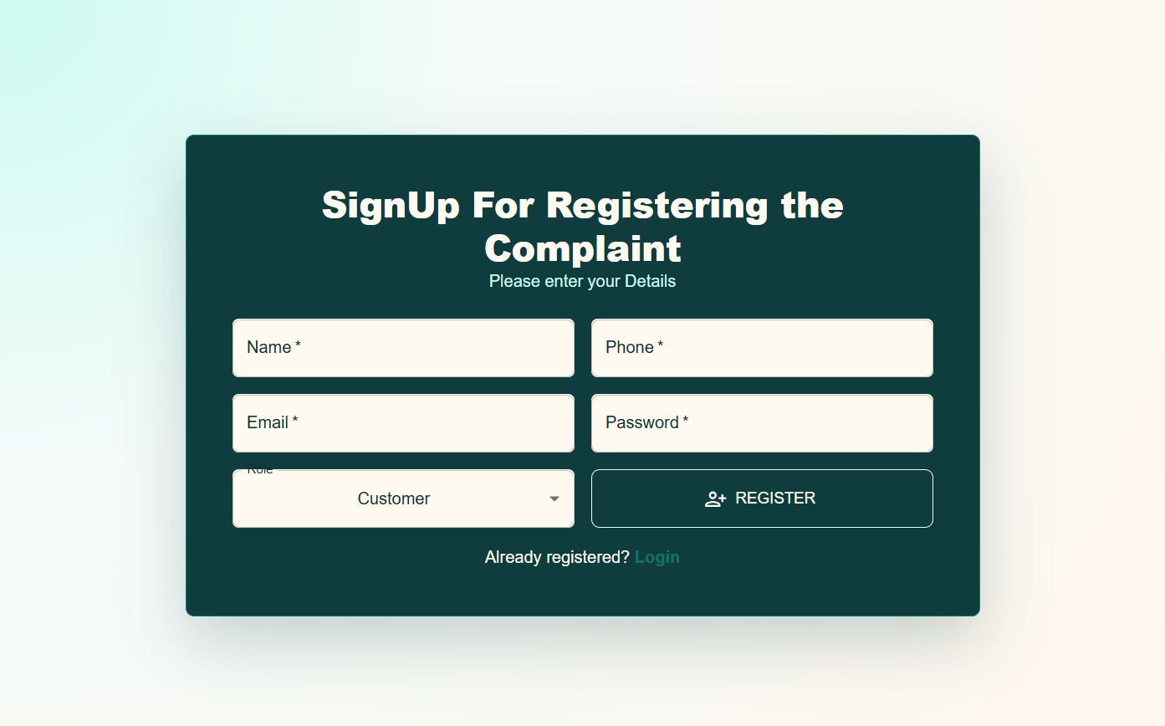
Registration form for users, officers, and admins.

Login Page
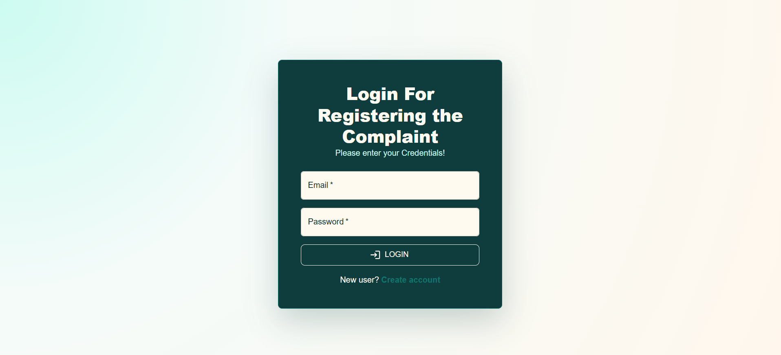
Login screen with email and password.

User Dashboard
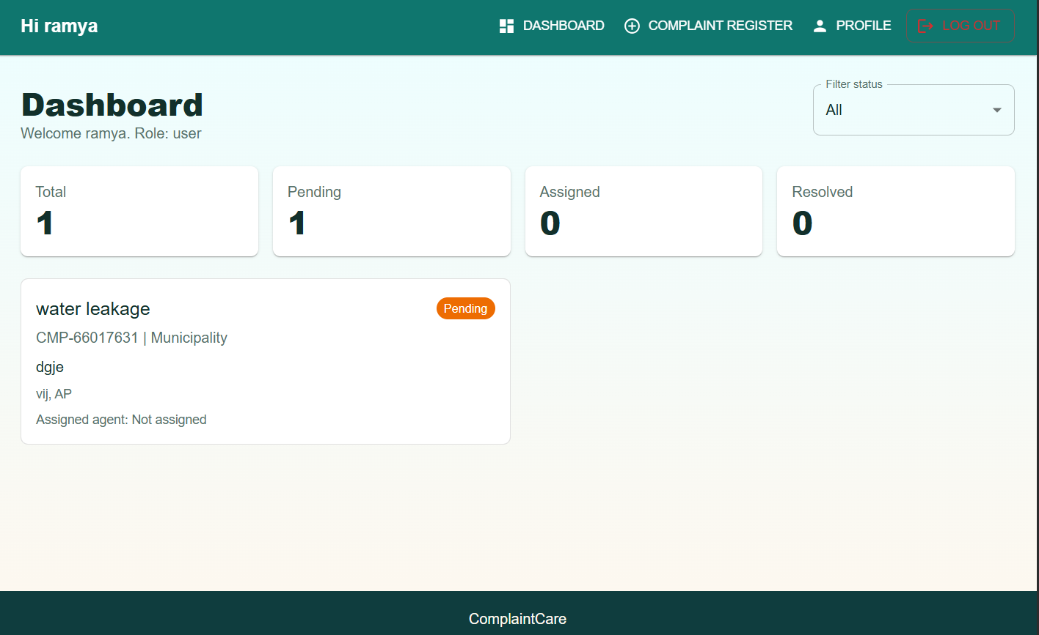
Dashboard showing complaint counts and status filters.

Complaint Register Page
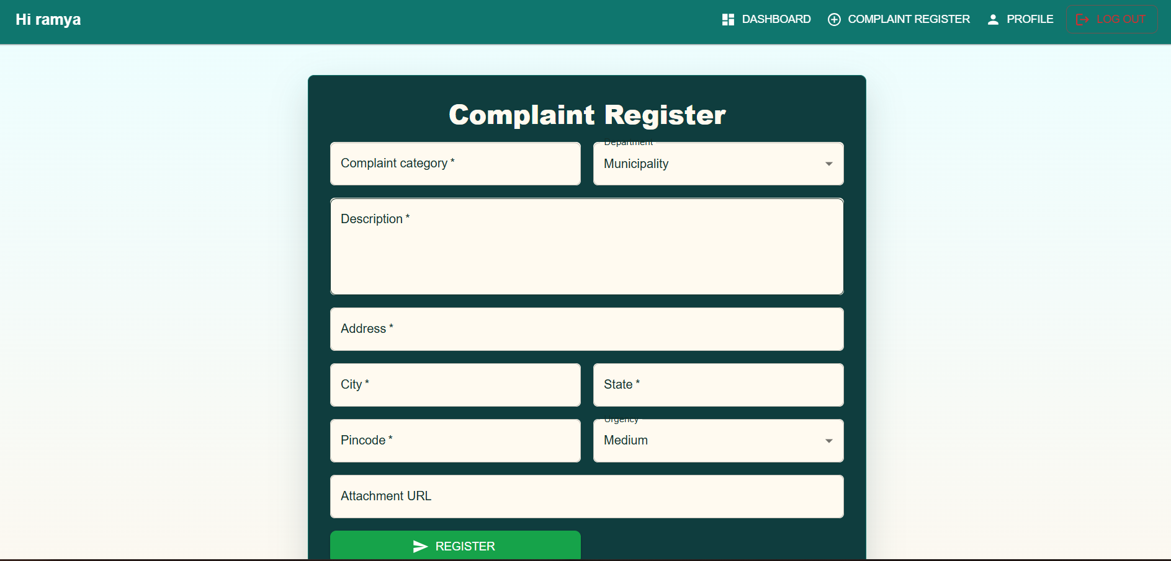
Form used to submit a new complaint.

Admin Dashboard
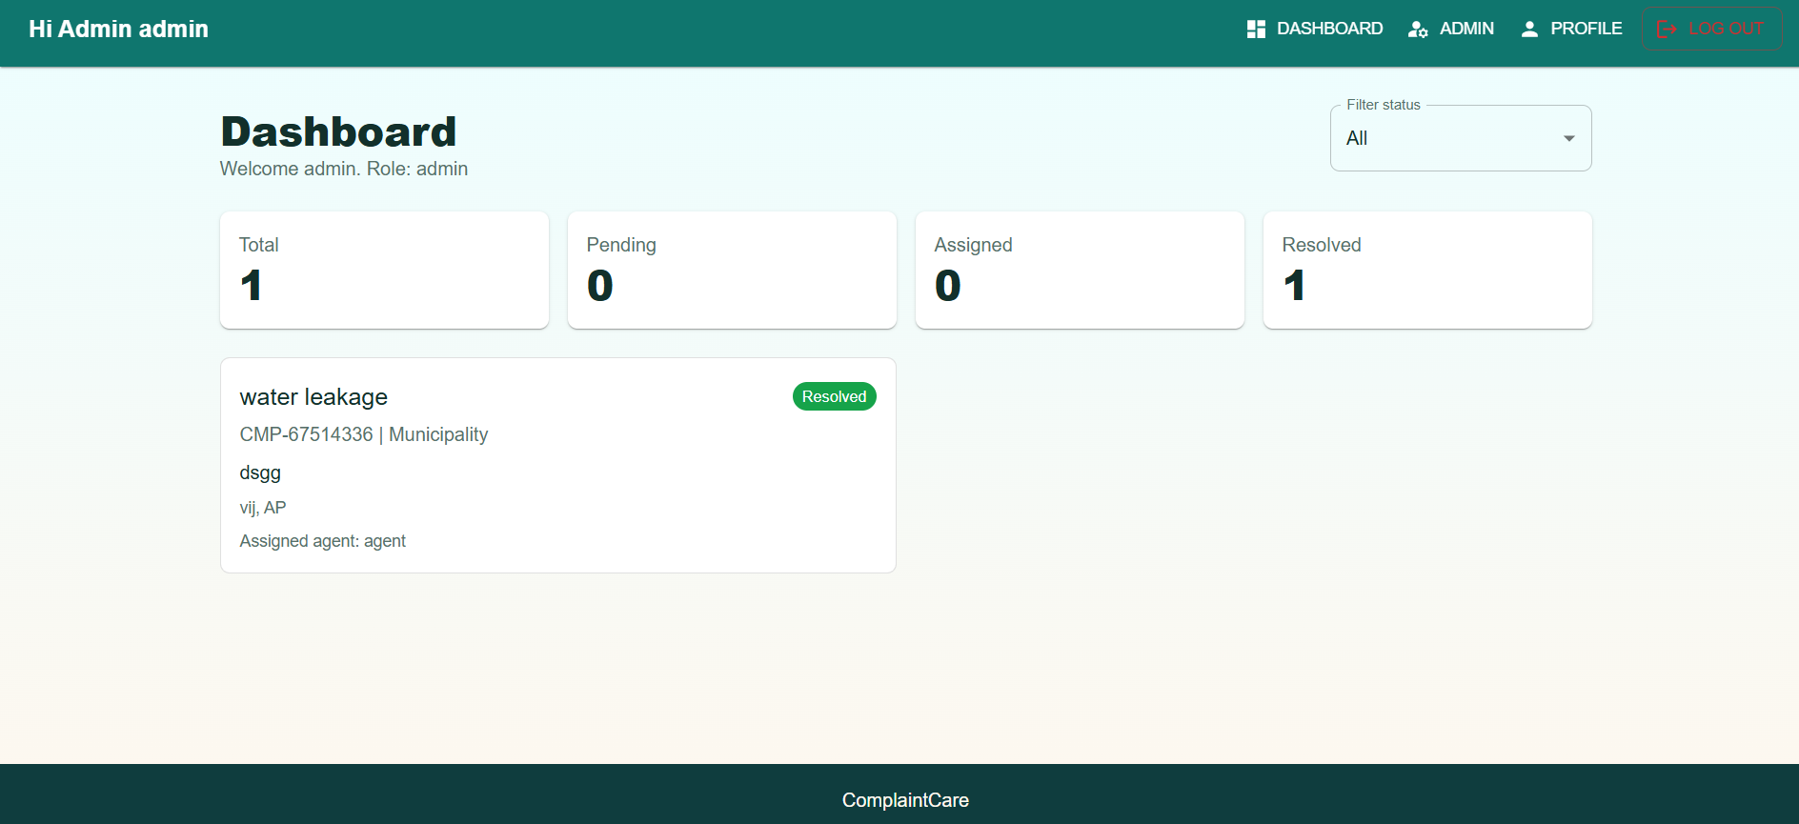
Administrator view of overall complaint activity.

Admin Panel
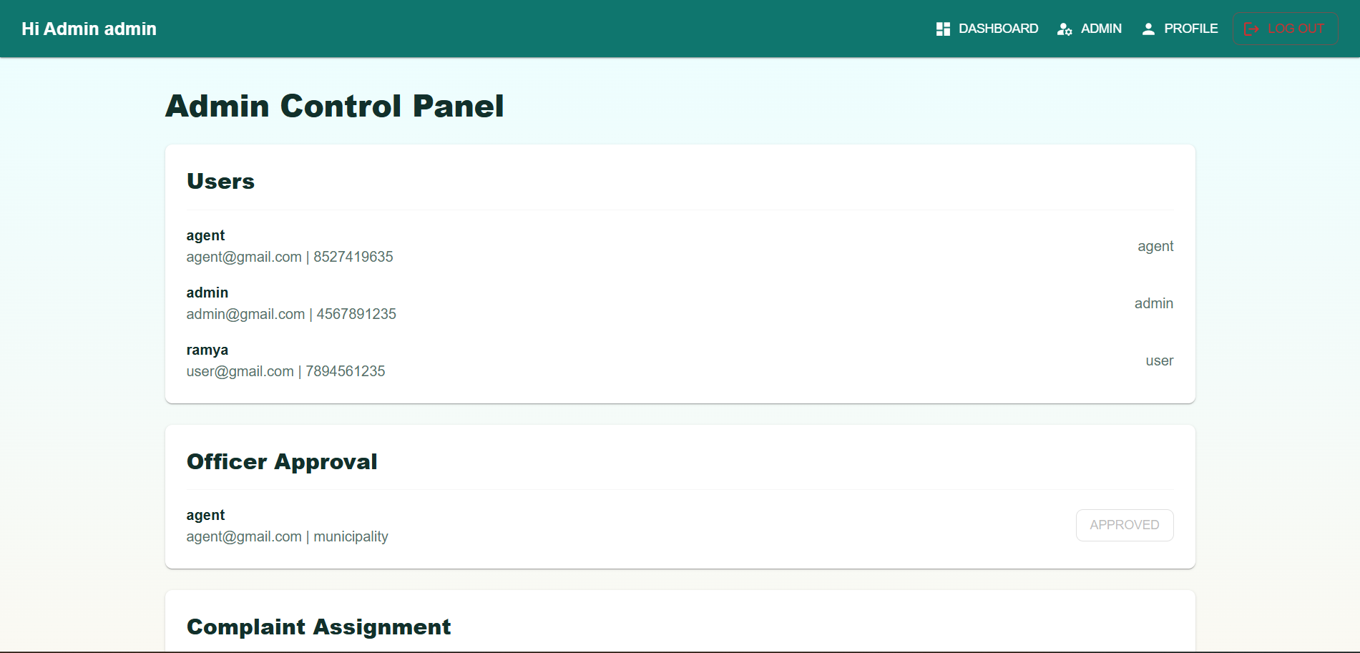
Admin panel — user and officer management.
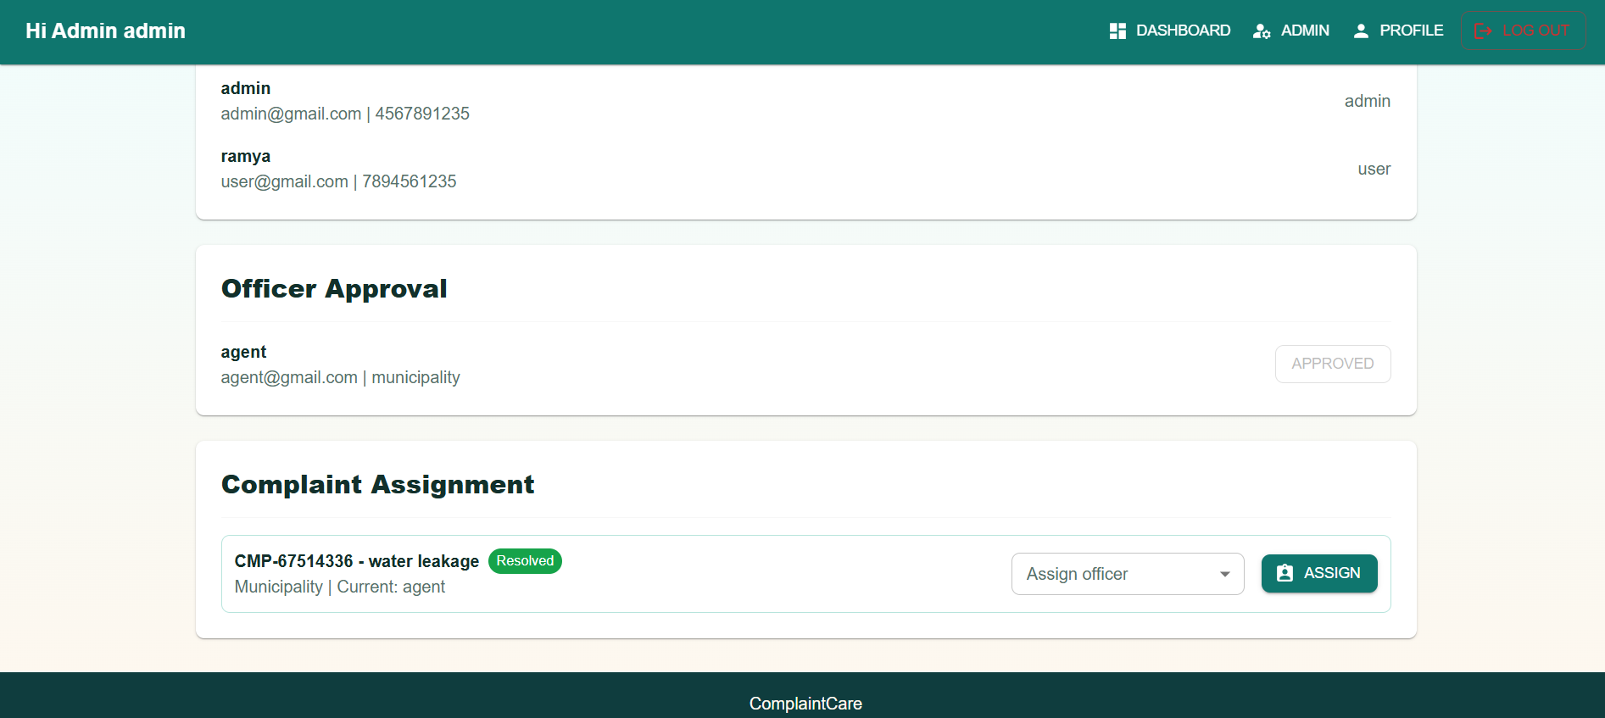
Admin panel — complaint assignment.

Officer Approval
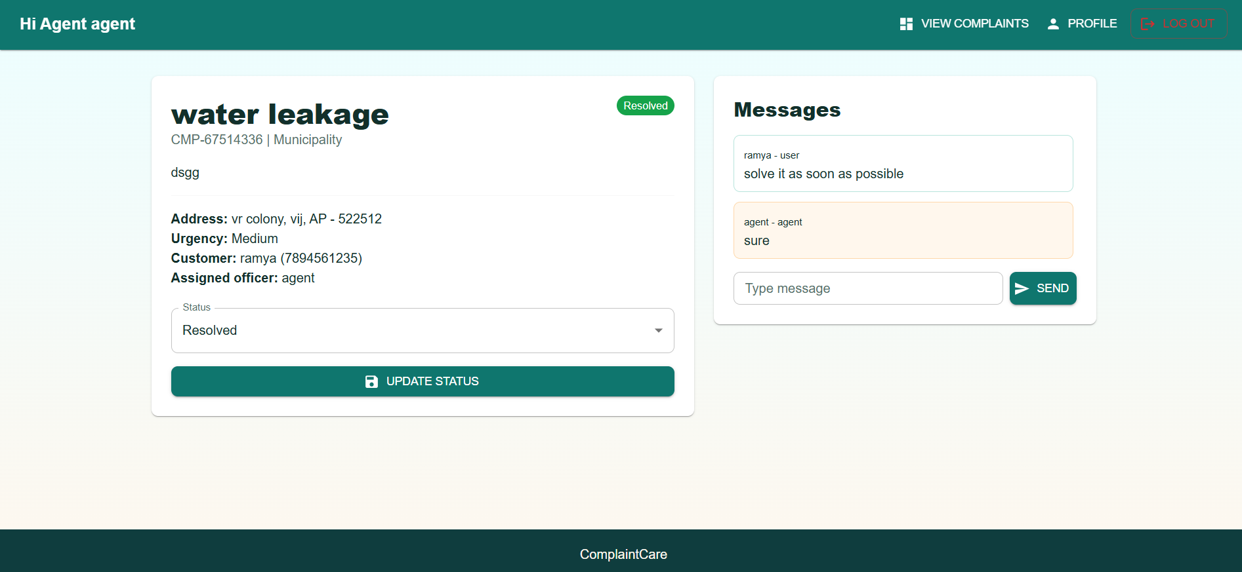
Admin approving a pending officer/agent account.

10. Testing
The project does not currently include an automated test suite (no test files or testing framework are configured in package.json). Testing has been carried out manually:
- Manual functional testing of each user flow: registration (user/agent/admin), login/lockout, complaint creation, status updates, assignment, messaging, and profile editing.
- API endpoints were exercised with a REST client (e.g., Postman/Thunder Client) to verify status codes, validation errors, and role-based access rules.
- Cross-role testing was performed by creating one account of each role (user, agent, admin) and confirming that each role only sees and can perform the actions permitted to it.
Suggested future work: add automated unit tests for controllers/middleware (e.g., Jest + Supertest) and component/integration tests for the React app (e.g., Vitest + React Testing Library).

11. Screenshots or Demo
A full walk through of the application is available in the demo video below. See Section 9 (User Interface) for individual annotated screenshots of every major screen.
Demo video: https://drive.google.com/file/d/16SELoijIrlrDEUjKOrP_OeIeeN03gKaI/view?usp=sharing

12. Known Issues
- Complaint attachments are stored as a plain URL text field (attachmentUrl); there is no built-in file upload endpoint, so users must host an image/document elsewhere and paste the link.
- The API rate limiter and login-attempt lockout are stored in memory, so counts reset on server restart and are not shared across multiple server instances.
- The frontend has two separate Axios setups (src/api/axios.js and src/services/api.js); only the former attaches the JWT token, so services/api.js should be removed or unified to avoid confusion.
- There is no password-reset / "forgot password" flow yet.
- No pagination is implemented on complaint or user lists, which may not scale well with large datasets.
- [Add any additional bugs or limitations discovered during your own testing here.]

13. Future Enhancements
- Add real file/image upload for complaint attachments (e.g., using Multer + cloud storage).
- Email/SMS notifications when a complaint is assigned, updated, or resolved.
- Forgot-password / password-reset flow via email.
- Pagination, search, and advanced filtering on complaint and user lists.
- Analytics dashboard for admins (complaints by category, department, resolution time).
- Rating/feedback from users after a complaint is resolved.
- Real-time updates (e.g., WebSockets) for live status changes and new messages.
- Automated test coverage for backend and frontend.

