AMRESCO Automation – Enterprise AI Performance Reporting Platform

Project Objectives, Architecture & Implementation Plan
AMRESCO Automation is an enterprise-grade AI-powered web application designed to automate Excel-based performance reporting, data validation, anomaly detection, and intelligent insights generation for energy production datasets.

Project Objectives
- Primary Objectives:
- Automated Data Quality Validation (Missing values, zero values, structural validation, formula detection)
- Anomaly Detection & Performance Monitoring (Outlier detection, underperformance analysis)
- AI-Driven Report Generation (Executive summaries, contextual insights)
- Enterprise Workflow & Validation (Manual review, audit logs, compliance)
- Multi-Format Report Export (Excel, PDF, HTML)

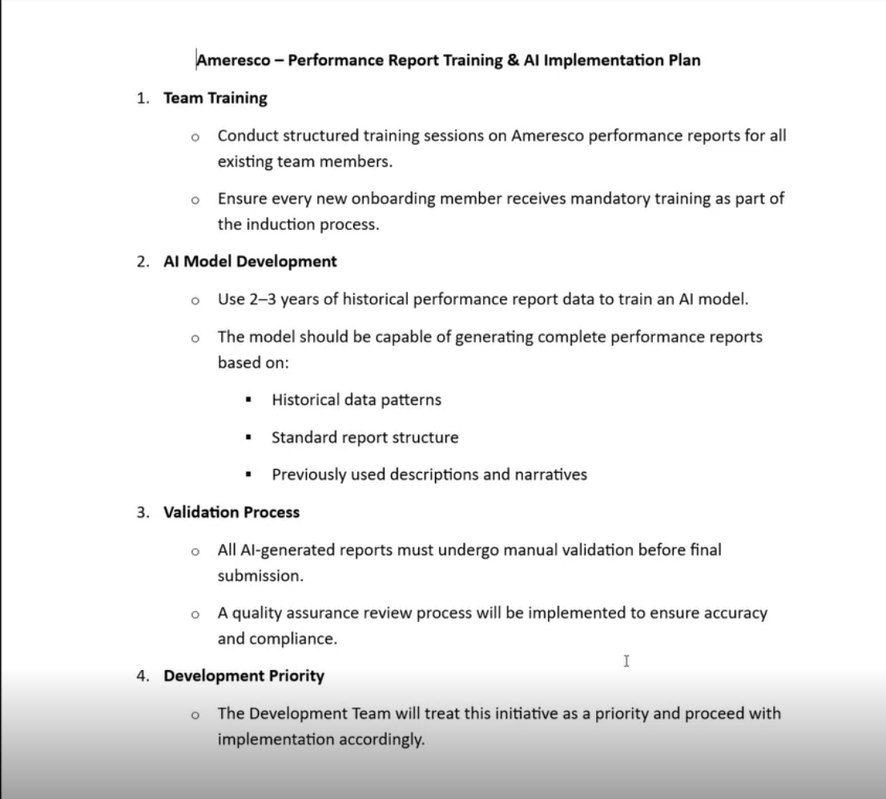

2. Current Project Status
- Completed:
- Initial Upload UI built using React
- Missing value detection implemented
- Anomaly detection logic implemented
- Underperforming site detection completed
- Formula detection using OpenPyXL
- Sub-pages under development
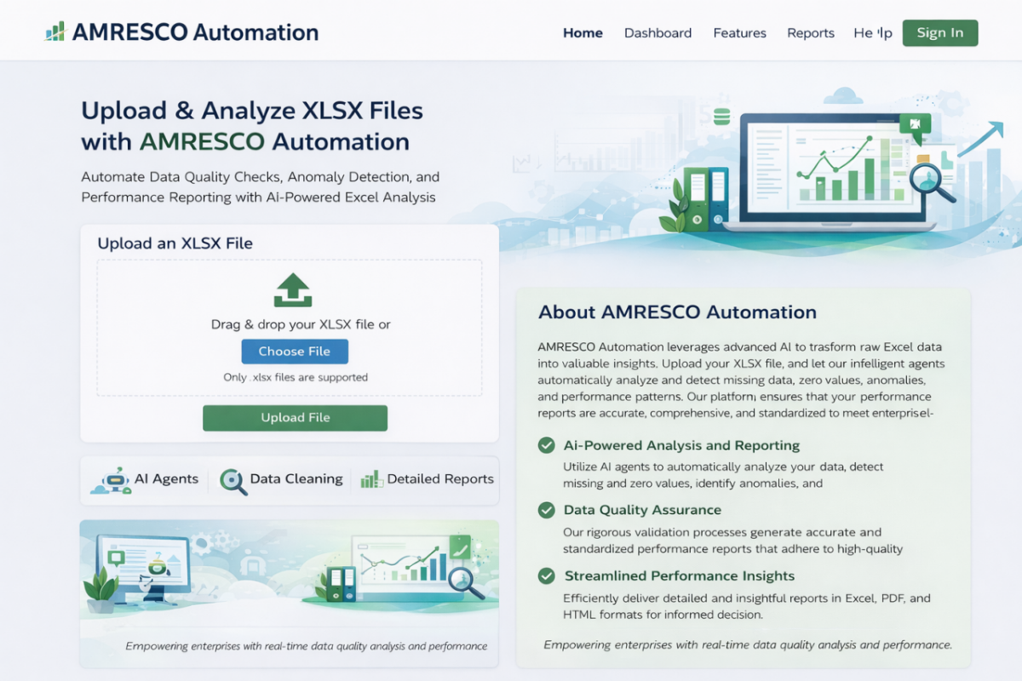

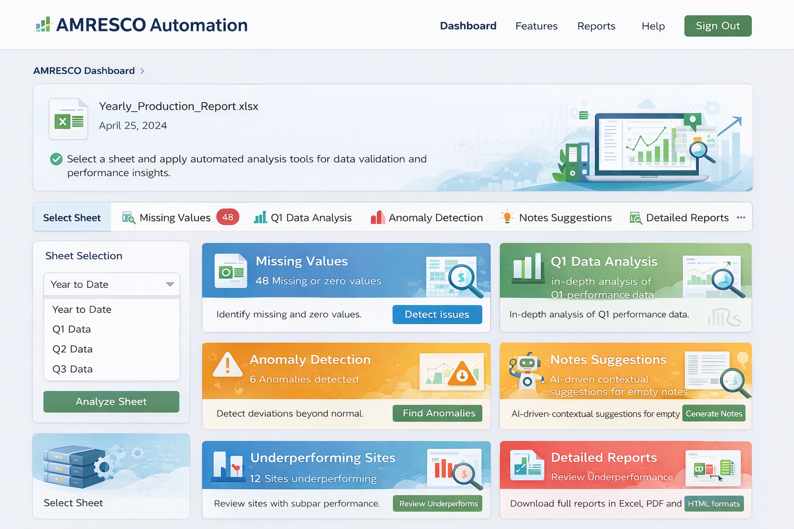

3. Technology Stack

Frontend Technologies
- React.js (UI framework)
- TailwindCSS (Styling)
- Recharts / Chart.js (Data Visualization)
- Axios (API Communication)
- React Router (Navigation & Sub-pages)

Backend Technologies
- FastAPI (High-performance API framework)
- Pandas & NumPy (Data Processing)
- Scikit-learn (Anomaly Detection)
- PostgreSQL (Database)
- Redis + Celery (Background Processing)
- Docker (Containerization)

4. AI Layer – Ollama AI Agent
Ollama will be integrated to run local large language models for secure, enterprise-grade AI processing. This ensures data privacy and eliminates external API dependencies.
- AI Use Cases:
- Executive Summary Generation
- Performance Narrative Writing
- Data Trend Explanation
- Automated Notes Suggestions

5. System Architecture & Workflow
Workflow Overview: User uploads XLSX file → Backend processes sheets → Data validation & ML analysis executed → Results stored in PostgreSQL → Ollama generates AI insights → Manual validation → Report export.

6. How the System Works (Workflow)
Step 1: Upload XLSX
User uploads Excel file via React UI.
Step 2: Backend Processing
File saved to cloud storage.
Background task triggered via Celery.
All sheets extracted.
Data validation performed.
Step 3: Analysis Modules
Backend generates:
Missing value JSON
Anomaly detection results
Underperforming sites list
Formula metadata
Results stored in PostgreSQL.
Step 4: Dashboard Rendering
Frontend fetches data via REST APIs:
GET /api/analysis/{file_id}/missing
GET /api/analysis/{file_id}/anomalies
GET /api/analysis/{file_id}/underperforming
Step 5: AI Insights
Frontend calls:
POST /api/ai/generate-notes
Backend sends structured data to Ollama → AI generates summary → Stored for validation.
Step 6: Manual Validation
Admin reviews AI-generated report before final submission.
Step 7: Report Export
User downloads final report in Excel / PDF / HTML format.

6. Sub-Page Development Plan (React)
- Modules to be developed:
- Missing Values Page (Issue table & filters)
- Sheet Data Analysis Page (Graphs & AI explanation)
- Anomaly Detection Page (Outlier visualization)
- Notes Suggestions Page (AI editable summary)
- Underperforming Sites Page (Ranked KPI breakdown)
- Detailed Reports Page (Download & approval workflow)

7. Implementation Phases
- Phase 1 – Backend Modularization
- Phase 2 – API Development & Database Integration
- Phase 3 – Frontend Sub-Page Development
- Phase 4 – Ollama AI Integration
- Phase 5 – Enterprise Hardening & Cloud Deployment

8. Conclusion
AMRESCO Automation is a scalable AI-powered enterprise analytics platform that transforms manual Excel reporting into an intelligent, standardized, and automated performance monitoring system.

