🍺 How strongly is a beer's alcohol content related to its rating?
Recently, I've been working on a hobby project focused on data engineering and machine learning, using Hungarian beer data as a playground for learning and experimentation.
The project is based on data collected from the Untappd platform. At the time of analysis, there were 2,302 Hungarian beers listed on the site, and I gathered and processed data for all of them. I will cover the data collection, scraping, and QA process in more detail in a separate post.
As a first step, I investigated which of the available numerical variables might be related to average of user ratings. For this analysis, I chose ABV (Alcohol By Volume). A small number of beers were missing ABV information, which I fixed manually using publicly available online sources.
After importing the data into Python, I built an initial linear regression model and calculated the key performance metrics (correlation, R², etc.).
The first results indicated a weak-to-moderate positive relationship between alcohol content and beer ratings. However, when examining the scatter plot, the relationship did not appear to be purely linear. Instead, it seemed to follow a root-like function.
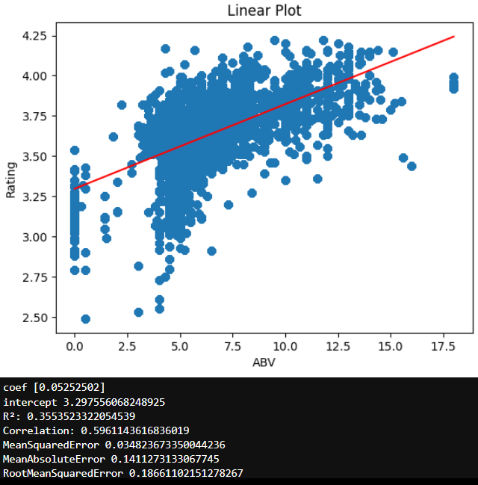

Based on the shape of the point cloud, I started experimenting with different power transformations of the ABV variable and monitored how the KPIs changed.
The best result was achieved using an ABV^(2/3) transformation. In this case, the correlation increased to 0.61 (while the other KPIs remained essentially unchanged), which can be considered a moderate positive relationship.
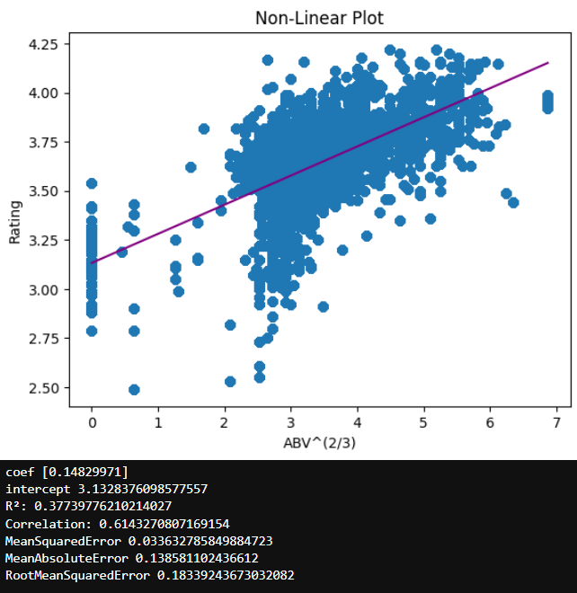
The results suggest a measurable positive correlation between beer ratings and the two-thirds power of ABV.
There are several plausible explanations for this finding. Low-alcohol and especially alcohol-free beers are often produced using technological compromises. For example, during dealcoholization by evaporation, not only alcohol is removed, but also part of the beer's aroma profile. In addition, alcohol itself acts as an important flavor carrier. Methods based on interrupted fermentation can likewise limit the development of certain aroma compounds.
At the other end of the spectrum, many high-ABV beers are barrel-aged stouts, porters, or other specialty beers that offer a significantly higher level of flavor complexity.
It is important to emphasize that this is a correlation, not a causal relationship. The chart clearly shows that there are many highly rated low-ABV beers, and conversely, some high-ABV beers receive relatively poor ratings.
What the results suggest is simply that, within this dataset, beers with higher alcohol content tend to receive better ratings on average.
If someone were specifically aiming to develop highly rated beers, stout and porter styles could be a reasonable starting point.
I'm curious whether similar patterns would emerge in larger international datasets.

