Menusi Menu Maker
MANUAL

It is a desktop application for the PC that allows you to select the programs from the LiliCPC collection, add them to the menus and generate the menu data files so that it can be opened with Menusi on the Amstrad CPC, all done in a faster and safer way than before. I have tried it with the Usifac card, but it should also work for the M4.
I put some images below so you can see how it works.
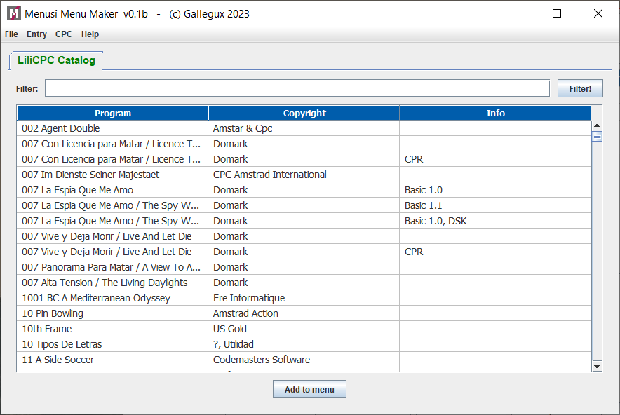
Initial screen. One tab with all LiliCPC programas
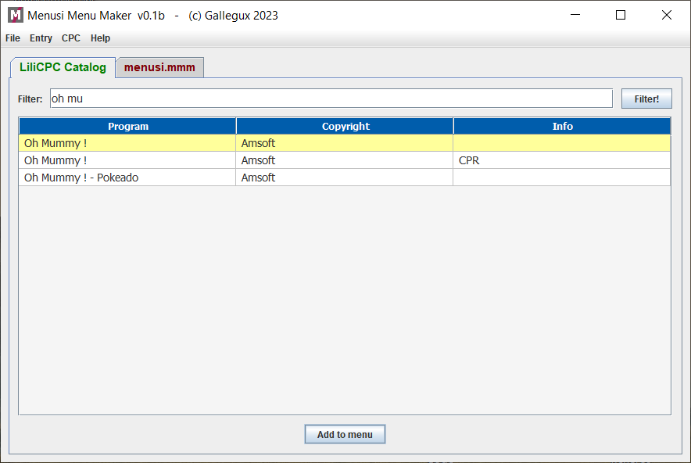
Searching "Oh mummy" and adding to last menu tab (in color red)
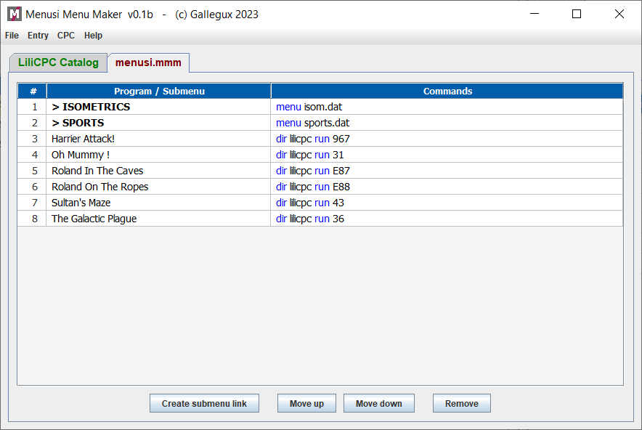
The main menu. The main menu must be called MENUSI.DAT in Amstrad CPC
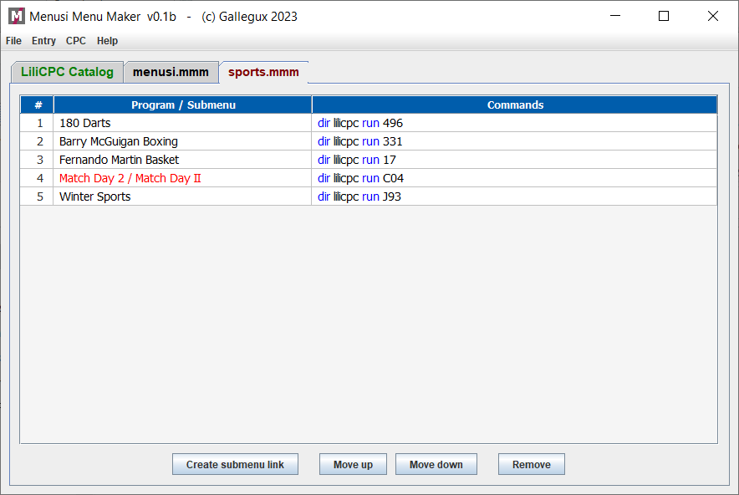
And the SPORTS menu. The max length for names is 24, so "Match Day II appears" in red.
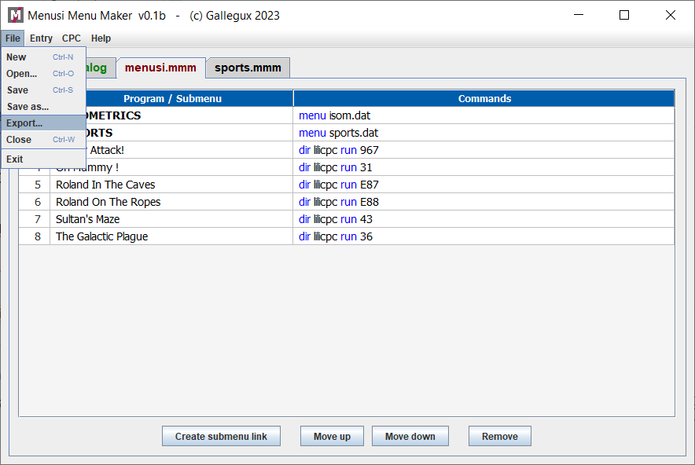
Exporting the menu to Menusi format.
On Amstrad CPC, after launching menusi, menus appers like that:


Use INTRO to access the selected menu (menus have the prefix >), and DEL to return to the previous menu

To save menusi programs to a pendrive or SD use the CPC menu.
This is an beta program. I would appreciate your feedback.

