1. Navigate to the branch you are merging and click ‘Compare and Pull Request’

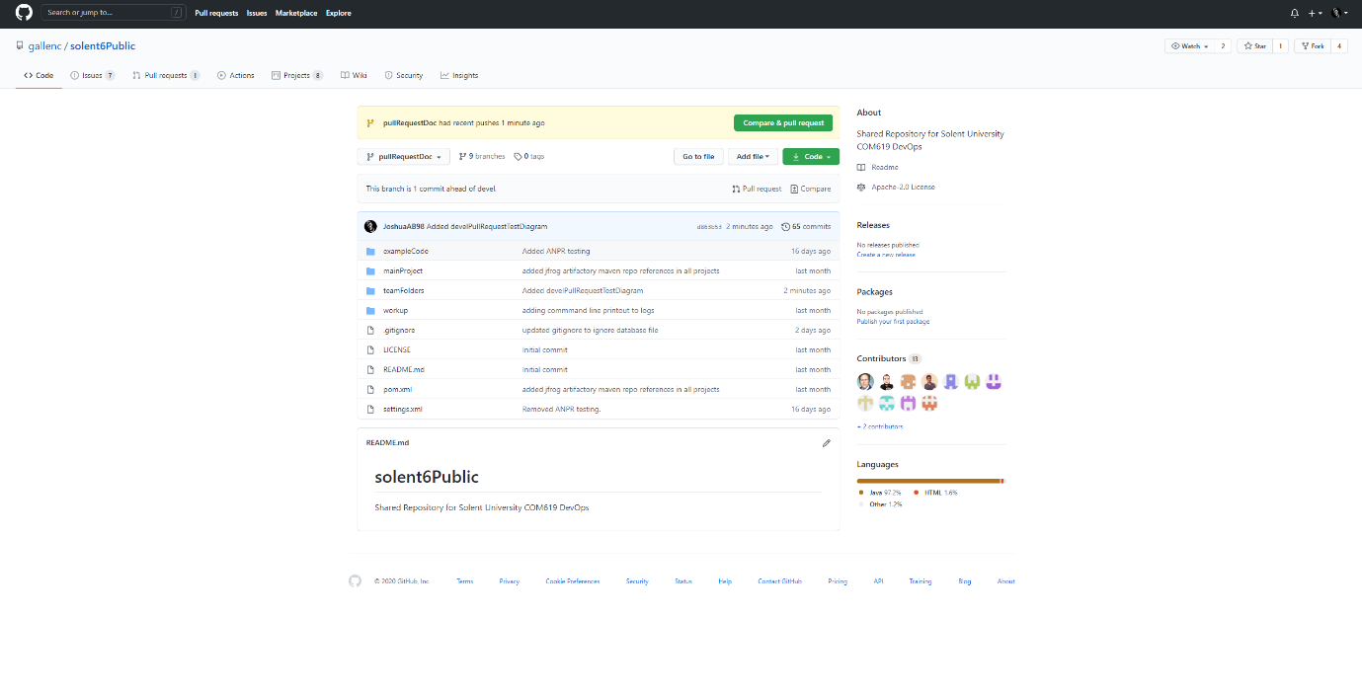

1. Click ‘Create Pull Request’

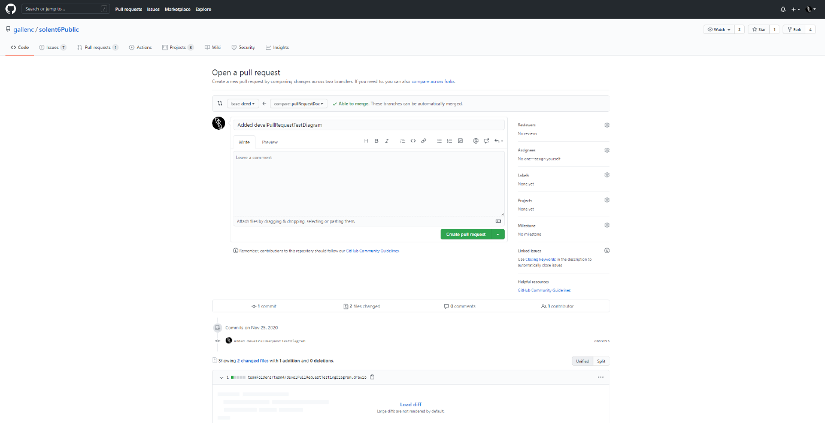

1. If the branch is able to be merged select a reviewer from groups above and below in addition to a member of p4 (dev ops)

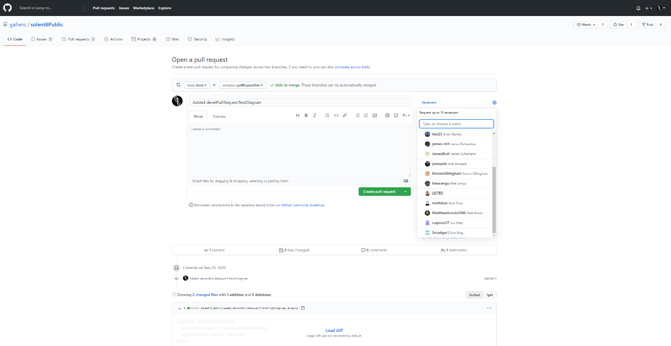

1. Once all of the reviewers have approved the pull request a member of p4 (dev ops) will Merge the pull request

