**Personalization document**

To personalize the party playlist based on preferences of multiple guests in the party, the Spotify’s recommendation web API will be used ( <https://developer.spotify.com/web-api/get-recommendations/>). The recommendation API needs the following parameters to generate an output consisting of tracks :-

1. Spotify track IDs : It is a compulsory field and can consist of maximum of 3 tracks
2. Spotify artist IDs: It is a compulsory field and can consist of maximum of 2 artists
3. Parameters such as popularity rating, energy, danceability, valence, and country can also be fed into the Spotify API so that the tracks being recommended by API match these parameters.

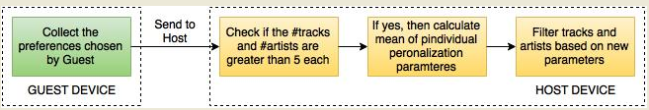

To make sure that the number of artists and tracks are restricted to 5, we need to filter them based on some parameters. Using Spotify’s web API, the metadata of tracks (such as energy, danceability, valence) and artists (such a popularity) can be retrieved. This metadata/parameters can be used to filter the artists and tracks. If the number of artists and tracks is greater than 5 even after filtering, then the “Mean Algorithm” will be applied i.e. the mean of individual parameters will be calculated for all songs and then filtering will be done based on the new mean values of parameters. This will help eliminating the tracks or artists whose parameters lie below the mean value of parameters.

