Mongolian Plateau Veg Stats

G Allington

3/9/2017

## Initial Data Explorartion & Analysis

This is the initial analysis and ordination of vegetation survey data from the Mongolian Plateau, collected in summer 2016. Data collection sites in Inner Mongolia and Mongolia. Eventually plot a map here of the sampling sites.  
Below are analyses of the entire dataset, which includes cover data for species from multiple plots per site, and of the same data with species cover per plot averaged by site. Data were aggregated for the second step to allow for comparison to the environmental data, which contain one value per site.

1. Load the data and prep it:

## NMDS Plot

Plot of the two NMDS axes, symbols separated by country (shape), site (color) and plot replicate (shade):

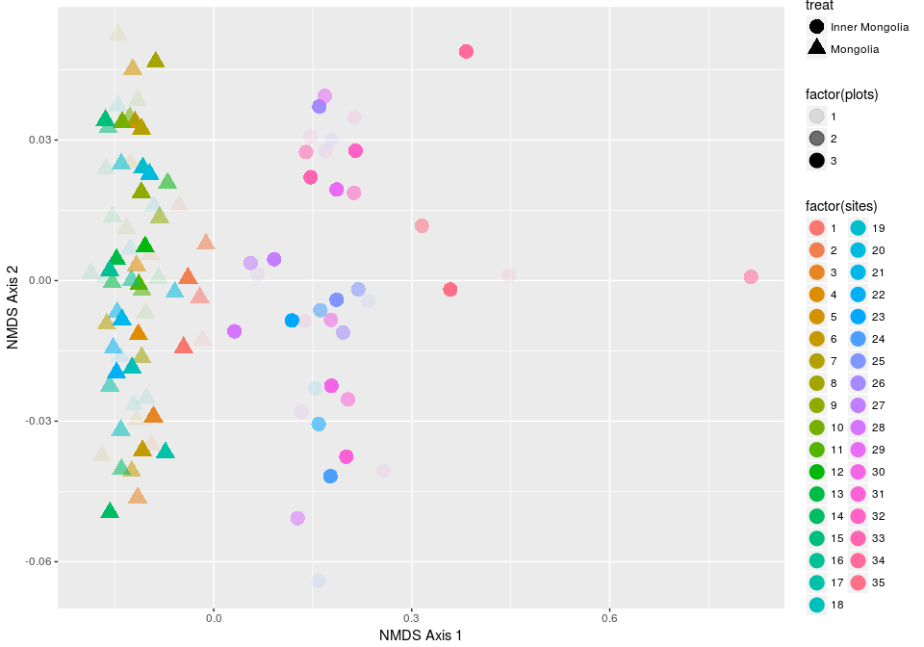

It is slightly easier to see the separation of sites by country if we just plot the hulls: Clear distinction between the clusters for IMAR and MG with NMDS. Sites within country are clustered together. Most spread is along the first NMDS axis. All the difference between the MG adn IMAR clusters is on the first axis. They have very similar ranges on the second axis. We discussed that the first axis (at least for combined country data) may be separated by land use intensity? Not sure how that would change when just looking at one country at a time.. 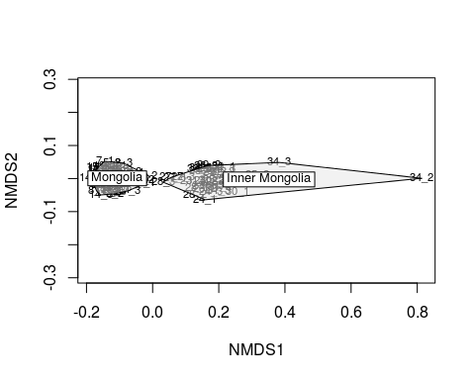 If we look at each countyr separately, the plots within sites show diff patterns by country as well. In IMAR there is clear distinction between individual sites; plots are more similar wihtin site than among. Again sites 34 and 35 are located farther out on the first axis.

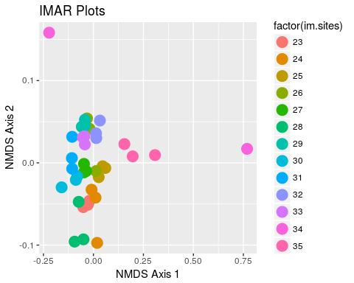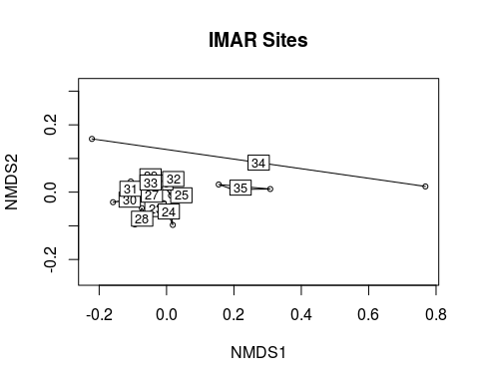 In MG there is much more overlap among sites, along both axes. Sites 1 and 2 are clearly separated from the rest on the left side of the firs axis.  
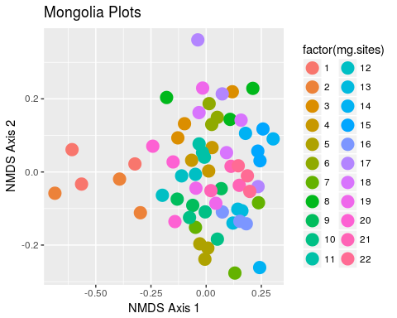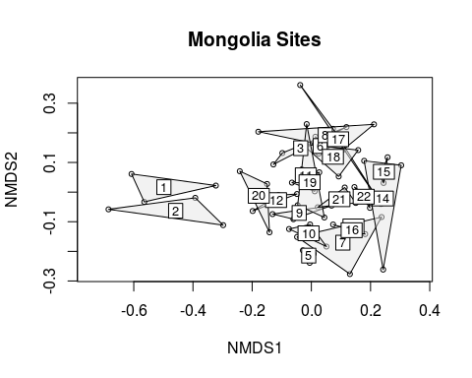

## Incorporating environmental data from Ranjeet to try and explain the spread

I am using EVI and albedo here. GPP and EVI are so highly correlated it doesn't make sense to use both.

First with the entire plateau: The labels in black are of the Sites, which are labelled w row for some reason.

## # A tibble: 36 × 15  
## ID Category Lat Long year month day LCnum  
## <int> <chr> <dbl> <dbl> <int> <int> <int> <int>  
## 1 1 MG 47.48105 106.7982 2016 7 4 10  
## 2 2 MG 46.74555 106.5843 2016 7 4 10  
## 3 3 MG 46.03637 106.3602 2016 7 5 10  
## 4 4 MG 45.52472 105.7858 2016 7 5 10  
## 5 5 MG 44.81020 105.4702 2016 7 5 10  
## 6 6 MG 43.94786 104.9519 2016 7 5 10  
## 7 7 MG 43.68481 104.6453 2016 7 6 10  
## 8 8 MG 43.49828 104.0399 2016 7 6 7  
## 9 9 MG 43.77528 104.8554 2016 7 6 10  
## 10 10 MG 43.72150 105.1370 2016 7 6 7  
## # ... with 26 more rows, and 7 more variables: LCtype <chr>, GPPkg <dbl>,  
## # GPPg <dbl>, EVI <dbl>, NDVI <dbl>, daily.albedo.BSA <dbl>,  
## # daily.albedo.WSA <dbl>

## [1] 0.2016

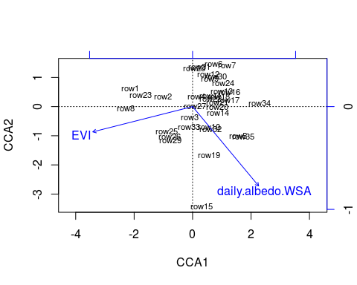

## Then for IMAR:

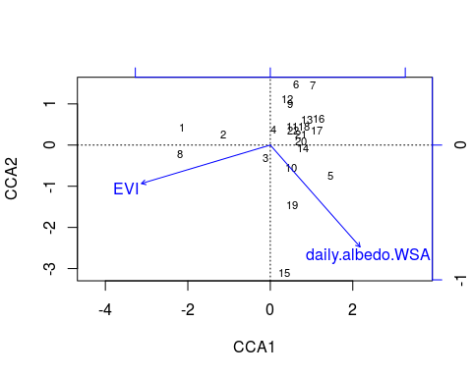

## And for MONGOLIA:

Note that the fit is not as great for the MG data. Need to investigate other variables. 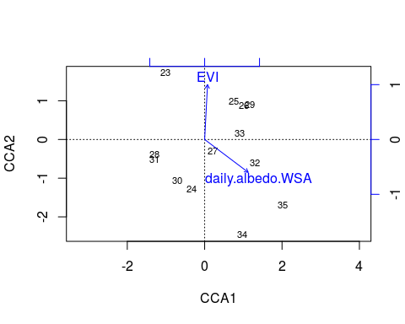

** TO DO ** * I still need to calculate richness stats to estimate turnover, compare between IMAR/MG * We need to think about what other environmental variables we might be able to access and incorporate in to this. * This is just a first stab with the CCA so Ia m going to work with these analyses some mrore as well.