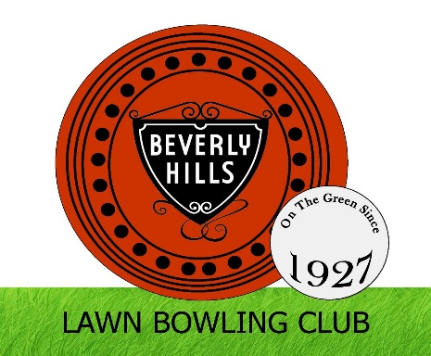
Joe Siegman Pairs Tournament
This tournament will be held on Sunday, May 3, 2026 at
Beverly Hills Lawn Bowling Club, 401 S Roxbury Dr, Beverly Hills,
entrance fee $100 each team
Prize money Winners $1200, 2nd place $500, 3rd place $300
Individual medals for all winners.
Registration 830am, Play 9am, lunch provided
The tournament will be pairs, 4 bowls, 4×10 ends
Open to men/women mix or match teams
Click on this link to enter this tournament
https://docs.google.com/forms/d/e/1FAIpQLScFvVUnfGLWc6ynjl4sNyc9yhAgLyzsr964E1-uEuUfEX5G6w/viewform
Payment: via Zelle to treasurer@bhlbc.com
Or mail your application and check payable to:
Beverly Hills Lawn Bowling Club, Mail Entries to:
Catherine Uribe, 9118 Vista Grande Way, Porter Ranch CA 91326

