1. The poles are 100 meters wide and 140 meters tall
2. (4,14) and (16,14)
3. 10 meters long
4. (10,5)
5. 

Substitute:(h,k)=(10,5)



Substitute the coordinates of any point in the parabola

(4,14)

14=a(4-10)^2+5



9 = 36a

36 36

a=1/4

substitute the value of a and vertex to the formula



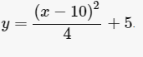

1. 5 additional

|  |  |
| --- | --- |
| x | y |
| 6 | 9 |
| 8 | 6 |
| 12 | 6 |
| 14 | 9 |

We get the height of each hanger of one side then we subtracted it to 40 because the hanger will only reach the road. Then we multiplied it by 2 because we need the hanger for both sides of the bridge.

1. 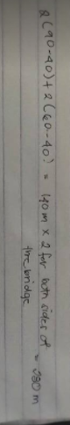
2. 