YANIGPH: AN IOS MOBILE APPLICATION FOR EMERGENCIES AND CALAMITIES

Daniel D. Dasig, Jr.¹, Rudolph Val F. Guarin² , Arlene Mae C. Valderama², Mengvi P. Gatpandan^{2,} Ryan Ebardo²,Roel C. Traballo², Mary Ann Taduyo², Arnel E. Galorio³, Ma. Concepcion B. Hernandez³, Dominick V. Enaje³, Analiza V. Galas³, Maricar Ann M. Abrigo³, Ma. Joanne Christine R. Enfestan³, John Paul G. Evangelista³, Ralph Martin J. Juaño³, Mark Lopez³, Bonna May P. Lopez³

¹Program Chair, Computer Engineering

College of Computer Studies and Engineering, Jose Rizal University,

Mandaluyong City, Philippines
Corresponding Author: daniel.dasig@jru.edu

²Faculty, Information Technology Department, College of Computer Studies & Engineering,

Jose Rizal University, Mandaluyong City, Philippines

³Student Researchers, College of Computer Studies and Engineering,

Jose Rizal University, Mandaluyong City, Philippines

ABSTRACT

The Philippines is a Southeast Asian country in the Western Pacific, comprising of 7,107 islands. Its geographical location and history has opened the eyes of the world as one of the countries being hit by natural calamities every year. It also lies in the co-called “Pacific Ring of Fire”. Its sprawling capital, Metro Manila, as industrial and business districts are under the earthquake fault lines known as Valley Fault System, hit by flooding, and has experienced a number of man-made and natural calamities. The government and support agencies for national and international development focus and funds were reverted to reconstruction and mitigation programs.

Using the Scrum methodology, YANIGPH, an IOS mobile application, was developed as support system to save lives and properties during emergencies. The application presents Yanig button to be pressed by someone who needs assistance with distress signal via Morse code using sound and light. Tulong lines provide emergency numbers of various emergency responders’ team, rescue and relief centers, and non-government organizations. The application also provides Life Hacks which is a survival kit or life hacks during calamities.

Keywords: IOS mobile application, YanigPH, disaster prevention, calamities, emergency rescue

Introduction

The Philippines is a Southeast Asian country in the Western Pacific, comprising of 7,107 islands. According to Dasig (2015), the Philippines is considered as one of the most hazards prone countries in the world brought about by man-made and natural disasters due to its geographic circumstance which is exposed to catastrophic earthquakes, volcanic eruptions, tropical cyclones, floods droughts and fires as reflected by the National Disaster Risk Management in the Philippines: Enhancing Poverty Alleviation through Disaster Reduction 33822 v1, The World Bank-East Asia and Pacific Region Rural Development and National Disaster Coordinating Council- Republic of the Philippines. Accordingly, Chhibber, A., &Laajaj, R (2011) cited reported incidents and cases of devastations of these natural hazards and disasters including fires have increased in recent years of about 50 per year in the early 1970’5 to 400 per year in 2005. Its geographical location and history has opened the eyes of the world as one of the countries being hit by natural calamities every year. It also lies in the co-called “Pacific Ring of Fire”. It’s sprawling capital, Metro Manila, as industrial and business districts are under the earthquake fault lines known as Valley Fault System, hit by flooding, and has experience number of man-made and natural calamities.

According to the GMANews.TV (2009), the aftermath of Typhoon Ketsana, known in the Philippines as Tropical Storm Ondoy, with a damage of $1.09 billion and 747 fatalities, which caused 789 deaths and damages worth $6.2 billion was the second most devastating tropical cyclone in the 2009 Pacific typhoon season to hit Manila. It was very unfortunate for the Philippines in the early-November 2013 when typhoon Haiyan, locally known as Typhoon Yolanda, was one of the strongest tropical cyclones ever recorded; devastating portions of Southeast Asia, particularly the Philippines killed at least 6,300 people. The deadly typhoon that swept through the Philippines was one of the strongest ever recorded, NPR report said.

In the Philippines where house fires are prevalent, it has effect to derail the economic growth, destroyed social and physical capital including infrastructures, which resort to reallocation of ongoing programs to finance relief operations to fatalities and inhabitants and reconstruction efforts based on the experience pointed out in the World Bank-East Asia and Pacific Region Rural Development and National Disaster Coordinating Council- Republic of the Philippines which diverts funds to social services. The risk of fire occurrence is high especially during summer (Dasig, 2015; Lloret, J., Garcia, M., Bri, D., &Sendra, S., 2009) Christmas and New Year celebration due to firecrackers.

Reviews of Emerging Technologies and Mobile Application

GMA Network’s IMREADY, the Philippines’ one-stop shop for real-time information on safety and preparedness, now comes in a mobile app that is simple, accessible and easy to use.It also provides an accurate and up-to-the-minute information in weather, traffic situation, floods earthquakes and many more.

Project NOAH (Nationwide Operational Assessment of Hazards) is the official mobile application of the Philippines’ Department of Science and Technology (DOST)’s website of the same name. The app provides a lot of useful tools and information such as weather news and flood forecasting and warning. It also provides a map view of the Philippine ‘Area of Responsibility’ (PAR), rainfall contours, chance of rain, radar images (for Subic, Tagaytay, Cebu, Hinatuan, Tampakan), sensors, and typhoon forecasts. Screenshots and information from the app can be shared on Facebook, Twitter, Instagram, Gmail, and even via Bluetooth.

Disaster Alert covers lists and maps of disaster risks across the globe. ‘Active hazards’ are incidents that are deemed hazardous by the Pacific Disaster Center (PDC) and are recorded and listed by the app in real-time. Among the active hazards are common natural disasters in Asia such as tropical cyclones, earthquakes, tsunamis, and floods. MMDA conduct a largest earthquake drill here in the country to inform the public about the possible hit of the earthquake. The corporation takes the opportunities to market the application to public to make them prepared and aware in case of the said earthquake.

The government and support agencies for national and international development focus and funds were reverted to reconstruction and mitigation programs. This paper YanigPH reports claims and walkthroughs of design and development of an IOS mobile application which instigates awareness on earthquakes and disaster guides.

Methodology

The study used the developmental research design. The researchers employed Scrum methodology. According to Schwaber (1997) Scrum methodology is a system development philosophy which is an enhanced iterative/ incremental development cycle where the requirements and solutions evolve throughout the development process.. The Scrum team composed of project development members were provided with individual tasks as part of the product backlogs. A daily scrum meeting has been made to provide opportunities for each scrum team members elicit and present the status of the sprint backlogs. Cervone (2011) emphasized that;

Agile project management using the Scrum methodology allows project teams to manage digital library projects more effectively by decreasing the amount of overhead dedicated to managing the project. Using an iterative process of continuous review and short‐design time frames, the project team is better able to quickly adapt projects to rapidly evolving environments in which systems will be used”.

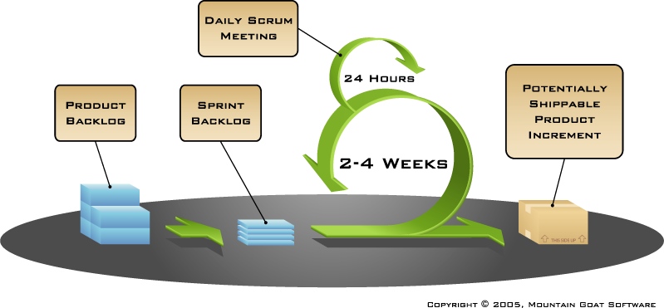

Figure 1. The Scrum Methodology (Source: Google Image)

The programming languages used for the YanigPH are HTML, CSS, and JavaScript. The application developer used the compiler Phonegap build and to access the native functions of an iPhone the Cordova plugins was utilized.

Results and Discussion

The YanigPH is an IOS mobile application which presents Yanig button to be pressed by someone who needs assistance with distress signal via Morse code using sound and light. This allows the application to provide the whereabouts of the person/s or group of evacuees who are in need of rescue and immediate response and assistance.

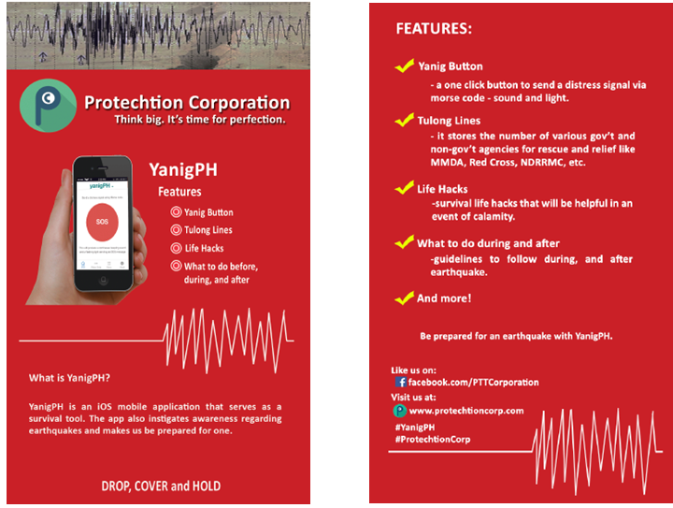

Figure 2. The Menu Page of YanigPH Mobile Application
Tulong lines provide emergency numbers of various emergency responders’ team, rescue and relief centers, and non-government organizations. Emergency responders database provides quick information, such as contact names, contact numbers to the apps end-users including the national and local disaster and risk mitigation team; National Disaster and Risk Reduction and Management Council, Regional Disaster and Risk Reduction and Management Council, Provincial Disaster and Risk Reduction and Management Council, Municipal Disaster and Risk Reduction and Management Council, Philippine Red Cross, Armed Forces of the Philippines (Philippine National Police, Philippine Army, Philippine Air Force), Department of Health, Department of Social Welfare and Development, other non-government organization, civil society organizations, volunteer groups and the local, national and international development support and response teams.

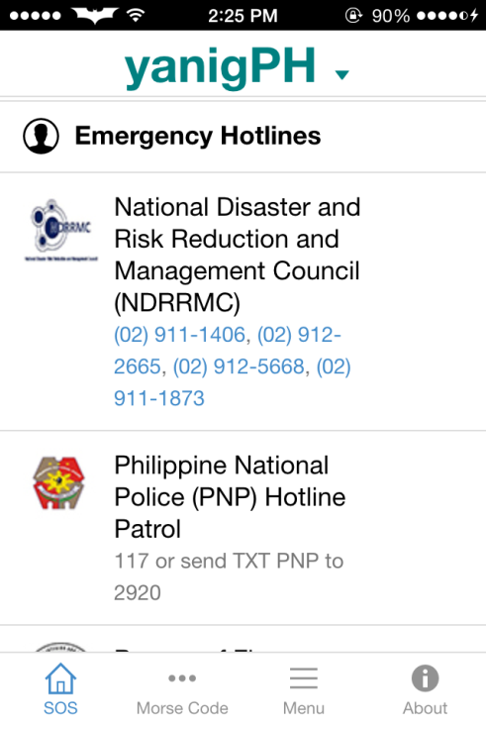
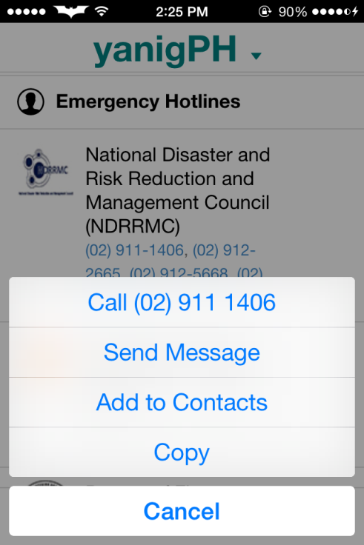

Figure 3. The YanigPH Mobile Application- Tulong Lines Interface

The app user (admin) can append response team, update and copy information. The smarphone features were embedded to the app to provide user-friendly feature.

Fundamental to the need which is to protect and save lives and properties, the mobile application provides relevant and up to date information about man-made and natural calamities. The application also provides Life Hacks which is a survival kit or life hacks during calamities.

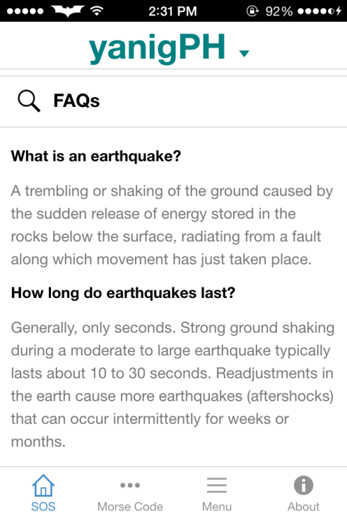
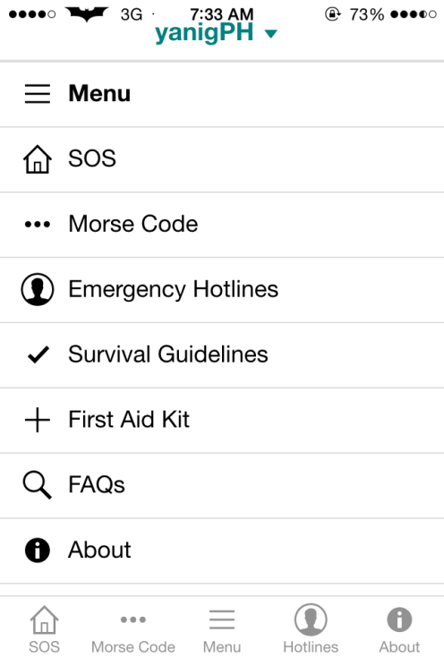

Figure 4. The YanigPH Mobile Application- Life Hacks Interface

Aside from the information about the floods, hurricanes, tornadoes, fires, toxic gas releases, chemical spills, radiological accidents, explosions, civil disturbances, and workplace violence resulting in bodily harm and trauma, it also maintain and educational library on Survival Guidelines and First Aid Kit. The Survival Guidelines provides measures and emergency action plan with a designated Incident Commander and Triage Team. The emergency action plan contains designated actions that must be taken into consideration during emergencies. Incident Commander is usually a designated Site Manager/ Chief Executive Officer of the firm. The Triage team is composed of the medical and technical team available in every company or organizations.

System Administration and Management

The system is managed by a qualified and designated System Administrator who holds diverse functions and responsibilities. Currently, the system is hosted with the domain www.protechtioncorp.com . The current information technology infrastructure Dasig, Jr. D. & Gatpandan, M. (2013) integrates the mobile and web applications. Depending on the circumstance of practice, the system environment and services includes the; on-going maintenance and update of the software, security measures throughout its uptime, management of devices and installations, bugs fix and upgrades.

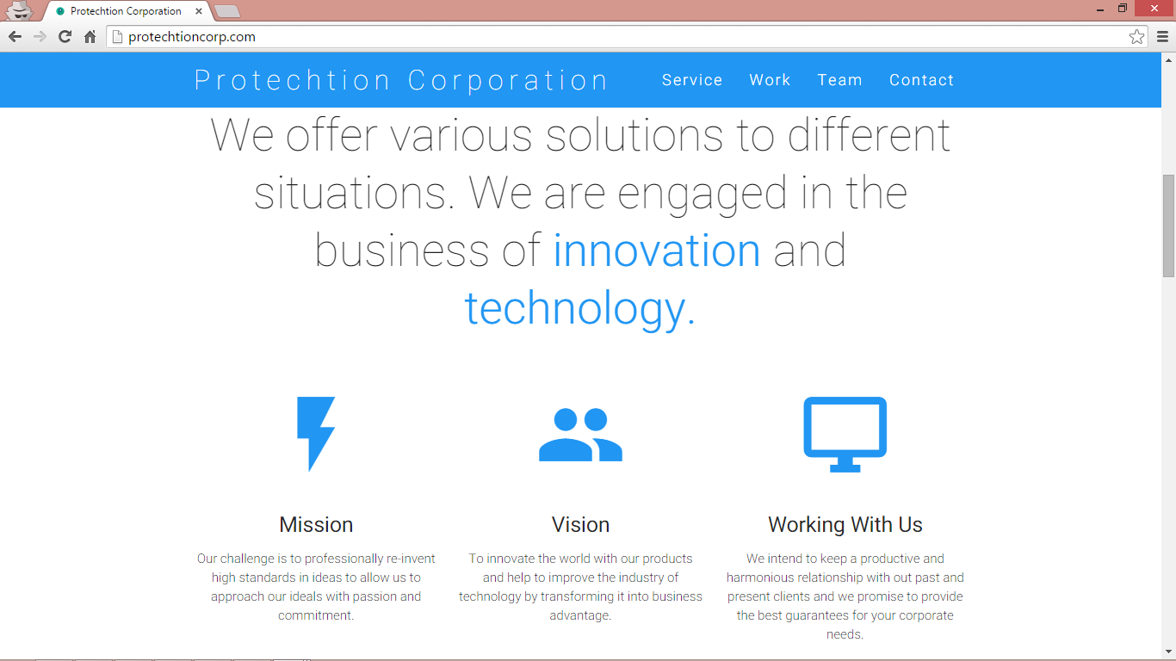

Figure 5. The YanigPH Web Application- Homepage
Available at www.protechtioncorp.com

Customer Service

- Description of Customer Service Activities: Through the website and fan page, any concerns regarding the app will be addressed. One of the main goals is to provide continuous support for our app users thru direct email and voice calls.

- Description of Return Policy or Re-installation of Software: Upon the first installation of the app the Apple AppStore keeps the user’s account to provide receipt. If, however the app was accidentally deleted, thru the Apple purchase history the application can be reinstalled without additional cost provided that it is the same device. Users can refer to Apple’s end-user license agreement.


Figure 6. The YanigPH Facebook Page
Available at www.facebook.com/PTTCorporation
Table 1. Evaluation of the Mobile and Web Application based on ISO/IEC 9126 Quality Model

Criterion | Weighted Mean | Interpretation
Functionality | 4.7 | SA
Reliability | 4.8 | SA
Usability | 4.6 | SA
Efficiency | 4.6 | SA
Maintainability | 4.6 | SA
Portability | 4.8 | SA
Grand Mean | 4.9 | Strongly Agree
Legend: 1-Strongly disagree (SD) 2-Disagree (D) 3- Neither agree nor disagree
4-Agree (A) 5-Strongly agree (SA)
Computed weighted mean for each of the 6 system quality criterion from functionality to portability criteria as reflected in the table 1 have been interpreted using 5 points Likert Scale as follows: very functional, highly functional, functional, poorly functional and not functional at all. The sub-characteristics being considered in the functionality includes; suitability, accurateness, interoperability, compliance, security. As reflected in the table, the computed functionality level in all criterions ranges from 4.7 which can be interpreted that the functionality level of the system is highly functional. And the overall computed mean for all criterions is ranges from 4.7 – 4.9 which again can be interpreted that the system quality is highly functional, highly reliable, highly usable, highly efficient, highly maintainable, and highly portable as evaluated by the 500 respondents.

Conclusion and Recommendation
Based on the study, the mobile and web application can support apps users through IOS Smartphone during emergencies, and calamities by means of Morse Code. The apps can also support government and development organizations to mitigate and provide awareness campaign on how the community will become resilient. Further, the researchers recommend the same application which is available in Android Smartphone’s.

References

Cervone, H. F. (2011). Understanding agile project management methods using Scrum. OCLC Systems & Services: International digital library perspectives, 27(1), 18-22.

Chhibber, A., &Laajaj, R., 8. Securing Against Natural Disasters: Better Preparedness and Better Development. Security and Development, 2011, pp. 171.

Dasig, Jr., D.(2015), International Journal of Advances in Computer Science & Its Applications –IJCSIA. ISSN : 2250-3765.5(2) p 306

Dasig Jr, D. D., & Gatpandan, M. P. (2013, October). Change Management of Transitioned Information System (IS) to Management Information System (MIS) of the Course System Analysis and Design 1 & 2 of Jose Rizal University: A Basis for a Comprehensive Policies Redirection. In CIMQUSEF'2013: 10ème session du congrès international sur la qualité de l'éducation et de la formation.

"Metro Manila, 25 provinces placed under state of calamity". GMANews.TV. 2009-09-26. Retrieved 2015-10-09.

Schwaber, K. (1997). Scrum development process. In Business Object Design and Implementation (pp. 117-134). Springer London.

Why Typhoon Haiyan Caused So Much Damage (Report). NPR. November 11, 2013. Retrieved 2015-10-09.

