**Survival Guidelines During and After Earthquake**

**During Earthquake**

1. 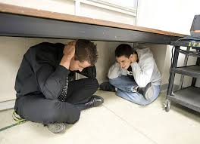If you are indoors, stay there. Quickly move to a safe location in the room such as under a strong desk, a strong table, or along an interior wall. The goal is to protect yourself from falling objects and be located near the structural strong points of the room. Avoid taking cover near windows, large mirrors, hanging objects, heavy furniture, heavy appliances or fireplaces.
2. If you are outdoors, move to an open area where falling objects are unlikely to strike you. Move away from buildings, powerlines and trees.

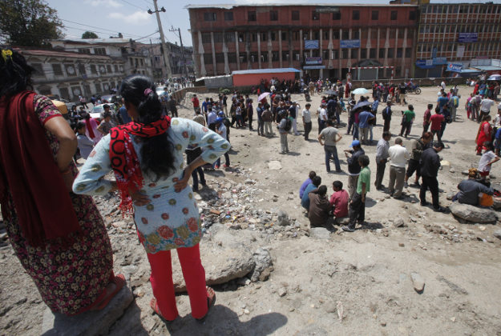

1. 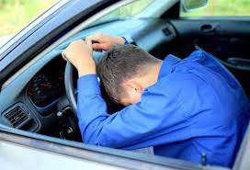If you're in a car, stop the car and stay inside the car until the earthquake stops.
2. Don't use elevators (they'll probably get stuck anyway).

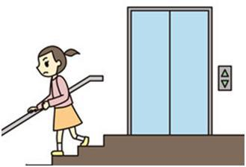

**After Earthquake**

1. 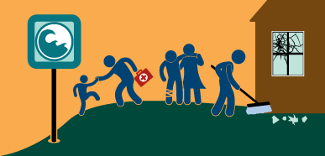Check for injuries, attend to injuries if needed, help ensure the safety of people around you.
2. Check for damage. If your building is badly damaged you should leave it until it has been inspected by a safety professional.

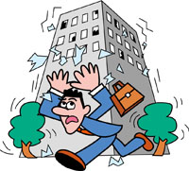

1. If you smell or hear a gas leak, get everyone outside and open windows and doors. If you can do it safely, turn off the gas at the meter. Report the leak to the gas company and fire department. Do not use any electrical appliances because a tiny spark could ignite the gas.

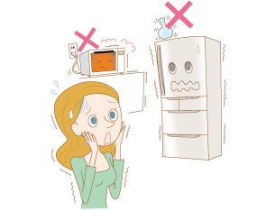

1. If the power is out, unplug major appliances to prevent possible damage when the power is turned back on. If you see sparks, frayed wires, or smell hot insulation turn off electricity at the main fuse box or breaker. If you will have to step in water to turn off the electricity you should call a professional to turn it off for you.

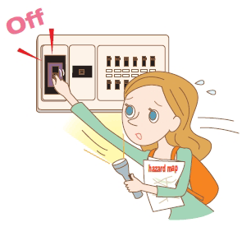

1. Stay away from beaches. Tsunamis and seiches sometimes hit after the ground has stopped shaking.

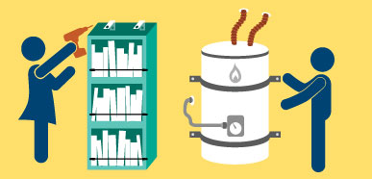

[Secure your space](http://www.earthquakecountry.org/step1) by identifying hazards and securing moveable items.

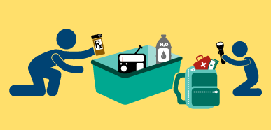

[Organize disaster supplies](http://www.earthquakecountry.org/step3) in convenient locations.

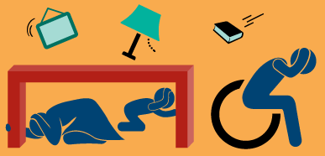

[Drop, Cover, and Hold On](http://www.earthquakecountry.org/step5) when the earth shakes.



[Improve safety](http://www.earthquakecountry.org/step6) after earthquakes by evacuating if necessary, helping the injured, and preventing further injuries or damage.

