**17th century**.

* [A magnitude 7.5 quake struck Luzon](https://en.wikipedia.org/wiki/1645_Luzon_earthquake) on November 30, 1645. The earthquake was then the strongest to hit the Islands since the Spanish conquest.  It had greatly damaged newly constructed churches and [Manila Cathedral](https://en.wikipedia.org/wiki/Manila_Cathedral), along with residential villas and buildings in the city and nearby provinces. Some 600 people were reported dead.
* An intensity IX quake struck Southern Luzon on August 20, 1658. It was comparable to the [1645 Luzon earthquake](https://en.wikipedia.org/wiki/1645_Luzon_earthquake), but had caused less damage on building and was less proximity from the epicenter. It had destroyed the Royal Monastery of Santa Clara, several monasteries of the [Dominicans](https://en.wikipedia.org/wiki/Order_of_Preachers) and [Recollects](https://en.wikipedia.org/wiki/Augustinian_Recollects), the [Jesuit](https://en.wikipedia.org/wiki/Society_of_Jesus) College and episcopal palaces.[[3]](https://en.wikipedia.org/wiki/List_of_earthquakes_in_the_Philippines#cite_note-Eqtap-3)

**18th century**

* An intensity VII struck Lake Bombon (now known as [Taal Lake](https://en.wikipedia.org/wiki/Taal_Lake" \o "Taal Lake)) on September 24, 1716. It was connected with the eruption of [Taal volcano](https://en.wikipedia.org/wiki/Taal_volcano" \o "Taal volcano); the constant volcanic activity in the area of Taal caused seismic movements.
* An intensity IX struck Tayabas (now known as [Quezon](https://en.wikipedia.org/wiki/Quezon)) in 1730. It had ruined the churches and convent in [Mauban](https://en.wikipedia.org/wiki/Mauban" \o "Mauban) and several other churches in the province of [Tayabas](https://en.wikipedia.org/wiki/Quezon" \o "Quezon) and [Laguna](https://en.wikipedia.org/wiki/Laguna_(province)).

**19th century**

* An earthquake on June 3, 1863, destroyed [Manila Cathedral](https://en.wikipedia.org/wiki/Manila_Cathedral), the *[Ayuntamiento](https://en.wikipedia.org/wiki/Ayuntamiento_de_Manila" \o "Ayuntamiento de Manila)* (city hall), the Governor's Palace (all three located at the time on Plaza Mayor, now [Plaza de Roma](https://en.wikipedia.org/wiki/Plaza_de_Roma)) and much of the city. The residence of the Governor-General was moved to [Malacañang Palace](https://en.wikipedia.org/wiki/Malaca%C3%B1ang_Palace" \o "Malacañang Palace) located about 3 km (1.9 miles) up the [Pasig River](https://en.wikipedia.org/wiki/Pasig_River), while the other two buildings were rebuilt in place.
* [An intensity X quake](https://en.wikipedia.org/wiki/1880_Luzon_earthquakes) struck Luzon on July 14–24, 1880. The quake caused severe damage to these major cities in Luzon, most significantly in Manila where a lot of buildings collapsed.

.

American period and post-World War II

**Early 20th century**

* A magnitude 7.5 quake struck [Northeastern Mindanao](https://en.wikipedia.org/wiki/Northern_Mindanao) on July 11, 1912. Damage and high intensity were experienced by towns of [La Paz](https://en.wikipedia.org/wiki/La_Paz,_Agusan_del_Sur), [Bunauan](https://en.wikipedia.org/w/index.php?title=Bunauan,_Agusan_del_Sur&action=edit&redlink=1" \o "Bunauan, Agusan del Sur (page does not exist)), [Veruela](https://en.wikipedia.org/wiki/Veruela,_Agusan_del_Sur" \o "Veruela, Agusan del Sur) and [Talacogon](https://en.wikipedia.org/w/index.php?title=Talacagon,_Agusan_del_Sur&action=edit&redlink=1" \o "Talacagon, Agusan del Sur (page does not exist)) in the [Agusan Valley](https://en.wikipedia.org/wiki/Legislative_district_of_Agusan" \o "Legislative district of Agusan) where intense ground shaking, liquefaction, widespread landslides and river/lake seiches occurred.
* An intensity VII earthquake struck [Luzon](https://en.wikipedia.org/wiki/Luzon), mainly [Isabela](https://en.wikipedia.org/wiki/Isabela_(province)) on December 29, 1949. Starting at 11:05 a.m., it lasted for two-and-a-half minutes. The damage was moderately destructive, causing landslides and rough waves capsizing boats, as well as fissures that spat out black water. The intensity ranged from IV to VII throughout Luzon.
* A magnitude 8.3 [M](https://en.wikipedia.org/wiki/Richter_magnitude_scale" \o "Richter magnitude scale)[s](https://en.wikipedia.org/wiki/Richter_magnitude_scale" \o "Richter magnitude scale) earthquake struck [Panay Island on January 25, 1948 at 1:46 AM](https://en.wikipedia.org/wiki/1948_Lady_Caycay_Earthquake). The epicenter was between the municipalities of [Anini-y](https://en.wikipedia.org/wiki/Anini-y,_Antique" \o "Anini-y, Antique) and [Dao](https://en.wikipedia.org/w/index.php?title=Dao,_Antique&action=edit&redlink=1) in Antique province.

Contemporary period

**Mid to late 20th century**

* A magnitude of 7.3 quake struck [Casiguran, Aurora, on August 2, 1968](https://en.wikipedia.org/wiki/1968_Casiguran_earthquake" \o "1968 Casiguran earthquake), at the depth of approximately 31 km. It was considered the most severe and destructive earthquake experienced in the Philippines during the last 20 years. 270 people were reported dead and 261 were injured.

[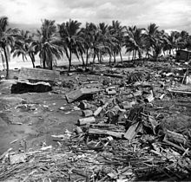](https://en.wikipedia.org/wiki/File:Lebak_Tsunami.jpg)

The damage caused by a tsunami at Barangay Tibpuan, [Lebak, Mindanao](https://en.wikipedia.org/wiki/Lebak,_Sultan_Kudarat" \o "Lebak, Sultan Kudarat)after the 7.9 [Moro Gulf](https://en.wikipedia.org/wiki/Moro_Gulf) Earthquake on August 16, 1976.

* A magnitude 7.0 quake struck [Ragay Gulf](https://en.wikipedia.org/wiki/Ragay_Gulf" \o "Ragay Gulf) on March 17, 1973. [Calauag, Quezon](https://en.wikipedia.org/wiki/Calauag,_Quezon" \o "Calauag, Quezon) was the worst hit, as the quake caused 98 houses totally destroyed, and 270 more were partially damaged.
* A magnitude 7.9 quake struck [Mindanao on August 16, 1976.](https://en.wikipedia.org/wiki/1976_Moro_Gulf_earthquake) The quake caused a devastating tsunami that had hit the 700 km coastline of the island of [Mindanao](https://en.wikipedia.org/wiki/Mindanao) bordering [Moro Gulf](https://en.wikipedia.org/wiki/Moro_Gulf) in the [North Celebes Sea](https://en.wikipedia.org/wiki/Celebes_Sea). An estimated 5,000 - 8,000 people died. The major cause of the great number of casualties during the event could be attributed to the fact that the quake happened just after midnight when most people were sleeping; and a great tsunami was spawned, struck the coasts from different directions and caught the people unaware.
* A magnitude 6.5 quake struck [Laoag on August 17, 1983](https://en.wikipedia.org/wiki/1983_Luzon_earthquake" \o "1983 Luzon earthquake), at a depth of 42 km. The quake has caused death of 16 people and injured 47 persons.
* A magnitude 6.8 quake struck [Bohol](https://en.wikipedia.org/wiki/Bohol) on February 8, 1990. Six fatalities were reported and more than 200 were injured in the event. About 46,000 people were displaced by the event and at least 7,000 among them were rendered homeless. Estimated damage to properties is amounting to [₱](https://en.wikipedia.org/wiki/Philippine_peso)154-million.
* A magnitude 7.1 quake struck [Panay Island](https://en.wikipedia.org/wiki/Panay_Island) on June 14, 1990 at a depth of 15 km. 7 persons died and 31 others were injured.
* A magnitude 7.8 quake struck [Luzon on July 16, 1990](https://en.wikipedia.org/wiki/1990_Luzon_earthquake). It caused severe damage to major cities in Luzon: [Dagupan City](https://en.wikipedia.org/wiki/Dagupan_City" \o "Dagupan City) (soil liquefaction), [Baguio City](https://en.wikipedia.org/wiki/Baguio_City), and [Cabanatuan City](https://en.wikipedia.org/wiki/Cabanatuan_City); Hyatt Terraces Baguio collapsed. 1,621 were reported dead. Damage to buildings, infrastructures, and properties amounted to at least ₱10-billion, a part of which was caused by ground rupturing. However, some houses within 1–2 m on either side of the ground rupture survived owing to their light-weight construction while those built of reinforced concrete within this zone suffered partial damage. Damage beyond 2m depended mainly on the structural integrity of the building and effects of local topography and ground conditions.
* A magnitude 7.1 quake struck [Mindoro on November 15, 1994](https://en.wikipedia.org/wiki/1994_Mindoro_earthquake) at depth of 15 km. The quake caused a tsunami killed 41 persons and destroyed 1530 houses.
* A magnitude 5.6 quake struck [Bohol](https://en.wikipedia.org/wiki/Bohol) on May 27, 1996 at a depth of 4 km. The earthquake did not cause major damage to properties. Damage was confined to poorly built structures and/or old wooden, masonry, limestone walls of houses and buildings, generally due to ground shaking.
* A magnitude of 5.1 struck [Bayugan](https://en.wikipedia.org/wiki/Bayugan" \o "Bayugan), [Agusan del Sur](https://en.wikipedia.org/wiki/Agusan_del_Sur" \o "Agusan del Sur) on June 7 and 9, 1999. The towns of [Bayugan](https://en.wikipedia.org/wiki/Bayugan" \o "Bayugan) and [Talacogon](https://en.wikipedia.org/wiki/Talacogon" \o "Talacogon) were the most devastated.

**21st century**

* A magnitude of 7.5 quake struck [Mindanao](https://en.wikipedia.org/wiki/Mindanao) on January 1, 2001 at a depth of 33 km.
* A magnitude of 7.5 quake struck [*Central and Southern Mindanao* on March 5, 2002](https://en.wikipedia.org/wiki/2002_Mindanao_earthquake) at a depth of 31 km. At least 15 people were killed, 100 injured and 800 buildings were damaged or destroyed.
* A magnitude of 6.1 quake struck [Sultan Kudarat](https://en.wikipedia.org/wiki/Sultan_Kudarat) on March 6, 2002. Office of Civil Defense (OCD) records show that 8 people had died and 41 were injured due to the earthquake. It affected 7,684 families in the provinces of [Sultan Kudarat](https://en.wikipedia.org/wiki/Sultan_Kudarat), [Sarangani](https://en.wikipedia.org/wiki/Sarangani" \o "Sarangani), [North Cotabato](https://en.wikipedia.org/wiki/North_Cotabato) and [South Cotabato](https://en.wikipedia.org/wiki/South_Cotabato) including four cities and 17 municipalities.
* A magnitude of 6.2 quake struck [Masbate](https://en.wikipedia.org/wiki/Masbate) on February 15, 2003 at a depth of 22 km. The quake damaged major infrastructures in Masbate. A magnitude of 6.5 quake struck [Samar](https://en.wikipedia.org/wiki/Samar) on November 18, 2003. 1 person was reported dead.
* A magnitude of 6.5 quake struck [Mindoro](https://en.wikipedia.org/wiki/Mindoro) on October 8, 2004.
* A magnitude of 6.6 quake struck [Moro Gulf](https://en.wikipedia.org/wiki/Moro_Gulf) on October 4, 2009.
* A series of quakes with the main quake's magnitude of 7.3 struck [Moro Gulf on July 23–24, 2010](https://en.wikipedia.org/wiki/2010_Mindanao_earthquakes).
* A magnitude of 6.4 quake struck [Ilocos Region](https://en.wikipedia.org/wiki/Ilocos_Region" \o "Ilocos Region) on March 20, 2011.
* A magnitude of 5.2 quake struck [Valencia City, Bukidnon](https://en.wikipedia.org/wiki/Valencia_City,_Bukidnon) on November 8, 2011 at a depth of 1 km. 39 people were injured, and several establishments were damaged.
* A magnitude of 6.9 quake struck [Negros, the rest of Central Visayas, and some parts of Mindanao on February 6, 2012](https://en.wikipedia.org/wiki/2012_Visayas_earthquake), at a depth of 20 km. The quake killed people, caused major damage on infrastructures, and buildings. A tsunami alert level 2 was raised due to the quake. The quake also caused a landslide, burying a barangay. More than a thousand of aftershocks were recorded by PHIVOLCS within 2 days since the quake occurred. According to National Disaster Risk Reduction and Management Council, as of February 18, 2012, the death toll have risen to 51 with 62 people still missing, and injuring 112 people. Most deaths came from the city of [Guihulngan](https://en.wikipedia.org/wiki/Guihulngan" \o "Guihulngan) and [La Libertad](https://en.wikipedia.org/wiki/La_Libertad,_Negros_Oriental) where landslides occurred. 63, 697 from provinces in [Region VII](https://en.wikipedia.org/wiki/Central_Visayas) were affected by the quake. 15, 483 houses were partially or totally damaged, and a total of ₱383-million worth of damage to buildings, roads and bridges, and other infrastructures were recorded.
* A magnitude of 5.9 quake struck [Surigao City](https://en.wikipedia.org/wiki/Surigao_City" \o "Surigao City) on March 16, 2012. Many were injured in the city for that certain day was the grand opening of Gaisano Capital Surigao. An estimated 6,000 people were in Gaisano when the earthquake happened. The earthquake caused a stampede which injured people.
* An earthquake with magnitude 7.6 struck 106 km near [Guiuan, Eastern Samar](https://en.wikipedia.org/wiki/2012_Samar_earthquake" \o "2012 Samar earthquake) on August 31, 2012. It was felt in certain areas of Visayas and Mindanao. 1 person died, and another one was injured in [Cagayan de Oro City](https://en.wikipedia.org/wiki/Cagayan_de_Oro_City) after being trapped in a collapsed house due to a landslide. Minutes after the quake, power interruptions occurred in the affected areas. The [National Disaster Risk Reduction and Management Council](https://en.wikipedia.org/wiki/National_Disaster_Risk_Reduction_and_Management_Council) reported that a house in [Agusan del Sur](https://en.wikipedia.org/wiki/Agusan_del_Sur" \o "Agusan del Sur) province caught fire sparked by a gas lamp that was toppled during the earthquake. It also reported that two bridges in [Eastern Samar](https://en.wikipedia.org/wiki/Eastern_Samar), particularly the Buyayawan Bridge in Mercedes town and the Barangay Casuroy Bridge in San Julian town, were partially damaged. The Abreeza Mall in Bajada, Davao City suffered minor cracks on the floor due to the earthquake. In [General MacArthur, Eastern Samar](https://en.wikipedia.org/wiki/General_MacArthur,_Eastern_Samar), 77 homes were damaged. There were also 6 houses damaged in Barangay Casoroy, San Julian. In [Balangiga, Eastern Samar](https://en.wikipedia.org/wiki/Balangiga,_Eastern_Samar" \o "Balangiga, Eastern Samar), a hospital sustained serious damage. A wall from an old building collapsed in [Butuan City](https://en.wikipedia.org/wiki/Butuan_City" \o "Butuan City). The NDRRMC reported on Saturday noon there were cracks on some roads and bridges and other establishments in areas where the quake was felt. Most of the homes destroyed were those made of light materials, while overall damage to infrastructure remained minimal.A tsunami warning of Level 3 was raised by the [Philippine Institute of Volcanology and Seismology](https://en.wikipedia.org/wiki/Philippine_Institute_of_Volcanology_and_Seismology), but was lifted 5 hours after the quake only caused tiny waves.
* An earthquake with magnitude 5.9 struck [Sultan Kudarat](https://en.wikipedia.org/wiki/Sultan_Kudarat) on September 3, 2012.
* A series of earthquakes, struck cities of [Malaybalay](https://en.wikipedia.org/wiki/Malaybalay" \o "Malaybalay) and [Valencia](https://en.wikipedia.org/wiki/Valencia_City,_Bukidnon), and the sitio of [Musuan](https://en.wikipedia.org/wiki/Musuan" \o "Musuan), [Maramag](https://en.wikipedia.org/wiki/Maramag" \o "Maramag) in [Bukidnon](https://en.wikipedia.org/wiki/Bukidnon" \o "Bukidnon) last September 3–4, 2012. The first quake has a magnitude of 3.4 and was felt at 06:48 PM, and was followed by magnitude 4.0 at 07:45 PM,and 4.7 at 09:21 PM. Hours after the first three, a series of quakes occurred in 03:44 AM and in 03:52 AM. The first quake had a magnitude of 5.6 with a depth of focus of 3 km;[[](https://en.wikipedia.org/wiki/List_of_earthquakes_in_the_Philippines" \l "cite_note-Bukidnon4-44)  while the second one was recorded at a magnitude of 4.9 with a depth focus of 3 km. The quake was felt as far as [Cagayan de Oro](https://en.wikipedia.org/wiki/Cagayan_de_Oro), [Kidapawan](https://en.wikipedia.org/wiki/Kidapawan" \o "Kidapawan), [Butuan](https://en.wikipedia.org/wiki/Butuan" \o "Butuan), and [Cotabato](https://en.wikipedia.org/wiki/Cotabato_City" \o "Cotabato City) cities. A nun was injured in Barangay Lourdes in Valencia City after the incident. Valencia City Disaster Risk Reduction and Management Council reported that 144 houses and structures were destroyed. Mayor Ignacio Zubiri of Malaybalay City reported no casualties nor damage in his city. The quakes were of tectonic in origin. A total of 131 aftershocks were recorded after the 5.6 quake in September 4, 2012.
* A 6.2 earthquake struck off the coast of Southern Mindanao on February 16, 2013, 28 kilometers southeast of Caburan, Davao del Sur. According to the [United States Geological Survey](https://en.wikipedia.org/wiki/United_States_Geological_Survey), the quake struck at a depth of 98.2 km.
* A 5.7 earthquake struck the island of Mindanao on June 1, 2013. The quake's epicenter was located in [Carmen, Cotabato](https://en.wikipedia.org/wiki/Carmen,_Cotabato) and struck with a depth of 5 kilometers. The said quake injured six people, 4 of them were children, and fully or partly destroyed several houses, and some school buildings. It also damaged a bridge at Barangay Kimadzil, and another one at Barangay Kibudtungan.  The quake was followed by 15 aftershocks, the last one was followed by a 4.3 quake on June 2, 2013.  The quake caused ₱71-million worth of damage. Another quake jolted the said town after 4:00 AM on June 3, 2013. The quake was recorded at 5.7 and struck at a depth of 3 kilometers. The newest quake further injured 8 more people, and damaged more houses. Classes which was slated to open on June 3, 2013, were cancelled due to a series of quakes that hit the town since June 1, 2013.
* A [magnitude of 7.2 earthquake struck Bohol](https://en.wikipedia.org/wiki/2013_Bohol_earthquake) on October 15, 2013 at 8:12 a.m. ([PST](https://en.wikipedia.org/wiki/Philippine_Standard_Time)). Its epicenter was located 6 kilometres (3.7 mi) SW of [Sagbayan](https://en.wikipedia.org/wiki/Sagbayan,_Bohol" \o "Sagbayan, Bohol) at a depth of 12 kilometres (7.5 mi). According to the official report by the [National Disaster Risk Reduction and Management Council](https://en.wikipedia.org/wiki/National_Disaster_Risk_Reduction_and_Management_Council), 222 were reported dead while 796 people were injured. Tens of thousands of structures were damaged by the earthquake. Most notable were the national historical churches in Bohol and Cebu.
* **Loon Church before and after the Bohol earthquake of October 15, 2013**
* [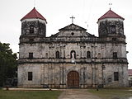](https://en.wikipedia.org/wiki/File:Loon_Church_Facade.JPG)

Loon Church prior to the earthquake

* [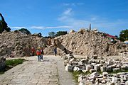](https://en.wikipedia.org/wiki/File:Loon_1_earthquake.JPG)

The rubble that was Loon Church after the quake

* A magnitude of 5.7 earthquake struck [Batangas](https://en.wikipedia.org/wiki/Batangas" \o "Batangas) on June 25, 2014, at 7:56 p.m. at a depth of 48 km.
* A magnitude of 4.6 quake struck [Misamis Oriental](https://en.wikipedia.org/wiki/Misamis_Oriental" \o "Misamis Oriental) on December 17, 2014, 2:36 p.m. at a depth of 18 km.
* A magnitude of 5.9 quake struck [San Antonio, Zambales](https://en.wikipedia.org/wiki/San_Antonio,_Zambales) before dawn of Sunday, January 11, 2015, at 3:31 am
* A magnitude 6.1 quake struck 47 km N 47°E of Burgos (Surigao del Norte) on July 3, 2015, 2:43 pm at a depth of 26 km

# The strongest earthquakes in the Philippines

**1968 - Casiguran earthquake**

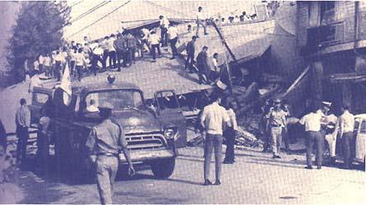The earthquake, which had a magnitude of 7.3, killed 270 people were killed and injured 261. The Ruby Tower in Binondo was among the destroyed buildings. Landslides, large fissures, and tsunami were also observed during the earthquake.

**1973 - Ragay Gulf earthquake**

Five years after the Casiguran quake, another tremor occurred that measured magnitude 7. Several houses, transporation and communication lines, and underground pipes were destroyed.

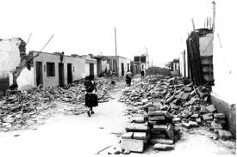

**1976 - Moro Gulf quake**

One of the strongest earthquakes recorded in history had measured magnitude 7.9. It happened on the island of Mindanao and resulted in a tsunami.

Around 1,440 died in Region 9 while 1,379 got killed in Region 12. More than 40,000 were left homeless in both regions because of the quake.

**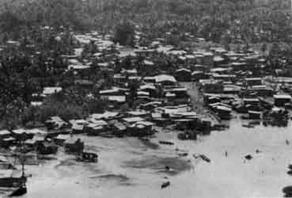**

**1983 - Laoag quake**

A magnitude 6.5 quake occurred in the Ilocos Norte in 1983. The quake resulted in the death of 16 people and injured 47. Establishments including malls, buildings, residences, church, municipal hall, and schools were damaged. Aside from landslides, sandboils and sandblows were also observed.

**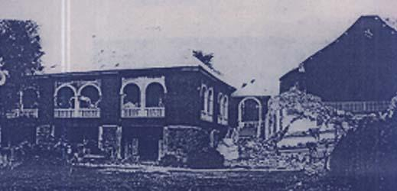**

**1990 - Bohol earthquake**

A magnitude 6.8 quake that happened in February 1990 killed 6 people and injured more than 200. The damage was estimated at P154 million. Some bridges, including the Jagna and Duero, collapsed. Aside from the quake, ground fissures, landslides, rockfalls, ground subsidence, sand/mud fountaining and increase in sea levels were also recorded.

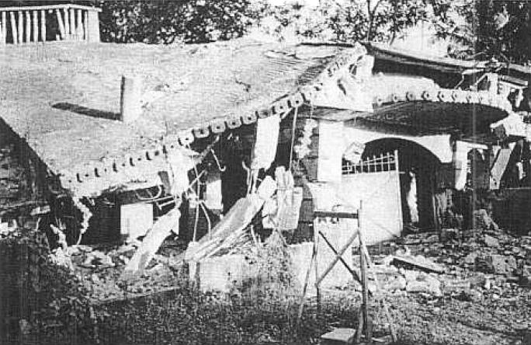

**1990 - Panay quake**

**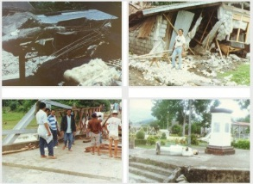**Four months after the Bohol tremor, Panay was severely damaged by a magnitude 7.1 earthquake that left 8 people dead and 41 injured. The quake was caused by fault movement in off western Panay Island. Several cities in Aklan, Iloilo, Capiz, and Antique were damaged.

**1990 - Luzon earthquake**

The strongest earthquake to happen that year occurred a month after the Panay quake. It was recorded at 7.7 magnitude. According to New York times, the quake killed at least 258 people, including 48 children whose school collapsed and 210 others caught in stampedes and fallen buildings.

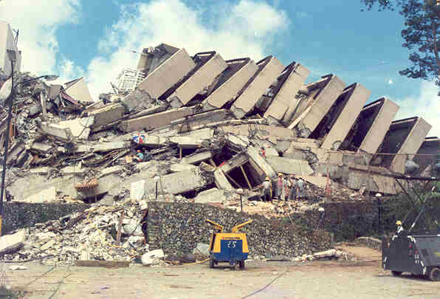

**1994 - Mindoro earthquake**

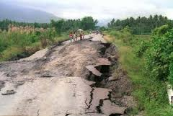A magnitude 7.1 quake resulted in 78 casualties. The quake also generated a tsunami, causing more damage and casualties.

**2002 - Palembang earthquake**

The magnitude 6.8 earthquake happened affected the provinces of Sultan Kudarat, Sarangani, North and South Cotabato.. The Office of Civil Defense said 8 people were killed, 41 were injured and 7,684 families were affected. the quake also damaged 4 road networks, 7 bridges, 36 school buildings, 29 business establishments, a megadike, health centers, and public buildings.

**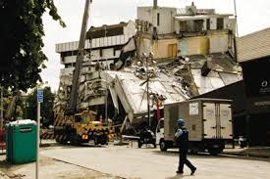**

**2003 - Masbate quake**

The Masbate quaked happened in February 2003. The 6.2 magnitude quake was felt not only in Masbate but also in Bicol, Leyte, Panay, Cebu, Negros and Romblon.

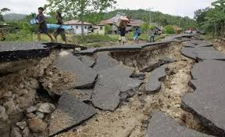

**2013 - Bohol quake**

The magnitude 7.2 quake that struck in Bohol Tuesday has killed more than 150 people so far and affected almost 3 million familes.

