Problems of the 1st International Physics Olympiad
(Warsaw, 1967)

Waldemar Gorzkowski

Institute of Physics, Polish Academy of Sciences, Warsaw, Poland

Abstract

The article contains the competition problems given at he 1st International Physics Olympiad (Warsaw, 1967) and their solutions. Additionally it contains comments of historical character.

Introduction

One of the most important points when preparing the students to the International Physics Olympiads is solving and analysis of the competition problems given in the past. Unfortunately, it is very difficult to find appropriate materials. The proceedings of the subsequent Olympiads are published starting from the XV IPhO in Sigtuna (Sweden, 1984). It is true that some of very old problems were published (not always in English) in different books or articles, but they are practically unavailable. Moreover, sometimes they are more or less substantially changed.
The original English versions of the problems of the 1st IPhO have not been conserved. The permanent Secretariat of the IPhOs was created in 1983. Until this year the Olympic materials were collected by different persons in their private archives. These archives as a rule were of amateur character and practically no one of them was complete. This article is based on the books by R. Kunfalvi [1], Tadeusz Pniewski [2] and Waldemar Gorzkowski [3]. Tadeusz Pniewski was one of the members of the Organizing Committee of the Polish Physics Olympiad when the 1st IPhO took place, while R. Kunfalvi was one of the members of the International Board at the 1st IPhO. For that it seems that credibility of these materials is very high. The differences between versions presented by R. Kunfalvi and T. Pniewski are rather very small (although the book by Pniewski is richer, especially with respect to the solution to the experimental problem).
As regards the competition problems given in Sigtuna (1984) or later, they are available, in principle, in appropriate proceedings. “In principle” as the proceedings usually were published in a small number of copies, not enough to satisfy present needs of people interested in our competition. It is true that every year the organizers provide the permanent Secretariat with a number of copies of the proceedings for free dissemination. But the needs are continually growing up and we have disseminated practically all what we had.
The competition problems were commonly available (at least for some time) just only from the XXVI IPhO in Canberra (Australia) as from that time the organizers started putting the problems on their home pages. The Olympic home page www.jyu.fi/ipho contains the problems starting from the XXVIII IPhO in Sudbury (Canada). Unfortunately, the problems given in Canberra (XXVI IPhO) and in Oslo (XXVII IPhO) are not present there.
The net result is such that finding the competition problems of the Olympiads organized prior to Sudbury is very difficult. It seems that the best way of improving the situation is publishing the competition problems of the older Olympiads in our journal. The question arises, however, who should do it. According to the Statutes the problems are created by the local organizing committees. It is true that the texts are improved and accepted by the International Board, but always the organizers bear the main responsibility for the topics of the problems, their structure and quality. On the other hand, the glory resulting of high level problems goes to them. For the above it is absolutely clear to me that they should have an absolute priority with respect to any form of publication. So, the best way would be to publish the problems of the older Olympiads by representatives of the organizers from different countries.
Poland organized the IPhOs for thee times: I IPhO (1967), VII IPhO (1974) and XX IPhO (1989). So, I have decided to give a good example and present the competition problems of these Olympiads in three subsequent articles. At the same time I ask our Colleagues and Friends from other countries for doing the same with respect to the Olympiads organized in their countries prior to the XXVIII IPhO (Sudbury).

I IPhO (Warsaw 1967)

The problems were created by the Organizing Committee. At present we are not able to recover the names of the authors of the problems.

Theoretical problems

Problem 1

A small ball with mass M = 0.2 kg rests on a vertical column with height h = 5m. A bullet with mass m = 0.01 kg, moving with velocity v₀ = 500 m/s, passes horizontally through the center of the ball (Fig. 1). The ball reaches the ground at a distance s = 20 m. Where does the bullet reach the ground? What part of the kinetic energy of the bullet was converted into heat when the bullet passed trough the ball? Neglect resistance of the air. Assume that g = 10 m/s².
s
h

m v₀
M
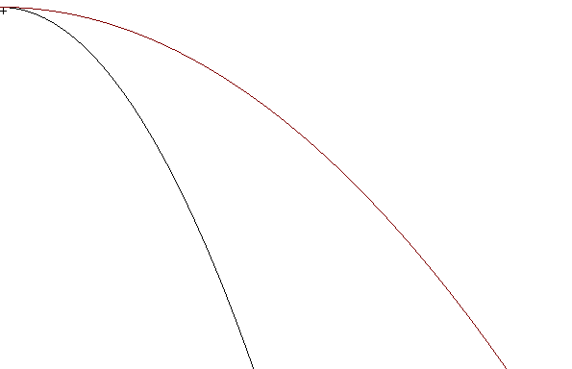 Fig. 1

Solution
s
h

m v₀
M
v – horizontal component of the velocity of the bullet after collision
V – horizontal component of the velocity of the ball after collision

d

Fig. 2

We will use notation shown in Fig. 2.

As no horizontal force acts on the system ball + bullet, the horizontal component of momentum of this system before collision and after collision must be the same:

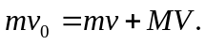

So,

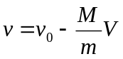.

From conditions described in the text of the problem it follows that

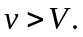

After collision both the ball and the bullet continue a free motion in the gravitational field with initial horizontal velocities v and V, respectively. Motion of the ball and motion of the bullet are continued for the same time:

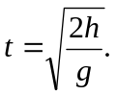

It is time of free fall from height h.
The distances passed by the ball and bullet during time t are:

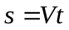 and 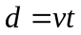,

respectively. Thus

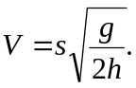

Therefore

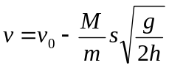.

Finally:

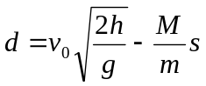.

Numerically:
d = 100 m.

The total kinetic energy of the system was equal to the initial kinetic energy of the bullet:

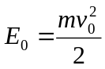.

Immediately after the collision the total kinetic energy of the system is equal to the sum of the kinetic energy of the bullet and the ball:

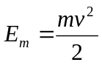, 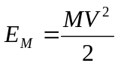.

Their difference, converted into heat, was

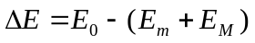.

It is the following part of the initial kinetic energy of the bullet:

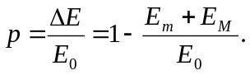
By using expressions for energies and velocities (quoted earlier) we get

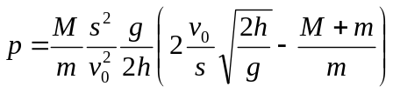.

Numerically:
p = 92,8%.

Problem 2

Consider an infinite network consisting of resistors (resistance of each of them is r) shown in Fig. 3. Find the resultant resistance 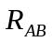 between points A and B.
r
r
r
r
r
r
A
B
A

Fig. 3

Solution

It is easy to remark that after removing the left part of the network, shown in Fig. 4 with the dotted square, then we receive a network that is identical with the initial network (it is result of the fact that the network is infinite).

r
r
r
r
r
r
A
B

Fig. 4

Thus, we may use the equivalence shown graphically in Fig. 5.
R_{AB}
R_{AB}
r
r
⇔

Fig. 5

Algebraically this equivalence can be written as

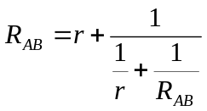.

Thus

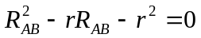.

This equation has two solutions:

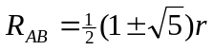.

The solution corresponding to “-“ in the above formula is negative, while resistance must be positive. So, we reject it. Finally we receive

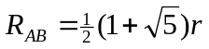.

Problem 3

Consider two identical homogeneous balls, A and B, with the same initial temperatures. One of them is at rest on a horizontal plane, while the second one hangs on a thread (Fig. 6). The same quantities of heat have been supplied to both balls. Are the final temperatures of the balls the same or not? Justify your answer. (All kinds of heat losses are negligible.)

B
A

Fig. 6

Solution

B
A
B
A

Fig. 7

As regards the text of the problem, the sentence “The same quantities of heat have been supplied to both balls.” is not too clear. We will follow intuitive understanding of this sentence, i.e. we will assume that both systems (A – the hanging ball and B – the ball resting on the plane) received the same portion of energy from outside. One should realize, however, that it is not the only possible interpretation.

When the balls are warmed up, their mass centers are moving as the radii of the balls are changing. The mass center of the ball A goes down, while the mass center of the ball B goes up. It is shown in Fig. 7 (scale is not conserved).

Displacement of the mass center corresponds to a change of the potential energy of the ball in the gravitational field.
In case of the ball A the potential energy decreases. From the 1st principle of thermodynamics it corresponds to additional heating of the ball.
In case of the ball B the potential energy increases. From the 1st principle of thermodynamics it corresponds to some “losses of the heat provided” for performing a mechanical work necessary to rise the ball. The net result is that the final temperature of the ball B should be lower than the final temperature of the ball A.
The above effect is very small. For example, one may find (see later) that for balls made of lead, with radius 10 cm, and portion of heat equal to 50 kcal, the difference of the final temperatures of the balls is of order 10⁻⁵ K. For spatial and time fluctuations such small quantity practically cannot be measured.
Calculation of the difference of the final temperatures was not required from the participants. Nevertheless, we present it here as an element of discussion.
We may assume that the work against the atmospheric pressure can be neglected. It is obvious that this work is small. Moreover, it is almost the same for both balls. So, it should not affect the difference of the temperatures substantially. We will assume that such quantities as specific heat of lead and coefficient of thermal expansion of lead are constant (i.e. do not depend on temperature).
The heat used for changing the temperatures of balls may be written as

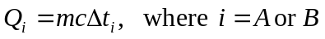,

Here: denotes the mass of ball, - the specific heat of lead and 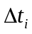 - the change of the temperature of ball.

The changes of the potential energy of the balls are (neglecting signs):

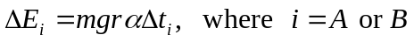.

Here: denotes the gravitational acceleration, - initial radius of the ball, - coefficient of thermal expansion of lead. We assume here that the thread does not change its length.

Taking into account conditions described in the text of the problem and the interpretation mentioned at the beginning of the solution, we may write:

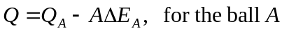,
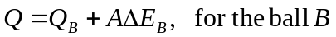.

 denotes the thermal equivalent of work: 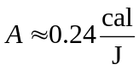. In fact, is only a conversion ratio between calories and joules. If you use a system of units in which calories are not present, you may omit at all.
Thus

,

and

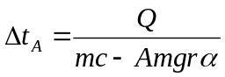, 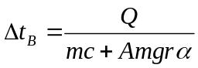.

Finally we get

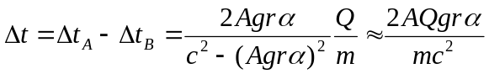.

(We neglected the term with 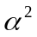 as the coefficient is very small.)

Now we may put the numerical values: 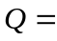50 kcal, 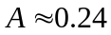cal/J, 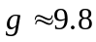m/s², 47 kg (mass of the lead ball with radius equal to 10 cm), 0.1 m, 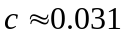cal/(gK), 2910⁻⁶ K⁻¹. After calculations we get 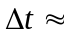1.510⁻⁵ K.

Problem 4

Comment: The Organizing Committee prepared three theoretical problems. Unfortunately, at the time of the 1st Olympiad the Romanian students from the last class had the entrance examinations at the universities. For that Romania sent a team consisting of students from younger classes. They were not familiar with electricity. To give them a chance the Organizers (under agreement of the International Board) added the fourth problem presented here. The students (not only from Romania) were allowed to chose three problems. The maximum possible scores for the problems were: 1st problem – 10 points, 2nd problem – 10 points, 3rd problem – 10 points and 4th problem – 6 points. The fourth problem was solved by 8 students. Only four of them solved the problem for 6 points.

A closed vessel with volume V₀ = 10 l contains dry air in the normal conditions (t₀ = 0°C, p₀ = 1 atm). In some moment 3 g of water were added to the vessel and the system was warmed up to t = 100°C. Find the pressure in the vessel. Discuss assumption you made to solve the problem.

Solution

The water added to the vessel evaporates. Assume that the whole portion of water evaporated. Then the density of water vapor in 100°C should be 0.300 g/l. It is less than the density of saturated vapor at 100°C equal to 0.597 g/l. (The students were allowed to use physical tables.) So, at 100°C the vessel contains air and unsaturated water vapor only (without any liquid phase).
Now we assume that both air and unsaturated water vapor behave as ideal gases. In view of Dalton law, the total pressure p in the vessel at 100°C is equal to the sum of partial pressures of the air p_{a} and unsaturated water vapor p_{v}:

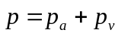.

As the volume of the vessel is constant, we may apply the Gay-Lussac law to the air. We obtain:

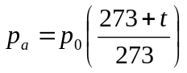.

The pressure of the water vapor may be found from the equation of state of the ideal gas:

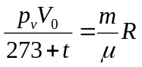,

where m denotes the mass of the vapor, μ - the molecular mass of the water and R – the universal gas constant. Thus,

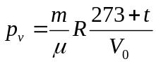

and finally

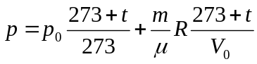.
Numerically:

Experimental problem

The following devices and materials are given:

- Balance (without weights)
- Calorimeter
- Thermometer
- Source of voltage
- Switches
- Wires
- Electric heater
- Stop-watch
- Beakers
- Water
- Petroleum
- Sand (for balancing)

Determine specific heat of petroleum. The specific heat of water is 1 cal/(g°C). The specific heat of the calorimeter is 0.092 cal/(g°C).
Discuss assumptions made in the solution.

Solution

The devices given to the students allowed using several methods. The students used the following three methods:

- Comparison of velocity of warming up water and petroleum;
- Comparison of cooling down water and petroleum;
- Traditional heat balance.

As no weights were given, the students had to use the sand to find portions of petroleum and water with masses equal to the mass of calorimeter.

First method: comparison of velocity of warming up

If the heater is inside water then both water and calorimeter are warming up. The heat taken by water and calorimeter is:

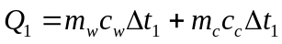,

where: 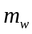 denotes mass of water, 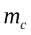- mass of calorimeter, 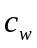- specific heat of water, 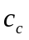- specific heat of calorimeter, 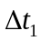- change of temperature of the system water + calorimeter.
On the other hand, the heat provided by the heater is equal:

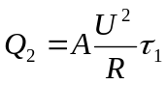,

where: A – denotes the thermal equivalent of work, U – voltage, R – resistance of the heater, τ₁ – time of work of the heater in the water.
Of course,

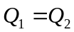.

Thus

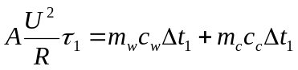.

For petroleum in the calorimeter we get a similar formula:

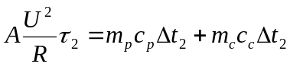.

where: 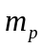 denotes mass of petroleum, 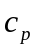- specific heat of petroleum, 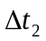- change of temperature of the system water + petroleum, τ₂ – time of work of the heater in the petroleum.

By dividing the last equations we get

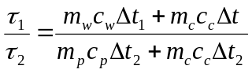.

It is convenient to perform the experiment by taking masses of water and petroleum equal to the mass of the calorimeter (for that we use the balance and the sand). For
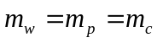

the last formula can be written in a very simple form:

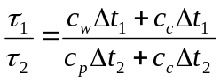.

Thus

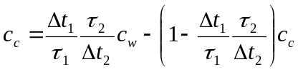
or

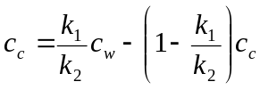,

where

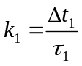 and 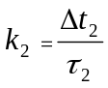

denote “velocities of heating” water and petroleum, respectively. These quantities can be determined experimentally by drawing graphs representing dependence and on time (τ). The experiment shows that these dependences are linear. Thus, it is enough to take slopes of appropriate straight lines. The experimental setup given to the students allowed measurements of the specific heat of petroleum, equal to 0.53 cal/(g°C), with accuracy about 1%.
Some students used certain mutations of this method by performing measurements at = or at 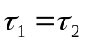. Then, of course, the error of the final result is greater (it is additionally affected by accuracy of establishing the conditions = or at ).

Second method: comparison of velocity of cooling down

Some students initially heated the liquids in the calorimeter and later observed their cooling down. This method is based on the Newton’s law of cooling. It says that the heat Q transferred during cooling in time is given by the formula:

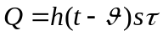,

where: t denotes the temperature of the body, - the temperature of surrounding, s – area of the body, and h – certain coefficient characterizing properties of the surface. This formula is correct for small differences of temperatures 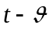 only (small compared to and in the absolute scale).

This method, like the previous one, can be applied in different versions. We will consider only one of them.

Consider the situation when cooling of water and petroleum is observed in the same calorimeter (containing initially water and later petroleum). The heat lost by the system water + calorimeter is

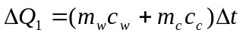,

where  denotes a change of the temperature of the system during certain period 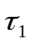. For the system petroleum + calorimeter, under assumption that the change in the temperature is the same, we have

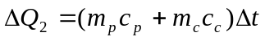.

Of course, the time corresponding to in the second case will be different. Let it be 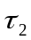.
From the Newton's law we get

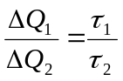.

Thus

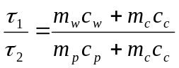.

If we conduct the experiment at
,

then we get

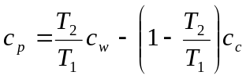.

As cooling is rather a very slow process, this method gives the result with definitely greater error.

Third method: heat balance

This method is rather typical. The students heated the water in the calorimeter to certain temperature and added the petroleum with the temperature . After reaching the thermal equilibrium the final temperature was t. From the thermal balance (neglecting the heat losses) we have

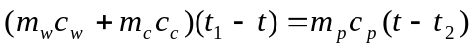.

If, like previously, the experiment is conducted at

,
then

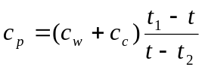.

In this methods the heat losses (when adding the petroleum to the water) always played a substantial role.

The accuracy of the result equal or better than 5% can be reached by using any of the methods described above. However, one should remark that in the first method it was easiest. The most common mistake was neglecting the heat capacity of the calorimeter. This mistake increased the error additionally by about 8%.

Marks

No marking schemes are present in my archive materials. Only the mean scores are available. They are:

Problem # 1 7.6 points
Problem # 2 7.8 points (without the Romanian students)
Problem # 3 5.9 points
Experimental problem 7.7 points

Thanks

The author would like to express deep thanks to Prof. Jan Mostowski and Dr. Yohanes Surya for reviewing the text and for valuable comments and remarks.

Literature

[1] R. Kunfalvi, Collection of Competition Tasks from the Ist trough XVth International Physics Olympiads, 1967 – 1984, Roland Eotvos Physical Society and UNESCO, Budapest 1985
[2] Tadeusz Pniewski, Olimpiady Fizyczne: XV i XVI, PZWS, Warszawa 1969
[3] Waldemar Gorzkowski, Zadania z fizyki z całego świata (z rozwiązaniami) - 20 lat Międzynarodowych Olimpiad Fizycznych, WNT, Warszawa 1994 [ISBN 83-204-1698-1]

This is somewhat extended version of the article sent for publication in Physics Competitions in July 2003.
e-mail: gorzk@ifpan.edu.pl

