Problems of the 2nd International Physics Olympiads
(Budapest, Hungary, 1968)

Péter Vankó

Institute of Physics, Budapest University of Technical Engineering, Budapest, Hungary

Abstract

After a short introduction the problems of the 2nd and the 9th International Physics Olympiad, organized in Budapest, Hungary, 1968 and 1976, and their solutions are presented.

Introduction

Following the initiative of Dr. Waldemar Gorzkowski [1] I present the problems and solutions of the 2nd and the 9th International Physics Olympiad, organized by Hungary. I have used Prof. Rezső Kunfalvi’s problem collection [2], its Hungarian version [3] and in the case of the 9th Olympiad the original Hungarian problem sheet given to the students (my own copy). Besides the digitalization of the text, the equations and the figures it has been made only small corrections where it was needed (type mistakes, small grammatical changes). I omitted old units, where both old and SI units were given, and converted them into SI units, where it was necessary.
If we compare the problem sheets of the early Olympiads with the last ones, we can realize at once the difference in length. It is not so easy to judge the difficulty of the problems, but the solutions are surely much shorter.
The problems of the 2nd Olympiad followed the more than hundred years tradition of physics competitions in Hungary. The tasks of the most important Hungarian theoretical physics competition (Eötvös Competition), for example, are always very short. Sometimes the solution is only a few lines, too, but to find the idea for this solution is rather difficult.
Of the 9th Olympiad I have personal memories; I was the youngest member of the Hungarian team. The problems of this Olympiad were collected and partly invented by Miklós Vermes, a legendary and famous Hungarian secondary school physics teacher. In the first problem only the detailed investigation of the stability was unusual, in the second problem one could forget to subtract the work of the atmospheric pressure, but the fully “open” third problem was really unexpected for us.
The experimental problem was difficult in the same way: in contrast to the Olympiads of today we got no instructions how to measure. (In the last years the only similarly open experimental problem was the investigation of “The magnetic puck” in Leicester, 2000, a really nice problem by Cyril Isenberg.) The challenge was not to perform many-many measurements in a short time, but to find out what to measure and how to do it.
Of course, the evaluating of such open problems is very difficult, especially for several hundred students. But in the 9th Olympiad, for example, only ten countries participated and the same person could read, compare, grade and mark all of the solutions.

2nd IPhO (Budapest, 1968)

Theoretical problems

Problem 1

On an inclined plane of 30° a block, mass m₂ = 4 kg, is joined by a light cord to a solid cylinder, mass m₁ = 8 kg, radius r = 5 cm (Fig. 1). Find the acceleration if the bodies are released. The coefficient of friction between the block and the inclined plane μ = 0.2. Friction at the bearing and rolling friction are negligible.

α
m₁
m₂
Figure 1
α
m₂gsinα
Figure 2
F
F
μ m₂gcosα
S
m₁gsinα
r

Solution

If the cord is stressed the cylinder and the block are moving with the same acceleration a. Let F be the tension in the cord, S the frictional force between the cylinder and the inclined plane (Fig. 2). The angular acceleration of the cylinder is a/r. The net force causing the acceleration of the block:

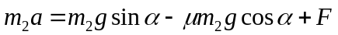,

and the net force causing the acceleration of the cylinder:

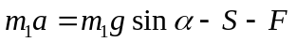.

The equation of motion for the rotation of the cylinder:

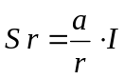.

(I is the moment of inertia of the cylinder, S⋅r is the torque of the frictional force.)
Solving the system of equations we get:

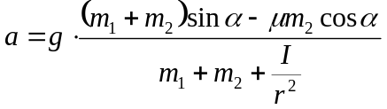, (1)

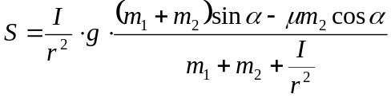, (2)

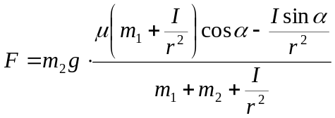. (3)

The moment of inertia of a solid cylinder is 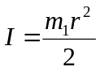. Using the given numerical values:

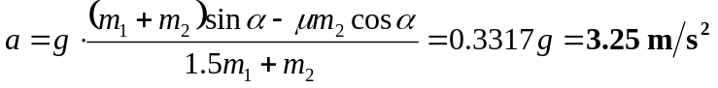,
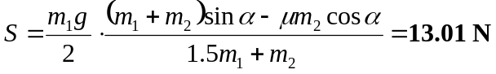,
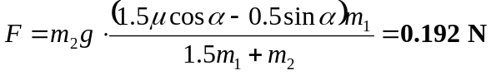.

Discussion (See Fig. 3.)

The condition for the system to start moving is a > 0. Inserting a = 0 into (1) we obtain the limit for angle α₁:

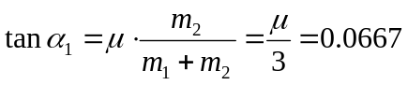, 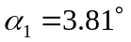.

For the cylinder separately 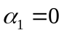, and for the block separately 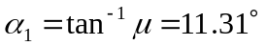.
If the cord is not stretched the bodies move separately. We obtain the limit by inserting F = 0 into (3):

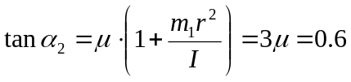, 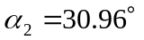.

The condition for the cylinder to slip is that the value of S (calculated from (2) taking the same coefficient of friction) exceeds the value of 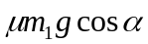. This gives the same value for α₃ as we had for α₂. The acceleration of the centers of the cylinder and the block is the same: 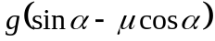, the frictional force at the bottom of the cylinder is , the peripheral acceleration of the cylinder is 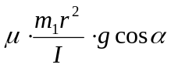.
β r, a
g
α
0°
30°
60°
90°
F, S (N)
α₁
α₂=α₃
10
20
F
S
β r
a
Figure 3

Problem 2

There are 300 cm³ toluene of 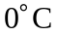 temperature in a glass and 110 cm³ toluene of 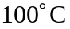 temperature in another glass. (The sum of the volumes is 410 cm³.) Find the final volume after the two liquids are mixed. The coefficient of volume expansion of toluene 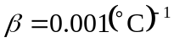. Neglect the loss of heat.
Solution

If the volume at temperature t₁ is V₁, then the volume at temperature is 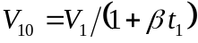. In the same way if the volume at t₂ temperature is V₂, at we have 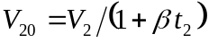. Furthermore if the density of the liquid at is d, then the masses are 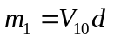 and 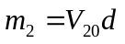, respectively. After mixing the liquids the temperature is

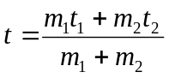.

The volumes at this temperature are 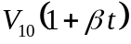 and 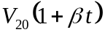.
The sum of the volumes after mixing:

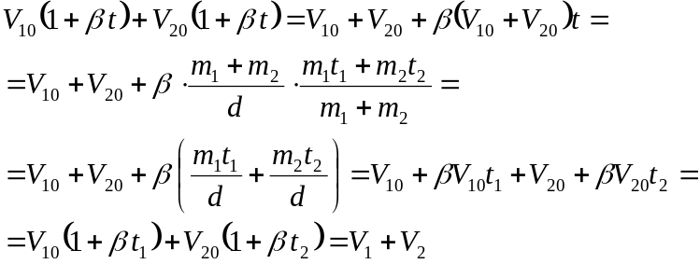

The sum of the volumes is constant. In our case it is 410 cm³. The result is valid for any number of quantities of toluene, as the mixing can be done successively adding always one more glass of liquid to the mixture.

Problem 3

Parallel light rays are falling on the plane surface of a semi-cylinder made of glass, at an angle of 45°, in such a plane which is perpendicular to the axis of the semi-cylinder (Fig. 4). (Index of refraction is .) Where are the rays emerging out of the cylindrical surface?
Figure 4
Figure 5
ϕ
α
β
A
C
D
O
B
E

Solution

Let us use angle ϕ to describe the position of the rays in the glass (Fig. 5). According to the law of refraction 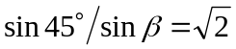, 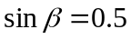, 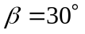. The refracted angle is 30° for all of the incoming rays. We have to investigate what happens if ϕ changes from 0° to 180°.
It is easy to see that ϕ can not be less than 60° (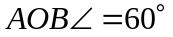). The critical angle is given by 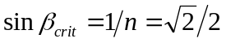; hence 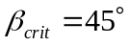. In the case of total internal reflection 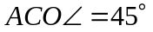, hence 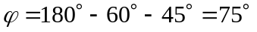. If ϕ is more than 75° the rays can emerge the cylinder. Increasing the angle we reach the critical angle again if 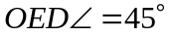. Thus the rays are leaving the glass cylinder if:
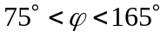,
CE, arc of the emerging rays, subtends a central angle of 90°.

Experimental problem

Three closed boxes (black boxes) with two plug sockets on each are present for investigation. The participants have to find out, without opening the boxes, what kind of elements are in them and measure their characteristic properties. AC and DC meters (their internal resistance and accuracy are given) and AC (5O Hz) and DC sources are put at the participants’ disposal.

Solution

No voltage is observed at any of the plug sockets therefore none of the boxes contains a source.
Measuring the resistances using first AC then DC, one of the boxes gives the same result. Conclusion: the box contains a simple resistor. Its resistance is determined by measurement.
One of the boxes has a very great resistance for DC but conducts AC well. It contains a capacitor, the value can be computed as 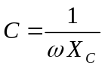.
The third box conducts both AC and DC, its resistance for AC is greater. It contains a resistor and an inductor connected in series. The values of the resistance and the inductance can be computed from the measurements.

