Problems of the IV International Olympiad, Moscow, 1970
The publication is prepared by Prof. S. Kozel & Prof. V.Orlov
(Moscow Institute of Physics and Technology)

The IV International Olympiad in Physics for schoolchildren took place in Moscow (USSR) in July 1970 on the basis of Moscow State University. Teams from 8 countries participated in the competition, namely Bulgaria, Hungary, Poland, Romania, Czechoslovakia, the DDR, the SFR Yugoslavia, the USSR. The problems for the theoretical competition have been prepared by the group from Moscow University stuff headed by professor V.Zubov. The problem for the experimental competition has been worked out by B. Zvorikin from the Academy of Pedagogical Sciences.
It is pity that marking schemes were not preserved.

Theoretical Problems

Problem 1.
A long bar with the mass M = 1 kg is placed on a smooth horizontal surface of a table where it can move frictionless. A carriage equipped with a motor can slide along the upper horizontal panel of the bar, the mass of the carriage is m = 0.1 kg. The friction coefficient of the carriage is μ = 0.02. The motor is winding a thread around a shaft at a constant speed v₀ = 0.1 m/s. The other end of the thread is tied up to a rather distant stationary support in one case (Fig.1, a), whereas in the other case it is attached to a picket at the edge of the bar (Fig.1, b). While holding the bar fixed one allows the carriage to start moving at the velocity V₀ then the bar is let loose.
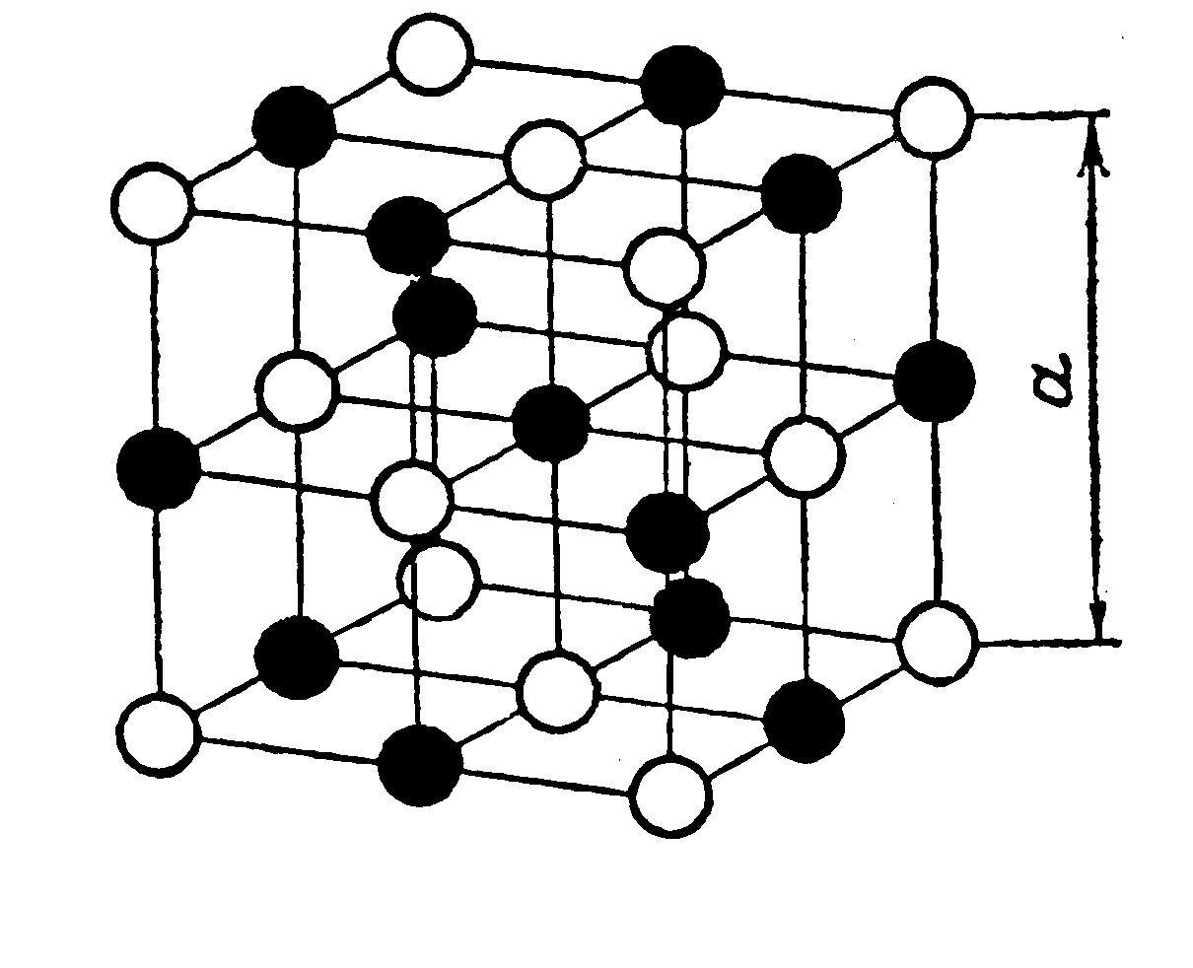
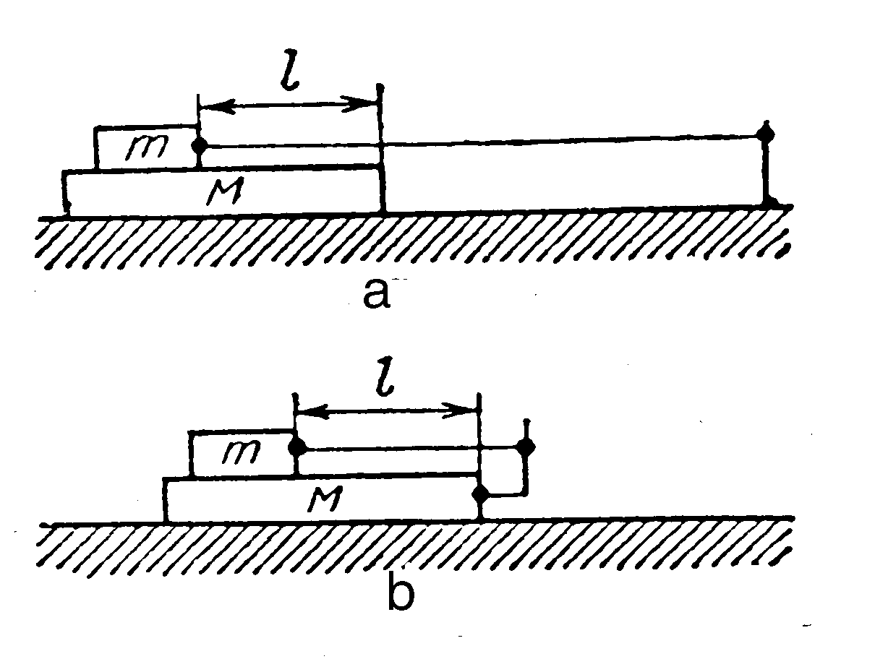

Fig. 1 Fig. 2
By the moment the bar is released the front edge of the carriage is at the distance l = 0.5 m from the front edge of the bar. For both cases find the laws of movement of both the bar and the carriage and the time during which the carriage will reach the front edge of the bar.

Problem 2.
A unit cell of a crystal of natrium chloride (common salt- NaCl) is a cube with the edge length a = 5.6ּ10⁻¹⁰ m (Fig.2). The black circles in the figure stand for the position of natrium atoms whereas the white ones are chlorine atoms. The entire crystal of common salt turns out to be a repetition of such unit cells. The relative atomic mass of natrium is 23 and that of chlorine is 35,5. The density of the common salt ρ = 2.22ּ10³ kg/m³ . Find the mass of a hydrogen atom.

Problem 3.
Inside a thin-walled metal sphere with radius R=20 cm there is a metal ball with the radius r = 10 cm which has a common centre with the sphere. The ball is connected with a very long wire to the Earth via an opening in the sphere (Fig. 3). A charge Q = 10⁻⁸ C is placed onto the outside sphere. Calculate the potential of this sphere, electrical capacity of the obtained system of conducting bodies and draw out an equivalent electric scheme.
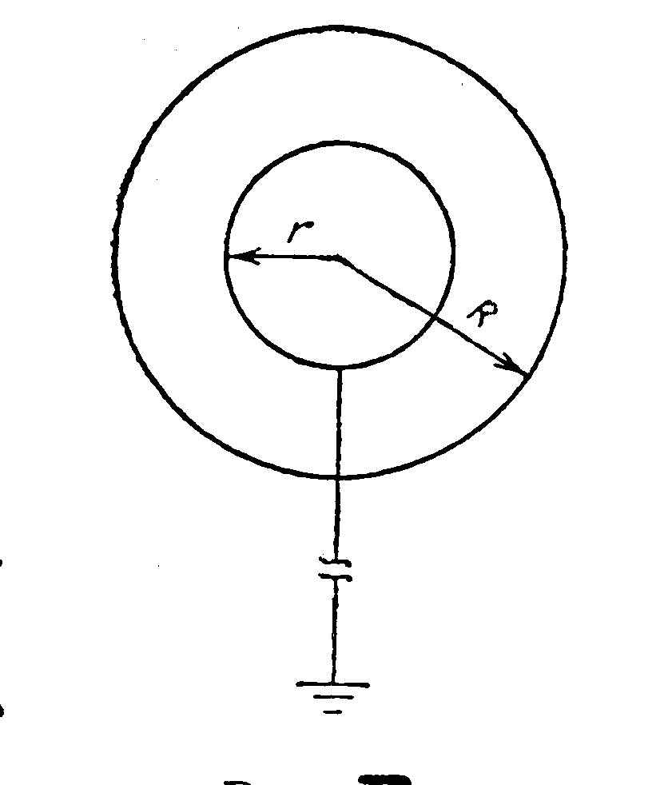
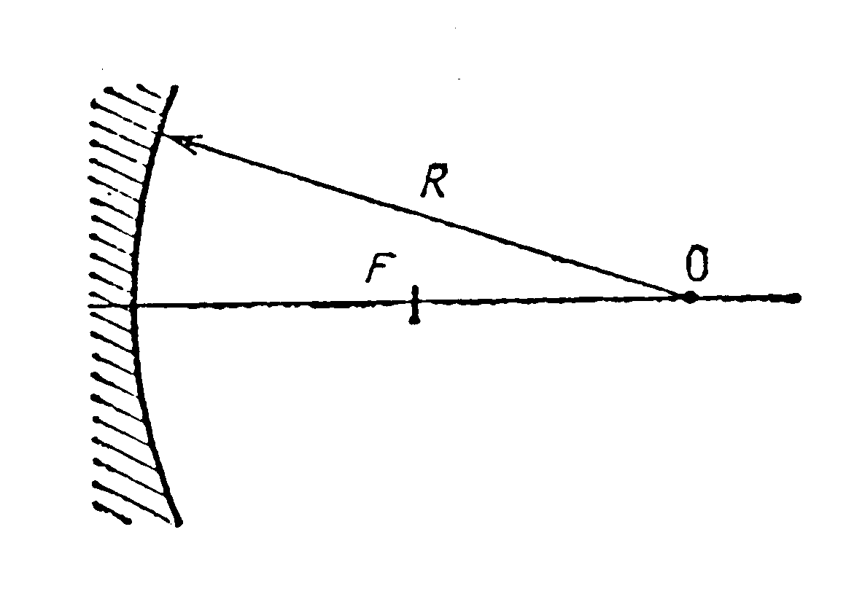

Fig. 3 Fig. 4

Problem 4.
A spherical mirror is installed into a telescope. Its lateral diameter is D=0,5 m and the radius of the curvature R=2 m. In the main focus of the mirror there is an emission receiver in the form of a round disk. The disk is placed perpendicular to the optical axis of the mirror (Fig.7). What should the radius r of the receiver be so that it could receive the entire flux of the emission reflected by the mirror? How would the received flux of the emission decrease if the detector’s dimensions decreased by 8 times?
Directions: 1) When calculating small values α (α<<1) one may perform a substitution 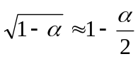; 2) diffraction should not be taken into account.

Experimental Problem

Determine the focal distances of lenses.
List of instruments: three different lenses installed on posts, a screen bearing an image of a geometric figure, some vertical wiring also fixed on the posts and a ruler.

Solutions of the problems of the IV International Olympiad, Moscow, 1970
Theoretical Competition

Problem 1.
a) By the moment of releasing the bar the carriage has a velocity v₀ relative to the table and continues to move at the same velocity.
The bar, influenced by the friction force F_{fr} = μmg from the carriage, gets an acceleration
a = F_{fr}/ M = μmg/M ; a = 0.02 m/s , while the velocity of the bar changes with time according to the law v_{b} = at. .
Since the bar can not move faster than the carriage then at a moment of time t = t₀ its sliding will stop, that is v_{b} = v₀. Let us determine this moment of time:
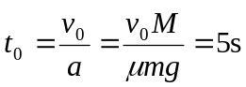

By that moment the displacement of the Sb bar and the carriage Sc relative to the table will be equal to
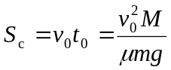 , 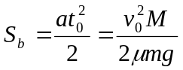.
The displacement of the carriage relative to the bar is equal to
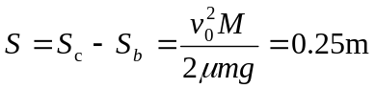
Since S<l, the carriage will not reach the edge of the bar until the bar is stopped by an immovable support. The distance to the support is not indicated in the problem condition so we can not calculate this time. Thus, the carriage is moving evenly at the velocity v₀ = 0.1 m/s, whereas the bar is moving for the first 5 sec uniformly accelerated with an acceleration a = 0.02 m/s and then the bar is moving with constant velocity together with the carriage.
b) Since there is no friction between the bar and the table surface the system of the bodies “bar-carriage” is a closed one. For this system one can apply the law of conservation of momentum:
mv + Mu = mv₀ (1)
where v and u are projections of velocities of the carriage and the bar relative to the table onto the horizontal axis directed along the vector of the velocity v₀. The velocity of the thread winding v₀ is equal to the velocity of the carriage relative to the bar (v-u), that is
v₀ = v – u (2)
Solving the system of equations (1) and (2) we obtain:
u = 0 , v = v_{0 .}
Thus, being released the bar remains fixed relative to the table, whereas the carriage will be moving with the same velocity v₀ and will reach the edge of the bar within the time t equal to
t = l/v₀ = 5 s.

Problem 2.
Let’s calculate the quantities of natrium atoms (n₁) and chlorine atoms (n₂) embedded in a single NaCl unit crystal cell (Fig.2).
One atom of natrium occupies the middle of the cell and it entirely belongs to the cell. 12 atoms of natrium hold the edges of a large cube and they belong to three more cells so as 1/4 part of each belongs to the first cell. Thus we have
n₁ = 1+12⋅1/4 = 4 atoms of natrium per unit cell.
In one cell there are 6 atoms of chlorine placed on the side of the cube and 8 placed in the vertices. Each atom from a side belongs to another cell and the atom in the vertex - to seven others. Then for one cell we have
n₂= 6⋅1/2 + 8⋅ 1/8 = 4 atoms of chlorine.
Thus 4 atoms of natriun and 4 atoms of chlorine belong to one unit cell of NaCl crystal.
The mass m of such a cell is equal
m = 4(m_{rNa} + m_{rCl}) (amu),
where m_{rNa} and m_{rCl} are relative atomic masses of natrium and clorine. Since the mass of hydrogen atom m_{H} is approximately equal to one atomic mass unit: m_{H} = 1.008 amu ≈ 1 amu then the mass of an unit cell of NaCl is
m = 4(m_{rNa} + m_{rCl}) m_{H} .

On the other hand, it is equal m = ρa³ , hence
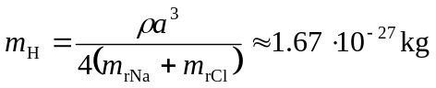.
Problem 3.
Having no charge on the ball the sphere has the potential
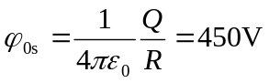.
When connected with the Earth the ball inside the sphere has the potential equal to zero so there is an electric field between the ball and the sphere. This field moves a certain charge q from the Earth to the ball. Charge Q`, uniformly distributed on the sphere, doesn’t create any field inside thus the electric field inside the sphere is defined by the ball’s charge q. The potential difference between the balls and the sphere is equal
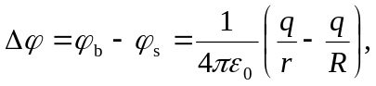 (1)
Outside the sphere the field is the same as in the case when all the charges were placed in its center. When the ball was connected with the Earth the potential of the sphere φ_{s} is equal
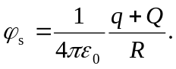 (2)

Then the potential of the ball
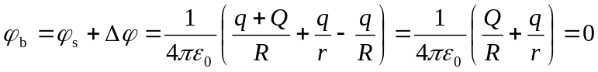 (3)
Which leads to
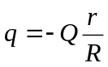. (4)
Substituting (4) into (2) we obtain for potential of the sphere to be found:
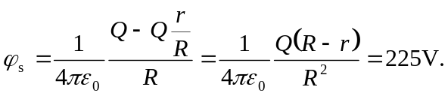
The electric capacity of whole system of conductors is
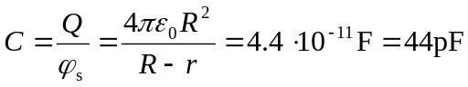
The equivalent electric scheme consists of two parallel capacitors: 1) a spherical one with charges +q and –q at the plates and 2) a capacitor “sphere – Earth” with charges +(Q-q) and
–(Q–q) at the plates (Fig.5).
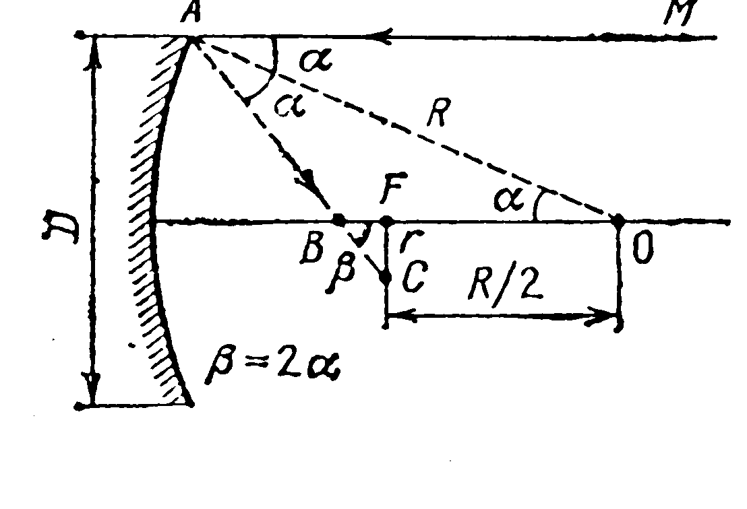
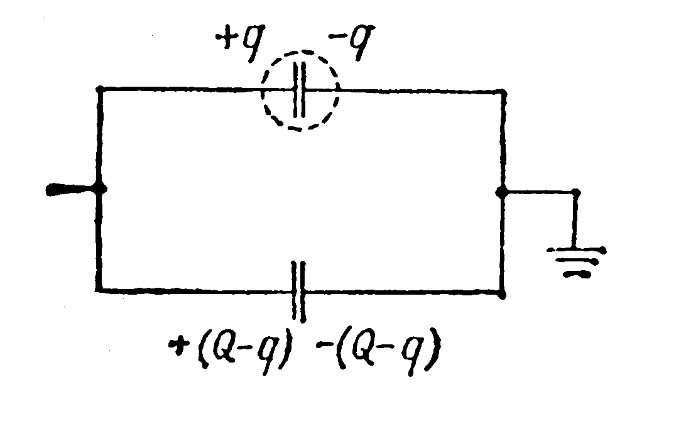

Fig. 5 Fig. 6

Problem 4.
As known, rays parallel to the main optical axis of a spherical mirror, passing at little distances from it after having been reflected, join at the main focus of the mirror F which is at the distance R/2 from the centre O of the spherical surface. Let us consider now the movement of the ray reflected near the edge of the spherical mirror of large diameter D (Fig. 6). The angle of incidence α of the ray onto the surface is equal to the angle of reflection. That is why the angle OAB within the triangle, formed by the radius OA of the sphere, traced to the incidence point of the ray by the reflected ray Ab and an intercept BO of the main optical axis, is equal to α. The angles BOA and MAO are equal, that is the angle BOA is equal to α.
Thus, the triangle AOB is isosceles with its side AB being equal to the side BO. Since the sum of the lengths of its two other sides exceeds the length of its third side, AB+BO>OA=R, hence BO>R/2. This means that a ray parallel to the main optical axis of the spherical mirror and passing not too close to it, after having been reflected, crosses the main optical axis at the point B lying between the focus F and the mirror. The focal surface is crossed by this ray at the point C which is at a certain distance CF = r from the main focus.
Thus, when reflecting a parallel beam of rays by a spherical mirror finite in size it does not join at the focus of the mirror but forms a beam with radius r on the focal plane.
From Δ BFC we can write :
r = BF tg β = BF tg 2α ,

where α is the maximum angle of incidence of the extreme ray onto the mirror, while sin α = D/2R:
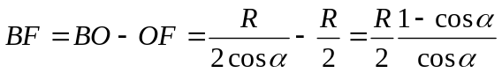.
Thus, 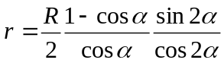. Let us express the values of cos α, sin 2α, cos 2α via sin α taking into account the small value of the angle α:

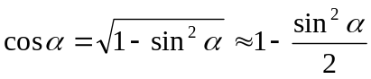,
sin2α = 2sinαcosα ,
cos2α =cos²α – sin²α = 1 – 2sin²α .
Then
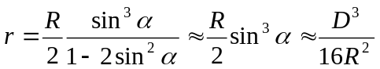.
Substituting numerical data we will obtain: r ≈ 1.95∙10⁻³ m ≈ 2mm .

From the expression 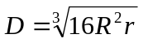 one can see that if the radius of the receiver is decreased 8 times the transversal diameter D’ of the mirror, from which the light comes to the receiver, will be decreased 2 times and thus the “effective” area of the mirror will be decreased 4 times.
The radiation flux Φ reflected by the mirror and received by the receiver will also be decreased twice since Φ ∼ S.

Solution of the Experimental Problem

While looking at objects through lenses it is easy to establish that there were given two converging lenses and a diverging one.
The peculiarity of the given problem is the absence of a white screen on the list of the equipment that is used to observe real images. The competitors were supposed to determine the position of the images by the parallance method observing the images with their eyes.
The focal distance of the converging lens may be determined by the following method.
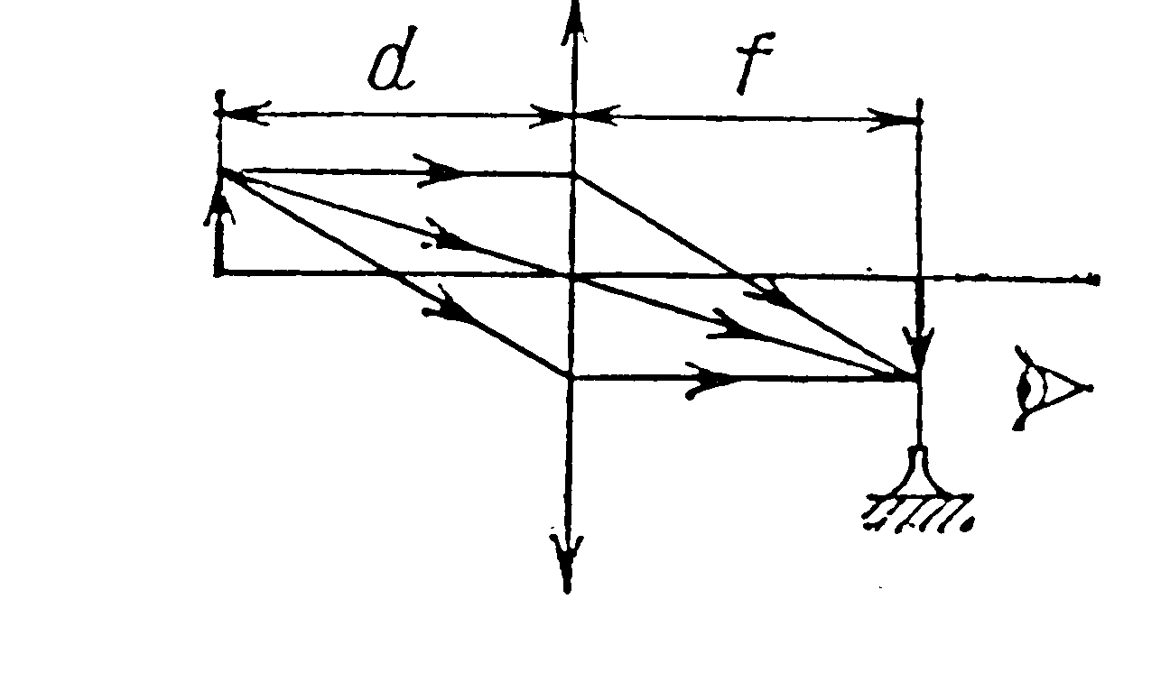
Using a lens one can obtain a real image of a geometrical figure shown on the screen. The position of the real image is registered by the parallax method: if one places a vertical wire (Fig.7) to the point, in which the image is located, then at small displacements of the eye from the main optical axis of the lens
Fig. 7
the image of this object and the wire will not diverge.
We obtain the value of focal distance F from the formula of thin lens by the measured distances d and f :
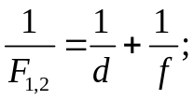 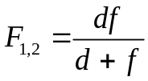 .

In this method the best accuracy is achieved in the case of
f = d.

The competitors were not asked to make a conclusion.
The error of measuring the focal distance for each of the two converging lenses can be determined by multiple repeated measurements. The total number of points was given to those competitors who carried out not less fewer than n=5 measurements of the focal distance and estimated the mean value of the focal distance Fav:
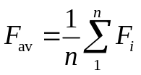

and the absolute error 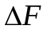
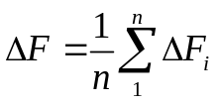, 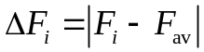
or root mean square error 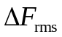
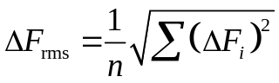.

One could calculate the error by graphic method.

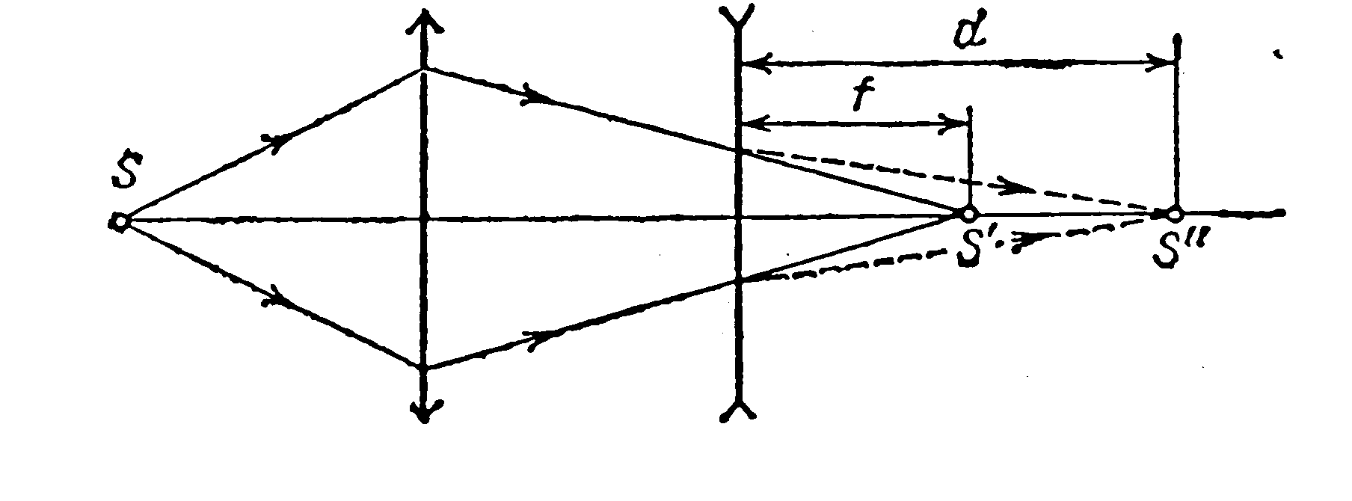

Fig. 8
Determination of the focal distance of the diverging lens can be carried out by the method of compensation. With this goal one has to obtain a real image S’ of the object S using a converging lens. The position of the image can be registered using the parallax method.
If one places a diverging lens between the image and the converging lens the image will be displaced. Let us find a new position of the image S”. Using the reversibility property of the light rays, one can admit that the light rays leave the point S”. Then point S’ is a virtual image of the point S”, whereas the distances from the optical centre of the concave lens to the points S’ and S” are, respectively, the distances f to the image and d to the object (Fig.8). Using the formula of a thin lens we obtain

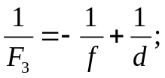 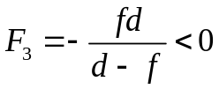 .

Here F < 0 is the focal distance of the diverging lens. In this case the error of measuring the focal distance can also be estimated by the method of repeated measurements similar to the case of the converging lens.
Typical results are:
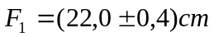, 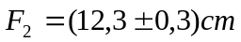, 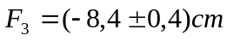.

Acknowledgement
The authors would like to thank Professor Waldemar Gorzkowski (Poland) and Professor Ivo Volf (Czech Republic) for their providing the materials of the IV IPhO in the Polish and Czech languages.

References:
- O.Kabardin, V.Orlov, International Physics Olympiads for Pupils, Nauka, Moskva 1985
- W.Gorzkowski, Zadania z fiziki z calego swiata – 20 lat. Miedzyna – rodowych Olimpiad Fizycznych, WNT, Warszawa 1994
- V.Urumov, Prosventno Delo, Skopje 1999
- D.Kluvanec, I.Volf, Mezinarodni Fysikalni Olympiady (metodycky material), MaFy, Hradec Kralowe 1993

