Problems of the 6th International Physics Olympiad
(Bucharest, 1972)

Romulus Pop
Civil Engineering University, Physics Department
Bucharest, Romania

The sixth IPhO was held in Bucharest and the participants were: Bulgaria, Czechoslovakia, Cuba, France, German Democratic Republic, Hungary, Poland, Romania, and Soviet Union. It was an important event because it was the first time when a non-European country and a western country participated (Cuba), and Sweden sent one observer.
The International Board selected four theoretical problems and an experimental problem. Each theoretical problem was scored from 0 to 10 and the maximum score for the experimental problem was 20. The highest score corresponding to actual marking system was 47,5 points. Each team consisted in six students. Four students obtained the first prize, seven students obtained the second prize, ten students obtained the third prize, thirteen students had got honorable mentions, and two special prizes were awarded too.
The article contains the competition problems given at the 6th International Physics Olympiad (Bucharest, 1972) and their solutions. The problems were translated from the book published in Romania concerning the first nine International Physics Olympiads, because I couldn’t find the original English version.

Theoretical problems

Problem 1 (Mechanics)

Three cylinders with the same mass, the same length and the same external radius are initially resting on an inclined plane. The coefficient of sliding friction on the inclined plane, μ, is known and has the same value for all the cylinders. The first cylinder is empty (tube) , the second is homogeneous filled, and the third has a cavity exactly like the first, but closed with two negligible mass lids and filled with a liquid with the same density like the cylinder’s walls. The friction between the liquid and the cylinder wall is considered negligible. The density of the material of the first cylinder is n times greater than that of the second or of the third cylinder.
Determine:
- The linear acceleration of the cylinders in the non-sliding case. Compare all the accelerations.
- Condition for angle α of the inclined plane so that no cylinders is sliding.
- The reciprocal ratios of the angular accelerations in the case of roll over with sliding of all the three cylinders. Make a comparison between these accelerations.
- The interaction force between the liquid and the walls of the cylinder in the case of sliding of this cylinder, knowing that the liquid mass is m_{l}.

Solution Problem 1

The inertia moments of the three cylinders are:

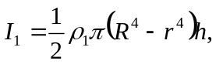 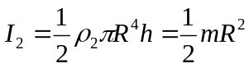 , 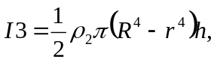 (1)
Because the three cylinders have the same mass :

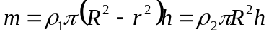 (2)
it results:

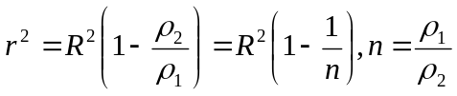 (3)

The inertia moments can be written:

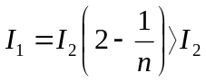 , 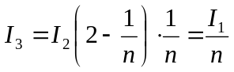 (4)

In the expression of the inertia momentum 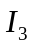 the sum of the two factors is constant:
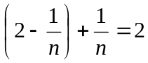
independent of n, so that their products are maximum when these factors are equal:
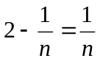 ; it results n = 1, and the products 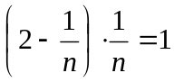. In fact n > 1, so that the products is les than 1. It results:

I₁ > I₂ > I₃ (5)
For a cylinder rolling over freely on the inclined plane (fig. 1.1) we can write the equations:

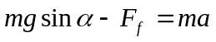 (6)
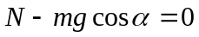
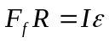 (7)

where ε is the angular acceleration. If the cylinder doesn’t slide we have the condition:

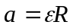 (8)

Solving the equation system (6-8) we find:

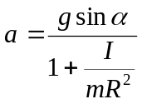 , 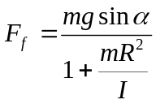 (9)

The condition of non-sliding is:

F_{f} < μN = μmgsinα

tgα < 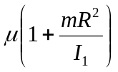 (10)

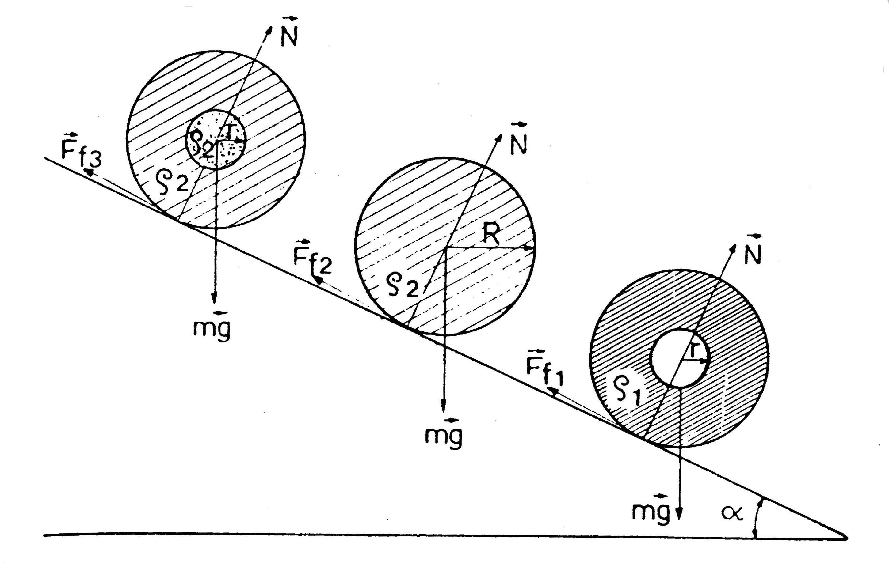
Fig. 1.1
In the case of the cylinders from this problem, the condition necessary so that none of them slides is obtained for maximum I:

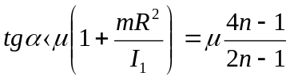 (11)

The accelerations of the cylinders are:

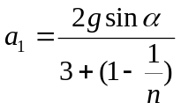 , 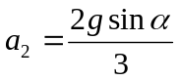 , 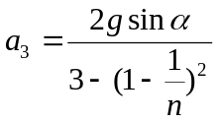. (12)

The relation between accelerations:

a₁ < a₂ < a₃ (13)

In the case than all the three cylinders slide:
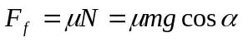 (14)
and from (7) results:
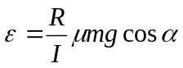 (15)
for the cylinders of the problem:

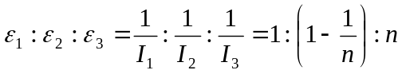

ε_{1 <} ε₂ < ε₃ (16)

In the case that one of the cylinders is sliding:

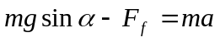, 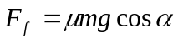, (17)
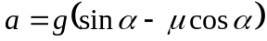 (18)

Let be the total force acting on the liquid mass m_{l} inside the cylinder (fig.1.2), we can write:

, 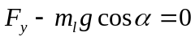 (19)
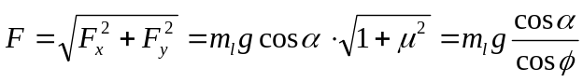 (20)
where is the friction angle 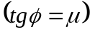.

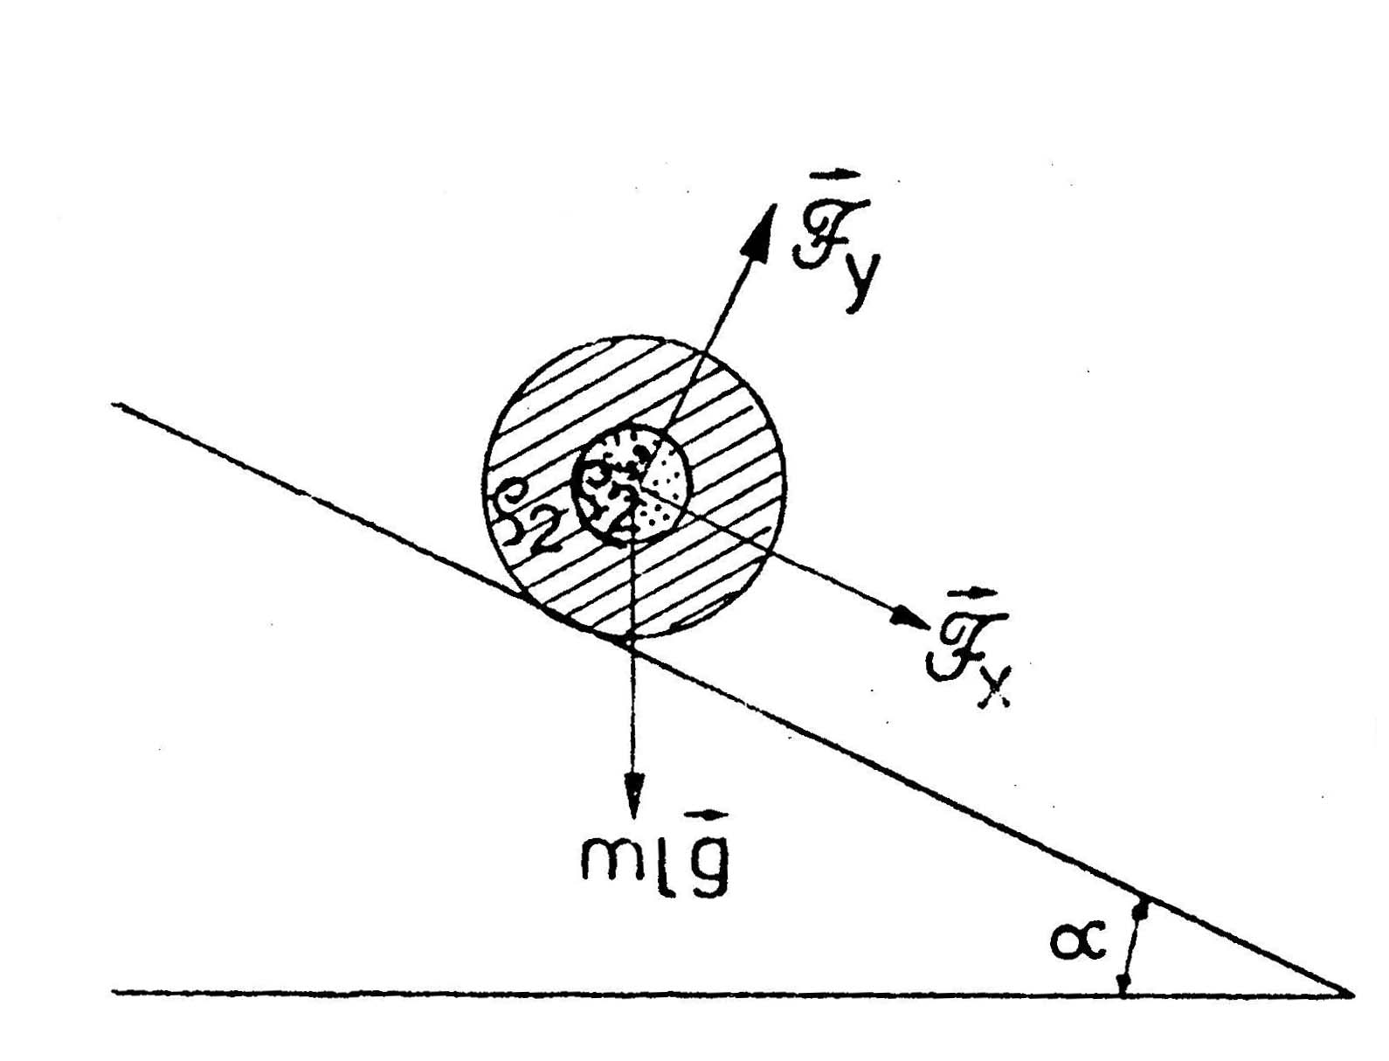
Fig. 1.2

Problem 2 (Molecular Physics)

Two cylinders A and B, with equal diameters have inside two pistons with negligible mass connected by a rigid rod. The pistons can move freely. The rod is a short tube with a valve. The valve is initially closed (fig. 2.1).

A
B
Fig. 2.1

The cylinder A and his piston is adiabatically insulated and the cylinder B is in thermal contact with a thermostat which has the temperature θ = 27ºC.
Initially the piston of the cylinder A is fixed and inside there is a mass m= 32 kg of argon at a pressure higher than the atmospheric pressure. Inside the cylinder B there is a mass of oxygen at the normal atmospheric pressure.
Liberating the piston of the cylinder A, it moves slowly enough (quasi-static) and at equilibrium the volume of the gas is eight times higher, and in the cylinder B de oxygen’s density increased two times. Knowing that the thermostat received the heat Q’=747,9.10⁴J, determine:
- Establish on the base of the kinetic theory of the gases, studying the elastic collisions of the molecules with the piston, that the thermal equation of the process taking place in the cylinder A is TV^{2/3} = constant.
- Calculate the parameters p, V, and T of argon in the initial and final states.
- Opening the valve which separates the two cylinders, calculate the final pressure of the mixture of the gases.
The kilo-molar mass of argon is μ = 40 kg/kmol.

Solution Problem 2

- We consider argon an ideal mono-atomic gas and the collisions of the atoms with the piston perfect elastic. In such a collision with a fix wall the speed of the particle changes only the direction so that the speed and the speed 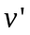after collision there are in the same plane with the normal and the incident and reflection angle are equal.
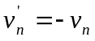, 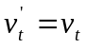 (1)
In the problem the wall moves with the speed perpendicular on the wall. The relative speed of the particle with respect the wall is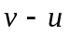. Choosing the Oz axis perpendicular on the wall in the sense of , the conditions of the elastic collision give:
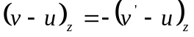 , 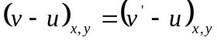;
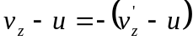 , 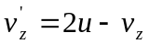, 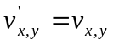 (2)
The increase of the kinetic energy of the particle with mass 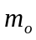 after collision is:
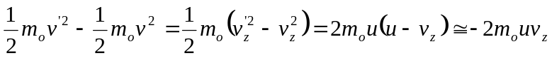 (3)
because u is much smaller than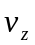.
If 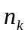is the number of molecules from unit volume with the speed component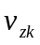, then the number of molecules with this component which collide in the time dt the area dS of the piston is:
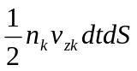 (4)
These molecules will have a change of the kinetic energy:
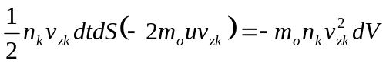 (5)

where 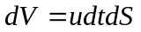 is the increase of the volume of gas.
The change of the kinetic energy of the gas corresponding to the increase of volume dV is:
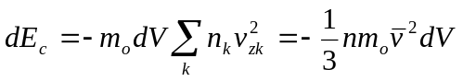 (6)

and:
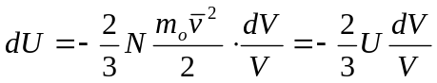 (7)

Integrating equation (7) results:
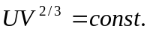 (8)
The internal energy of the ideal mono-atomic gas is proportional with the absolute temperature T and the equation (8) can be written:
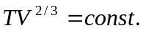 (9)
- The oxygen is in contact with a thermostat and will suffer an isothermal process. The internal energy will be modified only by the adiabatic process suffered by argon gas:
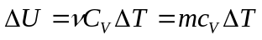 (10)
where is the number of kilomoles. For argon 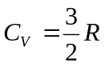.
For the entire system L=0 and 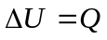.
We will use indices 1, respectively 2, for the measures corresponding to argon from cylinder A, respectively oxygen from the cylinder B:
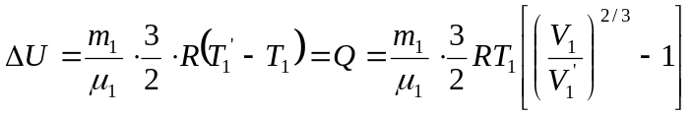 (11)
From equation (11) results:
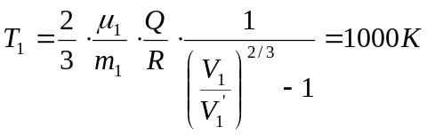 (12)
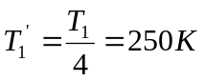 (13)
For the isothermal process suffered by oxygen:
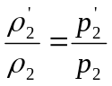 (14)

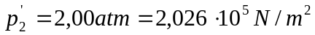
From the equilibrium condition:
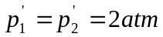 (15)
For argon:
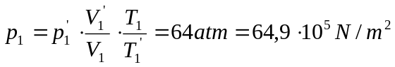 (16)
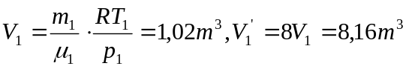 (17)
- When the valve is opened the gases intermix and at thermal equilibrium the final pressure will be 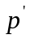 and the temperature T. The total number of kilomoles is constant:
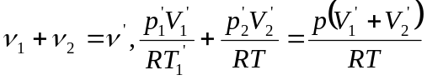 (18)
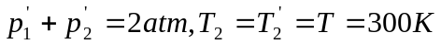
The total volume of the system is constant:
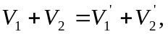 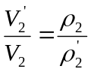, 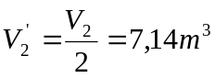 (19)

From equation (18) results the final pressure:
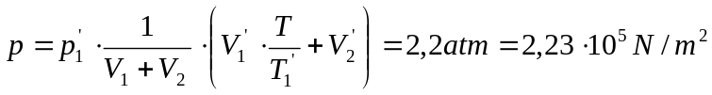 (20)

Problem 3 (Electricity)

A plane capacitor with rectangular plates is fixed in a vertical position having the lower part in contact with a dielectric liquid (fig. 3.1)
Determine the height, h, of the liquid between the plates and explain the phenomenon.
The capillarity effects are neglected.
It is supposed that the distance between the plates is much smaller than the linear dimensions of the plates.

h
H
Fig. 3.1

It is known: the initial intensity of the electric field of the charged capacitor, E, the density ρ, the relative electric permittivity ε_{r} of the liquid, and the height H of the plates of the capacitor. Discussion.

Solution Problem 3

The initial energy on the capacitor is:
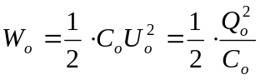, where 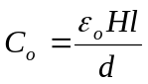 (1)
H is the height of the plates, l is the width of the capacitor’s plates, and d is the distance between the plates.
When the plates contact the liquid’s surface on the dielectric liquid is exerted a vertical force. The total electric charge remains constant and there is no energy transferred to the system from outside. The increase of the gravitational energy is compensated by the decrease of the electrical energy on the capacitor:
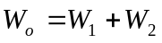 (2)
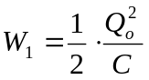, 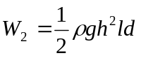 (3)
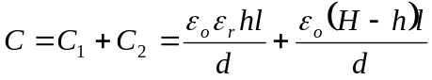 (4)
Introducing (3) and (4) in equation (2) it results:
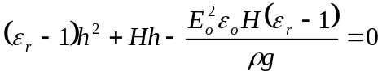
The solution is:
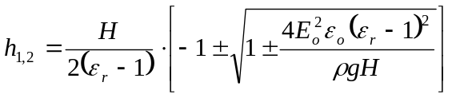 (8)

Discussion: Only the positive solution has sense. Taking in account that H is much more grater than h we obtain the final result:
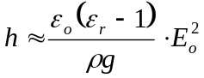

Problem 4 (Optics)

A thin lens plane-convex with the diameter 2r, the curvature radius R and the refractive index n_{o} is positioned so that on its left side is air (n₁ =1), and on its right side there is a transparent medium with the refractive index n₂ ≠ 1. The convex face of the lens is directed towards air. In the air, at the distance s₁from the lens, measured on the principal optic ax, there is a punctual source of monochromatic light.
a) Demonstrate, using Gauss approximation, that between the position of the image, given by the distance s₂ from the lens, and the position of the light source, exists the relation:
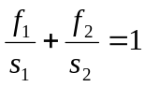
where f₁ and f₂ are the focal distances of the lens, in air, respectively in the medium with the refractive index n₂.
Observation: All the refractive indexes are absolute indexes.
b) The lens is cut perpendicular on its plane face in two equal parts. These parts are moved away at a distance δ << r (Billet lens). On the symmetry axis of the system obtained is led a punctual source of light at the distance s₁ (s₁ > f₁) (fig. 4.1). On the right side of the lens there is a screen E at the distance d. The screen is parallel with the plane face of the lens. On this screen there are N interference fringes, if on the right side of the lens is air.
Determine N function of the wave length.
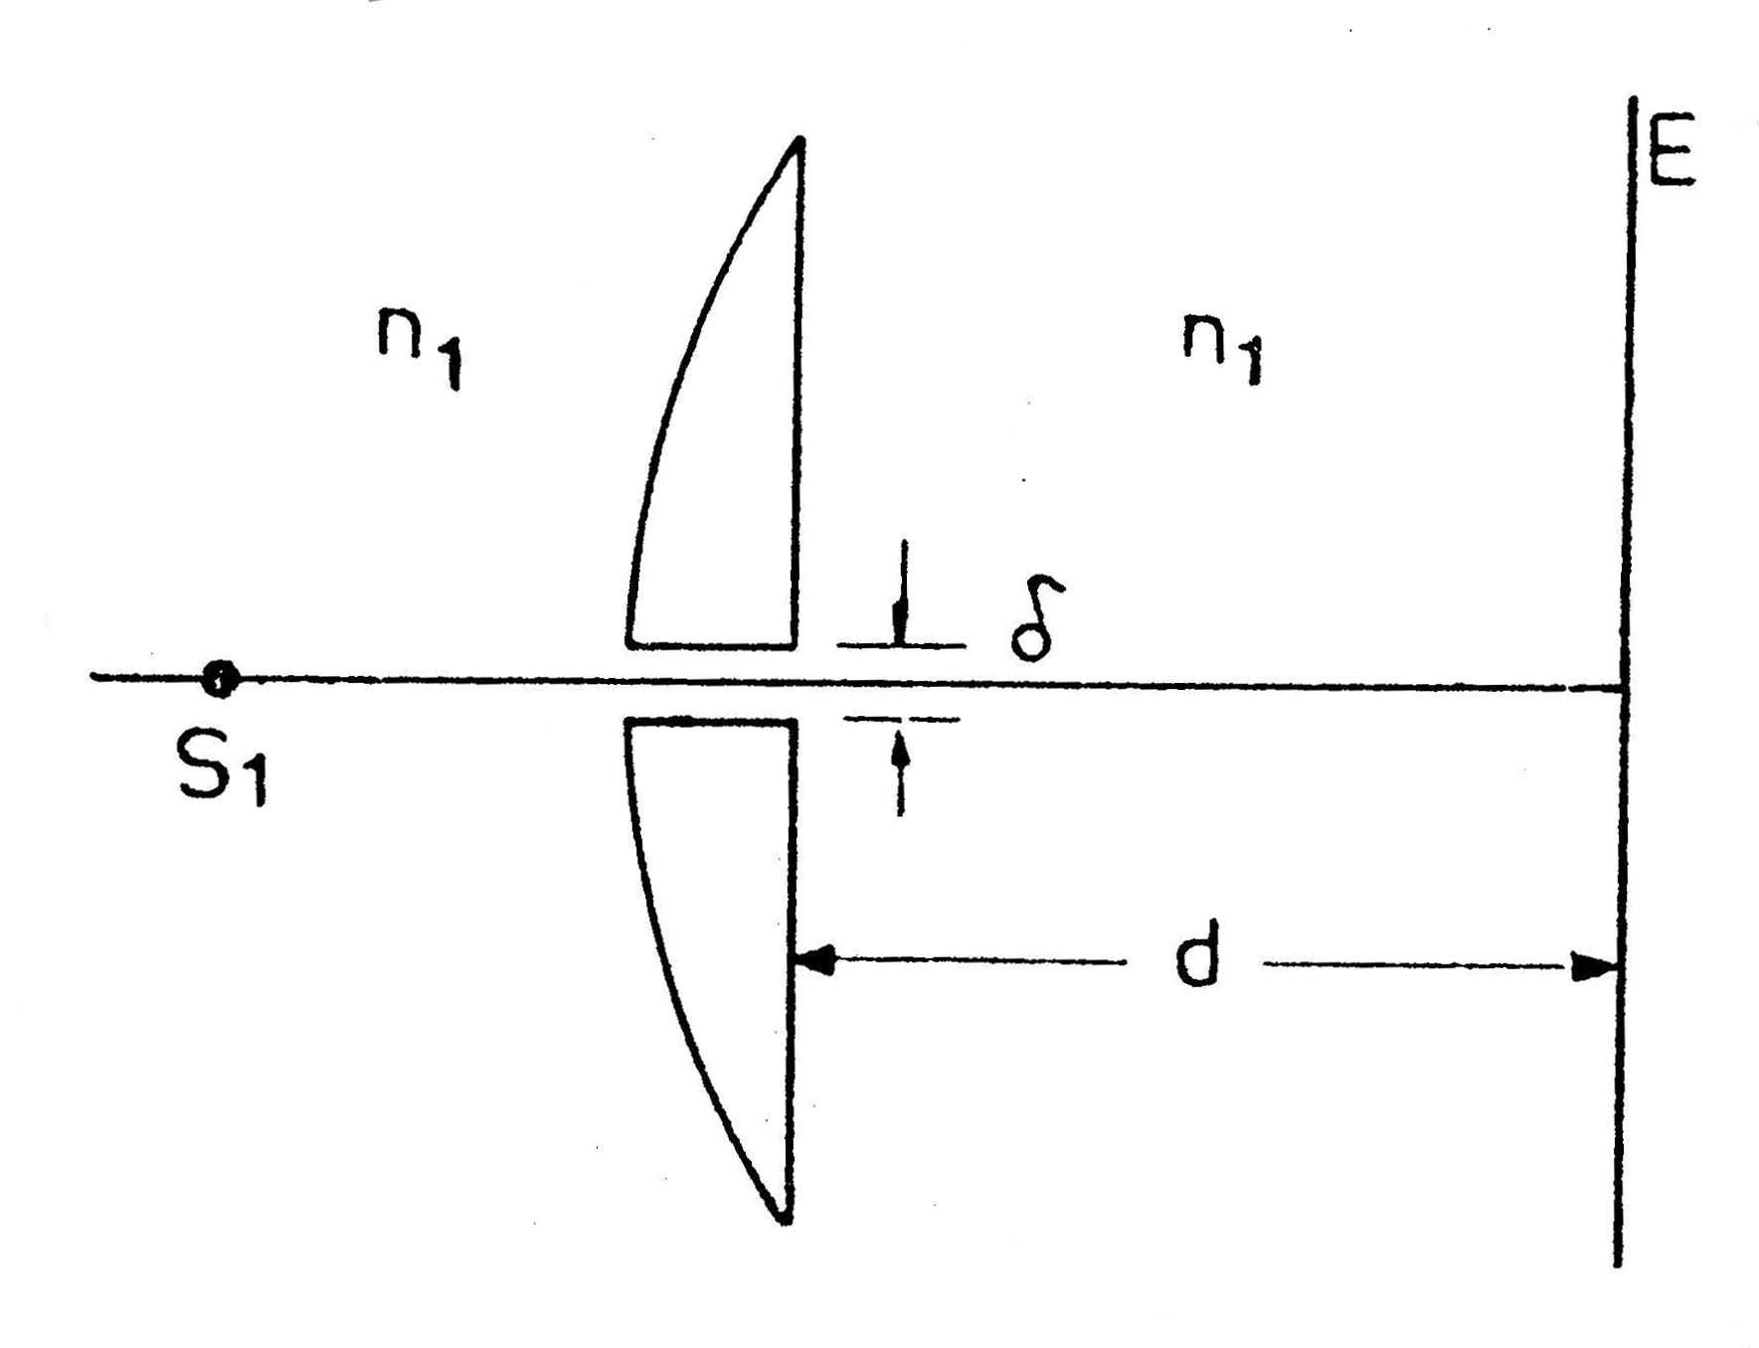

Fig. 4.1

Solution problem 4

- From the Fermat principle it results that the time the light arrives from 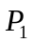 to 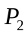is not dependent of the way, in gauss approximation ( and are conjugated points).
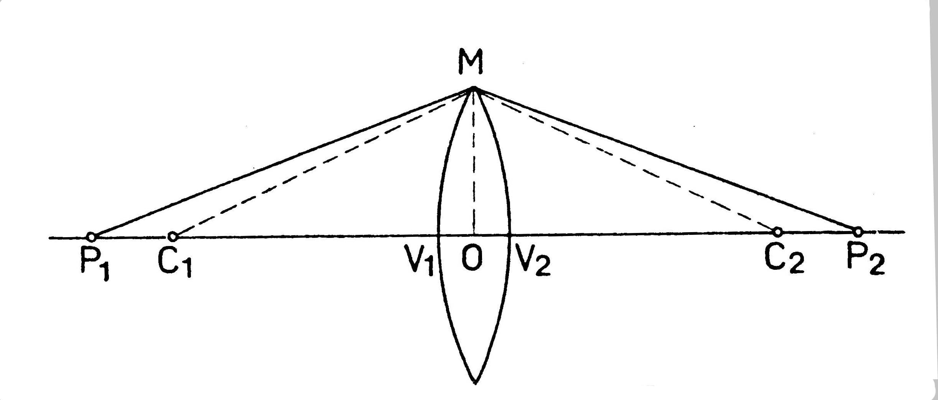
Fig. 4.2
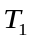 is the time the light roams the optical way 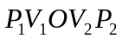 (fig. 4.2):
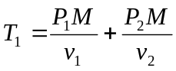, where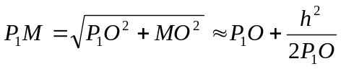, and 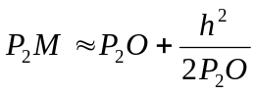
because 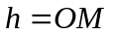is much more smaller than 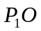 or 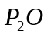.
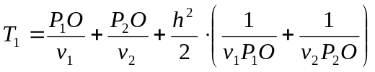; 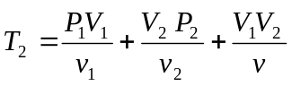 (1)
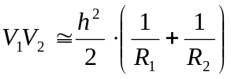 (2)
From condition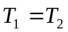, it results:

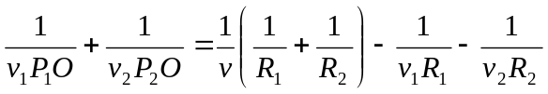 (3)
Taking in account the relation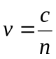, and using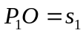,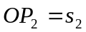, the relation (3) can be written:
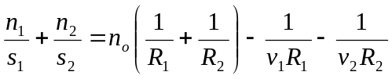 (4)
If the point is at infinite, 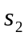 becomes the focal distance; the same for.
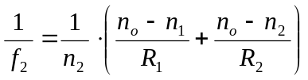; 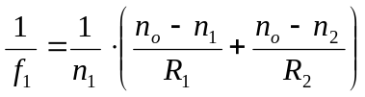 (5)
From the equations (30 and (4) it results:
(6)
The lens is plane-convex (fig. 4.3) and its focal distances are:

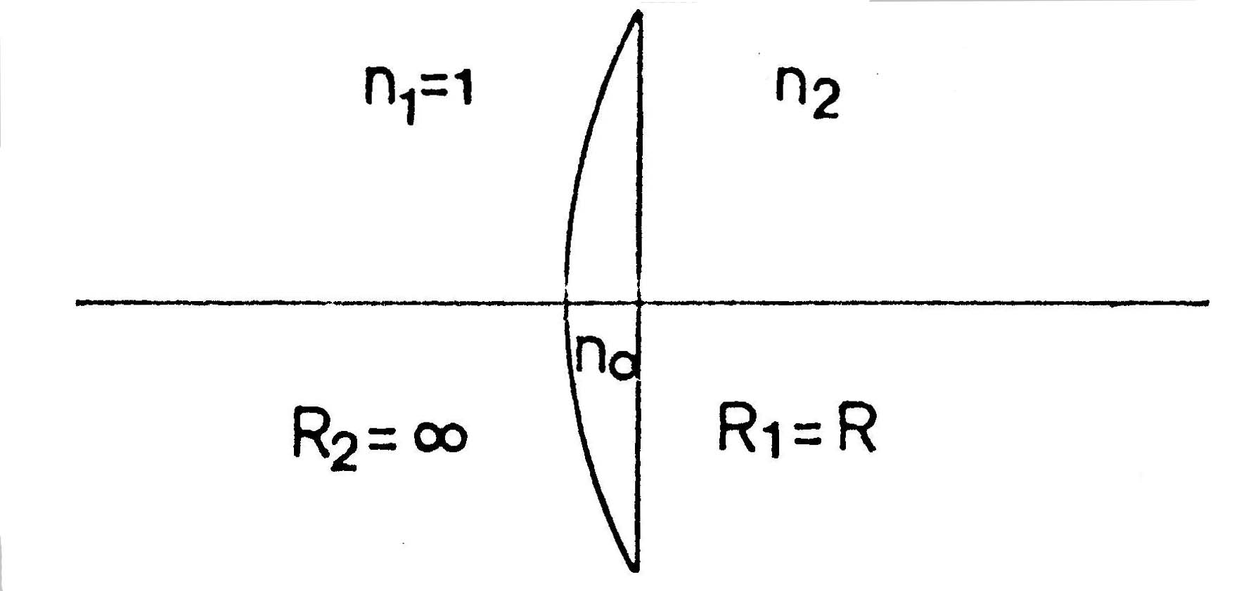

Fig. 4.3
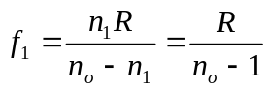 ; 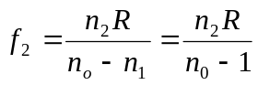 (7)
- In the case of Billet lenses,  and  are the real images of the object S and can be considered like coherent light sources (fig. 4.4).

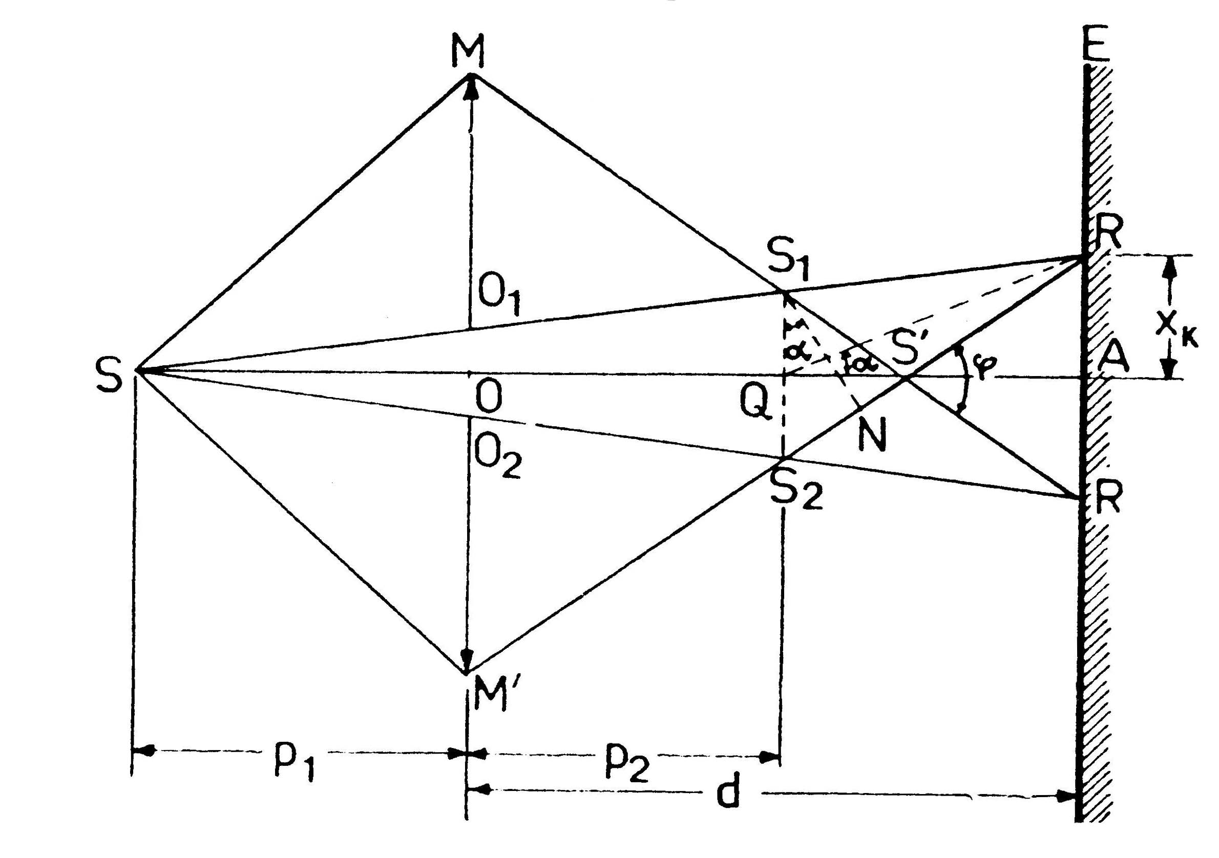
Fig. 4.4

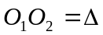 is much more smaller than r:
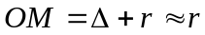, 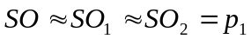, 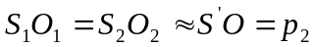, 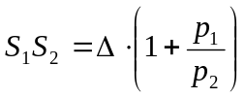
We calculate the width of the interference field 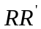 (fig. 4.4).
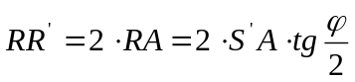, 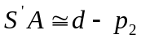, 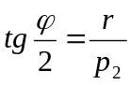, 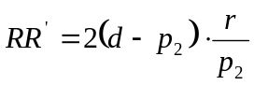
Maximum interference condition is:
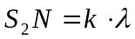
The fringe of k order is located at a distance 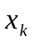 from A:
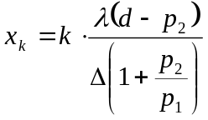 (8)
The expression of the inter-fringes distance is:
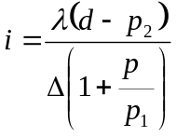 (9)
The number of observed fringes on the screen is:
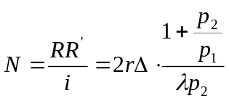 (10)
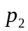 can be expressed from the lenses’ formula:
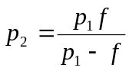

Experimental part (Mechanics)

There are given two cylindrical bodies (having identical external shapes and from the same material), two measuring rules, one graduated and other un-graduated, and a vessel with water.
It is known that one of the bodies is homogenous and the other has an internal cavity with the following characteristics:
- the cavity is cylindrical
- has the axis parallel with the axis of the body
- its length is practically equal with that of the body
Determine experimentally and justify theoretically:
- The density of the material the two bodies consist of.
- The radius of the internal cavity.
- The distance between the axis of the cavity and the axis of the cylinder.
- Indicate the sources of errors and appreciate which of them influences more the final results.
Write all the variants you have found.

Solution of the experimental problem

- Determination of the density of the material
The average density of the two bodies was chosen so that the bodies float on the water.
Using the mass of the liquid crowded out it is determined the mass of the first body (the homogenous body):
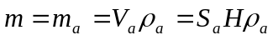 (1)
where S_{a} is the area of the base immersed in water, H the length of the cylinder and ρ_{a} is the density of water.
The mass of the cylinder is:
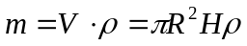 (2)
It results the density of the body:
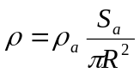 (3)
To calculate the area S_{a} it is measured the distance h above the water surface (fig. 5.1). Area is composed by the area of the triangle OAB plus the area of the circular sector with the angle 2π -2θ.
The triangle area:
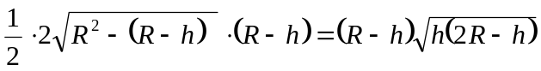 (4)

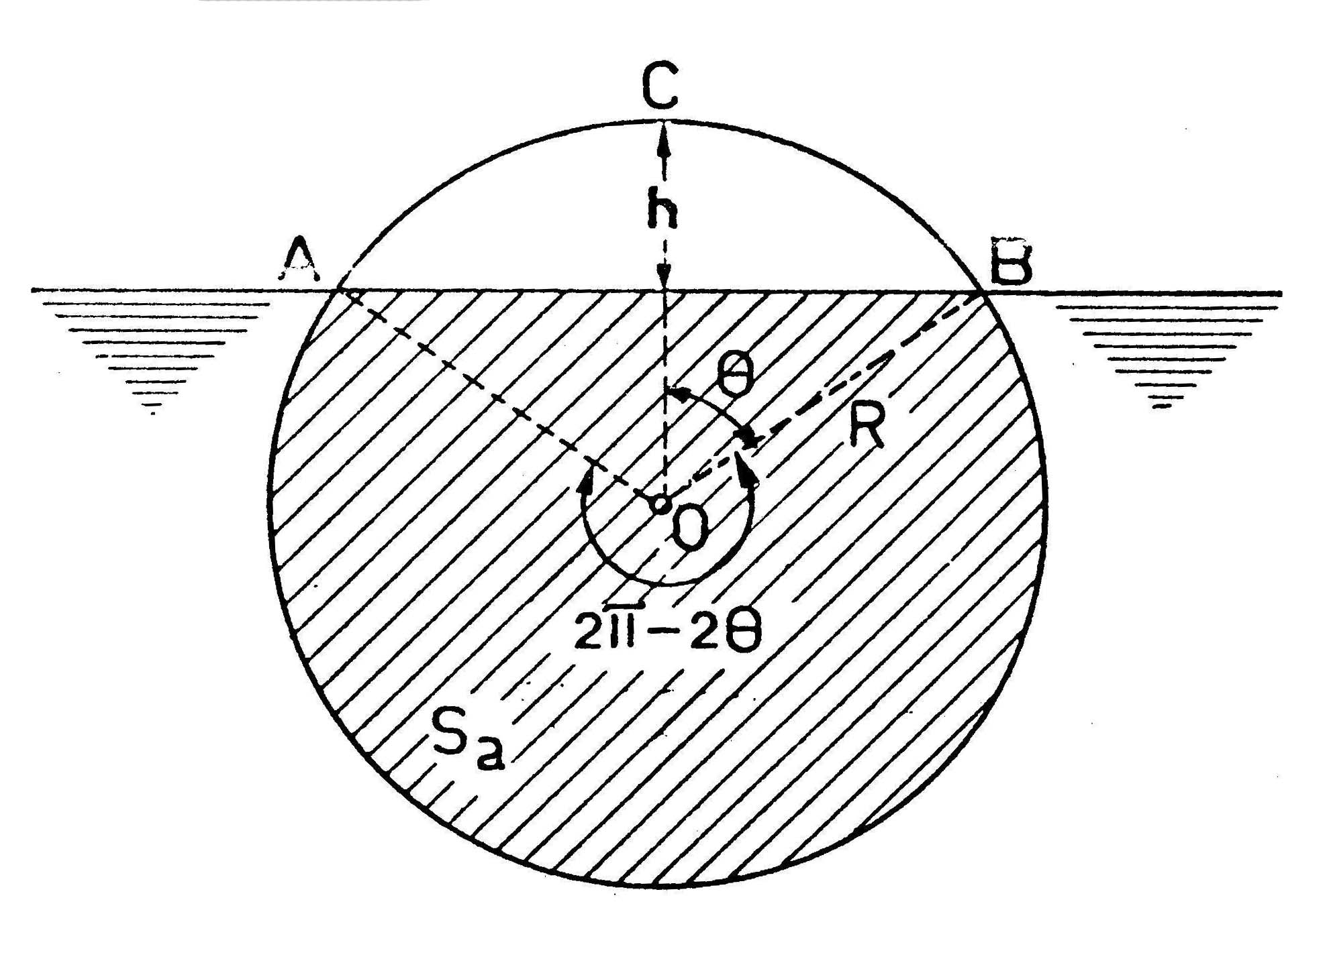
Fig. 5.1

The circular sector area is:

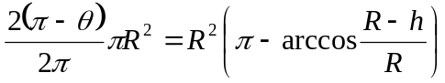 (5)
The immersed area is:

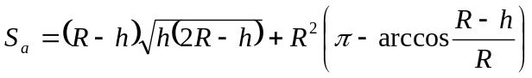 (6)
where R and h are measured by the graduated rule.
- The radius of the cylindrical cavity
The second body (with cavity) is dislocating a water mass:
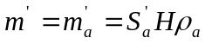 (7)
where S_{a}’ is area immersed in water.
The mass of the body having the cavity inside is:
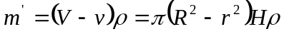 (8)
The cavity radius is:
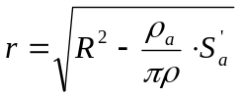 (9)
S_{a}’ is determined like S_{a}.
c) The distance between the cylinder’s axis and the cavity axis
We put the second body on the horizontal table (or let it to float in water) and we trace the vertical symmetry axis AB (fig. 5.2).
Using the rule we make an inclined plane. We put the body on this plane and we determine the maximum angle of the inclined plane for the situation the body remains in rest (the body doesn’t roll). Taking in account that the weight centre is located on the axis AB on the left side of the cylinder axis (point G in fig. 5.2) and that at equilibrium the weight centre is on the same vertical with the contact point between the cylinder and the inclined plane, we obtain the situation corresponding to the maximum angle of the inclined plane (the diameter AB is horizontal).

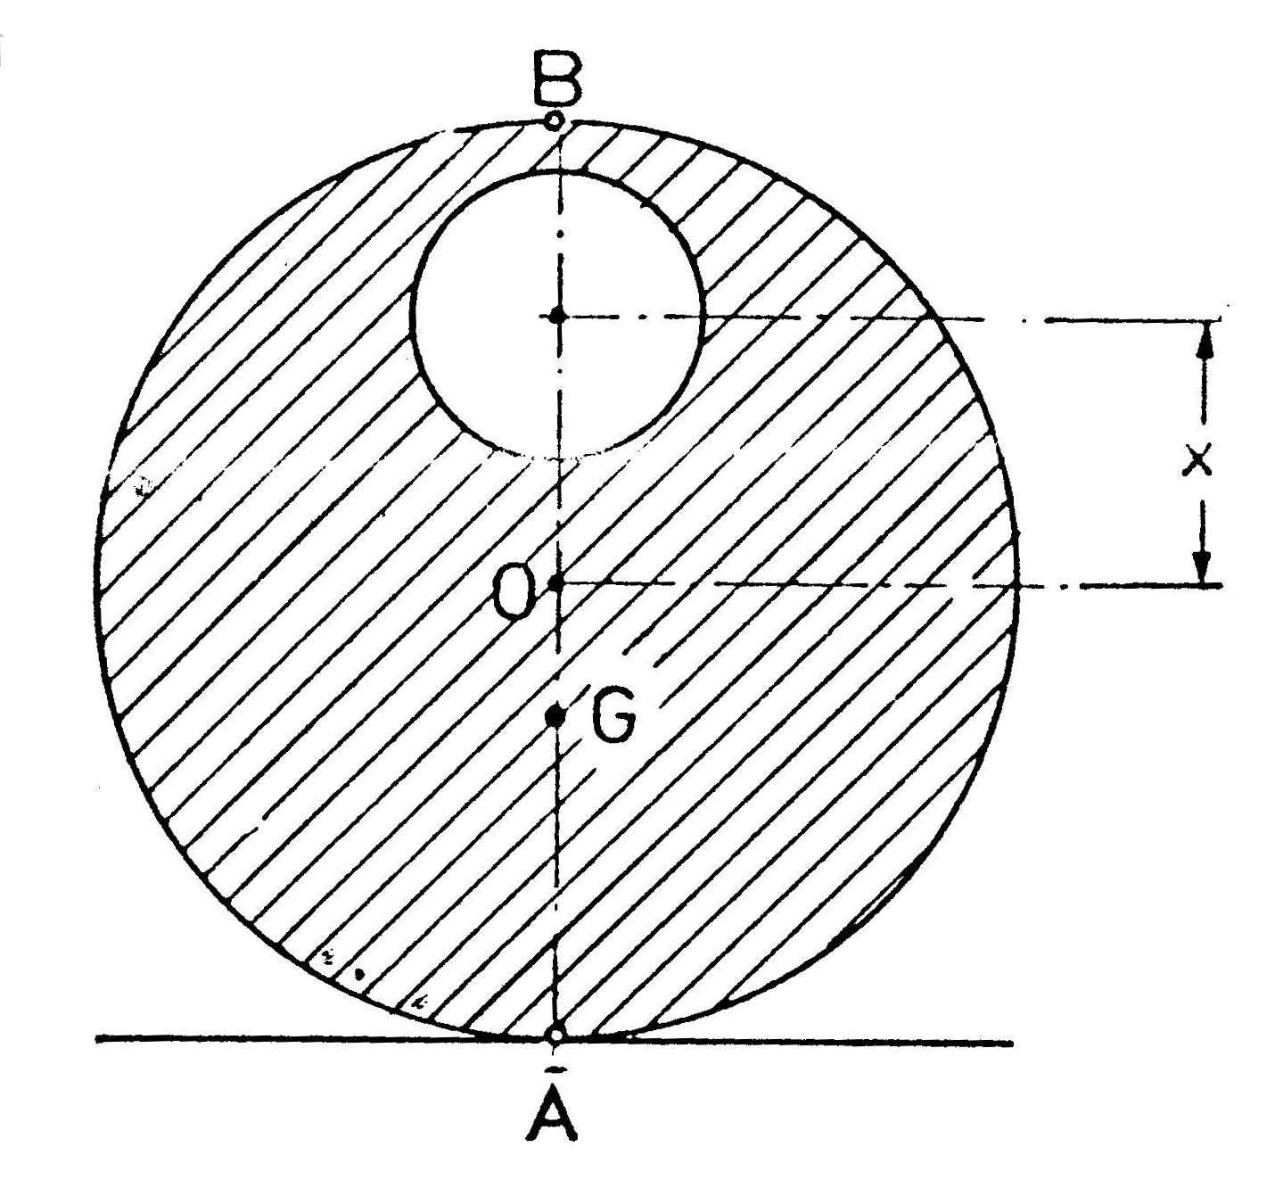
Fig. 5.2

The distance OG is calculated from the equilibrium condition:

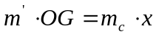 , (m_{c} = the mass dislocated by the cavity) (10)

OG = Rsinα (11)

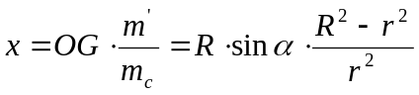 (12)
d) At every measurement it must be estimated the reading error. Taking in account the expressions for ρ, r and x it is evaluated the maximum error for the determination of these measures.

E-mail: popr@tvet.ro
Marius Gall and Anatolie Hristev, Probleme date la Olimpiadele de Fizica, Editura Didactica si Pedagogica – Bucuresti, 1978

