Problems of the 7th International Physics Olympiad
(Warsaw, 1974)

Waldemar Gorzkowski

Institute of Physics, Polish Academy of Sciences, Warsaw, Poland

Abstract

The article contains the competition problems given at the 7th International Physics Olympiad (Warsaw, 1974) and their solutions.

Introduction

The 7th International Physics Olympiad (Warsaw, 1974) was the second one organized in Poland. It took place after a one-year organizational gap, as no country was able to organize the competition in 1973.
The original English version of the problems of the 7th IPhO has not been preserved. We would like to remind that the permanent Secretariat of the IPhOs was established only in 1983; previously the Olympic materials had been collected by individual people in their private archives and, in general, are not complete. English texts of the problems and simplified solutions are available in the book by R. Kunfalvi [1]. Unfortunately, they are somewhat deformed as compared to the originals. Fortunately, we have very precise Polish texts. Also the full solutions in Polish are available. This article is based on the books [2, 3] and article [4].
The competition problems were prepared especially for the 7th IPhO by Andrzej Szymacha (theoretical problems) and Jerzy Langer (experimental problem).

THEORETICAL PROBLEMS

Problem 1

A hydrogen atom in the ground state, moving with velocity, collides with another hydrogen atom in the ground state at rest. Using the Bohr model find the smallest velocity 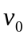 of the atom below which the collision must be elastic.
At velocity the collision may be inelastic and the colliding atoms may emit electromagnetic radiation. Estimate the difference of frequencies of the radiation emitted in the direction of the initial velocity of the hydrogen atom and in the opposite direction as a fraction (expressed in percents) of their arithmetic mean value.
Data:

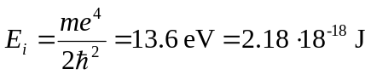; (ionization energy of hydrogen atom)

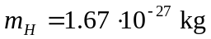; (mass of hydrogen atom)

( - mass of electron; - electric charge of electron; - Planck constant; numerical values of these quantities are not necessary.)

Solution

According to the Bohr model the energy levels of the hydrogen atom are given by the formula:

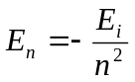,

where = 1, 2, 3, … The ground state corresponds to 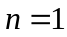, while the lowest excited state corresponds to 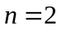. Thus, the smallest energy necessary for excitation of the hydrogen atom is:

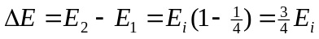.

During an inelastic collision a part of kinetic energy of the colliding particles is converted into their internal energy. The internal energy of the system of two hydrogen atoms considered in the problem cannot be changed by less than 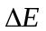. It means that if the kinetic energy of the colliding atoms with respect to their center of mass is less than , then the collision must be an elastic one. The value of can be found by considering the critical case, when the kinetic energy of the colliding atoms is equal to the smallest energy of excitation. With respect to the center of mass the atoms move in opposite direction with velocities 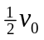. Thus

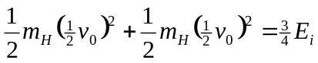

and

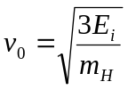 (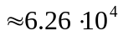 m/s).

Consider the case when 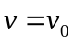. The collision may be elastic or inelastic. When the collision is elastic the atoms remain in their ground states and do not emit radiation. Radiation is possible only when the collision is inelastic. Of course, only the atom excited in the collision can emit the radiation. In principle, the radiation can be emitted in any direction, but according to the text of the problem we have to consider radiation emitted in the direction of the initial velocity and in the opposite direction only. After the inelastic collision both atom are moving (in the laboratory system) with the same velocities equal to . Let  denotes the frequency of radiation emitted by the hydrogen atom in the mass center (i.e. at rest). Because of the Doppler effect, in the laboratory system this frequency is observed as (c denotes the velocity of light):
a) 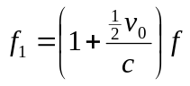- for radiation emitted in the direction of the initial velocity of the hydrogen atom,
b) 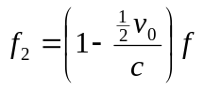 - for radiation emitted in opposite direction.

The arithmetic mean value of these frequencies is equal to. Thus the required ratio is

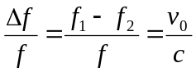 (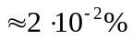).

In the above solution we took into account that 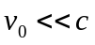. Otherwise it would be necessary to use relativistic formulae for the Doppler effect. Also we neglected the recoil of atom(s) in the emission process. One should notice that for the visible radiation or radiation not too far from the visible range the recoil cannot change significantly the numerical results for the critical velocity and the ratio 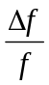. The recoil is important for high-energy quanta, but it is not this case.
The solutions were marked according to the following scheme (draft):
- Energy of excitation up to 3 points
- Correct description of the physical processes up to 4 points
- Doppler effect up to 3 points

Problem 2

Consider a parallel, transparent plate of thickness d – Fig. 1. Its refraction index varies as
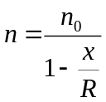.

y
α

B

d

x_{B}
A
x

Fig. 1

A light beam enters from the air perpendicularly to the plate at the point A (x_{A} = 0) and emerges from it at the point B at an angle .
- Find the refraction index 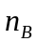 at the point B.
- Find 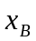(i.e. value of x at the point B)
- Find the thickness d of the plate.
Data:

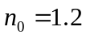; 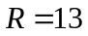cm; 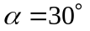.

Solution

n₁
n₂
n₃
β₁
β₂
β₃
β₃

β₂

Fig. 2

Consider a light ray passing through a system of parallel plates with different refractive indexes – Fig. 2. From the Snell law we have

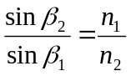
i.e.
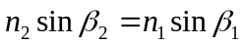.

In the same way we get

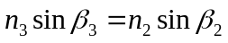, etc.

Thus, in general:
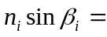const.

This relation does not involve plates thickness nor their number. So, we may make use of it also in case of continuous dependence of the refractive index in one direction (in our case in the x direction).

Consider the situation shown in Fig. 3.

α

B
β_{B}

x_{B}
A

Fig. 3

At the point A the angle 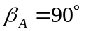. The refractive index at this point is 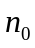. Thus, we have

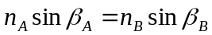,
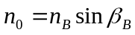.

Additionally, from the Snell law applied to the refraction at the point B, we have

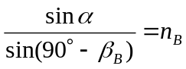.

Therefore

and finally

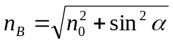.

Numerically

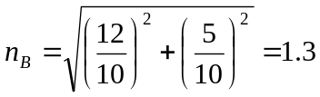

The value of can be found from the dependence 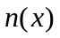 given in the text of the problem. We have

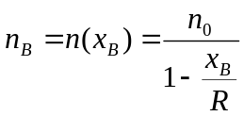,
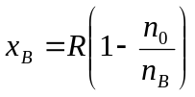,
Numerically
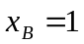 cm.
The answer to the third question requires determination of the trajectory of the light ray. According to considerations described at the beginning of the solution we may write (see Fig. 4):

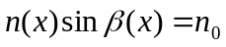.

Thus
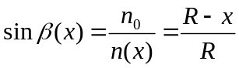.
A’
A
B
O
R
d
C
C’
R
R - x
B’
β(x)

R

Fig. 4

Consider the direction of the ray crossing a point C on the circle with radius  and center in point O as shown in Fig. 4. We see that

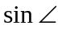COC' 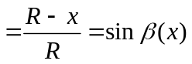.

Therefore, the angle COC' must be equal to the angle 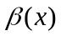 formed at the point C by the light ray and CC'. It means that at the point C the ray must be tangent to the circle. Moreover, the ray that is tangent to the circle at some point must be tangent also at farther points. Therefore, the ray cannot leave the circle (as long as it is inside the plate)! But at the beginning the ray (at the point A) is tangent to the circle. Thus, the ray must propagate along the circle shown in Fig. 4 until reaching point B where it leaves the plate.
Already we know that A'B = 1 cm. Thus, B'B = 12 cm and from the rectangular triangle BB'O we get

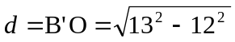cm = 5 cm.

The shape of the trajectory 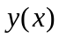 can be determined also by using more sophisticated calculations. Knowing we find 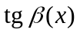:

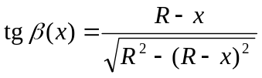.

But is the derivative of . So, we have

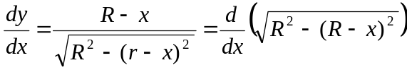.

Thus

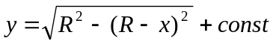

Value of const can be found from the condition

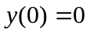.

Finally:

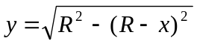.

It means that the ray moves in the plate along to the circle as found previously.

y

(R,0)
x

Fig. 5

Now we will present yet another, already the third, method of proving that the light in the plate must move along the circle.
We draw a number of straight lines (inside the plate) close to each other and passing trough the point (R,0) - Fig. 5. From the formula given in the text of the problem it follows that the refraction index on each of these lines is inversely proportional to the distance to the point (R,0). Now we draw several arcs with the center at (R,0). It is obvious that the geometric length of each arc between two lines is proportional to the distance to the point (R,0).
It follows from the above that the optical path (a product of geometric length and refractive index) along each arc between the two lines (close to each other) is the same for all the arcs.
Assume that at +-certain moment the wave front reached one of the lines, e.g. the line marked with a black dot in Fig. 5. According to the Huygens principle, the secondary sources on this line emit secondary waves. Their envelope forms the wave front of the real wave at some time 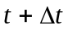. The wave fronts of secondary waves, shown in Fig. 5, have different geometric radii, but - in view of our previous considerations - their optical radii are exactly the same. It means that at the time the new wave front will correspond to one of the lines passing trough (R,0). At the beginning the wave front of the light coincided with the x axis, it means that inside the plate the light will move along the circle with center at the point (R,0).
The solutions were marked according to the following scheme (draft):
- Proof of the relation 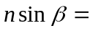 const up to 2 points
- Correct description of refraction at points A and B up to 2 points
- Calculation of 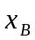 up to 1 point
- Calculation of d up to 5 points

Problem 3

A scientific expedition stayed on an uninhabited island. The members of the expedition had had some sources of energy, but after some time these sources exhausted. Then they decided to construct an alternative energy source. Unfortunately, the island was very quiet: there were no winds, clouds uniformly covered the sky, the air pressure was constant and the temperatures of air and water in the sea were the same during day and night. Fortunately, they found a source of chemically neutral gas outgoing very slowly from a cavity. The pressure and temperature of the gas are exactly the same as the pressure and temperature of the atmosphere.
The expedition had, however, certain membranes in its equipment. One of them was ideally transparent for gas and ideally non-transparent for air. Another one had an opposite property: it was ideally transparent for air and ideally non-transparent for gas. The members of the expedition had materials and tools that allowed them to make different mechanical devices such as cylinders with pistons, valves etc. They decided to construct an engine by using the gas from the cavity.
Show that there is no theoretical limit on the power of an ideal engine that uses the gas and the membranes considered above.

Solution

Let us construct the device shown in Fig. 6. B₁ denotes the membrane transparent for the gas from the cavity, but non-transparent for the air, while B₂ denotes the membrane with opposite property: it is transparent for the air but non-transparent for the gas.
Initially the valve Z₁ is open and the valve Z₂ is closed. In the initial situation, when we keep the piston at rest, the pressure under the piston is equal to 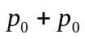 due to the Dalton law. Let denotes an initial volume of the gas (at pressure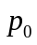).
Now we close the valve Z₁ and allow the gas in the cylinder to expand. During movement of the piston in the downwards direction we obtain certain work performed by excess pressure inside the cylinder with respect to the atmospheric pressure. The partial pressure of the gas in the cylinder will be reduced according to the formula 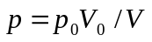, where V denotes volume closed by the piston (isothermal process). Due to the membrane B₂ the partial pressure of the air in the cylinder all the time is and balances the air pressure outside the cylinder. It means that only the gas from the cavity effectively performs the work.
Cavity
p₀

B₁
p₀

Z₁
Z₂

B₂
p

p₀

Fig. 6

Consider the problem of limits for the work that can be performed during isothermal expansion of an initial portion of the gas. Let us analyze the graph of the function 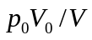 versus  shown in Fig. 7.
It is obvious that the amount of work performed by the gas during isothermal expansion from to 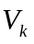 is represented by the area under the curve (shown in the graph) from to . Of course, the work is proportional to . We shall prove that for large enough the work can be arbitrarily large.
Consider 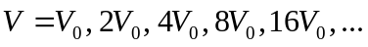 It is clear that the rectangles I, II, III, … (see Fig. 7) have the same area and that one may draw arbitrarily large number of such rectangles under the considered curve. It means that during isothermal expansion of a given portion of the gas we may obtain arbitrarily large work (at the cost of the heat taken from sthe urrounding) – it is enough to take large enough.
After reaching we open the valve Z₂ and move the piston to its initial position without performing any work. The cycle can be repeated as many times as we want.
In the above considerations we focused our attention on the work obtained during one cycle only. We entirely neglected dynamics of the process, while each cycle lasts some time. One may think that - in principle - the length of the cycle increases very rapidly with the effective work we obtain. This would limit the power of the device we consider.
Take, however, into account that, by proper choice of various parameters of the device, the time taken by one cycle can be made small and the initial volume of the gas can be made arbitrarily large (we consider only theoretical possibilities – we neglect practical difficulties entirely). E.g. by taking large size of the membrane B₁ and large size of the piston we may minimize the time of taking the initial portion of the gas from the cavity and make this portion very great.
In our analysis we neglected all losses, friction, etc. One should remark that there are no theoretical limits for them. These losses, friction etc. can be made negligibly small.

p

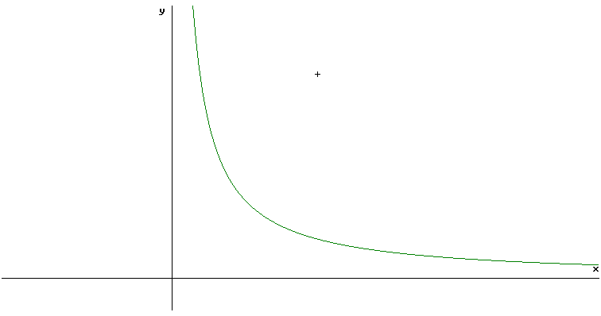

II
III
I
p₀
V
V₀
2V₀
4V₀
8V₀
p₀/2
p₀/4
p₀/8
V_{k}
Fig. 7

The device we analyzed is very interesting: it produces work at cost of heat taken from surrounding without any difference in temperatures. Does this contradict the second law of thermodynamics? No! It is true that there is no temperature difference in the system, but the work of the device makes irreversible changes in the system (mixing of the gas from the cavity and the air).
The solutions were marked according to the following scheme (draft):
- Model of an engine and its description up to 4 points
- Proof that there is no theoretical limit for power up to 4 points
- Remark on II law of thermodynamics up to 2 points

EXPERIMENTAL PROBLEM

In a "black box" there are two identical semiconducting diodes and one resistor connected in some unknown way. By using instruments provided by the organizers find the resistance of the resistor.
Remark: One may assume that the diode conducts current in one direction only.
List of instruments: two universal volt-ammeters (without ohmmeters), battery, wires with endings, graph paper, resistor with regulated resistance.

Solution

At the beginning we perform preliminary measurements by using the circuit shown in Fig. 8. For two values of voltage 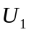 and 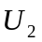, applied to the black box in both directions, we measure four values of current: 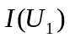, 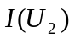, 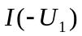 and 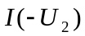. In this way we find that:

      - The black box conducts current in both directions;
      - There is an asymmetry with respect to the sign of the voltage;
      - In both directions current is a nonlinear function of voltage.

mV

mA

Fig. 8

The diodes and resistor can be connected in a limited number of ways shown in Fig. 9 (connections that differ from each other in a trivial way have been omitted).

Fig. 9

Only one of these connections has the properties mentioned at the beginning. It is:

B
A
B

Fig. 10

For absolute values of voltages we have

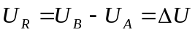,

where 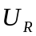 denotes voltage on the resistor when a current flows trough the branch B, 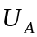 - voltage on the black box when the current flows through the branch A, and 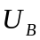 - voltage on the black box when the current flows through the branch B.
Therefore

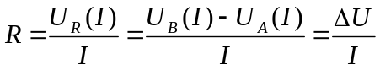.

It follows from the above that it is enough to take characteristics of the black box in both directions: by subtraction of the corresponding points (graphically) we obtain a straight line (example is shown in Fig. 11) whose slope allows to determine the value of .
The solutions were marked according to the following scheme (draft):
Theoretical part:
- Proper circuit and method allowing determination of connections
the elements in the black box up to 6 points
- Determination of R (principle) up to 2 points
- Remark that measurements at the same voltage in both
directions make the error smaller up to 1 point
- Role of number of measurements (affect on errors) up to 1 point
Experimental part:
- Proper use of regulated resistor as potentiometer up to 2 points
- Practical determination of R (including error) up to 4 points
- Proper use of measuring instruments up to 2 points
- Taking into account that temperature of diodes increases during
measurements up to 1 point
- Taking class of measuring instruments into account up to 1 point

20
40
60
80
100
150
200

I
[mA]
ΔU
[mV]
0
5
10
15
20
25

Fig. 11

Acknowledgement

Author wishes to express many thanks to Prof. Jan Mostowski for reading the text and for many valuable comments and remarks that allowed improving the final version.

Literature

[1] R. Kunfalvi, Collection of Competition Tasks from the Ist trough XVth International Physics Olympiads, 1967 – 1984, Roland Eotvos Physical Society and UNESCO, Budapest 1985
[2] W. Gorzkowski, Olimpiady Fizyczne – XXIII I XXIV, WSiP, Warszawa 1977
[3] W. Gorzkowski, Zadania z fizyki z całego świata (z rozwiązaniami) - 20 lat Międzynarodowych Olimpiad Fizycznych, WNT, Warszawa 1994 [ISBN 83-204-1698-1]
[4] W. Gorzkowski, VII Międzynarodowa Olimpiada Fizyczna, Fizyka w Szkole, nr 3/75, pp. 23 – 28

This article has been sent for publication in Physics Competitions in September 2003
e-mail: gorzk@ifpan.edu.pl

